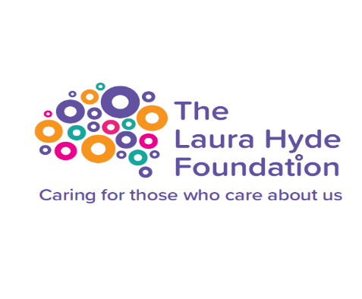
The Laura Hyde Foundation is the UK’s ONLY dedicated mental health charity for our emergency services across nurses, doctors, paramedics, fire and police personnel.
These people who dedicate their lives to helping us are often exposed daily to traumatic situations and work in an environment that faces many external pressures
100% of all monies raised are spent positively impacting the mental health landscape for our miracle workers.
Lets care for those who care about us.
Name | Email Address/Telephone Number | Amount

