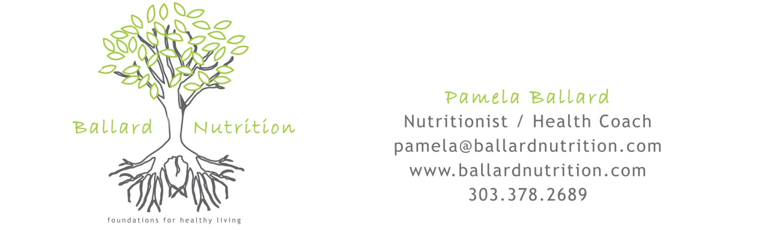

Name _________________________________________ Dates ___________________

5-Day Diet Diary Instructions
It is important to keep an accurate record of your usual food and beverage intake as a part of your lifestyle plan. Please complete this Diet Diary for 5 consecutive days including one weekend day. Do not change your eating behavior at this time, as the purpose of this food record is to analyze your present eating habits.
- Record information as soon as possible after the food has been consumed.
- Describe the food or beverage as accurately as possible e.g., milk – what kind? (whole, 2%, or nonfat); toast – (whole wheat, white, buttered); chicken - (fried, baked, or breaded); coffee – (decaffeinated w/ sugar & ½ ‘n’ ½)
- Record the amount of each food or beverage consumed using standard measurements such as 8 ounces, ½ cup, 1 teaspoon, etc.
- Include any added items. For example: tea with 1 teaspoon honey, potato with 2 teaspoons butter, etc.
- Record all beverages, including water, coffee, tea, sports drinks, sodas/diet sodas, etc.
- Include any additional comments about your eating habits at the end of this form (ex. craving sweet, skipped meal and why, when the meal was at a restaurant, moods, concerns, etc.)
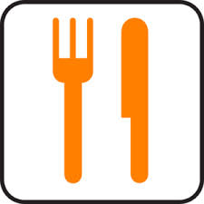
Day 1
Meal | Time | Food / Beverage / Amount | Comments

Breakfast

Lunch

Dinner

Snacks & Beverages

Day 2

Meal | Time | Food / Beverage / Amount | Comments

Breakfast

Lunch

Dinner

Snacks & Beverages

Day 3

Meal | Time | Food / Beverage / Amount | Comments

Breakfast

Lunch

Dinner

Snacks & Beverages

Day 4

Meal | Time | Food / Beverage / Amount | Comments

Breakfast

Lunch

Dinner

Snacks & Beverages

Day 5

Meal | Time | Food / Beverage / Amount | Comments

Breakfast

Lunch

Dinner

Snacks & Beverages

Other Comments _________________________________________________________________________________________________________________________________________________________________________
Thank you!

