THE SECOND SUNDAY OF EASTER
April 7, 2024

I think there is no suffering greater that what is caused by the doubts of those who want to believe. I know what torment this is, but I can only see it, in myself, anyway, as the process by which faith is deepened. A faith that just accepts is a child’s faith and all right for children, but eventually you have to grow religiously as every other way, though some never do.
What people don’t realize is how much religion costs. They think faith is a big electric blanket, when of course it is the cross. It is much harder to believe than not to believe. If you feel you can’t believe, you must at least do this: keep an open mind. Keep it open toward faith, keep wanting it, keep asking for it, and leave the rest to God.
When we get our spiritual house in order, we’ll be dead. This goes on. You arrive at enough certainty to be able to make your way, but it is making it in darkness. Don’t expect faith to clear things up for you. It is trust, not certainty.

Flannery O’Connor

In the Name of Jesus

INTRODUCTION

The Easter season is a week of weeks, seven Sundays when we play in the mystery of Christ’s presence, mostly through the glorious Gospel of John. Today we gather with the disciples on the first Easter, and Jesus breathes the Spirit on us. With Thomas we ask for a sign, and Jesus offers us his wounded self in the broken bread. From frightened individuals we are transformed into a community of open doors, peace, forgiveness, and material sharing such that no one among us is in need.

Albrecht Dürer, died 1528; Matthias Grünewald, died 1529; Lucas Cranach, died 1553; artists

These great artists revealed through their work the mystery of salvation and the wonder of creation. Dürer's work reflected the apocalyptic spirit of his time. Though he remained a Roman Catholic, he was sympathetic to Martin Luther's reforming work. Grünewald's paintings are known for their dramatic forms, vivid colors, and depiction of light. Cranach's work includes many fine religious examples and several portraits of Martin Luther. Cranach was also widely known for his woodcuts.

GATHERING

PRELUDE

THE EASTER ACCLAMATION

P: Christ is risen! Alleluia!

C: (Shouted) He is risen indeed! Alleluia!

ANNOUNCEMENTS
As you are able please rise

CONFESSION AND ABSOLUTION

P: In the name of the Father and of the Son and of the Holy Spirit.

C: Amen.

P: “God is light, and in Him there is no darkness at all. If we say that we have fellowship
with Him while we are walking in darkness, we lie and do not do what is true; but if
we walk in the light as He Himself is in the light, we have fellowship with one another,
and the blood of Jesus His Son cleanses us from all sin.” (1 John 1: 5b-7) In Baptism
we were buried with Christ that we might die to sin and walk in newness of life.
Therefore, let us confess our sin against God and one another.

Silence for reflection and self-examination is kept

P: Most merciful God,

C: We confess that we have sinned against You in thought, word, and deed. We have
not lived as the risen Body of Christ in the world. We are not of “one heart and
soul.” (Acts 4: 32) Our testimony to the resurrection of Christ has lacked power
and conviction. (4: 33) We have not always cared for the needy among us. (4: 34)
We have kept to ourselves in fear. (John 20: 19) For the sake of Your Son, Jesus
Christ, have mercy on us. Strengthen us by Your Spirit, and lead us from our sin,
that we may bear the fruits of Your love and mercy to all the world.

P: “If we say we have no sin, we deceive ourselves, and the truth is not in us. But if we
confess our sins, God Who is faithful and just, will forgive our sins and cleanse us from
all unrighteousness.” (1 John 1: 8-9) Upon your confession, as a called and ordained
minister of the Church of Christ, and by His authority, I therefore declare to you the
entire forgiveness of all your sins, in the name of the Father and of the Son and of
the Holy Spirit.

C: Amen.

GATHERING HYMN 384 That Easter Day With Joy Was Bright

THE GREETING PRAYER OF THE DAY

P: Alleluia! Christ is risen!

C: Christ is risen indeed! Alleluia!

P: The grace of our Lord Jesus Christ, the love of God, and the communion of the Holy
Spirit be with you all.

C: And also with you.

THE HYMN OF PRAISE (see pp. 3,4,5)

REFRAIN ALL; Vv. 1, 3 Women; Vv. 2, 4 Men

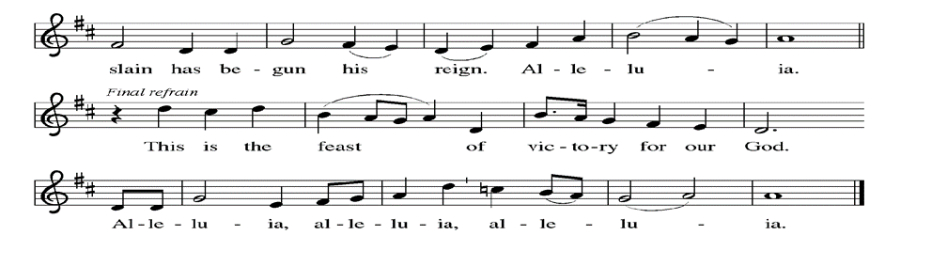

THE PRAYER OF THE DAY

P: The Lord be with you.

C: And also with you.

P: Let us pray. Almighty God, with joy we celebrate the Day of our Lord’s resurrection.
By the grace of Christ among us, enable us to show the power of the resurrection in all
that we say and do, through Jesus Christ, our Savior and Lord, Who lives and reigns
with You and the Holy Spirit, one God, now and forever.

C: Amen.

The assembly is seated

WORD

FIRST READING Acts 4: 32-35

While the apostles testified to others about the resurrection of Jesus, the early Christian community shared what they owned or sold their possessions to help their fellow believers who were in need.
³²Now the whole group of those who believed were of one heart and soul, and no one claimed private ownership of any possessions, but everything they owned was held in common. ³³With great power the apostles gave their testimony to the resurrection of the Lord Jesus, and great grace was upon them all.
³⁴There was not a needy person among them, for as many as owned lands or houses sold them and brought the proceeds of what was sold. ³⁵They laid it at the apostles' feet, and it was distributed to each as any had need.
The Word of the Lord.

Thanks be to God.

THE PSALM: Psalm 133 Read responsively

¹How good and how pleasant it is,
when kindred live together in unity!

²It is like fine oil upon the head, flowing down upon the beard,
upon the beard of Aaron,
flowing down upon the collar of his robe.

³It is like the dew of Hermon flowing down upon the hills of Zion.
For there the LORD has commanded the blessing:
life forevermore.

SECOND READING 1 John 1: 1-2:2

The opening of this letter serves as a reality check. The reality of God is light, but our confessed reality has been sin. God cleanses us from our sinful reality through Christ’s death so that we live in fellowship with Christ and walk in God’s light.
Chapter 1

We declare to you what was from the beginning, what we have heard, what we have seen with our eyes, what we have looked at and touched with our hands, concerning the Word of life — ²this life was revealed, and we have seen it and testify to it, and declare to you the eternal life that was with the Father and was revealed to us — ³we declare to you what we have seen and heard so that you also may have fellowship with us; and truly our fellowship is with the Father and with His Son Jesus Christ. ⁴We are writing these things so that our joy may be complete.
⁵This is the message we have heard from Him and proclaim to you, that God is light and Him there is no darkness at all. ⁶If we say that we have fellowship with Him while we are walking in darkness, we lie and do not do what is true; ⁷but if we walk in the light as He Himself is in the light, we have fellowship with one another, and the blood of Jesus His Son cleanses us from all sin. ⁸If we say that we have no sin, we deceive ourselves, and the truth is not in us. ⁹If we confess our sins, He Who is faithful and just will forgive us our sins and cleanse us from all unrighteousness. ¹⁰If we say that we have not sinned, we make Him a liar, and His word is not in us.
Chapter 2

My little children, I am writing these things to you so that you may not sin. But if anyone does sin, we have an advocate with the Father, Jesus Christ the righteous; ²and He is the atoning sacrifice for our sins, and not for ours only but also for the sins of the whole world.

The Word of the Lord.

Thanks be to God.

As you are able please rise

THE VERSE

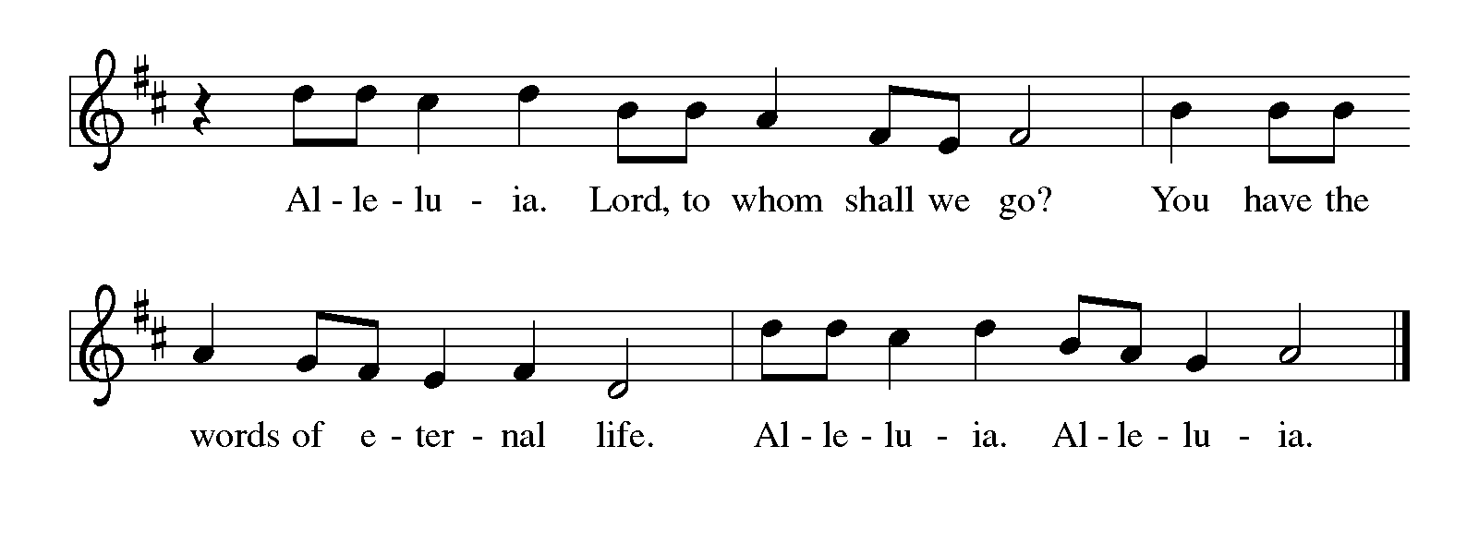
THE HOLY GOSPEL John 20: 19-31

The story of Easter continues as the risen Lord appears to His disciples. His words to Thomas offer a blessing to all who entrust themselves in faith to the risen Lord.

P: The Holy Gospel according to St. John, the twentieth chapter.

C: Glory to You, O Lord!

When it was evening on that day, the first day of the week, and the doors of the house where the disciples had met were locked for fear of the Judeans, Jesus came and stood among them and said, "Peace be with you." ²⁰After He said this, He showed them His hands and His side. Then the disciples rejoiced when they saw the Lord.
²¹Jesus said to them again, "Peace be with you. As the Father has sent Me, so I send you." ²²When He had said this, He breathed on them and said to them, "Receive the Holy Spirit. ²³If you forgive the sins of any, they are forgiven them; if you retain the sins of any, they are retained."
²⁴But Thomas (who was called the Twin), one of the twelve, was not with them when Jesus came. ²⁵So the other disciples told him, "We have seen the Lord." But he said to them, "Unless I see the mark of the nails in His hands, and put my finger in the mark of the nails and my hand in His side, I will not believe."
²⁶A week later His disciples were again in the house, and Thomas was with them. Although the doors were shut, Jesus came and stood among them and said, "Peace be with you." ²⁷Then He said to Thomas, "Put your finger here and see My hands. Reach out your hand and put it in My side. Do not doubt but believe."
²⁸Thomas answered Him, "My Lord and my God!" ²⁹Jesus said to him, "Have you believed because you have seen Me? Blessed are those who have not seen and yet have come to believe."
³⁰Now Jesus did many other signs in the presence of His disciples, which are not written in this book. ³¹But these are written so that you may come to believe that Jesus is
the Messiah, the Son of God, and that through believing you may have life in His name.

P: The Gospel of the Lord.
C: Praise to You, O Christ!

The assembly is seated

THE SERMON

Silence for reflection follows the sermon

As you are able please rise

THE HYMN OF THE DAY 635 We Walk by Faith and Not by Sight
Stanza 2—Men; Stanza 4--Women

THE NICENE CREED

A: God has made us His people through our Baptism into Christ. Living together in trust
and hope, we confess our faith.

C: We believe in one God,
the Father, the Almighty,
maker of heaven and earth,
of all that is, seen and unseen.

We believe in one Lord, Jesus Christ,
the only Son of God,
eternally begotten of the Father,
God from God, Light from Light,
true God from true God,
begotten, not made,
of one Being with the Father.
Through Him all things were made.
For us and for our salvation
He came down from heaven;
by the power of the Holy Spirit
He became incarnate from the virgin Mary, and was made man.
For our sake He was crucified under Pontius Pilate;
He suffered death and was buried.
On the third day He rose again
in accordance with the Scriptures;
He ascended into heaven
and is seated at the right hand of the Father.
He will come again in glory to judge the living and the dead,
and His kingdom will have no end.

We believe in the Holy Spirit, the Lord, the giver of life,
Who proceeds from the Father and the Son.
With the Father and the Son He is worshiped and glorified.
He has spoken through the prophets.
We believe in one holy catholic and apostolic Church.
We acknowledge one Baptism for the forgiveness of sins.
We look for the resurrection of the dead,
and the life of the world to come. Amen

THE PRAYER OF THE CHURCH

A: On this Day we praise our God for the dying which destroyed our death, and renewed
with Easter faith, we pray for all who await the fullness of life.

A: That God might continue to breathe new life and forgiveness into the Church, sent into
the world to bear witness to Jesus’ love, let us pray to the Lord:

C: Lord, hear our prayer.

A: That through the Spirit of the living Christ, breathed into the world, His gift of peace
might flourish in all places of warfare, hatred, mistrust, and violence, let us pray to the
Lord:

C: Lord, hear our prayer.

A: That we who have not seen the risen Lord may continue to believe and find life and
hope in His name that we bear, let us pray to the Lord:

C: Lord, hear our prayer.

A: That the homeless, the poor, and dispossessed may find in Christians today the same
generosity that marked the community at its beginnings, let us pray to the Lord:

C: Lord, hear our prayer.

A: That those who cannot yet believe in Christ, the despairing, the lonely, the forgotten,
and the sick, especially: Grace Romine; Pat Fischer; Kathy Stein; Jayla Jacobi;
Mark and Jary Tannehill; Venia Wendt; Debbie Martin; and Christine Kiser
might be touched by God’s renewing love, let us pray to the Lord:

C: Lord, hear our prayer.

A: That with those who staked their lives on the belief that Jesus is the Son of God,
especially Albrecht Dürer, Matthias Grünewald, and Lucas Cranach, artists,
whom we commemorate this Day we may confess Him through life, into death, and
into everlasting life, let us pray to the Lord:

C: Lord, hear our prayer.

P: Hear our prayers, faithful God, and renew the face of the earth with Your Spirit, made
known to us in Jesus Christ our Risen Savior, in Whose name we pray.

C: Amen.

MEAL
THE PEACE

P: The peace of the risen Lord be with you always.

C: and also with you.

The assembly is seated

THE OFFERING

THE VOLUNTARY Christ is Risen, Alleluia St. Paul Senior Choir
(Albrecht and Althouse)

As you are able please rise

THE OFFERTORY HYMN This Joyful Eastertide

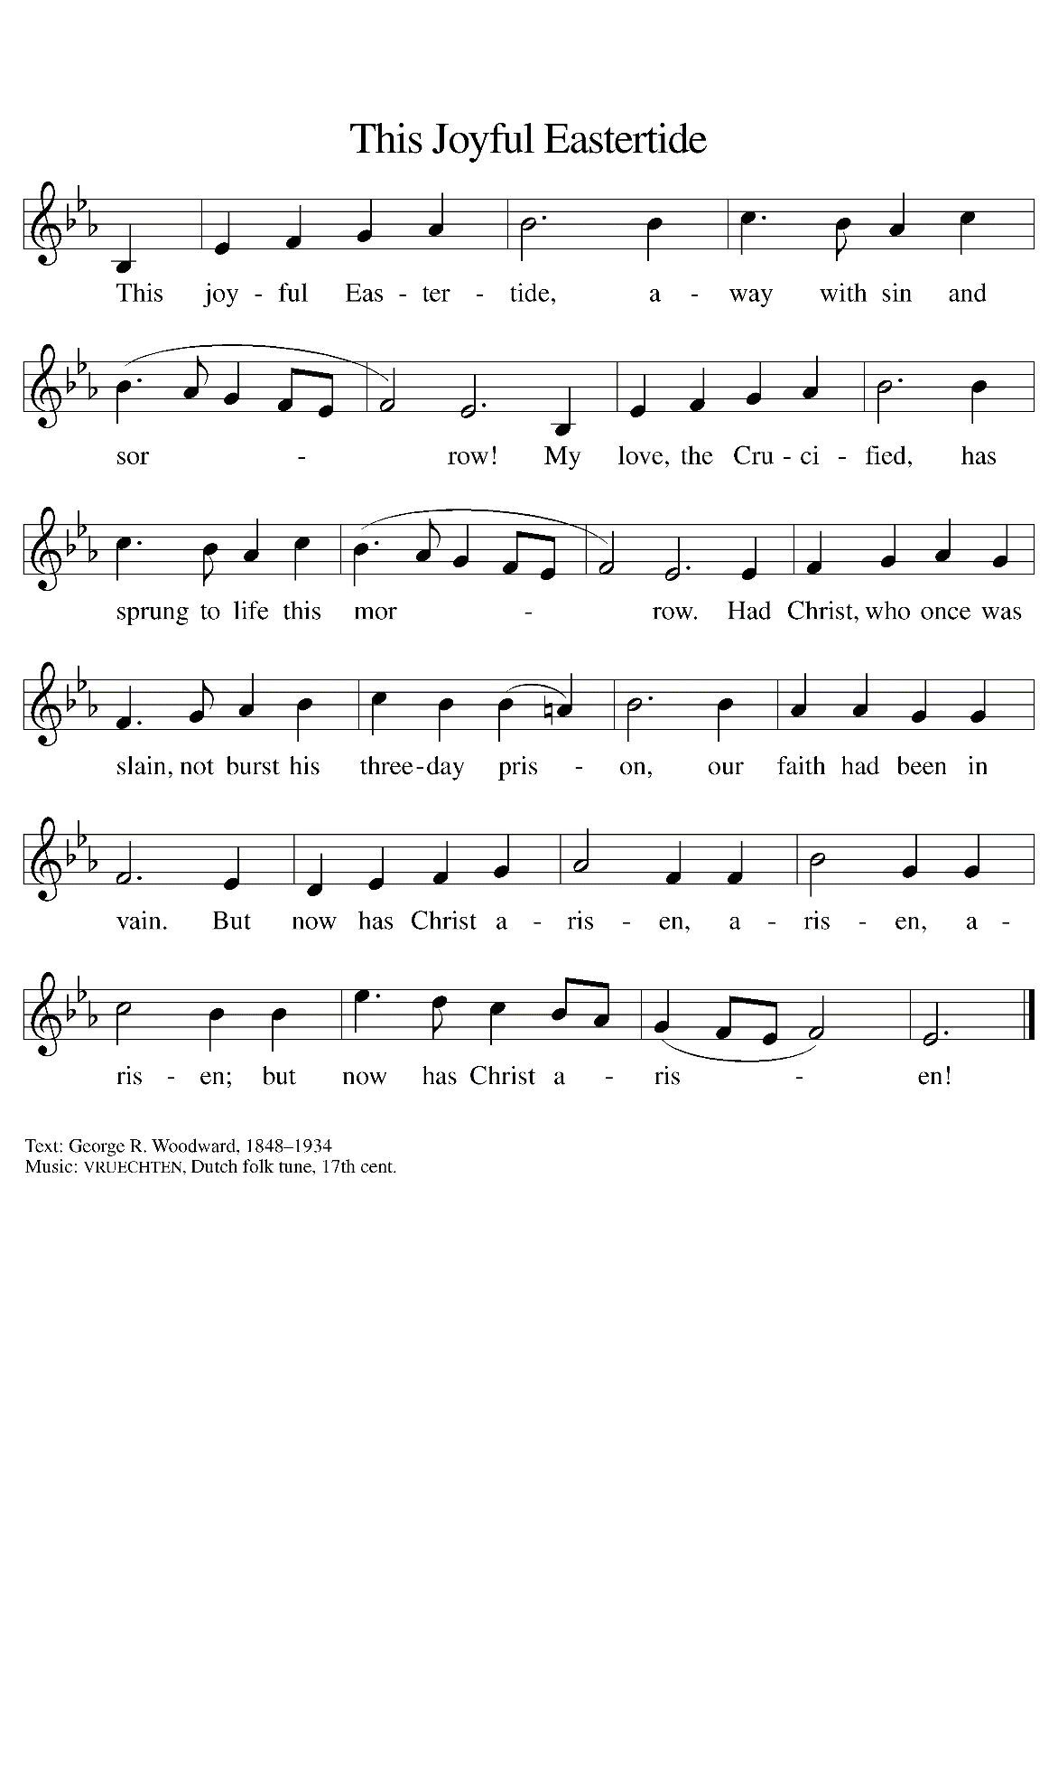

THE OFFERTORY PRAYER

A: Let us pray. Blessed are you, O God, ruler of heaven and earth,

C: Day by day Your shower us with Your blessings. As You have raised us to new
life in Christ, give us glad and generous hearts, ready to praise You and to respond
to those in need, through Jesus Christ, our Savior and Lord. Amen.

THE GREAT THANKSGIVING

P: The Lord be with you.

C: And also with you.

P: Lift up your hearts.

C: We lift them to the Lord.

P: Let us give thanks to the Lord our God.

C: It is right to give Him thanks and praise.

P: It is our duty and our joy to give You thanks and praise, Lord God of heaven and
earth,
Because You are continually renewing Your work of creation and transforming it to
show Your glory through resurrection.
With Your touch You formed us from the dust of the earth.
You raised Your people from slavery in Egypt; You bound them to You through Your
covenant on Sinai; and You made Yourself known to them in exile and in
the Promised Land.
In the cross of Jesus You take into Yourself the scars of our sin, and in His resurrected
Body You invite us to touch the wounds of Your love.
Forgiving God, Your Son’s disciples cowered behind locked doors; and yet in Him
You visited them on the evening of resurrection and breathed on them the Spirit of peace.
Breathe that Spirit upon us now, that Your Church may know the power of Your
forgiveness and these gifts of bread and wine may be for us the Body and
Blood of Your Son Jesus Christ,
Who, in the night ... “Do this for the remembrance of Me.”
As often as we eat ... we proclaim the Lord’s death until He comes.

C: Christ has died. Christ is risen. Christ will come again.

P: Lord and God, intimate Savior of our lives and cosmic Ruler of the universe, in
Jesus You are the substance of things hoped for and the knowledge of
things unseen.
Visit any who struggle under the shadow of doubt; minister among all who suffer
beneath the claims of oppressive rule; resurrect Your children, Your
Church, Your earth.
Bless those who have not seen and yet believe, and shape Your wounded Body
the Church to let the world see You through its scars.
Lift every voice to sing Your Easter glory, until the Day when all stand before
Your throne, in eternal communion with one another and with You,
Ever one God, Father, Son, and Holy Spirit.

C: Amen!

THE LORD’S PRAYER

P: Alleluia! The risen Christ intercedes on our behalf before the throne of God. Let us
therefore join Him in His prayers in the words He taught us:

C: Our Father in heaven, hallowed be Your name.
Your Kingdom come, Your will be done on earth as in heaven.
Give us today our daily bread, and forgive us our sins, as we forgive
those who sin against us.
Save us from the time of trial, and deliver us from evil.
For the Kingdom, the power, and the glory are Yours, now and forever.
Amen.

INVITATION TO THE MEAL

P: Jesus said, I am the true Vine. Abide in Me as I abide in you. Blessed are those who
are called to the Supper of the Lamb. God’s holy gifts for God’s holy people. Come,
for all is now ready.

The assembly is seated

THE DISTRIBUTION

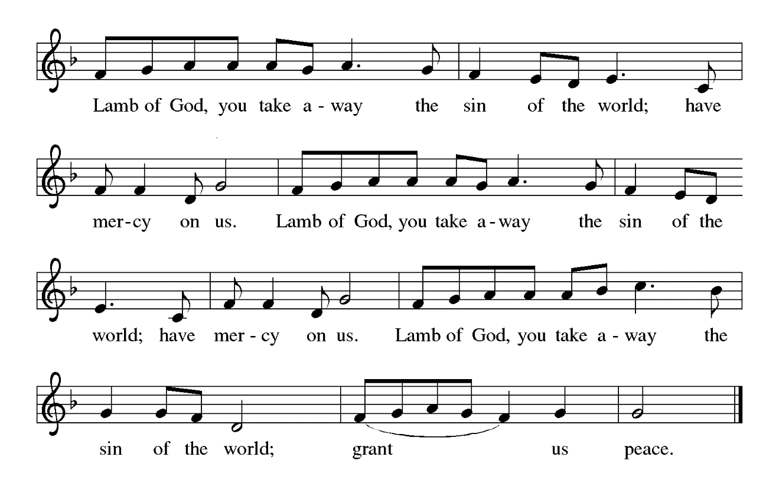
HYMNS DURING DISTRIBUTION 381 Peace, to Soothe Our Bitter Woes
376 Thine is the Glory
As you are able please rise

THE POST-COMMUNION BLESSING

P: The Body and Blood of our Lord Jesus Christ strengthen you and keep you in His grace.

C: Amen.

THE POST-COMMUNION PRAYER

A: Let us pray. Father of Jesus, we have seen with our eyes and touched with our hands
the Bread of Life, Your Son, Jesus Christ our Lord. By this Meal, energize our Easter
faith. Send us by Your Spirit to all who are wounded, that with us they may know Your
peace. Grant this through Christ our Lord.

C: Amen.

SENDING

THE BENEDICTION

P: God the Father, Who raised our Lord Jesus from death, lift you up and restore you to
wholeness.

C: Amen.

P: God the Son, Jesus Christ, the Word of Life, bless you and send you to be His witnesses.

C: Amen.

P: God the Holy Spirit, Who renews the earth, refresh you in the gift of Baptism this day
and always.

C: Amen.

THE SENDING HYMN 535 Hallelujah! We Sing Your Praises

THE DISMISSAL

A: Alleluia! Go and tell the News that Christ is risen!

C: Christ is risen indeed! Alleluia!

POSTLUDE

To God Alone Be Glory

ANNOUNCEMENTS

Please remember to mail your offering to the Church Office at 818 Franklin Street, Michigan City, IN 46360. Another alternative is to give on-line through Tithe.ly. Please see your closure letter for information on how to set up a Tithe.ly account.

St. Paul Members are reminded to have a loved one contact the office if you are hospitalized. Many times, the Pastor doesn’t know someone is in the hospital. If you call and leave a message, please tell us which hospital the patient is at.

PRAYER CONCERNS: Grace Romine, Debbie Martin, Erica McMahan, Sue Koziel, Jana Thomas, Margie Torres, Jayla Jacobi, Ronwynn Jones, Chris Jones, Mark Tannehill, Joan Seifert, Virginia Murray, Brian Wiseman, Jary Tannehill, Sue Granacki, and Kathy Stein.

OFFICE HOURS: Libby will be in the office on Mondays, Wednesdays,
and Fridays; volunteers will cover Tuesdays and Thursdays.

Monday & Wednesday 8:00 a.m. – 5 p.m.
Tuesday & Thursday 9:00 a.m. – 12:00 p.m.
Friday 8:00 a.m. – 12:00 p.m.

If you are listening to the worship broadcast on the radio and would like to watch the Sunday morning service live stream follow these steps:
(1) If you have You Tube available on your TV, search for
St. Paul Lutheran Church Michigan City, IN.

(2) The direct link on the computer is
https://www.youtube.com/channel/UC5AIPNaKr3QN50984jGOa1g.

(3) This link is also on the main page of the church’s website in
the church section and will continue to be posted weekly on the St.
Paul Facebook page.

And it will always be available on the radio broadcast Sunday mornings at 11:00 a.m.
on WEFM (95.9), and on the local cable access station #99 for the previous week’s
service on Sundays at 4:00 p.m. and the current service on Wednesdays at 7:00 p.m. and
Fridays at 8:30 p.m.

The approved and signed minutes of the January 25 and February 22, 2024 Church Council Meetings are on the table at the back of the church in the Narthex. Please take a copy with you as you go.

To send e-mail to the church office, please use the following addresses:
Pastor Mark Reshan: seniorpastor@stpaulmichigancity.com
Church Office Secretary (Libby Pollock): churchsecretary@stpaulmichigancity.com
Church Treasurer (Karen Fleming): finance@stpaulmichigancity.com

The Good News Newsletter: If you have an article or anything you want included in The Good News please send it to the following e-mail address: splcgoodnews@gmail.com. Pastor Pamela Thiede will be using this e-mail address to assemble The Good News each month. The deadline for getting information to Pastor Pamela will be the 20th of each month.

Worship Attendance:

March 28, Maundy Thursday, 10:00 a.m. Sr. Communion 39

March 29, Good Friday, 7:00 p.m. Tenebrae Service 41

March 30, Holy Saturday, 7:00 p.m. The Great Easter Vigil 25

March 31, Easter Sunday, 9:00 a.m. The Resurrection 169

TOTAL 274

LOOKING FOR IDEAS

We’d like to continue to highlight a different mission each month. We are looking for suggestions! If you volunteer somewhere or have a mission that is close to your heart, please let Paul or Lora Brooks know so we can set up a month to support that cause! Paul: (219) 221-0254, paulbrooks@gmail.com; or Lora: (260) 701-1586, loralmartin15@gmail.com.

MESSAGE:

Please consider supporting the pop machine in the hallway between the kitchen and the St. Paul Room in the basement as we look to move out existing drinks and add in new ones! All pop is 75 cents and all proceeds go to the Capital Improvement Fund. We are currently working with the vendor as Mountain Dew has been stocked but the machine is saying to choose another selection. Hoping to have that issue resolved soon. Thank you for your support!

Paul Brooks
Member of Church Council

MISSION OF THE MONTH FOR APRIL 2024
April’s monthly mission is Keys to Hope. Keys to Hope helps homeless and disenfranchised individuals get back to sustainable self-sufficiency through a variety of programs. We will be collecting money as well as razors and deodorant. Please make checks out to the church and place in the offering marked for Keys to Hope. There will be a bin in the Narthex for razors and deodorant.

Coming Soon:
We invite you to join us for an lakeshore cruise on the Emita II on Tuesday, June 4. The cost is $35 per person with $10 of that going to the church (no coupon required). Children up to age three are free. The link for making a reservation is:
https://app.bookingcentral.com/book/product/harborcountryadventures?location=5cb18b14-6f6a-46ba-a655-0d19a685fc47&product=21a85c71-60f2-4e91-ae49-75182f98bd2c&referer=&clearcart
For now, the day is blocked out on their main page, so the above link is the only way to book a reservation for this particular cruise. The cruise will be made public two to three weeks prior to the cruise date, so the earlier you make your reservation, the better.

Thank$ for $haring
Thanks to all who participated in the Give Back at Galveston on February 29, 2024. The church received $210.00 as a result of the event. And thanks also to all who participated in the Give Back at Holly’s on March 12, 2024. The church received $188 as a result of the event.
This month, we will see you at Leed’s Public House on Wednesday, April 10! Here are two coupons: one for you and one for a friend.

ACTIVITIES, EVENTS & MEETINGS
APRIL 2024

Wednesday, April 3, 2024 @ 10:00 a.m. God’s Purls/St. Paul Room

Thursday, April 4, 2024 Faith Circle

Saturday, April 6, 2024 @ 4:00 p.m. Worship Service

Sunday, April 7, 2024 @ 9:00 a.m. Worship Service

Monday, April 8, 2024 @ Noon Choir Rehearsal

@ 1:00 p.m. Hope Circle/Green Room

Tuesday, April 9, 2024 @ 7:00 p.m. Estuary/Luther House

Wednesday, April 10, 2024 @ 9:15 a.m. Bible Study/Luther House

@ 10:00 a.m. God’s Purls/St. Paul Room

@ 11am – 8pm GIVE BACK at LEED’S PUBLIC HOUSE (On Southwest Corner of 4th & Franklin St.)

@ 3:00 p.m. Worship & Music Meeting/Luther House

Saturday, April 13, 2024 @ 4:00 p.m. Worship Service

Sunday, April 14, 2024 @ 9:00 a.m. Worship Service

Monday, April 15, 2024 @ Noon Choir Rehearsal

Wednesday, April 17, 2024 @ 9:15 a.m. Bible Study/Luther House

@ 10:00 a.m. God’s Purls/St. Paul Room

Saturday, April 20, 2024 @ 4:00 p.m. Worship Service

Sunday, April 21, 2024 @ 9:00 a.m. Worship Service

Monday, April 22, 2024 @ Noon Choir Rehearsal

@ 2 p.m. Finance Committee Meeting/Luther House

@ 3:00 p.m. Executive Board Meeting/Luther House

Wednesday, April 24, 2024 @ 9:15 a.m. Bible Study/Luther House

@ 10:00 a.m. God’s Purls/St. Paul Room

Thursday, April 25, 2024 @ 5:30 p.m. Church Council Meeting/St. Paul Room

Saturday, April 27, 2024 @ 4:00 p.m. Worship Service

Sunday, April 28, 2024 @ 9:00 a.m. Worship Service

2024 Financial Stewardship
Weekly Church Operating Needs (x 2 weeks): $ 14,475.00

March 23-24; March 30-31, 2024
General Fund (including General Memorials): $ 12,137.00

Overage/Shortage: —- $ 2,338.00

Restricted Income (not including Memorials)
Supports IK Synod & Church wide Ministries: $ 205.00

Ministries in our Community/Congregation: $ 145.00

Capital Fund: $ 310.00

Memorials
General Fund $ 125.00

IT’S TIME FOR A NEW DIRECTORY

As you all are well aware the last two years have seen many changes and we are in need of an updated Directory for the church. Please think about how you want to be represented in the new Directory. If you have any changes to any of your information (i.e. new mailing and email addresses, new phone numbers, etc.) please send me an email or call the church office in the next couple weeks and let me know. I look forward to hearing from you as soon as you’re able.

Libby Pollock
Church Secretary

