THE SECOND SUNDAY IN LENT
February 25, 2024

So why are you afraid to take up the cross, when it leads to the kingdom?
In the cross is salvation, in the cross is life; in the cross is defense from enemies, in the cross heaven’s sweetness is outpoured; in the cross is strength of mind, in the cross is joy of spirit; in the cross is highest virtue, in the cross is perfect holiness. There is no salvation for the soul nor hope of eternal life except in the cross. Take up your cross then, and follow Jesus, and you will enter eternal life. He went before you, carrying his cross, and on the cross he died for you, so that you too should carry your cross, and long for a death on the cross. For if you share his death, you will also share his life. If you are with him in his suffering, you will be with him in his glory.
All that matters is the cross and dying on that cross--there is no other way to life and real inward peace except by the way of the holy cross, and of daily dying to self. Go where you like, look for what you like, you will not find a higher way above or a safer way below than the way of the holy cross ...”
“If you carry your cross with gladness, it will carry you and lead you to that longed-for goal where there will be no more suffering, though there will always be suffering here. If you carry it grudgingly, you will make it a burden and weigh yourself down, but all the same you will have to bear it. If you throw one cross aside you will certainly find another, and possibly one that is heavier to bear.”

Thomas à Kempis

But the hard truth is that the road to messianic glory runs through Golgotha. The disciples are following Jesus to a cross.
Much depends on how we interpret the “must” (dei: “it is necessary”) of verse 31. Too often the word is taken to mean that Jesus’ mission is principally to suffer and die, with interpreters inferring a latent theology of vicarious atonement. In this reading, Jesus “must” go to the cross in order to affect a sacrifice for the forgiveness of our sins. But while Mark may hint at some mysterious efficacy to Jesus’ death (10: 45; 14: 22-25), he is far from so specific an atonement theology (contrast Romans 3: 21-26; Hebrews 9: 23-28).
More to the point, when we pan out beyond one or two isolated verses, we find that the overarching narrative offers a simpler, but no less profound, explanation of Jesus’ death: Jesus dies because powerful humans oppose both his healing mission and, more specifically, the disruption that mission brings to established law and order. Unbeknownst to Jesus’ opponents, they are opposing the in-breaking reign (“kingdom”) of God…
…So the real epiphany of Mark 8: 31 is not that Jesus’ mission is to die, but that his faithfulness to God’s healing mission will inevitably result in his death. In Mark, Jesus “must” die because his commitment to human healing will not falter. With two millennia of Holy Weeks under our belts, we can easily underestimate the power of this epiphany. Essentially, Mark is saying that the Son of God will not dial down his ministry to spare his own life, or even to ease his suffering. His commitment to the healing of humanity literally knows no limits. And neither—Easter tells us—does God’s life-giving power.
Ira Diggers
In the Name of Jesus
GATHERING

INTRODUCTION

The second covenant in this year's Lenten readings is the one made with Abraham and Sarah: God's promise to make them the ancestors of many, with whom God will remain in everlasting covenant. Paul says this promise comes to all who share Abraham's faith in the God who brings life into being where there was no life. We receive this baptismal promise of resurrection life in faith. Sarah and Abraham receive new names as a sign of the covenant, and we too get new identities in baptism, as we put on Christ.

Elizabeth Fedde, deaconess

She was born in Norway and trained as a deaconess. In 1882 at the age of 32 she was asked to come to New York to minister to the poor and Norwegian seamen. She established the Deaconess House in Brooklyn and the Deaconess House and Hospital of the Lutheran Free Church in Minneapolis. She returned to Norway in 1895 and died there.

PRELUDE

ANNOUNCEMENTS

As you are able please rise

CONFESSION AND ABSOLUTION

P: In the name of the Father and of the Son and of the Holy Spirit.

C: Amen.

P: “All the ends of the earth shall remember and turn to the LORD, and all the families of the
nations bow before Him.” (Psalm 22: 26) The call of Lent is to repent, to “turn to the LORD”
in humility and hope. Let us therefore confess our sins.

Silence for reflection and self-examination is kept

P: Most merciful God,

C: We confess that we have sinned against You by turning away from Your grace and mercy.
We have not been “blameless” in our walk before You. (Genesis 17: 1) We have
“wavered” in our trust concerning Your promises. (Romans 4:20) We have doubted that
You were “able to do what You had promised.” (4: 21) We have set our mind on “human
things,” and not on “the things of God.” (Mark 8: 33) We have sought to “save our lives,”
instead of “losing them” for Your sake and the sake of the Good News. (8: 35) Deliver us
from our selfish ways, O God, and restore us to the joy of Your salvation.

P: May God have mercy on us, forgive us our sins, and bring us to everlasting life.

C: Amen.

GATHERING HYMN 324 In the Cross of Christ I Glory

THE GREETING

P: The grace of our Lord Jesus Christ, the love of God, and the communion of the Holy Spirit be
with you all.

C: And also with you.

THE KYRIE

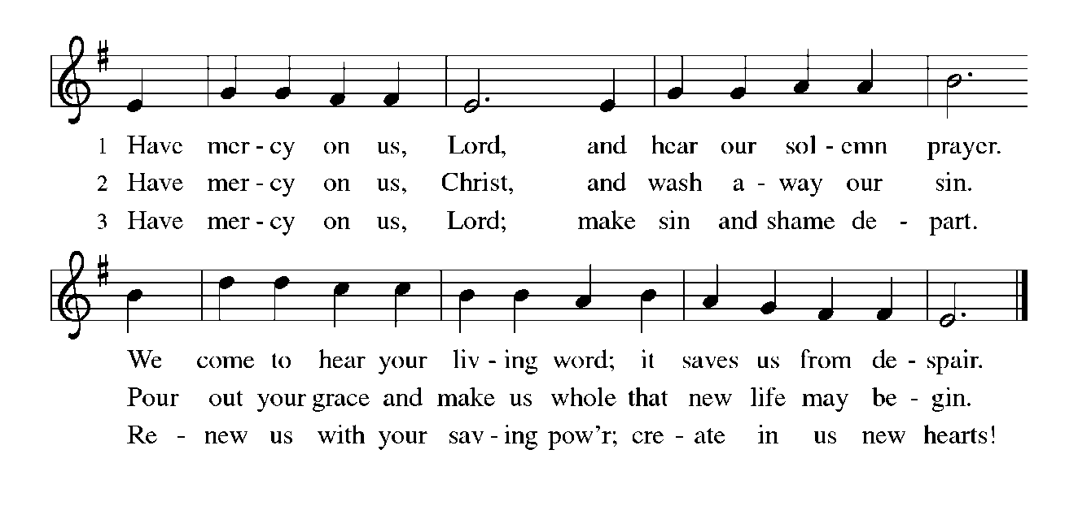

THE PRAYER OF THE DAY

P: The Lord be with you.

C: And also with you.

P: Let us pray. O God, by the passion of Your blessed Son You made an instrument of shameful
death to be for us the means of life. Grant us so to glory in the cross of Christ that we may
gladly suffer shame and loss for the sake of Your Son, Jesus Christ our Savior and Lord, Who
lives and reigns with You and the Holy Spirit, one God, now and forever.

C: Amen.

The assembly is seated

WORD

THE FIRST READING Genesis 17: 1-7, 15-16

In today's reading, the writer connects the covenant made with Abraham and Sarah to the "everlasting" covenant made with Noah. The relationship between God and Abraham's descendants is as sure as the relationship between God and the seasons and times of the year. The name changes further emphasize the firmness of God's promise.

When Abram was ninety-nine years old, the LORD appeared to Abram, and said to him, "I am God Almighty; walk before Me, and be blameless. ²And I will make My covenant between Me and you, and will make you exceedingly numerous." ³Then Abram fell on his face; and God said to him, ⁴ "As for Me, this is My covenant with you: You shall be the ancestor of a multitude of nations. ⁵No longer shall your name be Abram, but your name shall be Abraham; for I have made you the ancestor of a multitude of nations.
⁶I will make you exceedingly fruitful; and I will make nations of you, and kings shall come from you. ⁷I will establish My covenant between Me and you, and your offspring after you throughout their generations, for an everlasting covenant, to be God to you and to your offspring after you."
¹⁵God said to Abraham, "As for Sarah your wife, you shall not call her Sarai, but Sarah shall be her name. ¹⁶I will bless her, and moreover I will give you a son by her. I will bless her, and she shall give rise to nations; kings of peoples shall come from her."

The Word of the Lord.

Thanks be to God.

THE PSALM: Psalm 22: 23-31 Read responsively

²³You who fear the LORD, give praise! All you of Jacob's line, give glory.
Stand in awe of the LORD, all you offspring of Israel.

²⁴For the LORD does not despise nor abhor the poor in their poverty;
neither is the LORD's face hidden from them;
but when they cry out, the LORD hears them.

²⁵From You comes my praise in the great assembly;
I will perform my vows in the sight of those who fear the LORD.

²⁶The poor shall eat and be satisfied,
Let those who seek the LORD give praise!
May your hearts live forever!

²⁷All the ends of the earth shall remember and turn to the LORD;
all the families of nations shall bow before God.

²⁸For dominion belongs to the LORD,
Who rules over the nations.

²⁹Indeed, all who sleep in the earth shall bow down in worship;
all who go down to the dust, though they be dead,
shall kneel before the LORD.

³⁰Their descendants shall serve the LORD,
Whom they shall proclaim to generations to come.
³¹They shall proclaim God's deliverance to a people yet unborn,
saying to them, "The LORD has acted!"

THE SECOND READING Romans 4: 13-25

Paul is trying to persuade the Roman Christians that people are made right with God through faith rather than by works of the law. Abraham became the ancestor of God's chosen people not by keeping the law but by trusting God to keep his promises.

The promise that he would inherit the world did not come to Abraham or to his descendants through the law but through the righteousness of faith. ¹⁴If it is the adherents of the law who are to be the heirs, faith is null and the promise is void. ¹⁵For the law brings wrath; but where there is no law, neither is there violation.
¹⁶For this reason it depends on faith, in order that the promise may rest on grace and be guaranteed to all his descendants, not only to the adherents of the law but also to those who share the faith of Abraham (for he is the father of all of us, ¹⁷as it is written, "I have made you the father of many nations")--in the presence of the God in whom he believed, who gives life to the dead and calls into existence the things that do not exist.
¹⁸Hoping against hope, he believed that he would become "the father of many nations," according to what was said, "So numerous shall your descendants be." ¹⁹He did not weaken in faith when he considered his own body, which was already as good as dead (for he was about a hundred years old), or when he considered the barrenness of Sarah's womb.
²⁰No distrust made him waver concerning the promise of God, but he grew strong in his faith as he gave glory to God, ²¹being fully convinced that God was able to do what He had promised. ²²Therefore his faith "was reckoned to him as righteousness." ²³Now the words, "it was reckoned to him," were written not for his sake alone, ²⁴but for ours also. It will be reckoned to us who believe in Him Who raised Jesus our Lord from the dead, ²⁵Who was handed over to death for our trespasses and was raised for our justification.

The Word of the Lord.

Thanks be to God.

As you are able please rise

THE VERSE

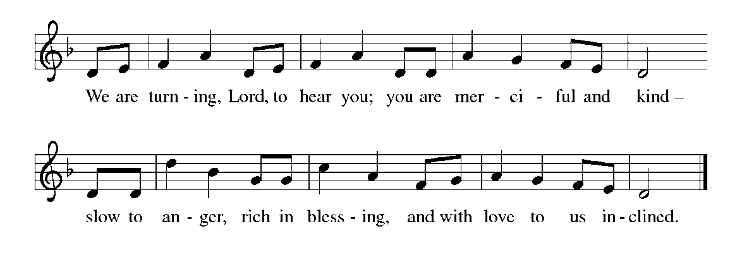

THE HOLY GOSPEL Mark 8: 31-38

After Peter confesses his belief that Jesus is the Messiah, Jesus tells His disciples for the first time what is to come. Peter’s response indicates that he does not yet understand the way of the cross that Jesus will travel.

P: The Holy Gospel according to St. Mark, the eighth chapter.

C: Glory to You, O Lord!

Jesus began to teach them that the Son of Man must undergo great suffering, and be rejected by the elders, the chief priests, and the scribes, and be killed, and after three days rise again. ³²He said all this quite openly. And Peter took Him aside and began to rebuke Him.
³³But turning and looking at His disciples, He rebuked Peter and said, "Get behind Me, Satan! For you are setting your mind not on divine things but on human things."
³⁴He called the crowd with His disciples, and said to them, "If any want to become My followers, let them deny themselves and take up their cross and follow Me. ³⁵For those who want to save their life will lose it, and those who lose their life for my sake, and for the sake of the gospel, will save it.
³⁶For what will it profit them to gain the whole world and forfeit their life? ³⁷Indeed, what can they give in return for their life? ³⁸Those who are ashamed of Me and of My words in this adulterous and sinful generation, of them the Son of Man will also be ashamed when He comes in the glory of His Father with the holy angels."

The Gospel of the Lord.

Praise to You, O Christ!

The assembly is seated

THE SERMON

Silence for reflection follows the sermon

As you are able please rise

THE HYMN OF THE DAY 799 Come, Follow Me, the Savior Spake

THE NICENE CREED

A: God has made us His people through our Baptism into Christ. Living together in trust and
hope, we confess our faith.

C: We believe in one God,
the Father, the Almighty,
maker of heaven and earth,
of all that is, seen and unseen.

We believe in one Lord, Jesus Christ,
the only Son of God,
eternally begotten of the Father,
God from God, Light from Light,
true God from true God,
begotten, not made,
of one Being with the Father.
Through Him all things were made.
For us and for our salvation
He came down from heaven;
by the power of the Holy Spirit
He became incarnate from the virgin Mary, and was made man.
For our sake He was crucified under Pontius Pilate;
He suffered death and was buried.
On the third day He rose again
in accordance with the Scriptures;
He ascended into heaven
and is seated at the right hand of the Father.
He will come again in glory to judge the living and the dead,
and His kingdom will have no end.

We believe in the Holy Spirit, the Lord, the giver of life,
Who proceeds from the Father and the Son.
With the Father and the Son He is worshiped and glorified.
He has spoken through the prophets.
We believe in one holy catholic and apostolic Church.
We acknowledge one Baptism for the forgiveness of sins.
We look for the resurrection of the dead,
and the life of the world to come. Amen

THE PRAYER OF THE CHURCH

A: As Jesus intercedes for us at all times, and mindful of God’s steadfast love and faithfulness,
let us pray for the Church, the world, and all who follow Christ in the way of the cross.

A: For the Church: that the fasting of these forty days may clear away all that is needless and so
open our eyes to the bright glory of the cross, let us pray to the Lord:

C: Lord, have mercy.

A: For those preparing for Baptism, that like Abraham and Sarah they might grow strong in their
faith as they give glory to God, let us pray to the Lord:

C: Lord, have mercy.

A: For the nations of the world: that in this time of crisis in Gaza, Ukraine, Senegal, and Venezuela
there might a way into a just and lasting peace in these and all places of violence, unrest, and
terrorism, let us pray to the Lord:

C: Lord, have mercy.

A: For this congregation: that we may walk as burdened with the hurts of the world and as free to
lose our lives for others as Jesus, let us pray to the Lord:

C: Lord, have mercy.

A: For the sick, especially. . . that God might hear their cries and bring health and strength, let us
pray to the Lord:

C: Lord, have mercy.

A: That with the faithful who have gone before us, especially Elizabeth Fedde, deaconess, whom
we commemorate this Day we may too may enter into the fullness of our inheritance in Christ
and into the joy of everlasting life with You, let us pray to the Lord:

C: Lord, have mercy.

P: God, Whose ways are beyond our knowing or approving, place the world’s troubles ever in our
plain sight, and be in our seeing and praying and serving in Jesus’ name. Receive our prayers,
and transform us into the likeness of Your Son, Jesus Christ our Lord, Whom we follow in this
life and in the life of the world to come.

C: Amen.
MEAL
THE PEACE

P: The peace of the Lord be with you always.

C: And also with you.

The assembly is seated

OFFERING

VOLUNTARY When I Survey the Wondrous Cross St. Paul Senior Choir
(Arr. By B. Harlan)

As you are able please rise

THE OFFERTORY HYMN (see p. 9)

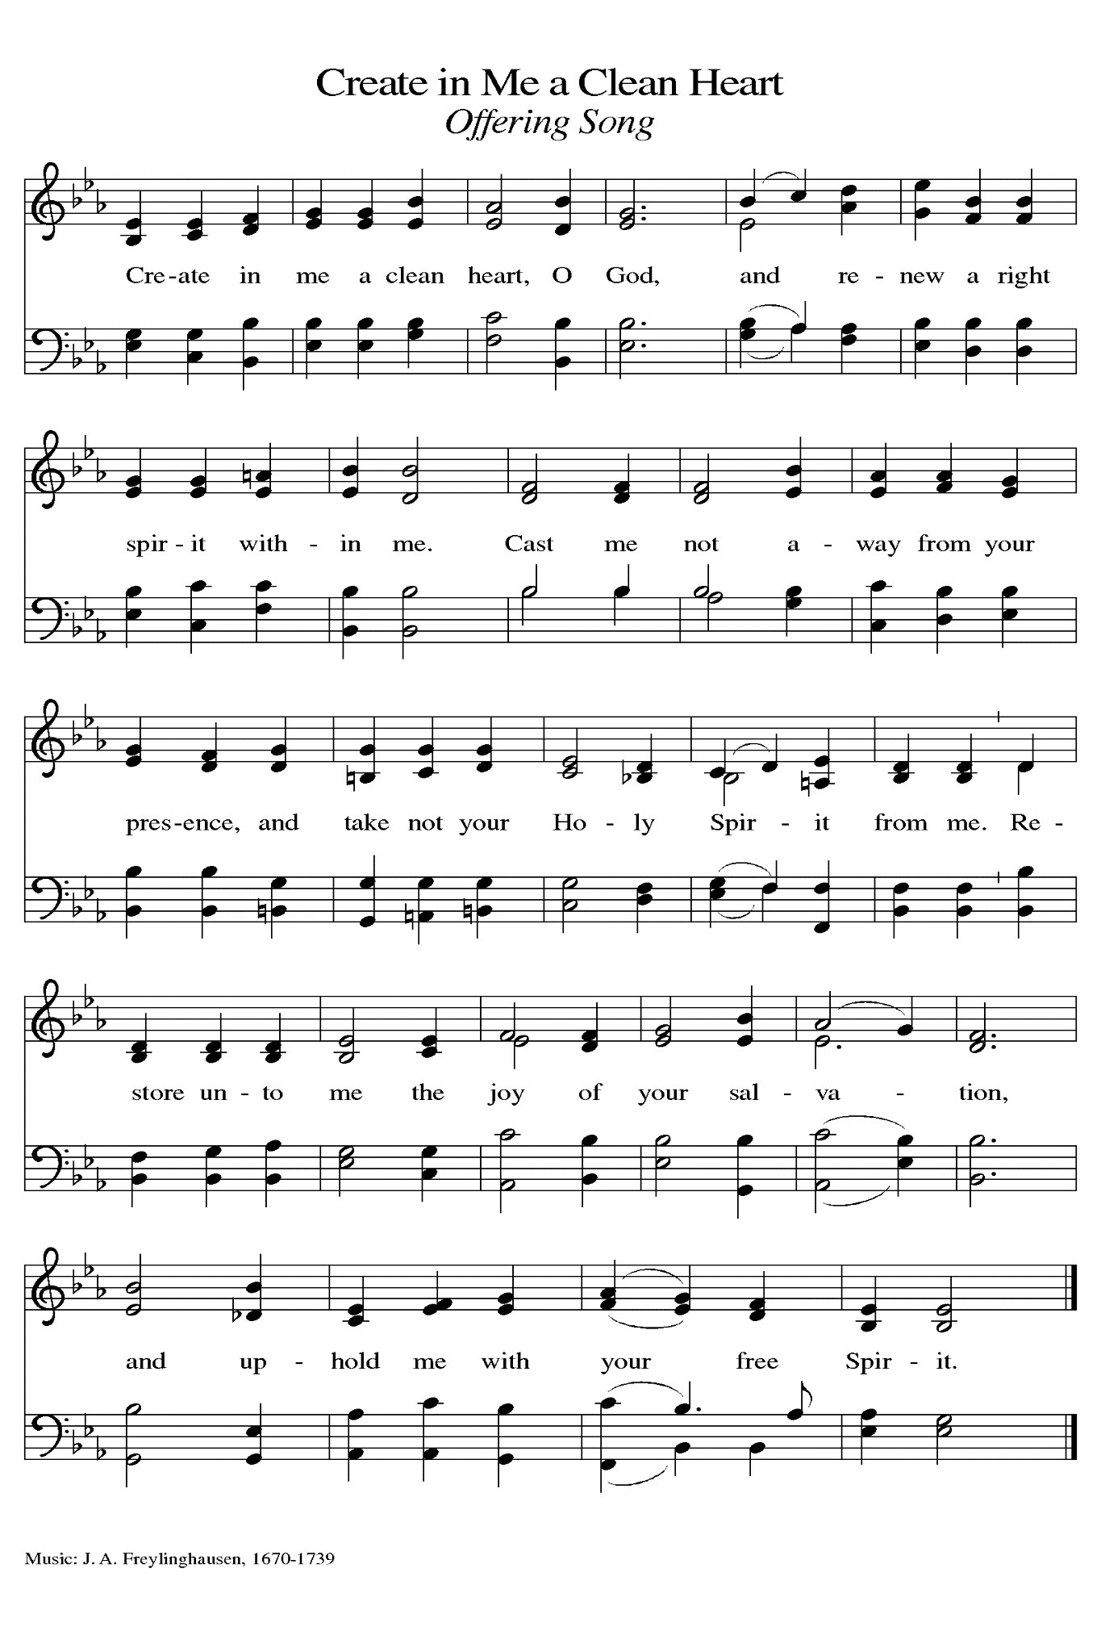THE OFFERTORY PRAYER

A: Let us pray. God of mercy,

C: Receive these gifts of our lives, and feed us with Your grace, that, following Jesus
faithfully, we might lead others to this Table of mercy and life. We ask this in the name
of Jesus the Lord. Amen.

THE GREAT THANKSGIVING

P: The Lord be with you.

C: And also with you.

P: Lift up your hearts.

C: We lift them to the Lord.

P: Let us give thanks to the Lord our God.

C: It is right to give Him thanks and praise.

P: Glory to You, God of Abraham and Sarah, for You uphold every hope of redemption
and upon You rests eternity.
In every age You have called Your people to receive Your blessings by faith, trusting
not their own righteousness but the promise that rests forever on Your grace.
In Christ You came to bear the weight of our sin, carry our offenses, and take up the
hope of salvation;
And, through Your power, the cross He bears across His shoulders has become for us
the resurrection and the life.
Renewing God, through the cross of Christ You redeem our failures by welcoming us
to the Feast of the forgiven.
As there is nothing we can give You in return for our life, send Your Holy Spirit to meet
us in the grace of this Meal;
And send Your Spirit upon this bread and wine that they may be for us the Body and Blood
of Christ;
Who, in the night … “Do this for the remembrance of Me.”
As often as we eat … we proclaim the Lord’s death until He comes.

C: Christ has died. Christ is risen. Christ will come again.

P: Saving God, show Your church the path of life.
Give each one of Your children courage and wisdom to take up their cross and follow You.
Stretch every heart with compassion for the heavy burdens their neighbors carry,
and transform all who are weighed down to become carriers of another’s burdens.
Come alongside any who shoulder heavy cares alone and give them companions in every
walking step.
Take upon Yourself the suffering of all who bear impossible weights at the demand of
another, are forced to labor, or given no rest,
Until all that is bowed down in sin or weighed down in struggle is lifted up and carried
by Your grace and transcended in Your glory,
Ever-reigning God, forever One: Father, Son, and Holy Spirit.

C: Amen!

THE LORD’S PRAYER

P: Baptized into Christ’s death that we might share in the resurrection, let us pray for the
fulfillment of this mystery as Jesus taught us:

C: (Sung) Music is on the front cover of the red hymnal.

INVITATION TO THE MEAL

P: Return to God with all your heart. Receive bread for the journey, drink for the desert. Blessed
are those who are called to the Supper of the Lamb. God’s holy gifts for God’s holy people.
Come, for all is now ready.

The assembly is seated

THE DISTRIBUTION

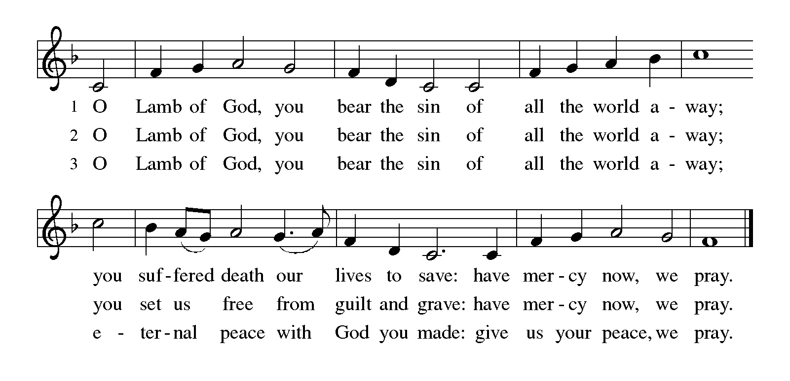
HYMNS DURING DISTRIBUTION 468 Around You, O Lord Jesus
798 Will You Come and Follow Me

As you are able please rise

THE POST-COMMUNION BLESSING

P: The body and blood of our Lord Jesus Christ strengthen you and keep you in His grace.

C: Amen.
THE POST-COMMUNION PRAYER
A: Let us pray. God of our pilgrimage, in this Meal You nourish us with the gifts of faith and
hope. Sustain us on our journey, keep us faithfully behind Jesus, and help us to lose our lives
in service to You and the Good News until we reach the promised land, the Easter Feast of
victory in Jesus Christ our Lord.

C: Amen.
SENDING

THE BENEDICTION

P: Almighty God: Father, Son, and Holy Spirit bless you now and forever.

C: Amen.

SENDING HYMN 802 Let Us Ever Walk With Jesus

THE DISMISSAL

A: Go in peace. Remember the poor.
C: Thanks be to God!
To God Alone Be Glory

POSTLUDE

The Meditation is adapted from Richer Fare for the Christian People. Gail Ramshaw, ed. (New York: Pueblo Publishing Company, 1990) 96.

The Greeting, Offertory Prayer, Post-Communion Prayer, and Dismissal are adapted from Sundays and Seasons. Copyright Augsburg Fortress, 1999.

The Prayers are adapted from Sundays and Seasons. Copyright 2003 Augsburg Fortress, and
Prayers for Sundays and Seasons. Year B. Peter A. Scagnelli. (Chicago: Liturgy Training Publications, 1998) 32-33.

ANNOUNCEMENTS

Please remember to mail your offering to the Church Office at 818 Franklin Street, Michigan City, IN 46360. Another alternative is to give on-line through Tithe.ly. Please see your closure letter for information on how to set up a Tithe.ly account.

St. Paul Members are reminded to have a loved one contact the office if you are hospitalized. Many times, the Pastor doesn’t know someone is in the hospital. If you call and leave a message, please tell us which hospital the patient is at.

PRAYER CONCERNS: Erica McMahan, Sue Koziel, Jana Thomas, Margie Torres, Jayla Jacobi, Jim Gleason, Ronwynn Jones, Chris Jones, Mark Tannehill, Joan Seifert, Virginia Murray, Brian Wiseman, Jary Tannehill and Sue Granacki.

OFFICE HOURS: Libby will be in the office on Mondays, Wednesdays,
and Fridays; volunteers will cover Tuesdays and Thursdays.

Monday & Wednesday 8:00 a.m. – 5 p.m.
Tuesday & Thursday 9:00 a.m. – 12:00 p.m.
Friday 8:00 a.m. – 12:00 p.m.

If you are listening to the worship broadcast on the radio and would like to watch the Sunday morning service live stream follow these steps:

(1) If you have You Tube available on your TV, search for
St. Paul Lutheran Church Michigan City, IN.

(2) The direct link on the computer is
https://www.youtube.com/channel/UC5AIPNaKr3QN50984jGOa1g.

(3) This link is also on the main page of the church’s website in
the church section and will continue to be posted weekly on the St.
Paul Facebook page.

And it will always be available on the radio broadcast Sunday mornings at 11:00 a.m.
on WEFM (95.9), and on the local cable access station #99 for the previous week’s
service on Sundays at 4:00 p.m. and the current service on Wednesdays at 7:00 p.m. and
Fridays at 8:30 p.m.

The approved and signed minutes of the November 16, 2023 and December 28, 2023 Church Council Meetings are on the table at the back of the church in the Narthex. Please take a copy with you as you go.
To send e-mail to the church office, please use the following addresses:
Pastor Mark Reshan: seniorpastor@stpaulmichigancity.com
Church Office Secretary (Libby Pollock): churchsecretary@stpaulmichigancity.com
Church Treasurer (Karen Fleming): finance@stpaulmichigancity.com
The Good News Newsletter: If you have an article or anything you want included in The Good News please send it to the following e-mail address: splcgoodnews@gmail.com. Pastor Pamela Thiede will be using this e-mail address to assemble The Good News each month. The deadline for getting information to Pastor Pamela will be the 20th of each month.

Worship Attendance: February 17 and 18, 2024:
4:00 p.m. 23
9:00 a.m. 67
TOTAL 90

LOOKING FOR IDEAS
We’d like to continue to highlight a different mission each month. We are looking for suggestions! If you volunteer somewhere or have a mission that is close to your heart, please let Paul or Lora Brooks know so we can set up a month to support that cause! Paul: (219) 221-0254, paulbrooks@gmail.com; or Lora: (260) 701-1586, loralmartin15@gmail.com.

LOCAL MONTHLY MISSION FOR FEBRUARY

Our local monthly mission for February 2024 for St. Paul Lutheran Church will be the LaPorte County Meals On Wheels. Meals on Wheels provides a hot, nutritious meal 5 days a week; as well as a safety check, to seniors with limited mobility, allowing them to stay in their home and remain independent. The idea of Meals on Wheels in Michigan City was formed in 1973 when the Pastor of Immanuel Lutheran Church asked the Bible Class, “If Immanuel Lutheran Church disappeared from the face of the earth, do you think anyone in the community would miss us?” Meals on Wheels started serving 5 people in Michigan City in 1974, and it has grown to serving over 370 people in the county over 66,000 meals in 2010. We have many congregation members who graciously volunteer with Meals on Wheels to deliver meals weekly. Please consider donating to support our community’s seniors! Please mark your donation to Meals on Wheels and place in the offering plate throughout the month of February.

If St. Paul disappeared from the face of the earth, do you think anyone in the community would miss us? Let’s continue to positively impact our community with our monthly missions. If you have a mission that is close to your heart, or an organization you would like to see supported, please give your ideas to Lora or Paul Brooks. We are always looking for suggestions on ways we can continue to support our community! Lora: 260-701-1586, loralmartin15@gmail.com; or Paul: 219-221-0254, paulbrooks@gmail.com.

ACTIVITIES, EVENTS & MEETINGS
FEBRUARY 2024

Sunday, February 18, 2024 @ 9:00 a.m. Worship Service

Monday, February 19, 2024 @ 3:00 p.m. Executive Board Mtg./Luther House

@ 4:00 p.m. Finance Comm. Mtg./Luther House

Wednesday, February 21, 2024 @ 9:15 a.m. Bible Study/Luther House

@ 10:00 p.m. God’s Purls/ St. Paul Room

@ 4:00 p.m. Choir Rehearsal

Thursday, February 22, 2024 @ 5:30 p.m. Church Council Mtg.

Saturday, February 24, 2024 @ 4:00 p.m. Worship service

Sunday, February 25, 2024 @ 9:00 a.m. Worship Service

Wednesday, February 28, 2024 @ 9:15 a.m. Bible Study/Luther House

@ 10:00 a.m. God’s Purls/St. Paul Room

@ 4:00 p.m. Choir Rehearsal

Thursday, February 29, 2024 4:00 p.m. – 9:00 p.m. GIVE BACK @ GALVESTON

MID-WEEK LENTEN SERVICES
As above, these services are tentative as of this writing. The hope is to continue our tradition of using Marty Haugen’s “Holden Evening Prayer” as the musical basis of our weekly worship services complemented by some Scripture readings, a brief homily, and some hymns.
This year, we will utilize a series from our worship resource, Sundays and Seasons, based upon a passage from this year’s appointed Gospel of St. Mark. It is entitled, “You Shall Love the Lord Your God,” from Mark 12:28-30 when a scribe asks
Jesus which commandment is the greatest. Jesus responds, “The first is, Hear O Israel, the Lord our God is one; you shall love the Lord your God with all your heart, and with all your soul, and with all your mind, and with all your strength.” Each of these will be highlighted at the mid-week services in this order:

Wednesday, February 21 “Hear, O Israel”

Wednesday, February 28 “You Shall Love the Lord Your God With All Your Heart”

Wednesday, March 6 “You Shall Love the Lord Your God With All Your Soul”

Wednesday, March 13 “You Shall Love the Lord Your God With All Your Mind”

Wednesday, March 20 “You Shall Love the Lord Your God With All Your Strength”

2024 Financial Stewardship

Weekly Church Operating Needs (x 2 weeks): $ 13,850.00

February 10 and 11, February 17 and 18, 2024

General Fund (including General Memorials): $ 9,300.00

Overage/Shortage: —- $ 4,550.00

Restricted Income (not including Memorials)
Supports IK Synod & Church wide Ministries: $ 254.00

Ministries in our Community/Congregation: $ ——
Capital Fund: $ 214.00

Memorials
General Fund: $ 85.00

Thank$ for $haring
This month,we will see you at Galveston on Thursday, February 29—Leap Day! Here are two coupons: one for you and one for a friend.

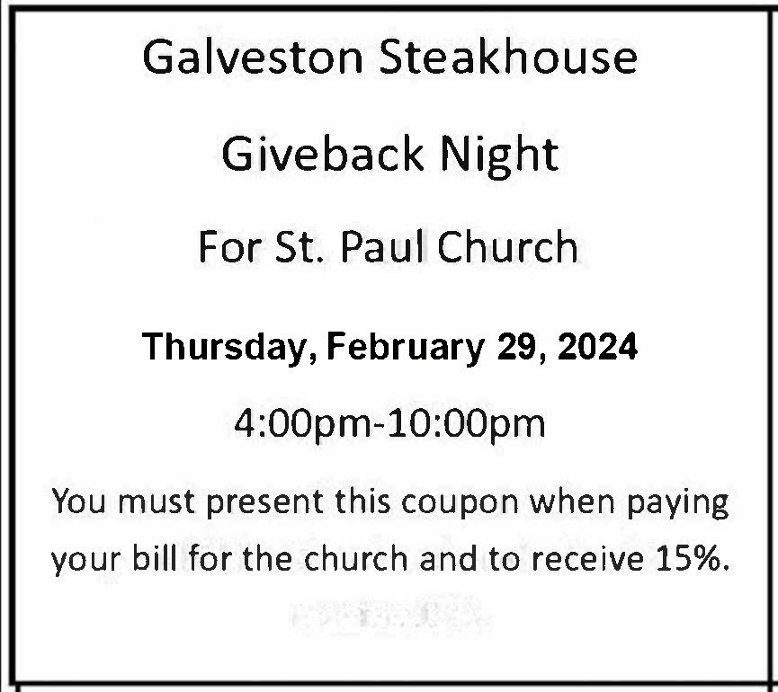

Easter Plants

A variety of spring plants will be available to order for decorating St. Paul’s Church on Easter Morning! The varieties available will be Lily, Tulips, Hydrangeas, Florist Mum, and Hanging Fern Baskets. Orders must be placed by Friday, March 15th.

The varieties and color available are Lily, Tulips in yellow, and pink, Florist Mum in yellow, Hydrangeas in pink or purple/blue, and the 10” Hanging Fern Basket.

Cost per plant is as follows:

$8.00 – Tulip (yellow or pink)
$9.00 – Lily (only white)
$11.00 – Florist Mum (yellow)
$13.00 – Hanging Fern
$15.00 - Hydrangea (pink or purple/blue)

Please specify your choice of plant and your choice of color when applicable.
Orders MUST be placed by Friday morning, March 15th.

Your order may be placed ‘In Memory or Honor of a Loved One’. Please call the Church Office, 219-874-7293, or place your order in an envelope and title it ‘Easter Flowers’ for ordering. REMEMBER, you must specify what type of plant and color, if applicable!! All checks should be made out to St. Paul Church.

Please plan on picking up your plant after the Easter Morning Service by 11:30 a.m..

