THE THIRD SUNDAY IN LENT
March 3, 2024

The Decalogue was God’s direct address to Israel: “God spoke all these words” (“words,” not commandments). God’s own introduction to these words is important for an appropriate understanding: “I am the Lord your God who brought you out of the land of Egypt out of the house of slavery …”
“ ...This opening word of God accomplishes several things. It keeps the commandments personally oriented: I am the Lord your (singular) God. Obedience to the commandments is relationally conceived. These are words given to you by your God. The law is a gift of a God who has redeemed you.
The Ten Commandments, then, are a gracious word of God and they begin with a word of good news about what God has done on behalf of “you” as a member of the community of faith. The commandments are to be read through the lens of that redemptive confession.
God’s saving actions have drawn the people of God into a new orbit of life and blessing, to which the people respond by giving a certain “commandment shape” to their lives.”

Terence Fretheim
In the Name of Jesus

GATHERING

INTRODUCTION

The third covenant in this year's Lenten readings is the central one of Israel's history: the gift of the law to those God freed from slavery. The Ten Commandments are one of the chief parts of Luther's catechism, a core piece of baptismal instruction. They begin with the statement that because God alone has freed us from the powers that oppressed us, we are to let nothing else claim first place in our lives. When Jesus throws the merchants out of the temple, he is defending the worship of God alone and rejecting the ways commerce and profit-making can become our gods.

John Wesley, died 1791; Charles Wesley, died 1788; renewers of the church

These brothers led a revival originally intended to remain within the Church of England, one that involved frequent communion and advocacy for the poor. Except for a brief time in America, they worked in England. Charles was also a prolific hymn writer. After their deaths, their work led to the formation of the Methodist Church.

PRELUDE

ANNOUNCEMENTS

As you are able please rise

CONFESSION AND ABSOLUTION

P: In the name of the Father and of the Son and of the Holy Spirit.

C: Amen.

P: “The commandment of the LORD is clear and gives light to the eyes; the judgments of
the LORD are true and righteous altogether; by them is Your servant enlightened.”
(Psalm 19: 8-9, 11) Let us therefore confess our sins against God’s “commandment”and
“judgment,” that our eyes may again be “enlightened” to see “clearly” our Lenten path
to death and new life in Christ.

Silence for reflection and self-examination is kept

P: Most merciful God,

C: We confess that we have sinned against You and our neighbor by thought, word,
and deed. We have not given our love, loyalty, and devotion to You above all else.
(Exodus 20: 3-6) We have misused Your name and failed to call upon You only in
prayer, praise, and thanksgiving (20: 7). We have failed to keep Your holy rest
(20: 8-11). We have dishonored our parents and families; (20: 12); and broken
our life together by anger, lust, gossip, and envy (20: 13-17). We grieve our sin, O
God, and ask for Your forgiveness for the sake of Your Son, Jesus Christ our
Lord.

P: The almighty and merciful Lord grant you pardon, forgiveness, and remission of all
your sins.

C: Amen.

GATHERING HYMN 803 When I Survey the Wondrous Cross

THE GREETING

P: The grace of our Lord Jesus Christ, the love of God, and the communion of the Holy
Spirit be with you all.

C: And also with you.

THE KYRIE
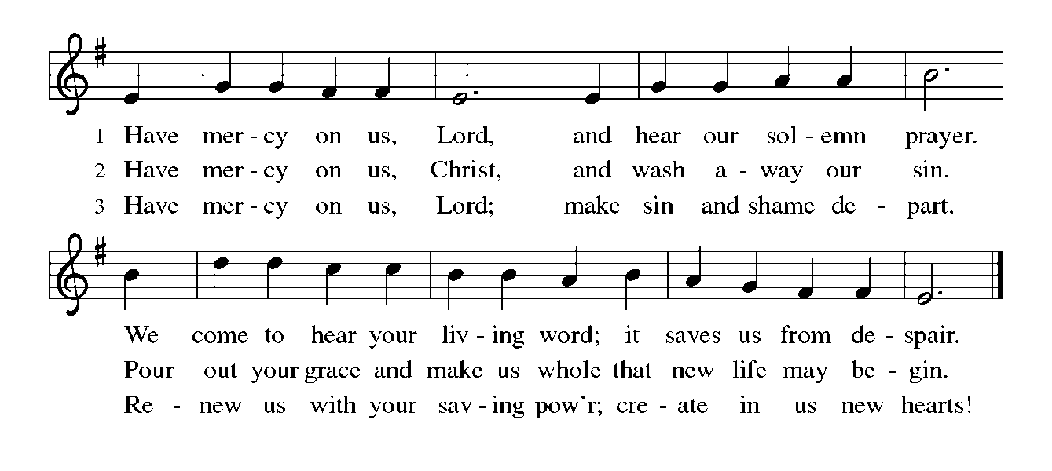
THE PRAYER OF THE DAY

P: The Lord be with you.

C: And also with you.

P: Let us pray. Holy God, through Your Son You have called us to live faithfully and act
courageously. Keep us steadfast in Your covenant of grace, and teach us the wisdom
that comes only through Jesus Christ, our Savior and Lord, Who lives and reigns with
You and the Holy Spirit, one God, now and forever.

C: Amen.

The assembly is seated

WORD

THE FIRST READING Exodus 20: 1-17

This covenant is the third one the church hears in this cycle of readings. After escaping from slavery, the Israelites come to Mount Sinai where God instructs them how to live together in community. The Ten Commandments recognize that God is the creator of all things. Flowing from God, the life of the community flourishes when marked by the basic building blocks recounted in today's reading: honesty, trust, fidelity, and respect for life, family, and property.

God spoke all these words: ²I am the LORD your God, Who brought you out of the land of Egypt, out of the house of slavery; ³you shall have no other gods before Me.
⁴You shall not make for yourself an idol, whether in the form of anything that is in heaven above, or that is on the earth beneath, or that is in the water under the earth. ⁵You shall not bow down to them or worship them; for I the LORD your God am a jealous God, punishing children for the iniquity of parents, to the third and the fourth generation of those who reject Me, ⁶but showing steadfast love to the thousandth generation of those who love Me and keep My commandments.
⁷You shall not make wrongful use of the name of the LORD your God, for the LORD will not acquit anyone who misuses His name.
⁸Remember the sabbath day, and keep it holy. ⁹Six days you shall labor and do all your work. ¹⁰But the seventh day is a sabbath to the LORD your God; you shall not do any work--you, your son or your daughter, your male or female slave, your livestock, or the alien resident in your towns. ¹¹For in six days the LORD made heaven and earth, the sea, and all that is in them, but rested the seventh day; therefore the LORD blessed the sabbath day and consecrated it.
¹²Honor your father and your mother, so that your days may be long in the land that the LORD your God is giving you.
¹³You shall not murder.
¹⁴You shall not commit adultery.
¹⁵You shall not steal.
¹⁶You shall not bear false witness against your neighbor.
¹⁷You shall not covet your neighbor's house; you shall not covet your neighbor's wife, or male or female slave, or ox, or donkey, or anything that belongs to your neighbor.

The Word of the Lord.

Thanks be to God.

THE PSALM: Psalm 19 Read responsively

¹The heavens declare the glory of God,
and the sky proclaims its Maker's handiwork.

²One day tells its tale to another,
and one night imparts knowledge to another.

³Although they have no words or language,
and their voices are not heard,

⁴their sound has gone out into all lands,
and their message to the ends of the world,
where God has pitched a tent for the sun.

⁵It comes forth like a bridegroom out of his chamber;
it rejoices like a champion to run its course.

⁶It goes forth from the uttermost edge of the heavens
and runs about to the end of it again;
nothing is hidden from its burning heat.

⁷The teaching of the LORD is perfect and revives the soul;
the testimony of the LORD is sure and gives wisdom to the simple.

⁸The statutes of the LORD are just and rejoice the heart;
the commandment of the LORD is clear and gives light to the eyes.

⁹The fear of the LORD is clean and endures forever;
the judgments of the LORD are true and righteous altogether.

¹⁰More to be desired are they than gold, more than much fine gold,
sweeter far than honey, than honey in the comb.

¹¹By them also is Your servant enlightened,
and in keeping them there is great reward.

¹²Who can detect one's own offenses?
Cleanse me from my secret faults.

¹³Above all, keep your servant from presumptuous sins;
let them not get dominion over me;
then shall I be whole and sound, and innocent of a great offense.

¹⁴Let the words of my mouth and the meditation of my heart
be acceptable in Your sight,
O LORD, my strength and my redeemer.

THE SECOND READING 1 Corinthians 1: 18-25

Paul's preaching about the salvation God offers through the cross was met with suspicion. How can victory come out of death? Some thought this message was nonsense. But Paul announces that God's wisdom overturns common expectations about who God is and where God intends to be.

The message about the cross is foolishness to those who are perishing, but to us who are being saved it is the power of God. ¹⁹For it is written,
"I will destroy the wisdom of the wise,
and the discernment of the discerning I will thwart."
²⁰Where is the one who is wise? Where is the scribe? Where is the debater of this age? Has not God made foolish the wisdom of the world? ²¹For since, in the wisdom of God, the world did not know God through wisdom, God decided, through the foolishness of our proclamation, to save those who believe.
²²For Jews demand signs and Greeks desire wisdom, ²³but we proclaim Christ crucified, a stumbling block to Jews and foolishness to Gentiles, ²⁴but to those who are the called, both Jews and Greeks, Christ the power of God and the wisdom of God. ²⁵For God's foolishness is wiser than human wisdom, and God's weakness is stronger than human strength.

The Word of the Lord.

Thanks be to God.

As you are able please rise

THE VERSE

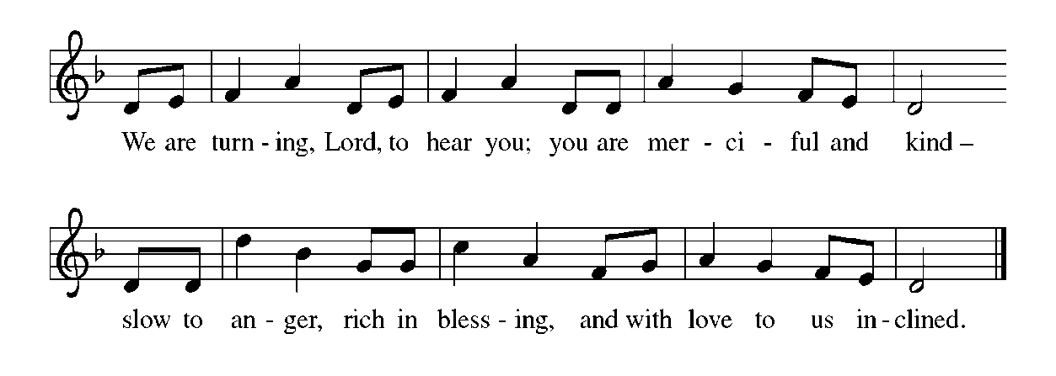
THE HOLY GOSPEL John 2: 13-22

Jesus attacks the commercialization of religion by driving merchants from the temple. When challenged, He responds mysteriously, with the first prediction of His own death and resurrection. In the midst of a seemingly stable religious center, Jesus suggests that the center itself has changed.
P: The Holy Gospel according to St. John, the second chapter.

C: Glory to You, O Lord!

The Passover of the Judeans was near, and Jesus went up to Jerusalem. ¹⁴In the temple He found people selling cattle, sheep, and doves, and the money changers seated at their tables. ¹⁵Making a whip of cords, He drove all of them out of the temple, both the sheep and the cattle. He also poured out the coins of the money changers and overturned their tables.
¹⁶He told those who were selling the doves, "Take these things out of here! Stop making My Father's house a marketplace!" ¹⁷His disciples remembered that it was written, "Zeal for Your house will consume me." ¹
⁸The Judeans then said to Him, "What sign can You show us for doing this?" ¹⁹Jesus answered them, "Destroy this temple, and in three days I will raise it up." ²⁰The Judeans then said, "This temple has been under construction for forty-six years, and will you raise it up in three days?"
²¹But He was speaking of the temple of His body. ²²After He was raised from the dead, His disciples remembered that He had said this; and they believed the scripture and the word that Jesus had spoken.

P: The Gospel of the Lord.

C: Praise to You, O Lord!

THE SERMON
Silence for reflection follows the sermon

As you are able please rise

THE HYMN OF THE DAY 772 Oh, That the Lord Would Guide My Ways

THE NICENE CREED

A: God has made us His people through our Baptism into Christ. Living together in trust
and hope, we confess our faith.

C: We believe in one God,
the Father, the Almighty,
maker of heaven and earth,
of all that is, seen and unseen.

We believe in one Lord, Jesus Christ,
the only Son of God,
eternally begotten of the Father,
God from God, Light from Light,
true God from true God,
begotten, not made,
of one Being with the Father.
Through Him all things were made.
For us and for our salvation
He came down from heaven;
by the power of the Holy Spirit
He became incarnate from the virgin Mary, and was made man.
For our sake He was crucified under Pontius Pilate;
He suffered death and was buried.
On the third day He rose again
in accordance with the Scriptures;
He ascended into heaven
and is seated at the right hand of the Father.
He will come again in glory to judge the living and the dead,
and his kingdom will have no end.

We believe in the Holy Spirit, the Lord, the giver of life,
Who proceeds from the Father and the Son.
With the Father and the Son He is worshiped and glorified.
He has spoken through the prophets.
We believe in one holy catholic and apostolic Church.
We acknowledge one Baptism for the forgiveness of sins.
We look for the resurrection of the dead,
and the life of the world to come. Amen

THE PRAYER OF THE CHURCH

A: Gathering all that commands our prayers, and mindful of God’s steadfast love and
faithfulness, let us intercede before God for the Church, the world, and all those who
seek to follow the Way of the Cross.

A: For the Church, that God’s commandments may be ever close to us, wonderful to
ponder and life-giving to keep, we pray to the Lord:

C: Have mercy and hear us.

A: For those preparing for Baptism this Easter, that their journey this Lent will draw them
deep into the wisdom and power of God, we pray to the Lord:

C: Have mercy and hear us.

A: For our bishops, especially Elizabeth and Bill; for our pastors, especially Mark, Dale,
Pamela and Mark; for missionaries, teachers, and deaconesses, that they may
faithfully lead us into God’s ways that direct our hearts to Him alone; use His name
prayerfully; keep Sabbath rest; honor parents and other’s live, marriages, property, and
good name, we pray to the Lord:

C: Have mercy and hear us.

A: For the an end to terrorism, for peace in Gaza, Ukraine, Nigeria, Estonia, Sudan and
other places of unrest; and for God’s intended wholeness of creation, we pray to the
Lord:
C: Have mercy and hear us.

A: For ourselves, that in our lives this week we may reflect the image and glory of God,
we pray to the Lord:

C: Have mercy and hear us.

A: For the sick, especially . . . that in their weakness they may know the strength and
power of God’s healing, we pray to the Lord:

C: Have mercy and hear us.

A: For those celebrating birthdays, especially Gail Leffew, that they may be filled with
grace this day and every day and grow in grace in the days ahead, we pray to the Lord:

C: Have mercy and hear us.

A: For the example of the faithful bearing the sign of the cross who have gone before us,
especially John and Samuel Wesley, renewers of the Church whom we
commemorate this Day we give thanks in our hope that by the power of God in Christ
we too may one Day be raised to everlasting life, we pray to the Lord:

C: Have mercy and hear us.

P: Jealous and merciful God, remember us and all those whom we hold in our hearts. In
these forty days teach us to do the work of our Baptism and so daily raise to You the
needs of the world. Grant this through Christ our Lord.

C: Amen.

MEAL

THE PEACE

P: The peace of the Lord be with you always.

C: And also with you.

The assembly is seated

OFFERING

VOLUNTARY Celtic Communion St. Paul Senior Choir
(M. Hayes)

As you are able please rise

THE OFFERTORY HYMN (see p. 9)

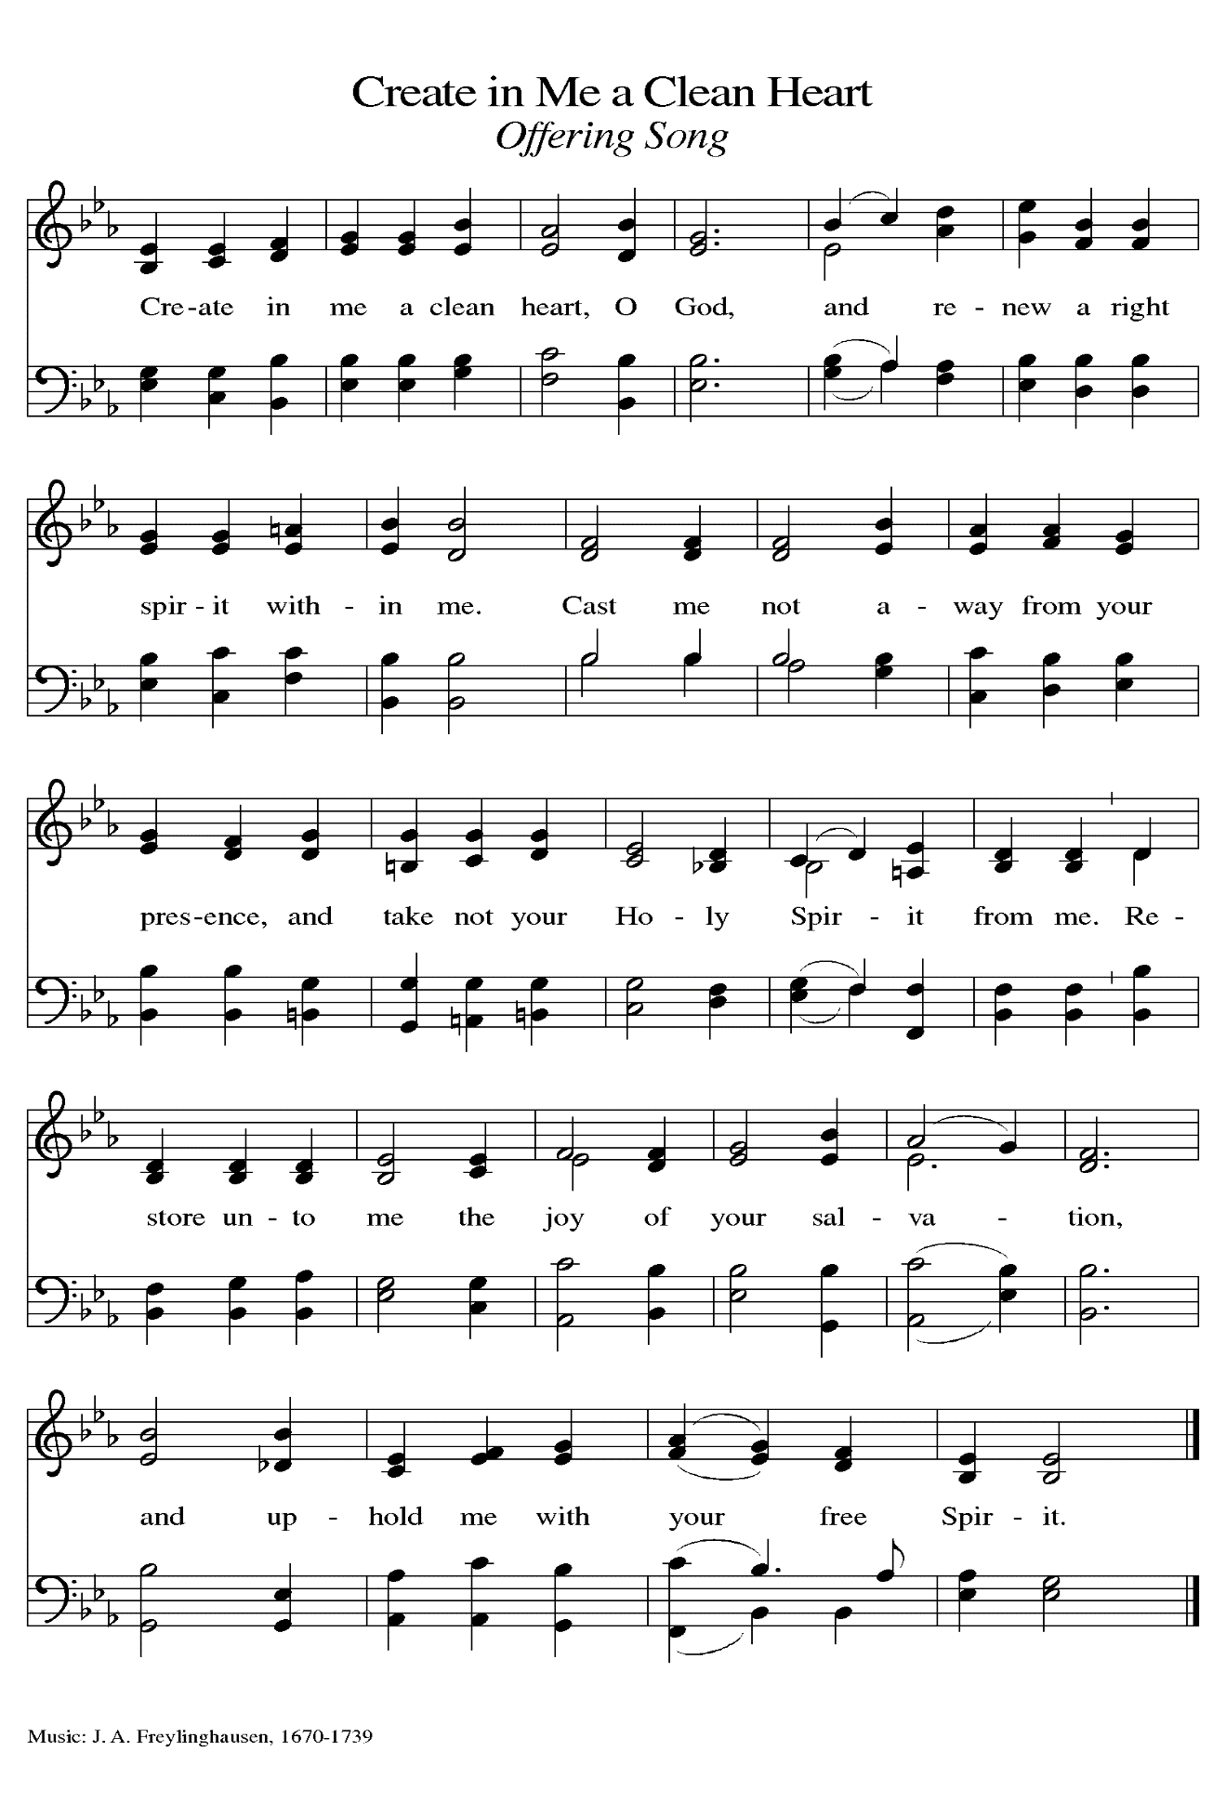
THE OFFERTORY PRAYER

A: Let us pray. God of mercy,

C: Receive these gifts we offer You, and feed us with Your grace, that through this
holy Sacrament our lives may be cleansed of all that is needless, and our hearts
may rest in Your promises alone. We ask this in the name of Jesus the Lord. Amen.

THE GREAT THANKSGIVING

P: The Lord be with you.

C: And also with you.

P: Lift up your hearts.

C: We lift them to the Lord.

P: Let us give thanks to the Lord our God.

C: It is right to give Him thanks and praise.

P: Covenanting God, You made this world and us to be Your companions, and in Moses
You revealed to us the spirit of freedom and the freedom of Your Spirit.
On Sinai You showed Your people how to keep their freedom and walk in Your
Spirit.
You called them to be a priestly kingdom and a holy nation.
In Your temple You enshrined Your law and made Your mercy seat the place of
Your people’s reconciliation with You.
Then in Jesus You came among Your people as the embodiment of Your law and the
personification of Your temple and the emblem of Your freedom.
His cross is the mercy seat in which You forgive our sin, and His resurrection is the
new law of life with You forever.
Righteous God, Your Son said, “Destroy this temple and in three days I will raise it
up.”
Here we gather before You to lament the agony of that destruction and to celebrate
the glory of that raising up.
Come into the temple of this Your body that Your people may become a temple of
Your presence,
And that these gifts of bread and wine may be for us the Body and Blood of Your
Son, Jesus Christ,
Who, in the night ... “Do this for the remembrance of Me.”
As often as we eat ... we proclaim the Lord’s death until He comes.

C: Christ has died. Christ is risen. Christ will come again.

P: Merciful Father, in Your commandments we see the simplicity and the sacrifice of our
life with You and Your life with us.
Make us holy as You are holy; raise up saints from this community, and make us
quick to recognize the saints we encounter elsewhere.

Fill our hearts with prophetic zeal for Your house, Your holiness, for Your Kingdom,
and for Your grace.
Take out of Your Church the idolatries that grieve You, and fill Your Church with the
transparency of heart that honors You,
Until the Day when all sin is transformed by Your grace, all scarcity filled with Your
abundance, and all disorder healed by Your mercy,
And you are all in all, Father, Son, and Holy Spirit.

C: Amen!

THE LORD’S PRAYER

P: Baptized into Christ’s death that we might share in the resurrection, let us pray for the
fulfillment of this mystery as Jesus taught us:

C: Our Father in heaven, hallowed be Your name.
Your Kingdom come, Your will be done on earth as in heaven.
Give us today our daily bread, and forgive us our sins, as we forgive
those who sin against us.
Save us from the time of trial, and deliver us from evil.
For the Kingdom, the power, and the glory are Yours, now and forever.
Amen.

INVITATION TO THE MEAL

P: Behold the Christ, in Whom we have become a new creation, in Whom God is
reconciling the world. Blessed are those who are called to the Supper of the Lamb.
God’s holy gifts for God’s holy people. Come, for all is now ready.

The assembly is seated

THE DISTRIBUTION
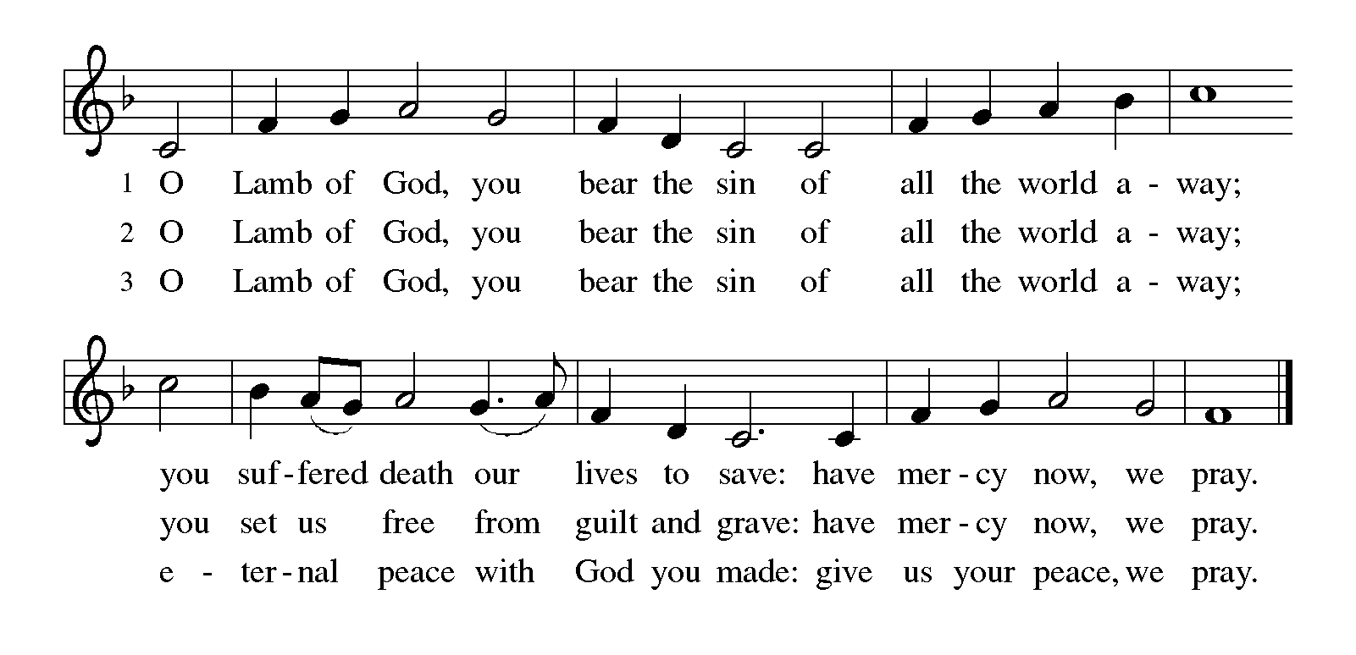

HYMNS DURING COMMUNION 856 How Great Thou Art
806 O God, My Faithful God
As you are able please rise

THE POST-COMMUNION BLESSING

P: The body and blood of our Lord Jesus Christ strengthen you and keep you in His grace.

C: Amen.
THE POST-COMMUNION PRAYER

A: Let us pray. God of our pilgrimage, in this Meal You nourish us with the gifts of faith
and hope. Sustain us on our journey, that refreshed by Your grace, we may fulfill Your
commands, and become living signs of Your redeeming love. Grant this through Christ
our Lord.

C: Amen.

SENDING

THE BENEDICTION

P: Almighty God: Father, Son, and Holy Spirit bless you now and forever.

C: Amen.

SENDING HYMN 705 God of Grace and God of Glory

THE DISMISSAL
A: Go in peace. Remember the poor.
C: Thanks be to God!

To God Alone Be Glory

POSTLUDE

The Meditation is from Words for Worship. Copyright 1999 Augsburg Fortress.

The Greeting, Offertory Prayer, Post-Communion Prayer, and Dismissal are adapted from
Sundays and Seasons. Copyright Augsburg Fortress, 1999.

The Prayers are adapted from Sundays and Seasons. Copyright 2003 Augsburg Fortress,
and Prayers for Sundays and Seasons. Year B. Peter A. Scagnelli. (Chicago:
Liturgy Training Publications, 1998) 32-33.

ANNOUNCEMENTS

Please remember to mail your offering to the Church Office at 818 Franklin Street, Michigan City, IN 46360. Another alternative is to give on-line through Tithe.ly. Please see your closure letter for information on how to set up a Tithe.ly account.

St. Paul Members are reminded to have a loved one contact the office if you are hospitalized. Many times, the Pastor doesn’t know someone is in the hospital. If you call and leave a message, please tell us which hospital the patient is at.

BIRTHDAYS: Gail Leffew (3/06)

PRAYER CONCERNS: Erica McMahan, Sue Koziel, Jana Thomas, Margie Torres, Jayla Jacobi, Jim Gleason, Ronwynn Jones, Chris Jones, Mark Tannehill, Joan Seifert, Virginia Murray, Brian Wiseman, Jary Tannehill and Sue Granacki.

OFFICE HOURS: Libby will be in the office on Mondays, Wednesdays,
and Fridays; volunteers will cover Tuesdays and Thursdays.

Monday & Wednesday 8:00 a.m. – 5 p.m.
Tuesday & Thursday 9:00 a.m. – 12:00 p.m.
Friday 8:00 a.m. – 12:00 p.m.

If you are listening to the worship broadcast on the radio and would like to watch the Sunday morning service live stream follow these steps:

(1) If you have You Tube available on your TV, search for
St. Paul Lutheran Church Michigan City, IN.

(2) The direct link on the computer is
https://www.youtube.com/channel/UC5AIPNaKr3QN50984jGOa1g.

(3) This link is also on the main page of the church’s website in
the church section and will continue to be posted weekly on the St.
Paul Facebook page.

And it will always be available on the radio broadcast Sunday mornings at 11:00 a.m.
on WEFM (95.9), and on the local cable access station #99 for the previous week’s
service on Sundays at 4:00 p.m. and the current service on Wednesdays at 7:00 p.m. and
Fridays at 8:30 p.m.

The approved and signed minutes of the December 28, 2023 and January 25, 2024 Church Council Meetings are on the table at the back of the church in the Narthex. Please take a copy with you as you go.

To send e-mail to the church office, please use the following addresses:

Pastor Mark Reshan: seniorpastor@stpaulmichigancity.com

Church Office Secretary (Libby Pollock): churchsecretary@stpaulmichigancity.com

Church Treasurer (Karen Fleming): finance@stpaulmichigancity.com

The Good News Newsletter: If you have an article or anything you want included in The Good News please send it to the following e-mail address: splcgoodnews@gmail.com. Pastor Pamela Thiede will be using this e-mail address to assemble The Good News each month. The deadline for getting information to Pastor Pamela will be the 20th of each month.

Worship Attendance: February 21, 24 and 25, 2024:

6:00 p.m. 33

4:00 p.m. 27

9:00 a.m. 57
TOTAL 117

LOOKING FOR IDEAS
We’d like to continue to highlight a different mission each month. We are looking for suggestions! If you volunteer somewhere or have a mission that is close to your heart, please let Paul or Lora Brooks know so we can set up a month to support that cause! Paul: (219) 221-0254, paulbrooks@gmail.com; or Lora: (260) 701-1586, loralmartin15@gmail.com.

Easter Plants

A variety of spring plants will be available to order for decorating St. Paul’s Church on Easter Morning! The varieties available will be Lily, Tulips, Hydrangeas, Florist Mum, and Hanging Fern Baskets. Orders must be placed by Friday, March 15th.

The varieties and color available are Lily, Tulips in yellow, and pink, Florist Mum in yellow, Hydrangeas in pink or purple/blue, and the 10” Hanging Fern Basket.

Cost per plant is as follows:

$8.00 – Tulip (yellow or pink)
$9.00 – Lily (only white)
$11.00 – Florist Mum (yellow)
$13.00 – Hanging Fern
$15.00 - Hydrangea (pink or purple/blue)

Please specify your choice of plant and your choice of color when applicable.
Orders MUST be placed by Friday morning, March 15th.

Your order may be placed ‘In Memory or Honor of a Loved One’. Please call the Church Office, 219-874-7293, or place your order in an envelope and title it ‘Easter Flowers’ for ordering. REMEMBER, you must specify what type of plant and color, if applicable!! All checks should be made out to St. Paul Church.

Please plan on picking up your plant after the Easter Morning Service by 11:30 a.m..

MID-WEEK LENTEN SERVICES
As above, these services are tentative as of this writing. The hope is to continue our tradition of using Marty Haugen’s “Holden Evening Prayer” as the musical basis of our weekly worship services complemented by some Scripture readings, a brief homily, and some hymns.
This year, we will utilize a series from our worship resource, Sundays and Seasons, based upon a passage from this year’s appointed Gospel of St. Mark. It is entitled, “You Shall Love the Lord Your God,” from Mark 12:28-30 when a scribe asks
Jesus which commandment is the greatest. Jesus responds, “The first is, Hear O Israel, the Lord our God is one; you shall love the Lord your God with all your heart, and with all your soul, and with all your mind, and with all your strength.” Each of these will be highlighted at the mid-week services in this order:

Wednesday, February 21 “Hear, O Israel”

Wednesday, February 28 “You Shall Love the Lord Your God With All Your Heart”

Wednesday, March 6 “You Shall Love the Lord Your God With All Your Soul”

Wednesday, March 13 “You Shall Love the Lord Your God With All Your Mind”

Wednesday, March 20 “You Shall Love the Lord Your God With All Your Strength”

ACTIVITIES, EVENTS & MEETINGS
MARCH 2024

Saturday, March 2, 2024 @ 4:00 p.m. Worship Service

Sunday, March 3, 2024 @ 9:00 a.m. Worship Service

Tuesday, March 5, 2024 @ 10:00 a.m. Altar Guild Mtg./Green Room

@ 4:00 p.m. Bell Choir Rehearsal

Wednesday, March 6, 2024 @ 9:15 a.m. Bible Study/Luther House

@ 10:00 a.m. God’s Purls/St. Paul Room

@ 4:00 p.m. Choir Rehearsal

@ 6:00 p.m. Holden Evening Prayer Service for Lent

Thursday, March 7, 2024 @ 10:30 a.m. Faith Circle/Green Room

Saturday, March 9, 2024 @ 4:00 p.m. Worship Service

Sunday, March 10, 2024 @ 9:00 a.m. Worship Service
Monday, March 11, 2024 @ 1:00 p.m. Hope Circle/Green Room
Tuesday, March 12, 2024 from 11:00 a.m. – close GIVE-BACK @ Holly’s
@ 4:00 p.m. Bell Choir Rehearsal
@ 7:00 P.M. Estuary/Luther House
Wednesday, March 13, 2024 @ 9:15 a.m. Bible Study/Luther House
@10:00 a.m. God’s Purls/St. Paul Room
@ 3:00 p.m. Worship & Music Comm./Luther House
@ 4:00 p.m. Choir Rehearsal
@ 6:00 p.m. Holden Evening Prayer Service for Lent
Friday, March 15, 2024 LAST DAY TO ORDER EASTER PLANTS
Saturday, March 16, 2024 @ 4:00 p.m. Worship Service

Sunday, March 17, 2024 9:00 a.m. Worship Service
Tuesday, March 19, 2024 @ 4:00 p.m. Bell Choir Rehearsal
Wednesday, March 20, 2024 @ 9:15 a.m. Bible Study/Luther House
@ 10:00 a.m. God’s Purls/St. Paul Room
@ 4:00 p.m. Choir Rehearsal
@ 6:00 p.m. Holden Evening Prayer Service for Lent
Saturday, March 23, 2024 @ 4:00 p.m. Worship Service

