THE FOURTH SUNDAY IN LENT
March 10, 2024

When the Israelites were frustrated and disgusted and rebelling against the circumstances of their own forced march to freedom, Moses needed something to get them going again. It was a bronze serpent, raised up like a standard, an artificial symbol of whatever it was, a seraph, that had afflicted them. It became the effective agent of their healing and forgiveness, the sign that injected hope and a renewed will to keep going toward the Promised Land. . . .
So the preacher has to get Jesus up there before people's consciousness in a call for their faith; telling all of us who share the responsibility for moving the Christian community on in life that we must proclaim the Lord as the source of hope and energy in a world of confounding circumstances and in the face of the death that defeats all our hopes.
At the heart of our own faith is a conviction in God's unfailing love; for generations of recurring cynicism, indifference, and despair have never had the last word or given the definitive comment on our human situation. The love of God is persistent, and the Word of God always finds a new voice in the most hopeless circumstances.

John Gerlach, O.P.

Jesus is never surprised by people in John’s Gospel, but he continually surprises, challenges, and confuses those who see him. They are dumbstruck by the presence of astounding Light in a regular human body (see John 2: 20; 8: 48-58).
Jesus’ arrival, therefore, can lead one out of darkness and into light and life, or it can confirm one’s place among the dead. God’s motivation for sending Jesus is not condemnation, but love. God sends Jesus into the camp, and that trip culminates with Jesus’ own exaltation upon a stake: a Roman cross.
Lifted high, Jesus’ pierced body demands attention as the narrator’s gaze lingers on this scene in John 19: 34-37. Just like the serpent in the wilderness, Jesus’ body, the very location of God’s glory (John 2: 21-22), is the most staggering revelation of the gospel. Rather than actively judging, Jesus’ form hangs, to be looked upon by those who dare face the horror of “the sin of the world” that caused the Lamb to die (John 1: 29).
Yet, rather than despair, this sight is also the place of life, the sign of God’s profound love for creation. Thus, verse 21 ends with hope: “But the one who does the truth comes to the light so that their works might be shined upon, because they are being done by God.” Jesus, the Light of the World, exposes truth all around him. That truth is not all beautiful; most of it is human mistakes, wickedness, and hatred prompted by selfishness and fear (verses 19-20).

Alicia Vargas
In the Name of Jesus

GATHERING

INTRODUCTION

The fourth of the Old Testament promises providing a baptismal lens this Lent is the promise God makes to Moses: those who look on the bronze serpent will live. In today's gospel Jesus says he will be lifted up on the cross like the serpent, so that those who look to him in faith will live. When we receive the sign of the cross in baptism, that cross becomes the sign we can look to in faith, for healing, for restored relationship to God, for hope when we are dying.

PRELUDE

ANNOUNCEMENTS

As you are able please rise

CONFESSION AND ABSOLUTION

P: In the name of the Father and of the Son and of the Holy Spirit.

C: Amen.

P: “Give thanks to the LORD, for He is good, and His mercy endures forever.” (Psalm
107: 1) Trusting in God’s goodness and mercy, let us confess our sins.

Silence for reflection and self-examination is kept

P: Most merciful God,

C: We confess that we have sinned against You by turning away from Your grace
and mercy. We have been impatient on our way through the wilderness times in
our lives. (Numbers 21: 4) We have complained of the path You have chosen for
us. (21: 5) You loved us while we were sinners, yet we often withdraw our love
from those who disappoint us. (Ephesians 2: 4) You sent Your Son to live and die
for us, and we choose too often to live only for ourselves. (John 3: 16) We ask
Your forgiveness, Lord. For the sake of the life and death of Your Son, be merciful
to us and grant us Your forgiveness.

P: God so loved the world, that He gave His only-begotten Son. Whoever believes in Him
is not condemned, but has everlasting life.

C: Amen.

GATHERING HYMN 666 What Wondrous Love is This

THE GREETING

P: The grace of our Lord Jesus Christ, the love of God, and the communion of the Holy
Spirit be with you all.

C: And also with you.

THE KYRIE

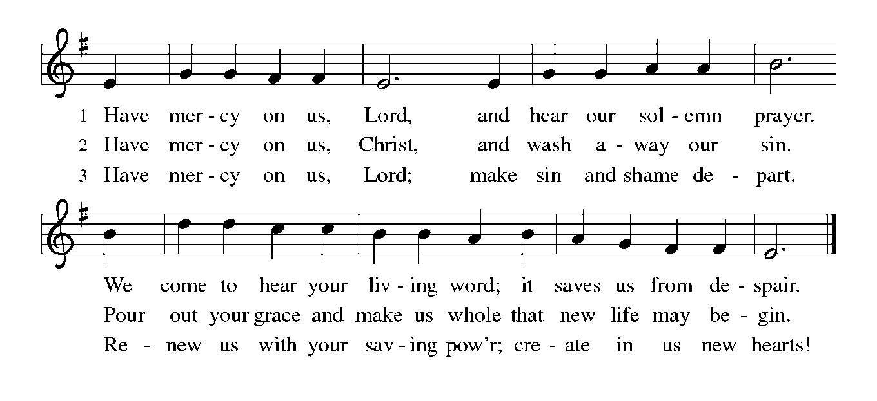
THE PRAYER OF THE DAY

P: The Lord be with you.

C: And also with you.

P: Let us pray. O God, rich in mercy, by the humiliation of Your Son you lifted up this
fallen world and rescued us from the hopelessness of death. Lead us into Your light,
that all our deeds may reflect Your love, through Jesus Christ, our Savior and Lord,
Who lives and reigns with You and the Holy Spirit, one God, now and forever.

C: Amen.

The assembly is seated

WORD

THE FIRST READING Numbers 21: 4-9

Throughout the Hebrew scriptures, the time of Israel's wandering in the desert is seen as a period of testing. Though God delivers the people from slavery and provides for all their needs on the journey, they whine and grumble. They fail to see the gift of salvation in the exodus. Yet God's anger is not the final word. God continues to lead the people toward the land promised to their ancestors.

From Mount Hor the Israelites set out by the way to the Red Sea, to go around the land of Edom; but the people became impatient on the way. ⁵The people spoke against God and against Moses, "Why have you brought us up out of Egypt to die in the wilderness? For there is no food and no water, and we detest this miserable food."
⁶Then the LORD sent poisonous serpents among the people, and they bit the people, so that many Israelites died. ⁷The people came to Moses and said, "We have sinned by speaking against the LORD and against you; pray to the LORD to take away the serpents from us." So Moses prayed for the people.
⁸And the LORD said to Moses, "Make a poisonous serpent, and set it on a pole; and everyone who is bitten shall look at it and live." ⁹So Moses made a serpent of bronze, and put it upon a pole; and whenever a serpent bit someone, that person would look at the serpent of bronze and live.

The Word of the Lord.

Thanks be to God.

THE PSALM: Psalm 107: 1-3, 17-22 Read responsively

¹Give thanks to the LORD, for the LORD is good,
for God's mercy endures forever.

²Let the redeemed of the LORD proclaim
that God redeemed them from the hand of the foe,

³gathering them in from the lands;
from the east and from the west, from the north and from the south.

¹⁷Some were fools and took rebellious paths;
through their sins they were afflicted.

¹⁸They loathed all manner of food
and drew near to death's door.

¹⁹Then in their trouble they cried to the LORD
and You delivered them from their distress.

²⁰You sent forth Your word and healed them
and rescued them from the grave.

²¹Let them give thanks to You, LORD, for Your steadfast love
and Your wonderful works for all people.

²²Let them offer sacrifices of thanksgiving
and tell of Your deeds with shouts of joy.

SECOND READING Ephesians 2: 1-10

God raised us up to new life while we yet belonged to powers of evil. If such was our past, we now live with Christ and will spend eternity discovering the breadth of God's goodness.

You were dead through the trespasses and sins ²in which you once lived, following the course of this world, following the ruler of the power of the air, the spirit that is now at work among those who are disobedient. ³All of us once lived among them in the passions of our flesh, following the desires of flesh and senses, and we were by nature children of wrath, like everyone else.
⁴But God, Who is rich in mercy, out of the great love with which He loved us ⁵even when we were dead through our trespasses, made us alive together with Christ--by grace you have been saved--⁶and raised us up with Him and seated us with Him in the heavenly places in Christ Jesus, ⁷so that in the ages to come He might show the immeasurable riches of His grace in kindness toward us in Christ Jesus.
⁸For by grace you have been saved through faith, and this is not your own doing; it is the gift of God--⁹not the result of works, so that no one may boast. ¹⁰For we are what He has made us, created in Christ Jesus for good works, which God prepared beforehand to be our way of life.

The Word of the Lord.

Thanks be to God.

As you are able please rise

THE VERSE
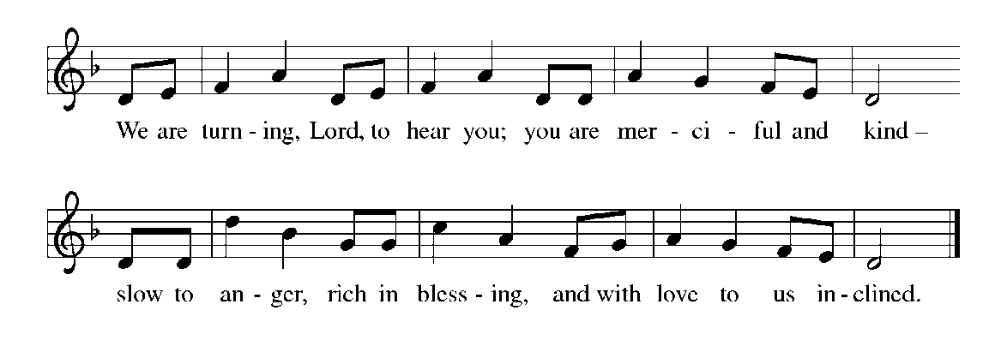
THE HOLY GOSPEL John 3: 14-21

To explain the salvation of God to the religious leader Nicodemus, Jesus refers to the Scripture passage quoted in today’s first reading. Just as those who looked upon the bronze serpent were healed, so people will be saved when they behold Christ lifted up on the cross.

P: The Holy Gospel according to St. John, the third chapter.

C: Glory to You, O Lord!

Jesus said: ¹⁴ "Just as Moses lifted up the serpent in the wilderness, so must the Son of Man be lifted up, ¹⁵that whoever believes in Him may have eternal life.
¹⁶ "For God so loved the world that He gave His only Son, so that everyone who believes in Him may not perish but may have eternal life.
¹⁷ "Indeed, God did not send the Son into the world to condemn the world, but in order that the world might be saved through Him. ¹⁸Those who believe in Him are not condemned; but those who do not believe are condemned already, because they have not believed in the name of the only Son of God.
¹⁹And this is the judgment, that the light has come into the world, and people loved darkness rather than light because their deeds were evil. ²⁰For all who do evil hate the light and do not come to the light, so that their deeds may not be exposed. ²¹But those who do what is true come to the light, so that it may be clearly seen that their deeds have been done in God."

The Gospel of the Lord.
Praise to You, O Christ!

The assembly is seated

THE SERMON
Silence for reflection follows the sermon

As you are able please rise

THE HYMN OF THE DAY 323 God Loved the World

THE NICENE CREED

A: God has made us His people through our Baptism into Christ. Living together in trust
and hope, we confess our faith.

C: We believe in one God,
the Father, the Almighty,
maker of heaven and earth,
of all that is, seen and unseen.

We believe in one Lord, Jesus Christ,
the only Son of God,
eternally begotten of the Father,
God from God, Light from Light,
true God from true God,
begotten, not made,
of one Being with the Father.
Through Him all things were made.
For us and for our salvation
He came down from heaven;
by the power of the Holy Spirit
He became incarnate from the virgin Mary, and was made man.
For our sake He was crucified under Pontius Pilate;
He suffered death and was buried.
On the third day He rose again
in accordance with the Scriptures;
He ascended into heaven
and is seated at the right hand of the Father.
He will come again in glory to judge the living and the dead,
and His kingdom will have no end.

We believe in the Holy Spirit, the Lord, the giver of life,
Who proceeds from the Father and the Son.
With the Father and the Son He is worshiped and glorified.
He has spoken through the prophets.
We believe in one holy catholic and apostolic Church.
We acknowledge one Baptism for the forgiveness of sins.
We look for the resurrection of the dead,
and the life of the world to come. Amen
THE PRAYER OF THE CHURCH

A: Embraced by the cross of Christ, and mindful of God’s steadfast love and faithfulness,
let us pray for the poor, the needy, and all who follow Christ in the Way of the cross.

A: For the Church, that our Lenten hunger may be for justice, and our thirst for giving
flesh and blood to the love of God, we pray: Hear us, O God:

C: For Your mercy is great.

A: For those preparing to be made alive in Christ through Baptismal waters at Easter, that
in these days of preparation their faith might be made strong, we pray: Hear us, O God:

C: For Your mercy is great.

A: For lands made desolate by war and for refugees driven from their homes by conflict,
that they may come to a Sabbath of healing and a season of peace, we pray: Hear us,
O God:

C: For Your mercy is great.

A: For this assembly, gifted in grace by God, that we may be diligent in the good works
of God’s love for which we are created, we pray: Hear us, O God:

C: For Your mercy is great.

A: For those who do not yet believe in Christ; those who have turned away from or lost
their faith; and for all who do evil and hate the light of truth, we pray: Hear us, O God:

C: For Your mercy is great.

A: For the sick and suffering, especially: Jim Gleason; Sue Granacki; Erica McMahan;
Martha Schroeder; Margie Torres; Mark and Jary Tannehill; Venia Wendt; and
Jayla Jacobi that the Lord might deliver them from their distress, we pray: Hear us, O
God:

C: For Your mercy is great.

A: For those celebrating birthdays, especially Jean Warner; that they may be filled with
grace this day and every day and grow in grace in the days ahead, we pray: Hear us, O
God:

C: For Your mercy is great.

A: For those who have died in Christ, that their faithfulness may inspire our living until
with them, we are made alive to worship Him in the heavenly places, we pray: Hear us,
O God:

C: For Your mercy is great.

P: God, full of goodness, remember all whom we remember, and remind us of all whom
we would forget. We ask these things in the name of Jesus the Lord.
C: Amen.
MEAL
THE PEACE

P: The peace of the Lord be with you always.

C: And also with you.

The assembly is seated

OFFERING

VOLUNTARY God So Loved the World St. Paul Senior Choir (J. Stainer )

As you are able please rise

THE OFFERTORY HYMN (see p. 9)

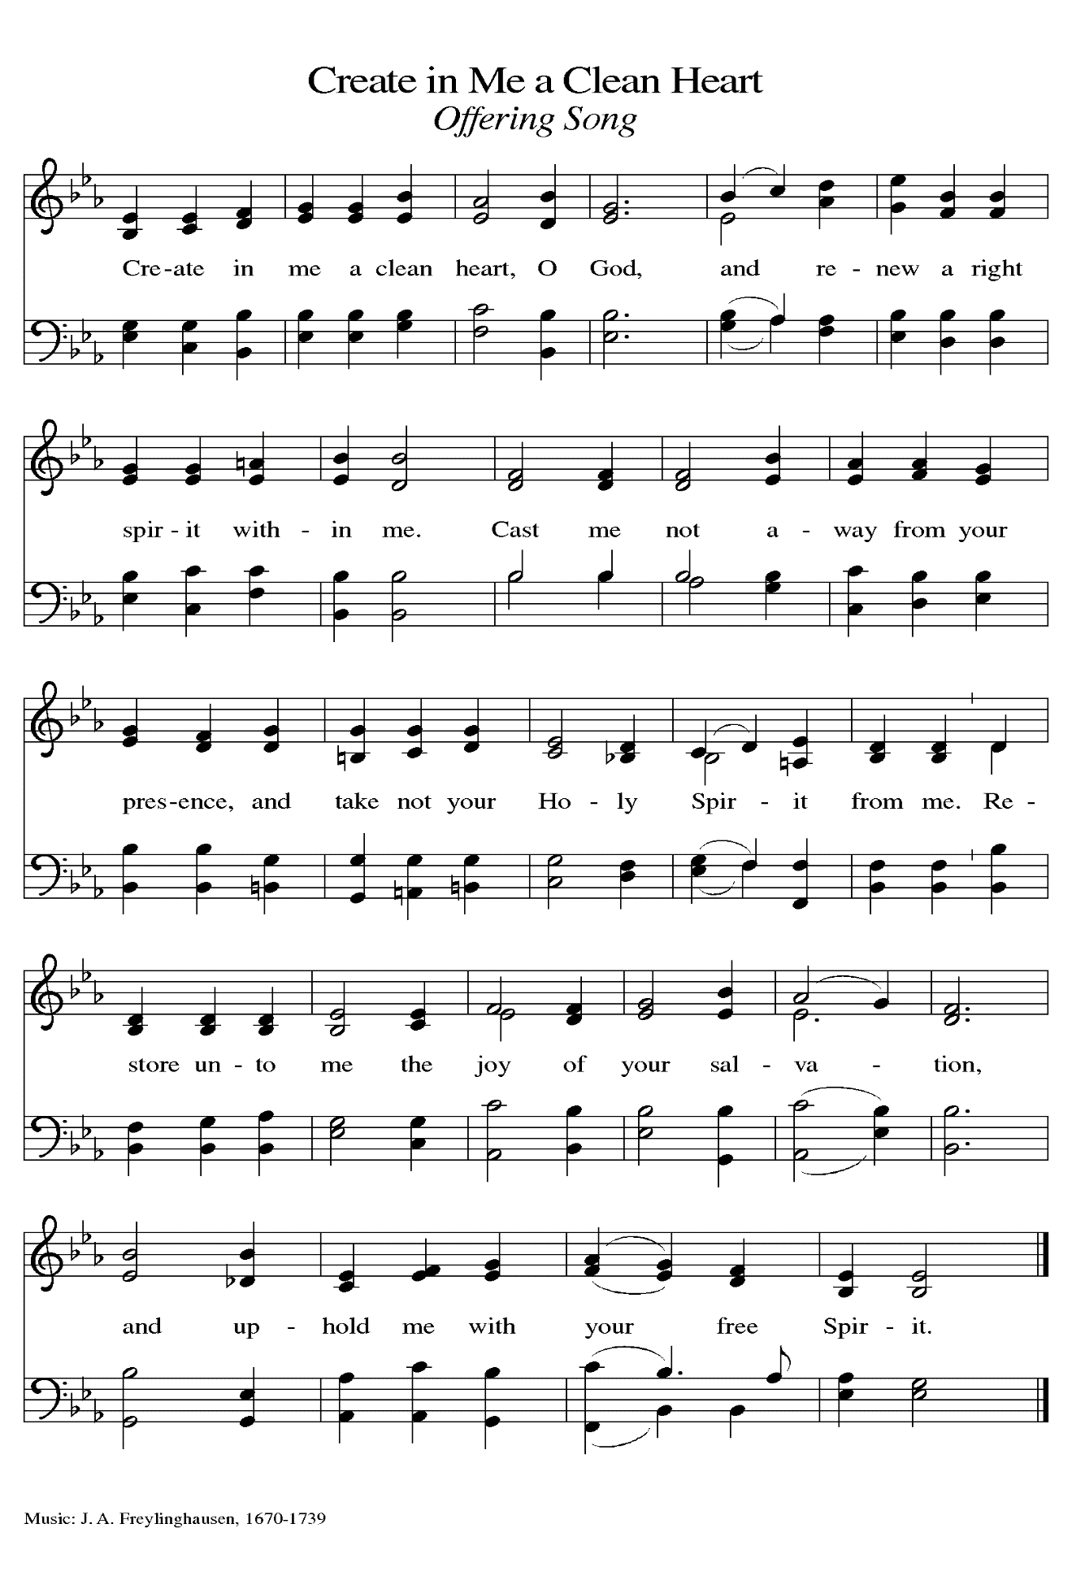
THE OFFERTORY PRAYER

A: Let us pray. God of mercy,

C: We offer these gifts as signs of our time and labor. Receive the offering of our
lives, and feed us with Your grace, that we might again be raised with Christ into
the heavenly joy of Your love and mercy. We ask this in the name of Jesus the
Lord. Amen.

THE GREAT THANKSGIVING

P: The Lord be with you.

C: And also with you.

P: Lift up your hearts.

C: We lift them to the Lord.

P: Let us give thanks to the Lord our God.

C: It is right to give Him thanks and praise.

P: Blessed be Your name, God of Moses, for You so love the world, and all that You
so love You created to share life with You.
When Your people were suffering as captives in Egypt You heard their cries, led them
to freedom, and made with them a covenant of life.
When Your people were perishing in the poison of sin, You sent Your only Son to
take our trespasses into Himself, to be our healing medicine.
Suffering His own death and rising in glory, He won our redemption and transformed
the poison of our sin into Your elixir of life.
Redeeming God, Who sent Your Son into the world not to condemn but so that the
world might be saved through Him,
Sanctify this everlasting Feast and through it draw Your Church into Your eternal,
Triune life.
By Your Spirit, bless these gifts of bread and wine that they may be for us the Body
and Blood of Your Son, Jesus Christ,
Who, in the night … “Do this for the remembrance of Me.”
As often as we eat ... we proclaim the Lord’s death until He comes.

C: Christ has died. Christ is risen. Christ will come again.

P: Restoring God, Whose Son was lifted up that we might look upon Him and live,
bring us through His cross to the glory of resurrection.
Shed Your mercy on those who look upon malady and disease and long for healing
of body, mind, or spirit.
Deliver Your children afflicted by the poison of enmity and strife in their families,
neighborhoods, and communities.
Hold Your redeeming cross before eyes cast down by injustice.

Lift up in every heart the hope born of Your passion until all Your children look upon
the Day when the world that You so love is, at last, one with You in glory,
And together with the saints we drink the wine of Your Kingdom, blessed and holy
Trinity, now and forever.

C: Amen!

THE LORD’S PRAYER

P: Baptized into Christ’s death that we might share in the resurrection, let us pray for the
fulfillment of this mystery as Jesus taught us:

C: Our Father, Who art in heaven, hallowed be Thy name.
Thy Kingdom come, Thy will be done on earth as it is in heaven.
Give us this day our daily bread, and forgive us our trespasses as we forgive
those who trespass against us.
And lead us not into temptation, but deliver us from evil.
For Thine is the Kingdom, and the power, and the glory, forever and ever. Amen.

INVITATION TO THE MEAL

P: Return to God with all your heart. Receive bread for the journey, drink for the desert.
Blessed are those who are called to the Supper of the Lamb. God’s holy gifts for God’s
holy people. Come, for all is now ready.

The assembly is seated

THE DISTRIBUTION
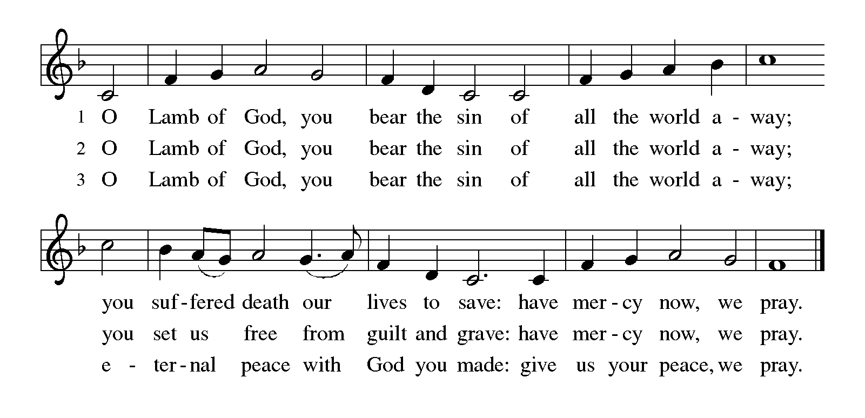
Those wishing to receive the Laying on of Hands, Anointing with Oil, and Prayer for
Healing may go to Pastor at the side aisle

HYMNS DURING DISTRIBUTION 848 Give to Our God Immortal Praise
779 Amazing Grace
604 O Christ, Our Hope
As you are able please rise

THE POST-COMMUNION BLESSING

P: The body and blood of our Lord Jesus Christ strengthen you and keep you in His grace.

C: Amen.
THE POST-COMMUNION PRAYER

A: Let us pray. God of our pilgrimage, in this Meal You nourish us with the gifts of faith
and hope. Sustain us on our journey, that refreshed by Your grace, we may ever turn
our eyes and hearts to rest alone in the love of the cross of Christ. Grant this through
Christ our Lord.

C: Amen.
SENDING
THE BENEDICTION

P: Almighty God: Father, Son, and Holy Spirit bless you now and forever.

C: Amen.

SENDING HYMN 660 Lift High the Cross

THE DISMISSAL
A: Go in peace. Remember the poor.
C: Thanks be to God!
To God Alone Be Glory

POSTLUDE

The Meditation is from Sundays and Seasons Online. Copyright 2015 Augsburg Fortress.

The Greeting, Offertory Prayer, Post-Communion Prayer, and Dismissal are adapted from
Sundays and Seasons. Copyright Augsburg Fortress, 1999.

The Prayer of the Church is also adapted from Intercessions for the Christian People. Gail
Ramshaw, ed. (New York: Pueblo Publishing Company, 1988) 96.

ANNOUNCEMENTS

Please remember to mail your offering to the Church Office at 818 Franklin Street, Michigan City, IN 46360. Another alternative is to give on-line through Tithe.ly. Please see your closure letter for information on how to set up a Tithe.ly account.

St. Paul Members are reminded to have a loved one contact the office if you are hospitalized. Many times, the Pastor doesn’t know someone is in the hospital. If you call and leave a message, please tell us which hospital the patient is at.

BIRTHDAYS: Jean Warner (3/14)

PRAYER CONCERNS: Erica McMahan, Sue Koziel, Jana Thomas, Margie Torres, Jayla Jacobi, Jim Gleason, Ronwynn Jones, Chris Jones, Mark Tannehill, Joan Seifert, Virginia Murray, Brian Wiseman, Jary Tannehill and Sue Granacki.

OFFICE HOURS: Libby will be in the office on Mondays, Wednesdays,
and Fridays; volunteers will cover Tuesdays and Thursdays.

Monday & Wednesday 8:00 a.m. – 5 p.m.
Tuesday & Thursday 9:00 a.m. – 12:00 p.m.
Friday 8:00 a.m. – 12:00 p.m.

If you are listening to the worship broadcast on the radio and would like to watch the Sunday morning service live stream follow these steps:

(1) If you have You Tube available on your TV, search for
St. Paul Lutheran Church Michigan City, IN.

(2) The direct link on the computer is
https://www.youtube.com/channel/UC5AIPNaKr3QN50984jGOa1g.

(3) This link is also on the main page of the church’s website in
the church section and will continue to be posted weekly on the St.
Paul Facebook page.

And it will always be available on the radio broadcast Sunday mornings at 11:00 a.m.
on WEFM (95.9), and on the local cable access station #99 for the previous week’s
service on Sundays at 4:00 p.m. and the current service on Wednesdays at 7:00 p.m. and
Fridays at 8:30 p.m.

The approved and signed minutes of the December 28, 2023 and January 25, 2024 Church Council Meetings are on the table at the back of the church in the Narthex. Please take a copy with you as you go.

To send e-mail to the church office, please use the following addresses:

Pastor Mark Reshan: seniorpastor@stpaulmichigancity.com

Church Office Secretary (Libby Pollock): churchsecretary@stpaulmichigancity.com

Church Treasurer (Karen Fleming): finance@stpaulmichigancity.com
The Good News Newsletter: If you have an article or anything you want included in The Good News please send it to the following e-mail address: splcgoodnews@gmail.com. Pastor Pamela Thiede will be using this e-mail address to assemble The Good News each month. The deadline for getting information to Pastor Pamela will be the 20th of each month.

Worship Attendance: February 28, March 2 and 3, 2024:
6:00 p.m. 29
4:00 p.m. 32
9:00 a.m. 53
TOTAL 114

LOOKING FOR IDEAS

We’d like to continue to highlight a different mission each month. We are looking for suggestions! If you volunteer somewhere or have a mission that is close to your heart, please let Paul or Lora Brooks know so we can set up a month to support that cause! Paul: (219) 221-0254, paulbrooks@gmail.com; or Lora: (260) 701-1586, loralmartin15@gmail.com.

March’s Local Monthly Mission will be the Service League of Michigan City. The Service League loans medical equipment to Michigan City residents as they recuperate at home. Some of the items they loan include bathroom and safety aids, wheelchairs, and knee walkers. Residents can also go each month to pick up adult briefs and bed pads free of charge. If you wish to support this month’s mission, please place your donation in the offering plate marked for the Service League.

Thank you! For your support of LaPorte County Meals on Wheels as the February monthly mission. We were able to donate $360.00 to help support their mission!

MID-WEEK LENTEN SERVICES
As above, these services are tentative as of this writing. The hope is to continue our tradition of using Marty Haugen’s “Holden Evening Prayer” as the musical basis of our weekly worship services complemented by some Scripture readings, a brief homily, and some hymns.
This year, we will utilize a series from our worship resource, Sundays and Seasons, based upon a passage from this year’s appointed Gospel of St. Mark. It is entitled, “You Shall Love the Lord Your God,” from Mark 12:28-30 when a scribe asks
Jesus which commandment is the greatest. Jesus responds, “The first is, Hear O Israel, the Lord our God is one; you shall love the Lord your God with all your heart, and with all your soul, and with all your mind, and with all your strength.” Each of these will be highlighted at the mid-week services in this order:

Wednesday, February 21 “Hear, O Israel”

Wednesday, February 28 “You Shall Love the Lord Your God With All Your Heart”
Wednesday, March 6 “You Shall Love the Lord Your God With All Your Soul”

Wednesday, March 13 “You Shall Love the Lord Your God With All Your Mind”

Wednesday, March 20 “You Shall Love the Lord Your God With All Your Strength”

Easter Plants

A variety of spring plants will be available to order for decorating St. Paul’s Church on Easter Morning! The varieties available will be Lily – only in white; Tulips - in yellow or pink; Hydrangeas - in pink or purple/blue; Florist Mum - in yellow; and the 10 inch Hanging Fern Baskets. Please specify your choice of plant(s) and choice of color where applicable. Orders must be placed by Friday morning, March 15th.

Cost per plant is as follows:

$8.00 – Tulip (yellow or pink)
$9.00 – Lily (only white)
$11.00 – Florist Mum (yellow)
$13.00 – Hanging Fern
$15.00 - Hydrangea (pink or purple/blue)

Your order may be placed ‘In Memory or Honor of a Loved One’. Please call the Church Office, 219-874-7293, or place your order in an envelope and title it ‘Easter Flowers’ for ordering. REMEMBER, you must specify what type of plant and color, if applicable!! All checks should be made out to St. Paul Church.

Please plan on picking up your plant after the Easter Morning Service by 11:30 a.m.

2024 Financial Stewardship

Weekly Church Operating Needs (x 2 weeks): $ 14,162.50
February 25-26, March 3 - 4, 2024
General Fund (including General Memorials): $ 8,164.00

Overage/Shortage: — $ 5,998.50

Restricted Income (not including Memorials)
Supports IK Synod & Church wide Ministries: $ 297.00

Ministries in our Community/Congregation: $ ——
Capital Fund: $ 248.00

Memorials
General Fund: $ 290.00

ACTIVITIES, EVENTS & MEETINGS
MARCH 2024

Saturday, March 9, 2024 @ 4:00 p.m. Worship Service

Sunday, March 10, 2024 @ 9:00 a.m. Worship Service

Monday, March 11, 2024 @ 1:00 p.m. Hope Circle/Green Room

Tuesday, March 12, 2024 from 11:00 a.m. – close GIVE-BACK @ Holly’s

@ 4:00 p.m. Bell Choir Rehearsal

@ 7:00 P.M. Estuary/Luther House

Wednesday, March 13, 2024 @ 9:15 a.m. Bible Study/Luther House

@10:00 a.m. God’s Purls/St. Paul Room

@ 3:00 p.m. Worship & Music Comm./Luther House

@ 4:00 p.m. Choir Rehearsal

@ 6:00 p.m. Holden Evening Prayer Service for Lent

Friday, March 15, 2024 LAST DAY TO ORDER EASTER PLANTS

Saturday, March 16, 2024 @ 4:00 p.m. Worship Service

Sunday, March 17, 2024 9:00 a.m. Worship Service

Monday, March 18, 2024 @3:00 p.m. Executive Board Mtg./Luther House

@ 4:00 p.m. Finance Mtg./Luther House

Tuesday, March 19, 2024 @ 4:00 p.m. Bell Choir Rehearsal

Wednesday, March 20, 2024 @ 9:15 a.m. Bible Study/Luther House

@ 10:00 a.m. God’s Purls/St. Paul Room

@ 4:00 p.m. Choir Rehearsal

@ 6:00 p.m. Holden Evening Prayer Service for Lent

Thursday, March 21, 2024 @ 5:30 p.m. Church Council Mtg./St. Paul Room

Saturday, March 23, 2024 @ 4:00 p.m. Palm/Passion Saturday Worship Service

Sunday, March 24, 2024 @ 9:00 a.m. Palm/Passion Sunday Worship Service

Tuesday, March 26, 2024 @ 4:00 p.m. Bell Choir Rehearsal

Wednesday, March 27, 2024 @ 9:15 a.m. Bible Study/Luther House

@ 10:00 a.m. God’s Purls/St. Paul Room

@ 4:00 p.m. Choir Rehearsal

@ 6:00 p.m. Holden Evening Prayer Service for Lent
Thursday, March 28, 2024 @ 10:00 a.m. Senior Communion with luncheon to
follow immediately after/St. Paul Room
Friday, March 29, 2024 @ 7:00 p.m. Good Friday/The Passion According to St.
John
Saturday, March 30, 2024 @ 7:00 p.m. The Great Vigil of Easter/The First
Communion of Easter
Sunday, March 31, 2024 @9:00 a.m. The Resurrection of Our Lord
Thank$ for $haring
This month,we will see you at Holly’s on Tuesday, March 12! Here are two coupons: one for you and one for a friend.





