THE SIXTH SUNDAY OF EASTER
May 5, 2024

The Spirit is shaping an affective and apostolic heart in all of us. Let us listen to that Spirit-song well and learn its melody. This song is a song of presence, of being with the other without calculation. We are not slaves; we are not members of Christ based on hierarchies of status or greater or lesser rank. We are lettered and unlettered, male and female, newborn and long-born, friends. Such friendship in Christ makes us companions at the Lord's table.
There is scandal in this: it goes against the competition models we have learned. It brings us into a communion of people bonded together in affective ties because God chose us and loved us first. The friendship we share here is one we can bring to others. Such a mission is a joy. Such action indicates a fresh initiative of the Spirit. Such a task brings delightful merriment and creative hope for our world.

John J. O’Brien
According to this passage at least (but see John 1:29) Jesus did not die as an atonement for sins but as a proof of God’s love toward humanity. One way to corroborate this idea is to notice that the institution of the Lord’s Supper is missing from John and it is replaced with the washing of the disciples’ feet, a clear sign of Jesus’ love for them. Jesus died as an example of love taken to its most extreme and radical manifestation, the greatest love of all (verse 13), not as a payoff for people’s sins.
I often wonder what would the church look like if its distinctive sign would have been the towel and the basin rather than the cross and the empty tomb. Instead of redemptive suffering -- which has justified so much bloodshed through the idea of the Christus Victor, from the Crusades, to the Conquest, to the Holocaust -- we would have love, the giving of oneself for the other.
Osvoldo Vena
In the Name of Jesus
GATHERING

INTRODUCTION

This Sunday's image of the life the risen Christ shares with us is the image of friendship. We are called to serve others as Jesus came to serve; but for John's gospel, the image of servanthood is too hierarchical, too distant, to capture the essence of life with Christ. Friendship captures the love, the joy, the deep mutuality of the relationship into which Christ invites us. The Greeks believed that true friends are willing to die for each other. This is the mutual love of Christian community commanded by Christ and enabled by the Spirit.

Monica, mother of Augustine, died 387

Monica was married to a pagan husband who was ill-tempered and unfaithful, but whom she helped bring into the Christian faith. She repeated the influence on her son Augustine, who went on to become one of the greatest church teachers.
PRESERVICE MUSIC I Will Celebrate St. Paul Praise Band (Linda Duvall)

THE EASTER ACCLAMATION

P: Christ is risen! Alleluia!

C: He is risen indeed! Alleluia!

ANNOUNCEMENTS

As you are able please rise

CONFESSION AND ABSOLUTION

P: In the name of the Father and of the Son and of the Holy Spirit.

C: Amen.

P: “In righteousness shall (God) judge the world.” (Psalm 98: 10) God’s “judgment” is to
set our lives and the world right according to His purposes in Jesus. By our Baptism
into the death and resurrection of Christ, God raised us to new life. Let us confess to
God our sins and all that waits for resurrection and “rightness” in our lives.

Silence for self-examination and reflection is kept

P: Most merciful God,

C: We confess that we have sinned against You in thought, word, and deed. We have
failed to obey Your commandments to love one another. (John 15: 12) We have
sought “joy” (John 15: 11) apart from You. We have turned away from Your gift
of new life, choosing instead the old ways of anger, fear, doubt, and sin that lead
to death. Free us from this power of sin, guide us by Your Spirit, and help us in
our weakness, that we may live as Your chosen, fruitful children, restored to
Easter life in Christ.

P: “(God) remembers His mercy and faithfulness ...” (Psalm 98: 4) In Jesus risen from the
dead God’s love is shown to be stronger than life or death or sin. Therefore, as a called
and ordained minister of the Church of Christ, and by His authority, I declare to you
the entire forgiveness of all your sins, in the name of the Father and of the Son and
of the Holy Spirit.

C: Amen.

GATHERING HYMN 720 We Are Called

THE GREETING AND PRAYER OF THE DAY

P: Alleluia! Christ is risen!

C: Christ is risen indeed! Alleluia!

P: The grace of our Lord Jesus Christ, the love of God, and the communion of the Holy
Spirit be with you all.
C: And also with you.

P: Let us pray. O God, You have prepared for those who love You joys beyond
understanding. Pour into our hearts such love for You that, loving You above all things,
we may obtain Your promises, which exceed all we can desire; through Jesus Christ,
Your Son and our Lord, Who lives and reigns with You and the Holy Spirit, one God,
now and forever.

C: Amen.

The assembly is seated

WORD

FIRST READING Acts 10: 44-48

While Peter shares the good news of Jesus with a Gentile soldier and his family, the Holy Spirit comes upon them. Recognizing that the Spirit works inclusively in the lives of both Jews and Gentiles, Peter commands that these Gentiles also be baptized in the name of Jesus Christ.

⁴⁴While Peter was still speaking, the Holy Spirit fell upon all who heard the word. ⁴⁵The circumcised believers who had come with Peter were astounded that the gift of the Holy Spirit had been poured out even on the Gentiles, ⁴⁶for they heard them speaking in tongues and extolling God.
Then Peter said, ⁴⁷Can anyone withhold the water for baptizing these people who have received the Holy Spirit just as we have? ⁴⁸So he ordered them to be baptized in the name of Jesus Christ. Then they invited him to stay for several days.

The Word of the Lord.

Thanks be to God.

THE PSALM: Psalm 98 Read responsively

¹Sing a new song to the LORD, Who has done marvelous things,
Whose right hand and holy arm have won the victory.

²O LORD, You have made known Your victory,
You have revealed Your righteousness
in the sight of the nations.

³You remember Your steadfast love and faithfulness to the house of Israel;
all the ends of the earth have seen the victory of our God.

⁴Shout with joy to the LORD, all you lands;
lift up your voice, rejoice, and sing.

⁵Sing to the LORD with the harp,
with the harp and the voice of song.

⁶With trumpets and the sound of the horn
shout with joy before the King, the LORD.
⁷Let the sea roar, and all that fills it,
the world and those who dwell therein.

⁸Let the rivers clap their hands,
and let the hills ring out with joy before the LORD,
Who comes to judge the earth.

⁹The LORD will judge the world with righteousness
and the peoples with equity.

SECOND READING 1 John 5: 1-6

God’s children believe that Jesus is the Messiah and love God by keeping God’s commandments. Thus the world is conquered not through military might but through love and faith.

Everyone who believes that Jesus is the Christ has been born of God, and everyone who loves the parent loves the child. ²By this we know that we love the children of God, when we love God and obey His commandments. ³For the love of God is this, that we obey His commandments. And His commandments are not burdensome, ⁴for whatever is born of God conquers the world. And this is the victory that conquers the world, our faith. ⁵Who is it that conquers the world but the one who believes that Jesus is the Son of God?
⁶This is the One Who came by water and blood, Jesus Christ, not with the water only but with the water and the blood. And the Spirit is the One that testifies, for the Spirit is the truth.

The Word of the Lord.

Thanks be to God.

As you are able please rise

THE VERSE

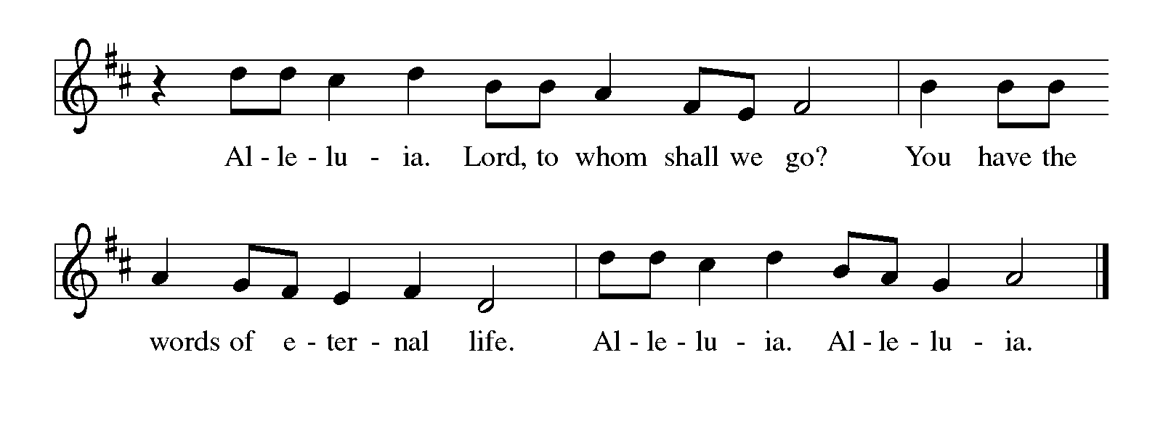
THE HOLY GOSPEL John 15: 9-17

On the night of his arrest, Jesus delivers a final testimony to his disciples to help them in the days ahead. Here, he repeats the most important of all his commands, that they love one another.

P: The Holy Gospel according to St. John, the fifteenth chapter.

C: Glory to You, O Lord!

⁹As the Father has loved Me, so I have loved you; abide in My love. ¹⁰If you keep My commandments, you will abide in My love, just as I have kept My Father's commandments and abide in His love. ¹¹I have said these things to you so that My joy may be in you, and that your joy may be complete.
¹²This is My commandment, that you love one another as I have loved you. ¹³No one has greater love than this, to lay down one's life for one's friends. ¹⁴You are My friends if you do what I command you. ¹⁵I do not call you servants any longer, because the servant does not know what the master is doing; but I have called you friends, because I have made known to you everything that I have heard from My Father.
¹⁶You did not choose Me but I chose you. And I appointed you to go and bear fruit, fruit that will last, so that the Father will give you whatever you ask Him in My name. ¹⁷I am giving you these commands so that you may love one another.

P: The Gospel of the Lord.

C: Praise to You, O Christ!

The assembly is seated

THE SERMON

Silence for reflection follows the sermon

As you are able please rise

THE HYMN OF THE DAY 358 Great God, Your Love Has Called Us

THE NICENE CREED
`
A: God has made us His people through our Baptism into Christ. Living together in trust
and hope, we confess our faith.

C: We believe in one God,
the Father, the Almighty,
maker of heaven and earth,
of all that is, seen and unseen.

We believe in one Lord, Jesus Christ,
the only Son of God,
eternally begotten of the Father,
God from God, Light from Light,
true God from true God,
begotten, not made,
of one Being with the Father.
Through Him all things were made.
For us and for our salvation
He came down from heaven;
by the power of the Holy Spirit
He became incarnate from the virgin Mary, and was made man.
For our sake He was crucified under Pontius Pilate;
He suffered death and was buried.
On the third day He rose again
in accordance with the Scriptures;
He ascended into heaven
and is seated at the right hand of the Father.
He will come again in glory to judge the living and the dead,
and His kingdom will have no end.

We believe in the Holy Spirit, the Lord, the giver of life,
Who proceeds from the Father and the Son.
With the Father and the Son He is worshiped and glorified.
He has spoken through the prophets.
We believe in one holy catholic and apostolic Church.
We acknowledge one Baptism for the forgiveness of sins.
We look for the resurrection of the dead,
and the life of the world to come. Amen

THE PRAYER OF THE CHURCH

A: The Father will give whatever we ask in Jesus’ name that will bear the fruits of His
love in the world. Renewed by Easter faith, let us pray for the Church, the world, and
all who await the fullness of Christ’s Easter life.

A: That through the Church’s faithful witness to Christ in word and deed the Holy Spirit
might fall upon those yet to believe, let us pray to the Lord:

C: Lord, have mercy.

A: That God’s victory over the powers of sin and death in Christ might continue to invade
the turmoil, hatred, and violence of our world with reconciliation, justice, and peace,
let us pray to the Lord:

C: Lord, have mercy.

A: That we who have been born of God and know the God Who is love may fulfill Jesus’
command to love one another and be filled with His own joy in that work in this week,
let us pray to the Lord:

C: Lord, have mercy.

A: That those who are burdened with hunger, loneliness, unemployment, poverty,
depression, and illness, especially . . . might be healed by God’s mercy and faithfulness,
let us pray to the Lord:

C: Lord, have mercy.

A: That those celebrating anniversaries, especially Chris and Cynthia Scheuchner might
be filled with grace this day and every day and grow in grace in the days ahead, let us
pray to the Lord:

C: Lord, have mercy.

A: That with all the saints who kept Christ’s commandment of love, especially Monica,
mother of Augustine, whom we commemorate this Day we too might one day know
the joy of forever abiding in Christ, let us pray to the Lord:

C: Lord, have mercy.

P: O God, we thank You for the power of divine love and for the presence of Your love in
one another. Grant that these petitions will reveal Your love, and guide us all finally
into that greatest love, Who is Christ our Lord, in Whose name we pray.

C: Amen.

MEAL
THE PEACE

P: The peace of the risen Lord be with you always.

C: And also with you.

The assembly is seated

THE OFFERING

THE VOLUNTARY Amazing Love St. Paul Praise Band
(Gary Ault)

As you are able please rise

THE PRESENTATION OF THE GIFTS
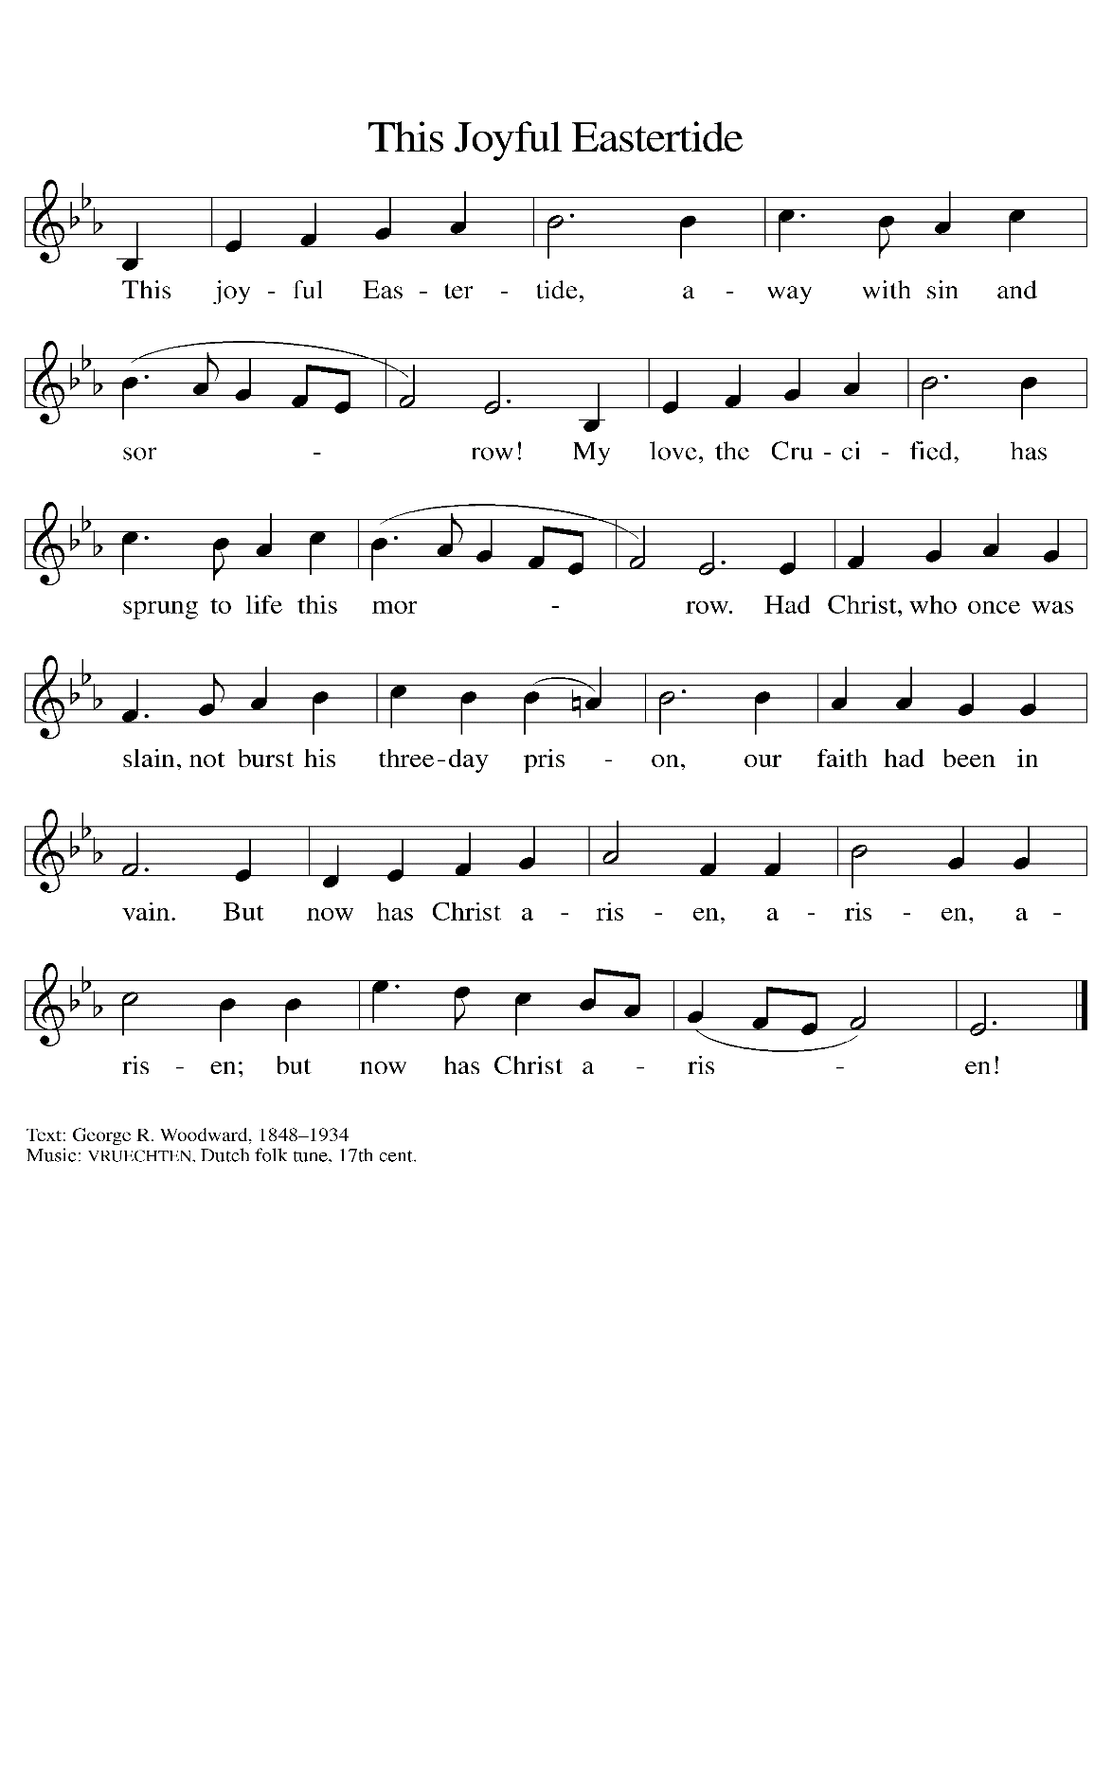

THE OFFERTORY PRAYER

A: Let us pray. God of glory,

C: You show us Your love by giving us Your Son, Jesus Christ, Who came by water
and blood to make us Your children. We show our love for You through the
offering of these gifts and our lives. Receive them for the sake of Your Son, and
by this holy Sacrament, strengthen us to love one another as You have so freely
loved us. We ask this in the name of Jesus the risen Lord. Amen.

THE GREAT THANKSGIVING

P: The Lord be with you.

C: And also with you.

P: Lift up your hearts.

C: We lift them up to the Lord.

P: Let us give thanks to the Lord our God.

C: It is right to give Him thanks and praise.

P: Wondrous and merciful God, we thank and praise You because we did not choose
You but You chose us.
You destined us to become Your friends from before the foundation of the world.
You showed steadfast love and faithfulness to Your covenant people and remembered
Your promises in every generation.
Greater love has no one than You, because in Christ You laid down Your life and
turned us from servants into friends;
And by Your Spirit You raise us up to be Your beloved companions forever.
God of joys and surprises, Your Son’s apostles were astounded that You sent Your
Spirit upon the Gentiles and that all the earth was awakening to the praise
of Your name.
You invite us to join Your company through Baptism and sustain us in Your fellowship
through this Meal of memory and hope.
Send Your Spirit upon Your Church that it may bear the image of Your crucified
and resurrected Son.
By the power of that same Spirit bless this bread and cup that they may be for us
the Body and Blood of Your Son Jesus Christ,
Who … “Do this for the remembrance of Me.”
As often as we eat ... we proclaim the Lord’s death until He comes.

C: Christ has died. Christ is risen. Christ will come again.

P: Overwhelming God, You give Your children faith that celebrates Your sovereignty.
Renew that faith among any who see Your Son’s continuing crucifixion more
evidently than His glorious resurrection.
Restore and inspire all who, in the face of evil and suffering, feel less like
conquerors and more like the conquered.
Walk with those who find Your commandments a burden rather than a gift.
Hasten the Day when all shall be drawn into the Banquet of Your Kingdom, and
You fill heaven and earth with the triumphs of Your grace,
Ever one God: Father, Son, and Holy Spirit, now and forever.

C: Amen!

THE LORD’S PRAYER

P: Alleluia! The risen Christ intercedes on our behalf before the throne of God. Let us
therefore join Him in His prayers in the words He taught us:

C: Our Father, Who art in heaven, hallowed be Thy Name.
Thy Kingdom come, Thy will be done on earth as it is in heaven.
Give us this day our daily bread, and forgive us our trespasses as we
forgive those who trespass against us.
And lead us not into temptation, but deliver us from evil.
For Thine is the Kingdom and the power and the glory forever and ever. Amen.

INVITATION TO THE MEAL

P: Alleluia! Christ our paschal Lamb has been sacrificed. Therefore, let us keep the Feast.
Blessed are those who are called to the Supper of the Lamb. God’s holy gifts for God’s
holy people. Come, for all is now ready.

THE DISTRIBUTION
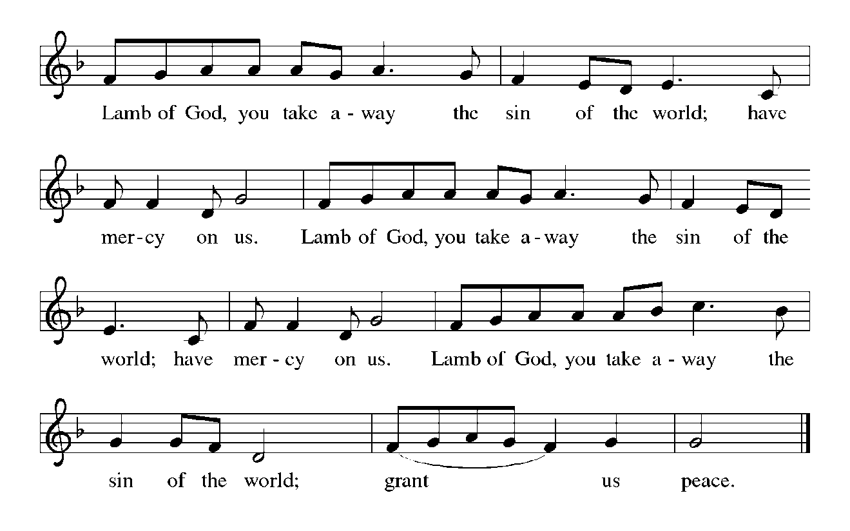
HYMNS DURING DISTRIBUTION 708 Jesu, Jesu, Fill Us With Your Love
595 Jesus Loves Me!

As you are able please rise

THE POST-COMMUNION BLESSING

P: The Body and Blood of our Lord Jesus Christ strengthen you and keep you in His grace.

C: Amen.

THE POST-COMMUNION PRAYER

A: Let us pray. O God of love, You bind us to Yourself in this Sacrament, and strengthen
us through this Meal for service to the world. Guide us by Your Spirit that we may
forever witness to the name of Jesus Christ, Lord of life.

C: Amen.

SENDING

THE BENEDICTION

P: God the Father, Who raised our Lord Jesus from death, lift you up and restore you to
wholeness.

C: Amen.

P: God the Son, Jesus Christ, the Word of Life, bless you and send you to be His witnesses.

C: Amen.

P: God the Holy Spirit, Who renews the earth, refresh you in the gift of Baptism this day
and always.

C: Amen.

P: Almighty God: Father, Son, and Holy Spirit bless you now and forever.

C: Amen.

THE SENDING HYMN 742 What a Friend We Have in Jesus

THE DISMISSAL

A: Alleluia! Go and tell the News that Christ is risen!

C: Christ is risen indeed! Alleluia!

POSTLUDE NSB 68 O, the Deep, Deep Love of Jesus Jary Tannehill

To God Alone Be Glory

The Meditation is from Sundays and Seasons Online. Copyright 2015 Augsburg Fortress.

The Greeting, Offertory Prayer, Post-Communion Prayer, and Dismissal are adapted from
Sundays and Seasons. Copyright Augsburg Fortress, 1999.

The Prayer of the Church is adapted from Intercessions for the Christian People. Gail
Ramshaw, ed. (New York: Pueblo Publishing Company, 1988) 103.
ANNOUNCEMENTS

Please remember to mail your offering to the Church Office at 818 Franklin Street, Michigan City, IN 46360. Another alternative is to give on-line through Tithe.ly. Please see your closure letter for information on how to set up a Tithe.ly account.

St. Paul Members are reminded to have a loved one contact the office if you are hospitalized. Many times, the Pastor doesn’t know someone is in the hospital. If you call and leave a message, please tell us which hospital the patient is at.

Anniversaries: Christian & Cynthia Scheuchner (5/6)

PRAYER CONCERNS: Jim Tomsheck, Marsha Kenney, Grace Romine, Debbie Martin, Sue Koziel, Jana Thomas, Margie Torres, Jayla Jacobi, Ronwynn Jones, Chris Jones, Mark Tannehill, Joan Seifert, Virginia Murray, Brian Wiseman, Jary Tannehill, Sue Granacki, Kathy Stein, Karen Peters and Pastor Charlie Streitelmeier.

OFFICE HOURS: Libby will be in the office on Mondays, Wednesdays,
and Fridays; volunteers will cover Tuesdays and Thursdays.

Monday & Wednesday 8:00 a.m. – 5 p.m.
Tuesday & Thursday 9:00 a.m. – 12:00 p.m.
Friday 8:00 a.m. – 12:00 p.m.

If you are listening to the worship broadcast on the radio and would like to watch the Sunday morning service live stream follow these steps:

(1) If you have You Tube available on your TV, search for
St. Paul Lutheran Church Michigan City, IN.

(2) The direct link on the computer is
https://www.youtube.com/channel/UC5AIPNaKr3QN50984jGOa1g.

(3) This link is also on the main page of the church’s website in
the church section and will continue to be posted weekly on the St.
Paul Facebook page.

And it will always be available on the radio broadcast Sunday mornings at 11:00 a.m.
on WEFM (95.9), and on the local cable access station #99 for the previous week’s
service on Sundays at 4:00 p.m. and the current service on Wednesdays at 7:00 p.m.
and Fridays at 8:30 p.m.

There will be no broadcast or streaming of the Sunday, May 12 service. Both Mike Bockover and Paul Brooks will be out of town that weekend. This also means that the service will not be available on the local cable access channel or on the normal radio broadcast on WEFM. Broadcasting and taping will resume on Sunday the 19th.

The approved and signed minutes of the February 22 and March 21, 2024 Church Council Meetings are on the table at the back of the church in the Narthex. Please take a copy with you as you go.

To send e-mail to the church office, please use the following addresses:

Pastor Mark Reshan: seniorpastor@stpaulmichigancity.com

Church Office Secretary (Libby Pollock): churchsecretary@stpaulmichigancity.com

Church Treasurer (Karen Fleming): finance@stpaulmichigancity.com

The Good News Newsletter: If you have an article or anything you want included in The Good News please send it to the following e-mail address: splcgoodnews@gmail.com. Pastor Pamela Thiede will be using this e-mail address to assemble The Good News each month. The deadline for getting information to Pastor Pamela will be the 20th of each month.

Worship Attendance:
Saturday, April 27, 2024 @ 4:00 p.m. 40
Sunday, April 28, 2024 @ 9:00 a.m. 60
TOTAL 100

IT’S TIME FOR A NEW DIRECTORY

As I get closer to the end of my first draft I find that some of the numbers I’ve called to check in with folks have been disconnected. If you know of anyone in the directory that has a new phone number or address please let me know by sending me an email or call the church office in the next couple weeks and let me know. I look forward to hearing from you as soon as you’re able.

Libby Pollock
Church Secretary

Our annual spring congregational meeting will take place on Sunday, May 19 at 10:00 in the St. Paul Room. There will be two main agenda items: the proposed budget for the 2024-2025 fiscal year; and a report on the sale of the school building.

POTLUCK DINNER

Following the congregational meeting on May 19, we will hold a traditional potluck meal. The Council will not be providing the main course this time, so whatever entrees, salads, sides, and desserts we have will come from those who attend. No need to sign up for anything; simply bring a favorite dish to share and enjoy good food and better fellowship following the meeting.

The Mission of the Month for May
May’s mission of the month is Dolly Parton’s Imagination Library of
LaPorte County. Dolly Parton’s Imagination Library is dedicated to inspiring a love of reading by gifting books each month to children from birth to age five, free of charge, through funding shared by Dolly and local community partners in the United States, Canada, United Kingdom, Australia and Republic of Ireland. Any child within LaPorte County who is under the age of 5 can sign up. Some of the books Leah has received are “The Little Engine That Could,” “Llama Llama Red Pajama,” “The Very Hungry Caterpillar’s First Summer,” and her favorite, “Goodnight Gorilla.” Please consider helping to foster a love of reading in young kids in our community by donating to the Imagination Library. Checks can be made out to the church and marked for the Imagination Library and placed in the offering plate. Thank you so much!

ACTIVITIES, EVENTS & MEETINGS
MAY 2024

Sunday, April 28, 2024 @ 9:00 a.m. 5 Easter Worship Service

Wednesday, May 1, 2024 @ 9:15 a.m. Bible Study/Luther House

@ 10:00 a.m. God’s Purls/St. Paul Room

Thursday, May 2, 2024 Faith Circle

Saturday, May 4, 2024 @ 4:00 p.m. 6 Easter Worship Service

Sunday, May 5, 2024 @ 9:00 a.m. 6 Easter Worship Service

Monday, May 6, 2024 @ Noon Choir Rehearsal

Tuesday, May 7, 2024 @ 10:00 a.m. Altar Guild/Green Room

Wednesday, May 8, 2024 @ 10:00 a.m. God’s Purls/St. Paul Room
Saturday, May 11, 2024 @ 4:00 p.m. Ascension Worship Service

Sunday, May 12, 2024 @ 9:00 a.m. Ascension Worship Service

Monday, May 13, 2024 @ Noon Choir Rehearsal
@ 1:00 p.m. Hope Circle/Green Room
@ 1:00 p.m. Worship & Music Committee Mtg./Luther House

Tuesday, May 14, 2024 @ 7:00 p.m. Estuary/Luther House
Wednesday, May 15, 2024 @ 9:15 a.m. Bible Study/Luther House
@10:00 a.m. God’s Purls/St. Paul Room
Saturday, May 18, 2024 @ 4:00 p.m. Vigil and Day of Pentecost Worship Service

Sunday, May 19, 2024 @ 9:00 a.m. Vigil and Day of Pentecost Worship Service
@ 10:00 a.m. Congregational Spring Meeting & Potluck in
St. Paul Room
Monday, May 20, 2024 @ 2:00 p.m. Finance Committee Mtg./Luther House
@3:00 p.m. Executive Board Mtg/Luther House

Wednesday, May 22, 2024 @ 9:15 a.m. Bible Study/Luther House
@10:00 a.m. God’s Purls/St. Paul Room
@5:30 p.m. Church Council Mtg./St. Paul Room

Thursday, May 23, 2024 @ 4:00-10:00 p.m. GIVE-BACK at Galveston Steakhouse

Saturday, May 25, 2024 @ 4:00 p.m. Holy Trinity Worship Service

Sunday, May 26, 2024 @ 9:00 a.m. Holy Trinity Worship Service

Monday, May 27, 2024 OFFICE IS CLOSED FOR MEMORIAL DAY

Wednesday, May 29, 2024 @10:00 a.m. God’s Purls/St. Paul Room

Thank$ for $haring

Thank you to all who participated in the Give-Back at Leed’s Public House on April 10, 2024. The church received $200.00 as a result of the event. This month, we will see you again at Galveston on Thursday, May 23! Here are two coupons: one for you and one for a friend.

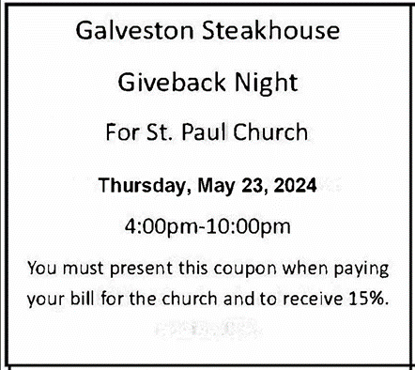

Coming Soon:

We invite you to join us for a lakeshore cruise on the Emita II on Tuesday, June 4. The cost is $35 per person with $10 of that going to the church (no coupon required). Children up to age three are free. The link for making a reservation is:

https://tinyurl.com/mtk3ach6
Please use this link for any communication instead of the longer one previously provided. They have to book via the site (they’re not able to book over the phone). If you have any issues with using a credit card online, you are invited to pay Paul Brooks in person and he will take care of it for you. (please include a few extra dollars for fees)
For now, the day is blocked out on their main page, so the above link is the only way to book a reservation for this particular cruise. The cruise will be made public two to three weeks prior to the cruise date, so the earlier you make your reservation, the better.

2024 Financial Stewardship

Weekly Church Operating Needs (x 2 weeks): $ 14,450.00

April 20-21; April 27-28, 2024
General Fund (including General Memorials): $ 10,567.00

Overage/Shortage: —- $ 3,883.00

Restricted Income (not including Memorials)
Supports IK Synod & Church wide Ministries: $ 265.00

Ministries in our Community/Congregation: $ 90.00

Capital Fund: $ 355.00

Memorials
General Fund $ 10.00

