THE RESURRECTION OF OUR LORD
March 31, 2024

Perhaps most curious in Mark's account is the "young man" at the tomb, dressed in a white robe, speaking to the women. The "young man" was part of the story of Jesus' arrest in Gethsemane, dressed then only in a sindon, Mark says, a strip of linen cloth used for wrapping corpses in preparation for burial. When someone tried to seize him, he fled away naked, leaving the garment behind. Now he appears at the tomb, dressed, a witness to Jesus' resurrection.
Mark's earliest readers could scarcely have missed noticing how much he was like them, for most of them had been dressed in burial attire on a night before the day of Easter, and had appeared next morning dressed in a white garment, bearing witness to the resurrection of Jesus. In between they had been stripped of the old garment, baptized, crucified with Christ, born again, and raised to a new life.
What got buried forever on that morning was themselves, their old selves. They were on their way to where they would be the body of Christ in the world. Their beloved Jesus would clothe himself in them, and say to those who came to dispose of the corpses, "She is not here, she is risen."

Frederick A. Niedner, Jr.

In Mark, the resurrected Jesus is not described as being “with you”; instead he is “going ahead of you.” If that is true, then death is stripped of its power. There is nothing Jesus’ followers will endure, no place they can go, that Jesus isn’t already there…
…Thus, from the beginning, the proper place for a disciple of Jesus is behind (or after) him, recalling that Jesus is ahead of them—even when they are unable to see him. If Jesus “goes ahead of us in death, can there be any doubt that he will be there ahead of us wherever life might take us? Jesus is absent, but he has not abandoned his followers—he is “ahead of them” and ahead of us.
Among those with shattered lives who long to be made whole, the followers of Jesus will see him, just as they did in Galilee. They (and we) might at any second run into him as the reign of God comes into its fullness.

Audrey West
In the Name of Jesus

GATHERING
INTRODUCTION

Our liturgy begins with the liturgy of light and the blessing of the Paschal Candle, which symbolizes Christ’s breaking of the darkness of sin and death to bring us all the Easter victory. The Paschal Candle will shine as our symbol of the resurrection throughout the Easter season, at all baptisms and at all funerals. After the blessing, the day is proclaimed with the ancient Easter shout, joyous songs and, festive musical offerings and the word of God that proclaims the victory of Christ for us all as He meets us in bread and wine.

John Donne, poet, died 1631

After finishing his education at Oxford University, Donne seemed headed for a career in the English public service. But a series of circumstances led him into the ordained ministry. He is well known as a writer of both secular and sacred poetry.

PRE-SERVICE MUSIC

Handbell Choir Christ Has Risen, Alleluia

I Know That My Redeemer Liveth G.F. Handel
(Dolores Van Ulzen, Soprano; Dan McNabb, Organ)

THE EASTER ACCLAMATION

P: Christ is risen! Alleluia!

C: (Shouted) He is risen indeed! Alleluia!

ANNOUNCEMENTS

LITURGY OF LIGHT

As you are able please rise and face the rear of the church.

P: The Lord be with you.

C: And also with you.

P. Let us pray. O God, You are like a refiner's fire, and Your Spirit kindles the hearts of
Your faithful people. Bless this flame and those who keep this Easter celebration so
that, burning with desire for life with You, they may be found fit to take part in that
festival of Light which has no ending, through Jesus Christ our Lord.

C: Amen.

The inscription on the Paschal Candle is traced by the Presiding Minister, while saying:

P: Jesus Christ, yesterday and today, the beginning and the ending, Alpha and Omega; all
time belongs to Him, and all ages; to Him be glory and dominion forever and ever.

C: Amen!

P: May the light of Christ Who rises this day in glory scatter the darkness of our hearts
and minds.

Let us pray. Almighty God, pour out Your abundant blessing on this lighted candle, so
that all who share in Your holy mysteries may be filled with Your grace and spiritual
blessings. Once we were in darkness, but since we have become the Lord's people, we
are in the light. Help us to live as people who belong to the light, through Jesus Christ
our Lord.

C: Amen.
THE PROCESSIONAL HYMN 365 Jesus Christ Is Risen Today!

The congregation faces the cross as it enters

EASTER DIALOG

A: Alleluia! Christ is risen!

C: He is risen indeed! Alleluia!

A: Worthy is Christ, the Lamb who was slain! Alleluia!

C: He gives us new life and hope through his resurrection! Alleluia!

A: Rejoice then, even in your distress.

C: We shall be counted worthy when Christ appears.

A: God has claimed us as His own.

C: God has called us from our darkness into the light of His day.

A: Alleluia! Christ is risen!

C: He is risen indeed! Alleluia!

THE HYMN OF PRAISE (see p. 4 – 5)

THE GREETING AND PRAYER OF THE DAY

P: Alleluia! Christ is risen!

C: Christ is risen indeed! Alleluia!

P: The grace of our Lord Jesus Christ, the love of God, and the communion of the Holy
Spirit be with you all.

C: And also with you.

P: Let us pray. God of mercy, we no longer look for Jesus among the dead, for He is alive
and has become the Lord of life. Increase in our minds and hearts the risen life we share
with Christ, and help us to grow as Your people toward the fullness of eternal life with
You, through Jesus Christ, our Savior and Lord, Who lives and reigns with You and
the Holy Spirit, one God, now and forever.

C: Amen.

The assembly is seated

WORD

ANTHEM Rejoice, He is Alive J. Schafferman
(Rick Carlson, Trumpet; St. Paul Senior Choir)

FIRST READING: Acts 10: 34-43
Peter's sermon, delivered at the home of Cornelius, a Roman army officer, is a summary of the essential message of Christianity: Everyone who believes in Jesus, whose life, death, and resurrection fulfilled the words of the prophets, receives forgiveness of sins through his name.
Peter began to speak to the people: "I truly understand that God shows no partiality, ³⁵but in every nation anyone who fears Him and does what is right is acceptable to Him. ³⁶You know the message He sent to the people of Israel, preaching peace by Jesus Christ--He is Lord of all.
³⁷That message spread throughout Judea, beginning in Galilee after the baptism that John announced: ³⁸how God anointed Jesus of Nazareth with the Holy Spirit and with power; how He went about doing good and healing all who were oppressed by the devil, for God was with Him.
³⁹We are witnesses to all that He did both in Judea and in Jerusalem. They put Him to death by hanging him on a tree; ⁴⁰but God raised Him on the third day and allowed Him to appear, ⁴¹not to all the people but to us who were chosen by God as witnesses, and who ate and drank with Him after he rose from the dead.
⁴²He commanded us to preach to the people and to testify that He is the One ordained by God as judge of the living and the dead. ⁴³All the prophets testify about Him that everyone who believes in Him receives forgiveness of sins through His name."

The Word of the Lord.

Thanks be to God.

THE PSALM: Psalm 118: 1-2, 14-24 Antiphon by Aaron David Miller

Choir sings refrain first, followed immediately by the congregation
and as indicated

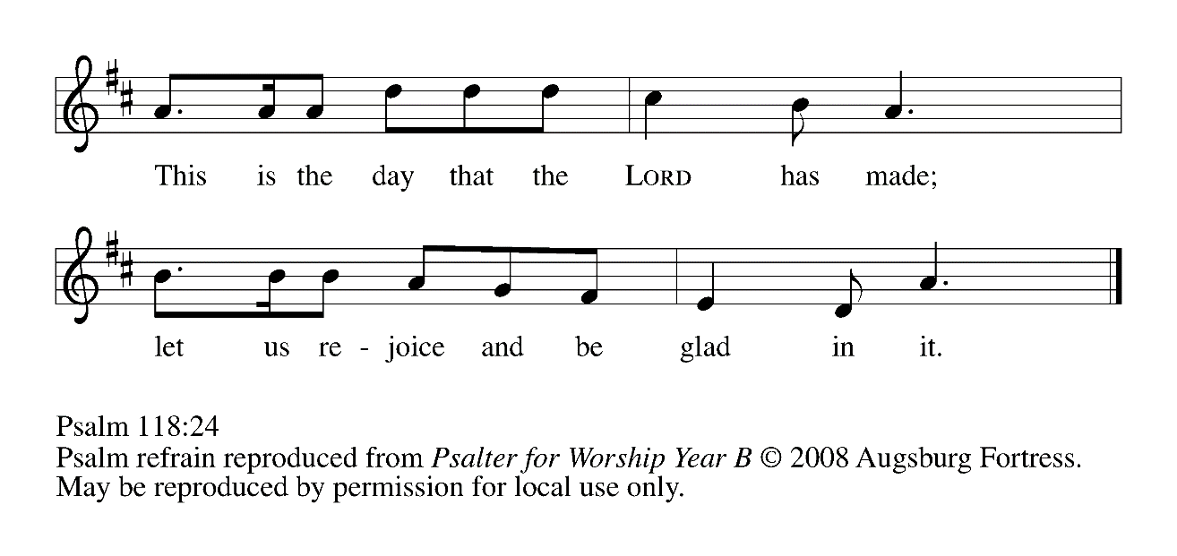
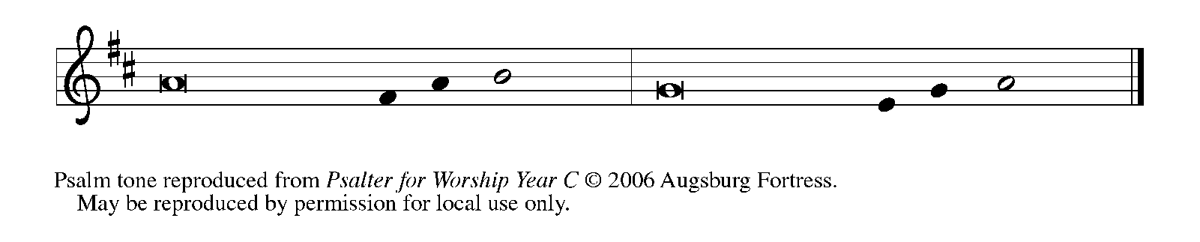

¹Give thanks to the LORD, for the | LORD is good;
God's mercy en- | dures forever.

²Let Israel | now declare,
"God's mercy en- | dures forever."

¹⁴The LORD is my strength | and my song,
and has become | my salvation.

¹⁵Shouts of rejoicing and salvation echo in the tents | of the righteous:
"The right hand of the | LORD acts valiantly!

¹⁶The right hand of the LORD | is exalted!
The right hand of the | LORD acts valiantly!"

¹⁷I shall not | die, but live,
and declare the works | of the LORD. REFRAIN

¹⁸The LORD indeed pun- | ished me sorely,
but did not hand me o- | ver to death.

¹⁹Open for me the | gates of righteousness;
I will enter them and give thanks | to the LORD.

²⁰"This is the gate | of the LORD;
here the righ- | teous may enter."

²¹I give thanks to You, for You have | answered me
and You have become | my salvation. REFRAIN

²²The stone that the build- | ers rejected
has become the chief | cornerstone.

²³By the LORD has | this been done;
it is marvelous | in our eyes.

²⁴This is the day that the | LORD has made;
let us rejoice and be | glad in it. REFRAIN

SECOND READING 1 Corinthians 15: 1-11

Paul discusses many things in his letters to the Corinthians, but in these verses he tells them what he thinks is most important of all: the good news that Jesus has been raised from the dead.

Now I would remind you, brothers and sisters, of the good news that I proclaimed to you, which you in turn received, in which also you stand, ²through which also you are being saved, if you hold firmly to the message that I proclaimed to you--unless you have come to believe in vain.
³For I handed on to you as of first importance what I in turn had received: that Christ died for our sins in accordance with the scriptures, ⁴and that He was buried, and that He was raised on the third day in accordance with the scriptures, ⁵and that He appeared to Cephas, then to the twelve.
⁶Then He appeared to more than five hundred brothers and sisters at one time, most of whom are still alive, though some have died. ⁷Then He appeared to James, then to all the apostles. ⁸Last of all, as to one untimely born, He appeared also to me.
⁹For I am the least of the apostles, unfit to be called an apostle, because I persecuted the church of God. ¹⁰But by the grace of God I am what I am, and His grace toward me has not been in vain. On the contrary, I worked harder than any of them--though it was not I, but the grace of God that is with me. ¹¹Whether then it was I or they, so we proclaim and so you have come to believe.

The Word of the Lord.

Thanks be to God.

As you are able please rise

THE GOSPEL VERSE
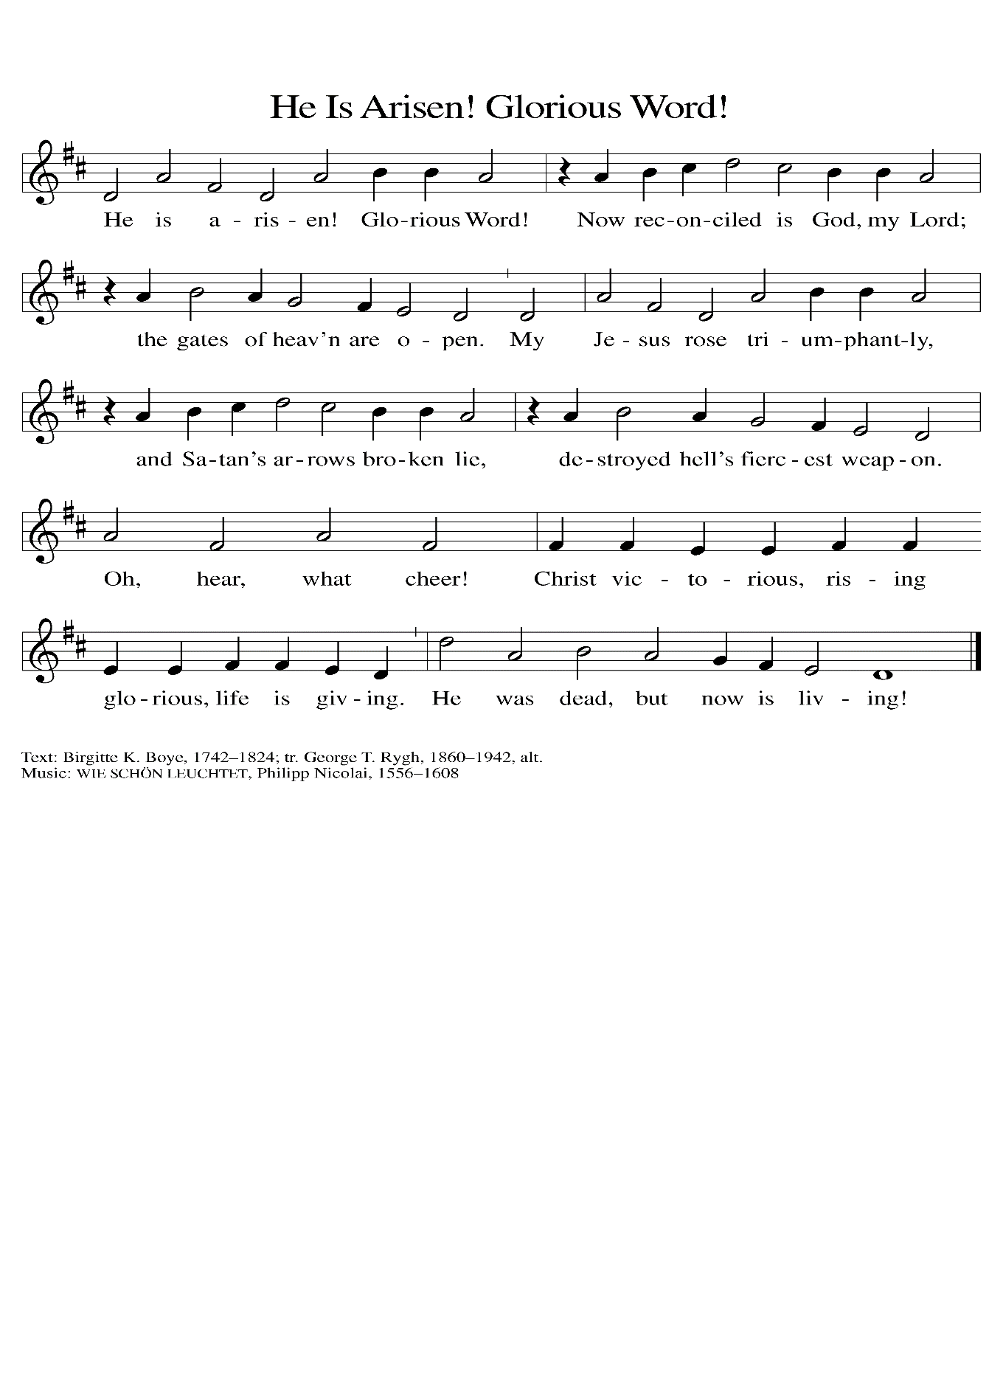
THE HOLY GOSPEL Mark 16: 1-8

Mark’s account of Jesus’ resurrection ends abruptly with the women leaving the tomb in terror and silence. The story is left open-ended so that we might give the witness to the Resurrection the women did not.

P: The Holy Gospel according to St. Mark, the sixteenth chapter.

C: Glory to You, O Lord!

When the Sabbath was over, Mary Magdalene, and Mary the mother of James, and Salome bought spices, so that they might go and anoint Him. ²And very early on the first day of the week, when the sun had risen, they went to the tomb.
³They had been saying to one another, "Who will roll away the stone for us from the entrance to the tomb?" ⁴When they looked up, they saw that the stone, which was very large, had already been rolled back. ⁵As they entered the tomb, they saw a young man, dressed in a white robe, sitting on the right side; and they were alarmed.
⁶But he said to them, "Do not be alarmed; you are looking for Jesus of Nazareth, Who was crucified. He has been raised; He is not here. Look, there is the place they laid Him.
⁷But go, tell His disciples and Peter that He is going ahead of you to Galilee; there you will see Him, just as He told you."
⁸So they went out and fled from the tomb, for terror and amazement had seized them; and they said nothing to anyone, because they were afraid.

P: The Gospel of the Lord.

C: Praise to You, O Christ!

The assembly is seated

THE SERMON

Silence for meditation follows the sermon

As you are able please rise

THE HYMN OF THE DAY 367 Now All the Vault of Heaven Resounds
Stanza 2—Women; Stanza 3—Men

THE NICENE CREED

A: God has made us His people through our Baptism into Christ. Living together in trust
and hope, we confess our faith.

C: We believe in one God,
the Father, the Almighty,
maker of heaven and earth,
of all that is, seen and unseen.

We believe in one Lord, Jesus Christ,
The only Son of God,
eternally begotten of the Father,
God from God, Light from Light,
true God from true God,
begotten, not made,
of one Being with the Father.
Through Him all things were made.
For us and for our salvation
He came down from heaven;
by the power of the Holy Spirit
He became incarnate from the virgin Mary, and was made man.
For our sake He was crucified under Pontius Pilate;
He suffered death and was buried.
On the third day He rose again
in accordance with the Scriptures;
He ascended into heaven
and is seated at the right hand of the Father.
He will come again in glory to judge the living and the dead,
and His kingdom will have no end.

We believe in the Holy Spirit, the Lord, the giver of life,
Who proceeds from the Father and the Son.
With the Father and the Son He is worshiped and glorified.
He has spoken through the prophets.
We believe in one holy catholic and apostolic Church.
We acknowledge one Baptism for the forgiveness of sins.
We look for the resurrection of the dead,
and the life of the world to come. Amen.

THE PRAYER OF THE CHURCH

A: Alleluia! What was dead shall live; what was dark shall shine; what was forgotten shall
be remembered; for the Lord is risen and walks among us. Renewed with Easter faith,
let us pray that God would bring to birth justice and healing for all who await fullness
of life.

A: On this Day, O God, give to Your Church boldness to proclaim the Good News of the
resurrection we have received, for Christ is risen:

C: Christ is risen indeed!

A: On this Day, O God, give to Your world the new life for which it longs. Give peace
and stability in Gaza, Ukraine and all places of conflict. Foster reconciliation between
enemies. Bring an end to ancient hatreds, violent bloodshed, and the persecution of the
Church. All this is possible, for Christ is risen:

C: Christ is risen indeed!

A: On this Day, O God, give to this assembly of the baptized the courage to share in Jesus’
work of bringing healing, forgiveness, and hope to all the “Galilees” of our world, for
Christ is risen:

C: Christ is risen indeed!

A: On this Day, O God, give to all who journey from despair to trust, from grief to
consolation, and from illness to health, especially . . . the joy of healing and new life,
for Christ is risen:

C: Christ is risen indeed!

A: On this Day, O God, bless those celebrating birthdays, especially Jana Thomas,
Marge Bockover and Sarah McNabb that they may grow in grace this day and every
day and be filled with grace for the days ahead, for Christ is risen:

C: Christ is risen indeed!

A: On this Day, O God, grant us, with all the saints, especially John Donne, poet, whom
we commemorate this Day the perseverance to remain faithful to Christ until our joyful
resurrection into His everlasting life, for Christ is risen:

C: Christ is risen indeed!

P: God of life, we thank You for the mystery planted in us, the paradox of life from death
and community from scattered disciples. We praise You for the dying which saves us
from death and for the rising which brings us life. We pray, as we live, through Jesus
the Risen One, in the power of the Holy Spirit, now and forever.

C: Amen.
MEAL

THE PEACE

P: The peace of the risen Lord be with you always.

C: And also with you.

The assembly is seated

THE OFFERING

THE VOLUNTARY

As you are able please rise

THE OFFERTORY HYMN This Joyful Eastertide (p. 14)

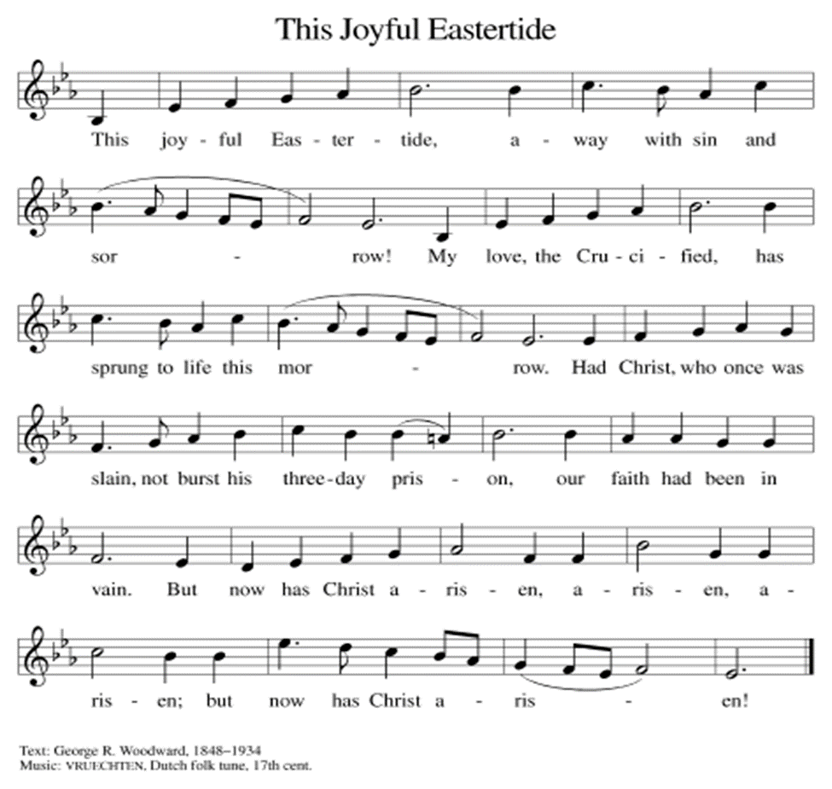

THE OFFERTORY PRAYER

A: Let us pray. God of life,

C: You spread a Table before us. We offer You these gifts, signs of Your gracious
love, and tokens of our grateful hearts. As we eat and drink with the Risen Christ,
nourish and strengthen us through this Sacrament to proclaim to all the world
Your triumphant love in Jesus Christ our Lord. Amen.

THE GREAT THANKSGIVING

P: The Lord be with you.

C: And also with you.

P: Lift up your hearts.

C: We lift them up to the Lord.

P: Let us give thanks to the Lord our God.

C: It is right to give Him thanks and praise.

EUCHARISTIC PRAYER

P: Thanks and praise fill our hearts, Almighty God, for You are the Lord of creation
and new creation, of covenant and new covenant.
You brought Your people out of slavery to freedom in the Promised Land, and You
brought Your Son from the depth of death to the glory of resurrection life.
Joy and gladness are our song, redeeming God, for in Your conquest of death we see
the destiny of every hope in You.
Come among us in the power of Your Holy Spirit, that Your children may be blessed
with power and grace,
And that this bread and cup may become for us the Body and Blood of our Lord
Jesus Christ,
Who, in the night … “Do this for the remembrance of Me.”
As often as we eat … we proclaim the Lord’s death until He comes.

C: Christ has died. Christ is risen. Christ will come again.

P: Hope and glory are our breath, merciful God, for You have rolled away the
stone of despair, the stone of oppression, the stone of lament, the
stone of grief, the stone of death, the stone of sin, the stone of fear.
Come and stand among us and breathe on us Your peace, breathe on us Your
power, breathe on us Your eternal life,
That all who labor, all who stumble, all who hunger and all who fall shall meet
You in the breaking of the bread and be lifted up by Your touch.
Shape Your Church to be Your risen Body; make our scars beautiful like Your
scars, make our lives life-giving life Your life,
And make our communion holy with Your saints, until You come again in glory
and we eat with You in Your Kingdom,
Father, Son, and Holy Spirit, ever-one God.

C: Amen!

THE LORD’S PRAYER

P: Alleluia! The risen Christ intercedes on our behalf before the throne of God. Let us
therefore join Him in His prayers in the words He taught us:

C: Our Father, Who art in heaven, hallowed be Thy Name. Thy Kingdom come.
Thy will be done on earth as it is in heaven. Give us this day our daily bread, and
forgive us our sins as we forgive those who sin against us. And lead us not into
temptation, and deliver us from evil, for Thine is the Kingdom, and the power,
and glory, forever and ever. Amen.

INVITATION TO THE MEAL
P: Alleluia! Christ the Lord is risen! Therefore, let us joyfully keep the Easter Feast.
Blessed are those who are called to the Supper of the Lamb. God’s holy gifts for God’s
holy people. Come, for all is now ready.

The assembly is seated

THE DISTRIBUTION
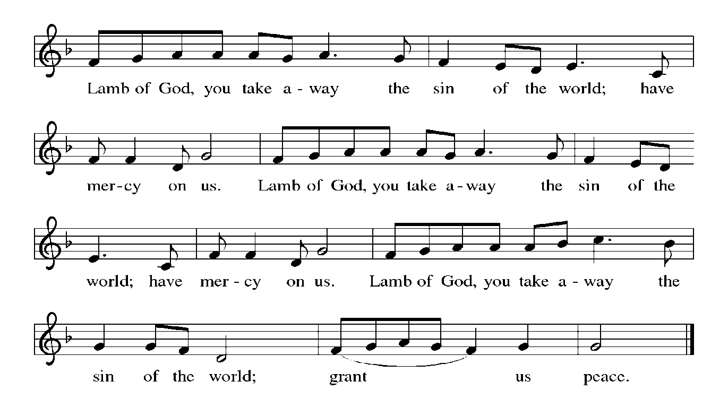
HYMNS DURING DISTRIBUTION 362 At the Lamb’s High Feast We Sing
392 Alleluia! Sing to Jesus
379 Now the Green Blade Rises
384 That Easter Day With Joy Was Bright

As you are able please rise

THE POST-COMMUNION BLESSING

P: The Body and Blood of our Lord Jesus Christ strengthen you and keep you in His grace.

C: Amen.

THE POST-COMMUNION PRAYER

A: Let us pray. O God, Giver of every good gift, You have fed us at Your Table that we
might remain in Your love and draw our life from You. By this holy Sacrament, help
us to stand firm in the Good News of the Resurrection. Send us now into those places
of fear and failure that need Your new life, that all creation might be filled with the
Easter victory and joy of the Risen Christ, in Whose name we pray.

C: Amen.
SENDING

THE SOLEMN BLESSINGS OF EASTER

P: May almighty God bless you on this solemn feast of Easter, and may He protect you
against all sin.

C: Amen.

P: Through the resurrection of His Son, God granted us healing. May He fulfill His
promises, and bless you with eternal life.

C: Amen.

P: You have mourned for Christ's sufferings; now you celebrate the joy of His resurrection.
May you come with joy to the feast which lasts forever.

C: Amen.

P: Almighty God: Father, Son, and Holy Spirit bless you now and forever.

C: Amen.

THE RECESSIONAL HYMN 449 We Know That Christ is Raised

The congregation faces the cross as it leaves
THE DISMISSAL

A: Alleluia! Go and tell the News that Christ is risen!

C: Christ is risen indeed! Alleluia!

To God Alone Be Glory

The Meditation is from Sundays and Seasons Online. Copyright 2015 Augsburg Fortress.

The Liturgy of Light, Easter Dialog and Solemn Blessing of Easter is used by permission of
and adapted from “The Resurrection of Our Lord and the Blessing of the Paschal Candle” by Thomas L. Weitzel.

The Greeting, Offertory Prayer, Post-Communion Prayer, and Dismissal are adapted from
Sundays and Seasons. Copyright Augsburg Fortress, 1999.

The Prayer of the Church is adapted from Prayers for Sundays and Seasons. Year B. Peter
J. Scagnelli. (Chicago: Liturgy Training Publications, 1998) 52-53.

The Eucharistic Prayer is adapted from Eucharistic Prayers. Samuel Wells and Abigail
Kocher. (Grand Rapids: Wm. Eerdmann Publishing Company, 2016) 156-157.
SPECIAL MUSIC FOR EASTER SERVICE

Christ Has Risen, Alleluia! St. Paul Handbell Choir
Judy Hunt; Judy Mutchler; Karen Fleming; Kelly Neulieb; Trish Sprague

I Know That My Redeemer Liveth (from The Messia) G. F. Handel
Dolores Van Ulzen, Soprano; Dan McNabb, Organ

Rejoice, He is Alive J. Shafferman
Rick Carlson, Trumpet; St. Paul Senior Choir
Susan Bagby; Stacie Crozier; Betty Ratliff; Mary Knaup; Judy Gustum; Sarah
McNabb; Sue Koziel; Dan McNabb; Doug Kienitz

THANK YOU

As this is being written we are moving toward the liturgies of this Holy Week and Easter morning. Although there are two less services this year than in the past there is still an enormous amount of work that goes into preparing for all those worship services. Like the services around Christmas we just assume (and expect) that the worship space will be decorated beautifully; the music will be uplifting and inspiring; and that the services will run smoothly and flawlessly.
All of that takes place because of the efforts of so many of our volunteers who selflessly give of their time, effort and energy to make our worship special. At the risk of overlooking someone here is a list of those who participated in preparations and our worship during Holy Week:

Deacons/Ushers Craig Hunt, Bob Kiser, Rich Fleming,
Tim Crozier

Assisting Ministers Donna Knoll, Sarah Payne, Trish Sprague,
Sue Koziel

Lectors for the Easter Vigil Donna Knoll, Trish Sprague, Susan Bagby,
Jeff Timmrick

Lectors for Palm Saturday/Sunday/ Trish Sprague, Sue Koziel, Sarah Payne,
Maundy Thursday/Good Friday Doug Kienitz, Donna Knoll

Altar Guild All of the members, especially Judy Hunt, Judy
Mutchler, Marge Bockover, Sandy Galinowski,
Bernadette Krueger, Karen Steinborn, Norma Milzarek, Virginia Murray, Stacie Crozier

Video Paul Brooks, Mike Bockover

THANKS continued . . .

Musicians Dr. George Karst, Mizue Fukushima,
Maggie Martin, John Carington, Dan McNabb,
The St. Paul Handbell Choir, The St. Paul
Senior Choir

Flowers and decorations Sue Koziel, Karen Steinborn, Kerry Steinborn,
Terry Wolter

Bulletins Libby Pollock

As always, we owe them a huge debt of gratitude for all their faithful and hard work. Please make sure that you thank these people when you see them for enriching our worship during the most holy time of the year.

MEMORIALS FOR EASTER PLANTS & FLOWERS

In memory of her parents, Walter & Dorothy Liebig, and her husband, John Mauman,
from Nancy Mauman and family.

In memory of her husband, Sonny (Henry) Robbins, from Sandy Robbins.

In memory of John Foldenauer from Laura (Gayle) Childers.

In memory of John Foldenauer and Christine Leslie from Carey Howard.

In memory of Paul Leffew from Gail Leffew.

In memory of Mom & Dad from Judy Mutchler.

In memory of my husband, Norman Egilske, from Diane Egilske.

In memory of loved ones from Janice White.

In memory of my husband, Lee Timm, from Sally Timm.

In memory of my husband, Joseph Koziel, and my parents, Roger & Lucille Storey, from Sue Koziel.

In memory of our father, Ronald Johnson, from his daughters, the Johnson Women.

In memory of my wife, Carol, and our son, Donald, from Fred Weiss.

In memory of my loving parents, William Manning and Joyce Manning, from Bethany Manning.

In memory of loved ones from Marge & Mike Bockover.

In memory of my husband, Roger Milzarek, from Norma Milzarek.

In memory of loved ones from Virginia Murray.

In memory of Laurence and Norma Wolgast, Violetta Raschka, David Hapke and Katie Gill, Elizabeth Hapke, Ceann Smith, and Teri Raschka from Stephen & Lauretta Hapke.

In memory of Maxine and Clinton Powell from Gayle and Rev. Ralph Kuespert.

In honor of Tim & Stacie Crozier’s 35th wedding anniversary from Stacie Crozier.

In memory of loved ones from Chip & Audrey Claussen.
In memory of my husband, George. and my parents, Pearl & Jack Latham, from Donna Ottersen

ACTIVITIES, EVENTS & MEETINGS
APRIL 2024

Wednesday, April 3, 2024 @ 10:00 a.m. God’s Purls/St. Paul Room

Thursday, April 4, 2024 Faith Circle

Saturday, April 6, 2024 @ 4:00 p.m. Worship Service

Sunday, April 7, 2024 @ 9:00 a.m. Worship Service

Monday, April 8, 2024 @ 1:00 p.m. Hope Circle/Green Room

Tuesday, April 9, 2024 @ 7:00 p.m. Estuary/Luther House

Wednesday, April 10, 2024 @ 9:15 a.m. Bible Study/Luther House

@ 10:00 a.m. God’s Purls/St. Paul Room

@ 11am – 8pm GIVE BACK at LEED’S PUBLIC HOUSE (On Southwest Corner of 4th & Franklin St.)

@ 3:00 p.m. Worship & Music Meeting/Luther House

Saturday, April 13, 2024 @ 4:00 p.m. Worship Service

Sunday, April 14, 2024 @ 9:00 a.m. Worship Service

Wednesday, April 17, 2024 @ 9:15 a.m. Bible Study/Luther House

@ 10:00 a.m. God’s Purls/St. Paul Room

Saturday, April 20, 2024 @ 4:00 p.m. Worship Service

Sunday, April 21, 2024 @ 9:00 a.m. Worship Service

Monday, April 22, 2024 @ 2 p.m. Finance Committee Meeting/Luther House

@ 3:00 p.m. Executive Board Meeting/Luther House

Wednesday, April 24, 2024 @ 9:15 a.m. Bible Study/Luther House

@ 10:00 a.m. God’s Purls/St. Paul Room

Thursday, April 25, 2024 @ 5:30 p.m. Church Council Meeting/St. Paul Room

Saturday, April 27, 2024 @ 4:00 p.m. Worship Service

Sunday, April 28, 2024 @ 9:00 a.m. Worship Service

ANNOUNCEMENTS

Please remember to mail your offering to the Church Office at 818 Franklin Street, Michigan City, IN 46360. Another alternative is to give on-line through Tithe.ly. Please see your closure letter for information on how to set up a Tithe.ly account.

St. Paul Members are reminded to have a loved one contact the office if you are hospitalized. Many times, the Pastor doesn’t know someone is in the hospital. If you call and leave a message, please tell us which hospital the patient is at.

BIRTHDAYS: Marge Bockover(4/1); Jana Thomas (4/1); Sarah McNabb (4/1)

ANNIVERSARIES: David & Nancy Zummak (4/2)

PRAYER CONCERNS: Debbie Martin, Erica McMahan, Sue Koziel, Jana Thomas, Margie Torres, Jayla Jacobi, Ronwynn Jones, Chris Jones, Mark Tannehill, Joan Seifert, Virginia Murray, Brian Wiseman, Jary Tannehill, Sue Granacki, and Kathy Stein.

OFFICE HOURS: Libby will be in the office on Mondays, Wednesdays,
and Fridays; volunteers will cover Tuesdays and Thursdays.

Monday & Wednesday 8:00 a.m. – 5 p.m.
Tuesday & Thursday 9:00 a.m. – 12:00 p.m.
Friday 8:00 a.m. – 12:00 p.m.

If you are listening to the worship broadcast on the radio and would like to watch the Sunday morning service live stream follow these steps:

(1) If you have You Tube available on your TV, search for
St. Paul Lutheran Church Michigan City, IN.

(2) The direct link on the computer is
https://www.youtube.com/channel/UC5AIPNaKr3QN50984jGOa1g.

(3) This link is also on the main page of the church’s website in
the church section and will continue to be posted weekly on the St.
Paul Facebook page.

And it will always be available on the radio broadcast Sunday mornings at 11:00 a.m.
on WEFM (95.9), and on the local cable access station #99 for the previous week’s
service on Sundays at 4:00 p.m. and the current service on Wednesdays at 7:00 p.m. and
Fridays at 8:30 p.m.

The approved and signed minutes of the January 25 and February 22, 2024 Church Council Meetings are on the table at the back of the church in the Narthex. Please take a copy with you as you go.

To send e-mail to the church office, please use the following addresses:
Pastor Mark Reshan: seniorpastor@stpaulmichigancity.com
Church Office Secretary (Libby Pollock): churchsecretary@stpaulmichigancity.com
Church Treasurer (Karen Fleming): finance@stpaulmichigancity.com

The Good News Newsletter: If you have an article or anything you want included in The Good News please send it to the following e-mail address: splcgoodnews@gmail.com. Pastor Pamela Thiede will be using this e-mail address to assemble The Good News each month. The deadline for getting information to Pastor Pamela will be the 20th of each month.

Worship Attendance: March 20, March 23 and 24, 2024:
6:00 p.m. 33
4:00 p.m. 52
9:00 a.m. 71
TOTAL 156

LOOKING FOR IDEAS

We’d like to continue to highlight a different mission each month. We are looking for suggestions! If you volunteer somewhere or have a mission that is close to your heart, please let Paul or Lora Brooks know so we can set up a month to support that cause! Paul: (219) 221-0254, paulbrooks@gmail.com; or Lora: (260) 701-1586, loralmartin15@gmail.com.

MESSAGE:

Please consider supporting the pop machine in the hallway between the kitchen and the St. Paul Room in the basement as we look to move out existing drinks and add in new ones! All pop is 75 cents and all proceeds go to the Capital Improvement Fund. We are currently working with the vendor as Mountain Dew has been stocked but the machine is saying to choose another selection. Hoping to have that issue resolved soon. Thank you for your support!

Paul Brooks
Member of Church Council

Comimg Soon:

We invite you to join us for an lakeshore cruise on the Emita II on Tuesday, June 4. The cost is $35 per person with $10 of that going to the church (no coupon required). Children up to age three are free. The link for making a reservation is:
https://app.bookingcentral.com/book/product/harborcountryadventures?location=5cb18b14-6f6a-46ba-a655-0d19a685fc47&product=21a85c71-60f2-4e91-ae49-75182f98bd2c&referer=&clearcart

For now, the day is blocked out on their main page, so the above link is the only way to book a reservation for this particular cruise. The cruise will be made public two to three weeks prior to the cruise date, so the earlier you make your reservation, the better.

Thank$ for $haring
Thanks to all who participated in the give back at Holly’s in March. The church received $188 as a result of the event.
This month,we will see you at Leed’s Public House on Wednesday, April 10! Here are two coupons: one for you and one for a friend.

