

July, 2023

**MARK: MY WORDS**

It is always a welcome change. The weeks of Pentecost are the longest of the six seasons of the church year. There is a logic and wisdom to that arrangement. Having experienced the entirety of Jesus’ earthly life and ministry: the anticipation and making ready for His coming among us in Advent; His birth during the Twelve Days of Christmas; the revelation of Him as the One in Whom God reaches out to all people in Epiphany; His movement toward and suffering of death during Lent; the celebration of His resurrection over the fifty Days of Easter; and His sending of His Spirit to empower the Church to continue His work on the Day of Pentecost. The subsequent days and weeks now chronicle the early church’s mission work even as they call us to be about that ministry in and for our time and world.

The downside to this abundance of weeks is that a sense of monotony can settle in. By the time we reach even half-way through the season we want to say, “We get it! We are to get out of our building and our own concerns and bring the presence and blessing of Jesus to others!” Preachers and hearers alike can easily feel wearied by the sheer length of this time.

So whenever there is an opportunity to break away from the relentless march of the appointed lectionary, it is refreshing to do so. July holds a number of commemorations of the faithful who have gone before us as well as a few minor festival days. One exception falls this year on Saturday, July 22. It is designated on the church calendar as the Day of Mary Magdalene, Apostle.

There are two surprises there. First, there are 29 minor festivals that can be observed throughout the year. Including this Day, only two others celebrate the life and faith of women: the “Visit of Mary to Elizabeth;” and “Mary, Mother of Our Lord.” So, if we have the opportunity to hold up a great heroine of the faith, we should be eager to do so.

Second, Mary is designated here as an “Apostle.” Normally we associate only the *male* disciples of Jesus that He chose with that title. (By the way, if the Church recognizes Mary as such that would seem to void the Roman Catholic Church’s argument that only men can be ordained since Jesus only had and called male apostles ☺).

How did Mary come to be known in that way? What does that mean for how we think not only about her ministry but ours as well? There is rich material here that we will explore on the weekend of the 22nd and 23rd that we pray will excite our imaginations and expand our understanding of what these many weeks call and prepare us to do as the Lord of the harvest sends us out again and again into His fields of those desperate to hear and know the Good News of Jesus.



**OUR NEW ORGANIST/CHOIR DIRECTOR**

Although at the time of this writing the final arrangements have not yet been made, I feel confident enough that they will be settled soon to introduce our new organist and choir director. His name is Pastor Tom Fischer, a retired Lutheran Church-Missouri Synod minister now living in Three Oaks, Michigan. Our good friend Donna Mitchell gave me his name several weeks ago.

Although Tom carried out “regular” pastoral ministry of preaching, teaching, presiding, etc., much of his time was spent in the music ministry of the congregations he served. He has been an organist/choir director and worked with hand bells and contemporary music/praise bands. He studied organ for four years at Concordia College in Ann Arbor, Michigan, where he worked under a Professor from the prestigious University of Michigan Organ Department, who played for all of Concordia’s chapel and worship services.

He has a deep love for Lutheran worship and is also comfortable with a less traditional style church music. He plays with great passion and enthusiasm. The few times I have heard him play, he has reminded me very much of the way our late organist Vernon Carey played. He enjoys and is skilled at improvising on hymns both in his accompaniments and as the basis for preludes and postludes.

We have been incredibly fortunate and blessed in our efforts to replace John Remmel as our permanent organist. First, Vernon came to us, and after his untimely death we have had Maggie Martin on piano and John Carington on organ to see us through the interim period. I know of congregations of colleagues that have gone months and sometimes years without, not just an organist, but any musician at all. God has richly provided such skilled and dedicated servants for us.

We plan to hold a simple reception for Tom after his first services on July 1 and 2 for people to meet him and welcome him to our congregation. More details will be forthcoming as those days draw near. I know that he will be received warmly, and we look forward to enjoying his many gifts in inspiring our praise and thanks to God.

**JUNE 11 SERVICE**

On Sunday, June 11, Bishop William Gafkjen of our Indiana-Kentucky Synod was with us to help us formally and officially close our school. He very helpfully reworked a rite for the Closing of a Congregation to fit our situation and preached a wonderful sermon that reflected both the sadness over its closing and the promise and hope of the “new things (God) is doing” (Isaiah 43:19) in and through us in the future.

We are deeply grateful to the school board: Bev Johnson; Melinda Nagle; Pastor Pamela Thiede; Sarah McNabb; and Janet Bakken for their work in arranging a reception in the school gym following the service to allow graduates and former staff members to take one last look through the building.

All in all, it was a day on which to remember and give thanks for the 147 years of faithful educational ministry that the school provided and to be encouraged to look toward the future with confidence and hope that God will indeed provide new opportunities for us to serve this neighborhood and community.

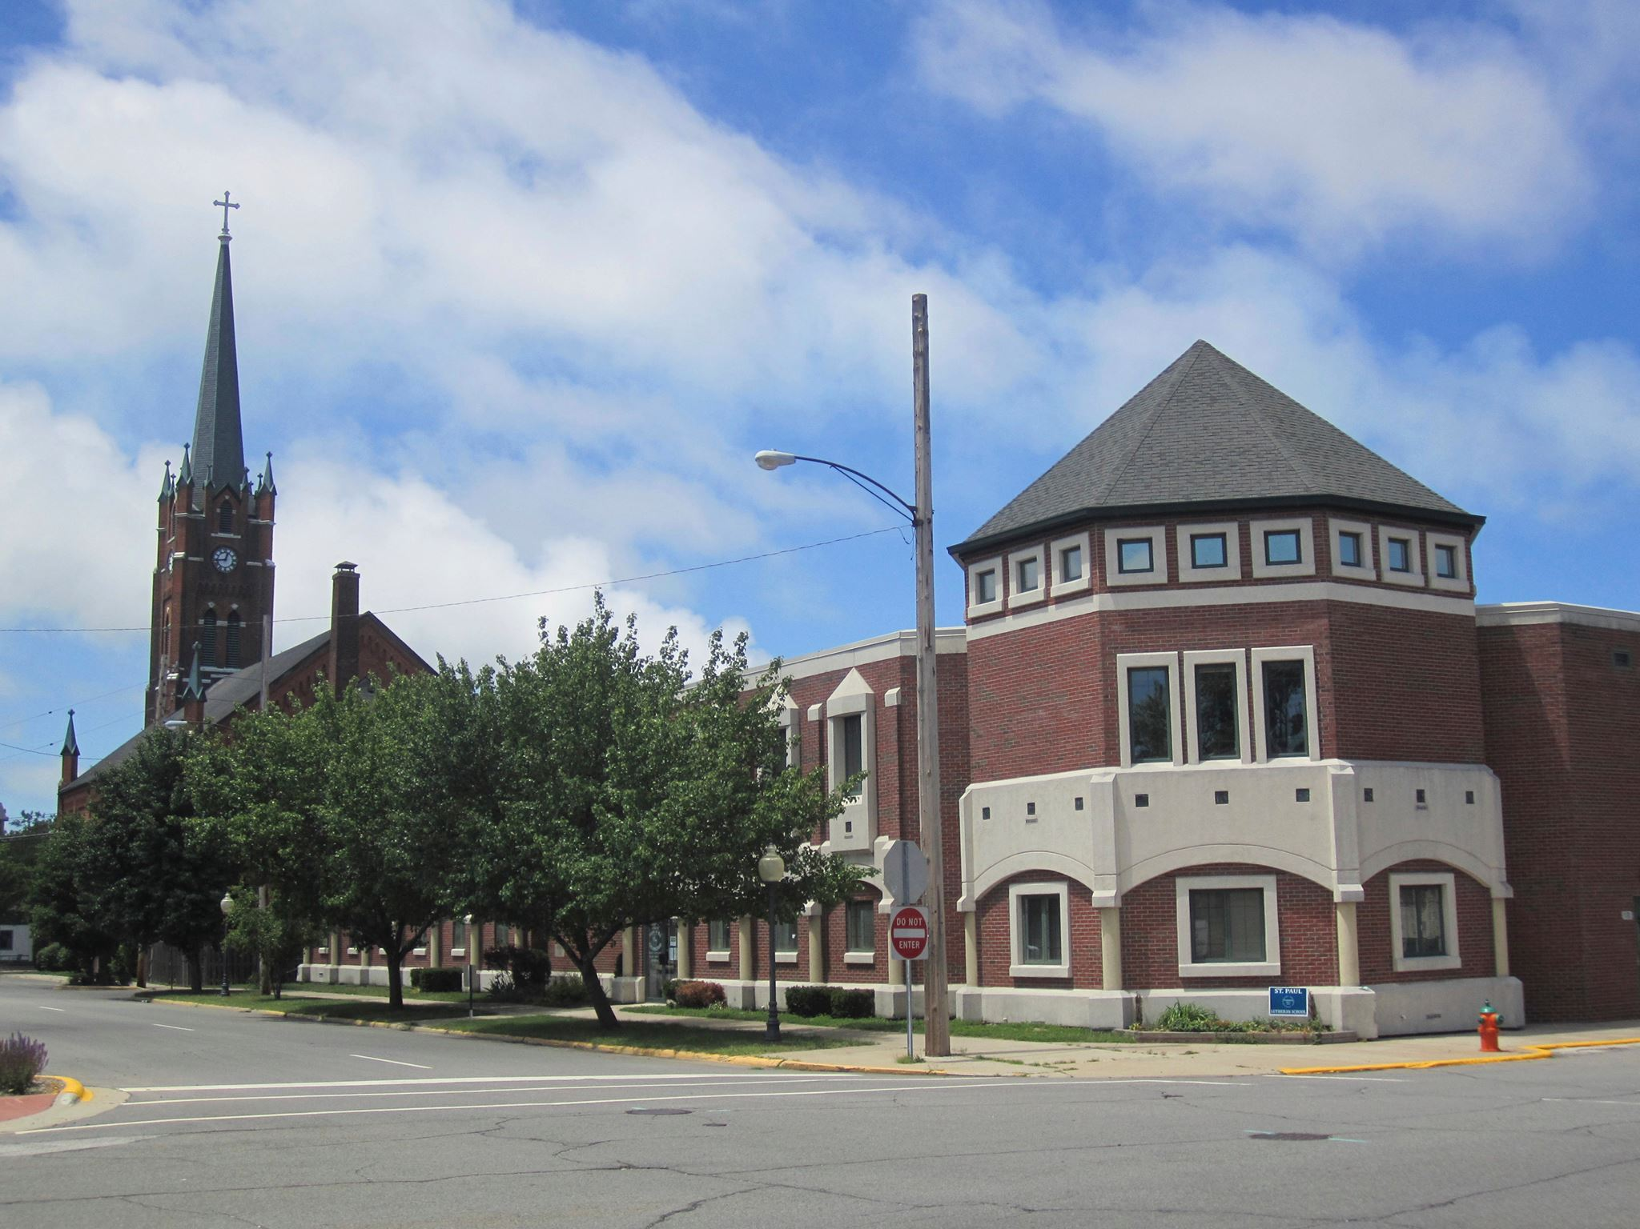

Thank you to the 2022-23 faculty and to all the teachers and staff who have taught and served

the children who have entered these classrooms for the last 147 years.



To any friends and family members who attended St. Paul Lutheran School: if you are interested in any memorabilia such as trophies, desks, etc., please send an e-mail to Judy Hunt at [cwtssc@yahoo.com](mailto:cwtssc@yahoo.com) She will put your request on a list; and when it’s found, we will contact you. There are many trophies from over the years, so it would be helpful to know th year and sport, spelling bee, etc., to help us find it for you. Sometime in the next few weeks, there will be a sale of items available, so watch the St. Paul Church website for dates.



**SYNOD ASSEMBLY**

On Saturday, June 10, our Synod Assembly was held via Zoom. Bishop Gafkjen presided over the three-and-one-half-hour meeting, and there were 237 registered voters participating. Donna Knoll, Bob Kiser, and I represented St. Paul.

Fortunately, there were far fewer technical glitches this time than the last Zoom-led Assembly several years ago. The video and sound were generally clear, and shifting between speakers went smoothly. Presiding Bishop Elizabeth Eaton of the ELCA was a special guest; and in her nearly one-hour presentation, she gave a detailed report on the workings of the larger church and plans for the future. There were several elections to Synod Council and various boards and committees.

The synod budget was presented in detail and a vote was taken to approve expenditures for the coming year. Two resolutions regarding the Recommended Compensation Guidelines for rostered ministers and ministers of Word and service were approved: an 8.7% cost-of-living increase and the extension of family leave to twelve weeks.

Next year’s gatherings will be split between three locations throughout the synod. The closest one to us will be in South Bend. There will be no assembly in 2025 because of the national ELCA Assembly that summer. And in 2026 the assembly will again be in-person in Louisville.



**WORSHIP SETTING**

In last month’s newsletter, I mentioned that we would be shifting to the beloved and familiar “Now the Feast and Celebration” musical setting of the liturgy by Marty Haugen that we have used over summer for a number of years. That was delayed because of our substitute musicians. I did not want to further stress them by asking them to learn a setting with which they were unfamiliar.

Our new musician, Pastor Fischer, knows that setting well, so by mid-July we will move more fully into it and use it the rest of the summer and into the fall. Thanks for your patience and understanding.

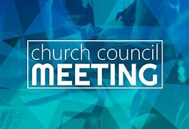

**MAY, 2023, SUMMARY OF ACTIONS**

* The Bishop will preach at the Closing of the School Service on June 11.
* Planning is underway for the 150-year celebration.  A theme has been chosen:  ”Serving You Who We Proclaim”.
* A candidate is being interviewed for the organist/choir director.
* The Property Evaluation Team reported that an offer from a commercial developer was received for the school building.
* Arise and Shine will start using the parking lot for their mobile food pantry after school is out.
* Outdoor Family Game night will begin on June 2 (First Friday).

Please note that copies of Council meetings are placed in the Narthex after approval at the monthly meetings.

 **July Birthdays July Anniversaries**

2 Ed Werner 1 Chip & Audrey Claussen.

3 Christian Scheuchner Wayne & Melinda Simerlein

4 Amy Petri 3 David & Nancy Squires

6 David Squires 9 Dan & Sarah McNabb

Donna Sutor 17 Allen & Jo Anne Sydow

8 Albert Green 18 Mike & Amy Maesch

Diane Waltz 28 Charles & Jana Thomas, Sr.

10 Elizabeth Thompson

11 Warren Schacht

12 Norma Milzarek

13 Warren Glanz

14 Craig GHunt

15 Kyle Neulieb

18 Al Lorentzen

20 Beverly Johnson

Nicholas Neulieb

24 Zachary Petri

25 Bernadette Krueger

28 Grace Romine

29 Charles Thomas, II



The Fourth falls on a Tuesday this year, so the office will be closed on that day and reopen again on Wednesday the Fifth at 9:00 a.m.



**Property Evaluation Team (PET) Report**

Our realtor, Michael Siwietz (McColly Bennett Commercial) received a written offer for the school building as he was loading our sales materials to the commercial sites that he uses. Because Mike was getting inquiries from local and national sources, the PET decided to go out to the deadline to see if we could get another offer. Another offer never materialized. The offer we got is a “where is, as is” offer. It is from an investor who is known in Michigan City, and the offer is between the listing price and the appraised price. The PET recommended to the Council that we sign the offer, and the Council voted to do so.

The investor, his architect, contractor, Bob Kiser, and Mike went through the building for the first time during the week of June19. The investor will start all of the inspections, investigations, searches, and surveys that he is paying for. Per the contract, he has two 90-day periods to complete those things.

The church has to have a lawyer and surveyor divide off that piece of land (our property is presently registered as on big parcel).

Now we wait.



**IN HONOR OF MARY DUHN**

**General Fund** from John Stamos

**IN HONOR OF DON THOMPSON’S FOUR DECADES**

**OF TEACHING AT ST. PAUL LUTHERAN SCHOOL**

**General Fund** from Richard & Pamela Henderson

**IN MEMORY OF ERIC TANNEHILL**

**General Fund** from Bob & Karen Kiser, Maxine Powell, Mike & Marge Bockover

**Soup Kitchen** from Robert & Robin Cross

**IN MEMORY OF IRENE BOHNSTADT**

**General Fund** from Jim & Bernadette Krueger and Ryan

**Long-Term Prayer List**

Audrey Beyer Irene Bohnstadt Donna Bostater

Laura Dovey Marla Furness Ed Gustum

Dolores Hackett Jess Kalvaitis Christine Kiser

Pastor Al Lorentzen Bethany Manning Christian Martinez

Michael Mellen Shane Nevels Jan Paholski

Kay Peglow Erik Tannehill Mark Tannehill

Kathy Thielman Margie Torres Venia Wendt

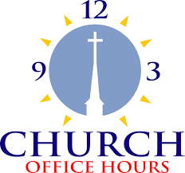

Monday 8:00 a.m. – 5 p.m.

Tuesday 9:00 a.m. – 12:00 noon

Wednesday 8:00 a.m. – 5 p.m.

Thursday 9:00 a.m. – 12 noon

Friday 8:00 a.m. – 12 noon

**St. Paul Lutheran Church & School Staff**

Pastor Rev. Mark Reshan

Secretary Libby Pollack

Organist Rev. Tom Fischer

Accompanists Jary Tannehill, Mark Tannehill, Jacob Tannehill

Custodian Mark Kloess



**Special Give-Back Opportunity**

2-hour sunset cruise along the Lake Michigan shoreline

Wednesday, September 6, departing at 6 p.m.

The cost is $35, with the church getting back $10.

To make reservations, go to

<https://app.bookingcentral.com/book/product/harborcountryadventures?location=5cb18b14-6f6a-46ba-a655-0d19a685fc47&product=152d5966-a46a-43a6-a7f9-c1378641aebf&referer=header&clearcart>

Thank$ for $haring

Thank you for participating in the Galveston give back. We raised $245.

This month,we will see you at Holly’s on Tuesday, July 18! Here are two coupons: one for you and one for a friend.

