THE SUNDAY OF THE PASSION/PALM SUNDAY
March 24, 2024

We read the passion according to St. Mark in the midst of the community on this day so that the story of Jesus' suffering and death will be a place where all our individual and communal stories of pain, loss, suffering, and death during the past year can find some meaning. For we are confronted each day with the tragedies of human suffering that seem to challenge the truth of God's love and providential care for us.
The Christian response to human suffering is not finally a philosophically reasoned series of answers, but an invitation to the kenosis, the self-emptying, of Jesus. The Marcan passion narrative bids us to enter into Jesus' struggle to accept in faith the reality of suffering in human life. God created us as human beings that we might have life and have it in abundance. In the self-emptying of Jesus' passion, death and sin are conquered because they are taken into the mystery of God and transformed into new life.
Today let us allow our experience of suffering to flow into the mystery of the cup of Christ's passion. Come to the table of the cross, and share in the victory of Christ by drinking new life greater than all the forces of suffering and death.

Thomas McGonigle, O.P.

One who has surrendered to it knows that the way ends on the Cross—even when it is leading through the jubilation of Gennesaret or the triumphal entry into Jerusalem.

Dag Hammarskjöld
In the Name of Jesus
INTRODUCTION

Today's liturgy begins with a palm procession, commemorating Jesus' triumphal entry into Jerusalem. Quickly the tone of the service changes as we meditate upon Jesus' passion and death. Because this story is so central to our faith, we hear Matthew's account of the passion today and John's version on Good Friday. Though Jesus is obedient even unto death on the cross, he is exalted by God. We gather to remember his offering for the life of the world, and to be fed by his life-giving mercy. This holy week will culminate in the celebration of the Three Days of Jesus' suffering, death, and resurrection.

Oscar Arnulfo Romero, Bishop of El Salvador, martyr, died 1980

Romero was deeply concerned with injustices evident toward the poor and powerless in El Salvador, and worked forthrightly against political repression. He was assassinated while presiding at the eucharist in a chapel near the cathedral in San Salvador.

GATHERING

PRELUDE

ANNOUNCEMENTS

THE PROCESSION WITH PALMS

P: Blessed is He Who comes in the name of the Lord.

C: Hosanna to the Son of David.

P: The Lord be with you.

C: And also with you.

P: Let us pray. Mercifully assist us, O Lord God of our salvation, that we may enter with
joy upon the contemplation of those mighty acts whereby You have given us life
everlasting; through Your Son, Jesus Christ our Lord.

C: Amen.

THE PROCESSIONAL GOSPEL: Mark 11: 1-10

When they were approaching Jerusalem, at Bethphage and Bethany, near the Mount of Olives, Jesus sent two of His disciples ²and said to them, "Go into the village ahead of you, and immediately as you enter it, you will find tied there a colt that has never been ridden; untie it and bring it. ³If anyone says to you, 'Why are you doing this?' just say this, 'The Lord needs it and will send it back here immediately.' "
⁴They went away and found a colt tied near a door, outside in the street. As they were untying it, ⁵some of the bystanders said to them, "What are you doing, untying the colt?" ⁶They told them what Jesus had said; and they allowed them to take it. ⁷Then they brought the colt to Jesus and threw their cloaks on it; and He sat on it.
⁸Many people spread their cloaks on the road, and others spread leafy branches that they had cut in the fields. ⁹Then those who went ahead and those who followed were shouting,
"Hosanna!
Blessed is the one who comes in the name of the Lord!
¹⁰Blessed is the coming kingdom of our ancestor David!
Hosanna in the highest heaven!"
¹¹Then He entered Jerusalem and went into the temple; and when He had looked around at everything, as it was already late, He went out to Bethany with the twelve.

A: The Gospel of the Lord.

C: Praise to You, O Christ!

The congregation raises their palm branches

P: The Lord be with you.

C: And also with you.

P: Let us give thanks to the Lord our God.

C: It is right to give Him thanks and praise.

P: We praise and thank You, O God, for the great acts of love by which You have redeemed
us through Your Son, Jesus Christ our Lord. On this day He entered the holy city
of Jerusalem in triumph, and was acclaimed Son of David and King of kings by those
who scattered their garments and branches of palm in His path.

We ask that You bless these branches and those who bear them, and grant that we may
ever hail Him as our Lord and King and follow Him with perfect confidence; through
the same Jesus Christ, our Lord, Who lives and reigns with You and the Holy Spirit,
one God, now and forever.

C: Amen.

P: Let us go forth in peace.

C: In the name of the Lord.

THE PROCESSIONAL HYMN All Glory, Laud, and Honor
The hymn is repeated until all have taken their seats

Refrain: All glory, laud, and honor to You, redeemer, King,
To Whom the lips of children made sweet hosannas ring.

1. You are the King of Israel, and David’s royal Son, now in the Lord’s name coming,
our King and Blessed One. Refrain

2. The company of angels are praising You on high; creation and all mortals in chorus
make reply. Refrain

3. The multitude of pilgrims with palms before You went. Our praise and prayer and
anthems before You we present. Refrain

4. To You, before Your Passion, they sang their hymns of praise. To You, now high
exalted, our melody we raise. Refrain

5. Their praises You accepted; accept the prayers we bring, great Author of all
goodness, O good and gracious King. Refrain

When all have reached their seats

P: Blessed is He Who comes in the name of the Lord.

C: Hosanna in the highest!

THE PRAYER OF THE DAY

P: The Lord be with you.

C: And also with you.

P: Let us pray. Sovereign God, You have established Your rule in the human heart through
the servanthood of Jesus Christ. By Your Spirit, keep us in the joyful procession of
those who with their tongues confess Jesus as Lord and with their lives praise Him as
Savior, Who lives and reigns with You and the Holy Spirit, one God, now and forever.
C: Amen.

The assembly is seated

FIRST READING Isaiah 50: 4-9a

This text, the third of the "Servant Songs" that arose in the last years of Israel's exile in Babylon, speaks of the servant's obedience in the midst of persecution. Though the servant has been variously understood as the prophet himself or a remnant of faithful Israel, Christians have often recognized the figure of Christ in these poems.

⁴The Lord God has given me
the tongue of a teacher,
that I may know how to sustain
the weary with a word.
Morning by morning He wakens--
wakens my ear
to listen as those who are taught.
⁵The Lord God has opened my ear,
and I was not rebellious,
I did not turn backward.
⁶I gave my back to those who struck me,
and my cheeks to those who
pulled out the beard;
I did not hide my face
from insult and spitting.
⁷The Lord God helps me;
therefore I have not been disgraced;
therefore I have set my face like flint,
and I know that I shall not be put to shame;
⁸He Who vindicates me is near.
Who will contend with me?
Let us stand up together.
Who are my adversaries?
Let them confront me.
⁹It is the Lord God who helps me;
who will declare me guilty?

The Word of the Lord.

Thanks be to God.

THE PSALM: Psalm 31: 9-16 Read responsively

⁹Have mercy on me, O Lord, for I am in trouble;
my eye is consumed with sorrow, and also my throat and my belly.

¹⁰For my life is wasted with grief, and my years with sighing;
my strength fails me because of affliction, and my bones are consumed.
¹¹I have become a reproach to all my enemies and even to my neighbors,
a dismay to those of my acquaintance;
when they see me in the street they avoid me.

¹²I am forgotten like a dead man, out of mind;
I am as useless as a broken pot.

¹³For I have heard the whispering of the crowd; fear is all around;
they put their heads together against me; they plot to take my life.

¹⁴But as for me, I have trusted in You, O Lord.
I have said, "You are my God.

¹⁵My times are in Your hand;
rescue me from the hand of my enemies, and from those who persecute me.

¹⁶Make Your face to shine upon Your servant,
and in Your lovingkindness save me."

SECOND READING Philippians 2: 5-11

Paul quotes from an early Christian hymn that describes Jesus' humble obedience, even to death, and his exaltation as Lord of all.

⁵Let the same mind be in you that was in Christ Jesus,
⁶Who, though He was in the form of God,
did not regard equality with God
as something to be exploited,
⁷but emptied Himself,
taking the form of a slave,
being born in human likeness.
And being found in human form,
⁸He humbled Himself
and became obedient to the point of death --
even death on a cross.
⁹Therefore God also highly exalted Him
and gave Him the name
that is above every name,
¹⁰so that at the name of Jesus
every knee should bend,
in heaven and on earth and
under the earth,
¹¹and every tongue should confess
that Jesus Christ is Lord,
to the glory of God the Father.

The Word of the Lord.

Thanks be to God.
As you are able please rise

THE VERSE

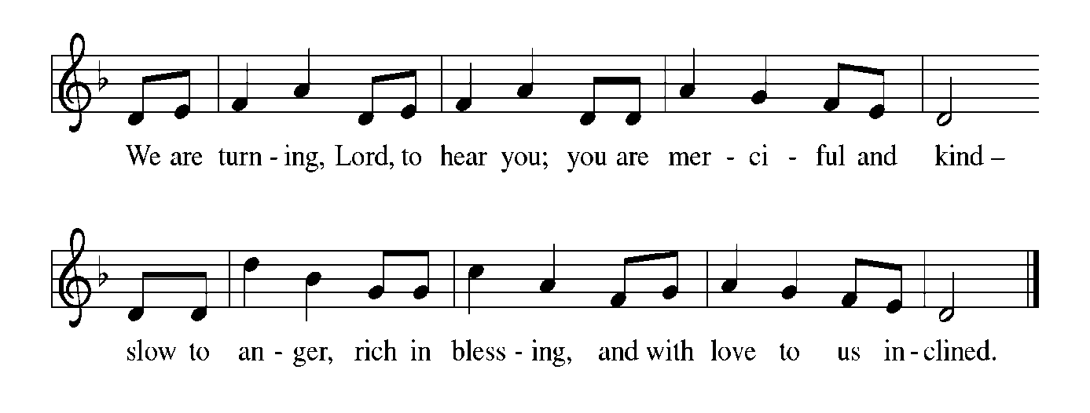
THE HOLY GOSPEL Mark 14: 1 - 15: 47

The passion story in Mark’s Gospel presents Jesus as One Who dies abandoned by all. He shows Himself to be the true Son of God by giving His life for those who have forsaken Him.

P: The Passion of Our Lord Jesus Christ, according to St. Mark.

C: Glory to You, O Lord!

The assembly is seated

Following the reading of the Passion

P: The Gospel of the Lord.

C: Praise to You, O Christ!

The assembly is seated for silence and meditation

THE HOMILY

Silence following the homily is kept

As you are able please rise

THE HYMN OF THE DAY 343 My Song is Love Unknown

Stanza 2—Men; Stanza 3—Women; Stanza 4--Choir

THE PRAYER OF THE CHURCH

A: On this Day the Church hears again the Passion of our Lord, into which we are baptized.
Re-created by the mind of Christ, let us pray for the Church, the world, and all those
for whom Christ died and rose again.

A: That the Church not grow weary in its witness and teaching of the Gospel but
courageously follow the way of the cross and proclaim the truth of Christ to all, let us
pray to the Lord:

C: Lord, have mercy.

A: That where persecution and injustice holds sway in our world the love of Jesus would
conquer and bring peace to all, let us pray to the Lord:

C: Lord, have mercy.

A: That those preparing for Baptism might be filled with grace as this Week they enter the
font of life, let us pray to the Lord:

C: Lord, have mercy.

A: That, as we celebrate Holy Week we may empty ourselves as Christ Jesus did, serving
in unselfish love, let us pray to the Lord:

C: Lord, have mercy.

A: That those who by their sufferings share in the passion of Christ, especially the hungry,
the homeless, the lonely, the grieving, and the sick, especially: Debbie Martin; Jim
Gleason; Erica McMahan; Venia Wendt; Pat Fischer; Chris and Ronwyn Jones;
and Margie Torres might also share in the power of Christ’s new life, let us pray to
the Lord:

C: Lord, have mercy.

A: That those celebrating anniversaries, especially Marvin and Diane Dirks; and Larry
and Judy Litchford may grow in grace this day and every day and be filled with grace
for the days ahead, let us pray to the Lord:

C: Lord, have mercy.

A: That with all the saints who live in the glory of Christ, especially Oscar Romero,
Bishop of El Salvador and martyr, whom we commemorate this Day and whose joy
is complete we too may one day enter with them into the full light of Christ, let us pray
to the Lord:

C: Lord, have mercy.

P: God our Creator, You show Your daughters and sons the way to freedom and life
through the gentle obedience of Your Son, Jesus Christ. Grant our petitions as we
faithfully follow Him through life, into death, and into new and glorious Easter life.
We ask this in the name above every name, Jesus Christ the Lord, to Your glory, Father.

C: Amen.

MEAL

THE PEACE

P: The peace of the Lord be with you always.

C: And also with you.
The assembly is seated

OFFERING

VOLUNTARY Hosanna, Blessed is He That Cometh St. Paul Senior Choir
(H. Hedges)
As you are able please rise

THE OFFERTORY (see p. 9)
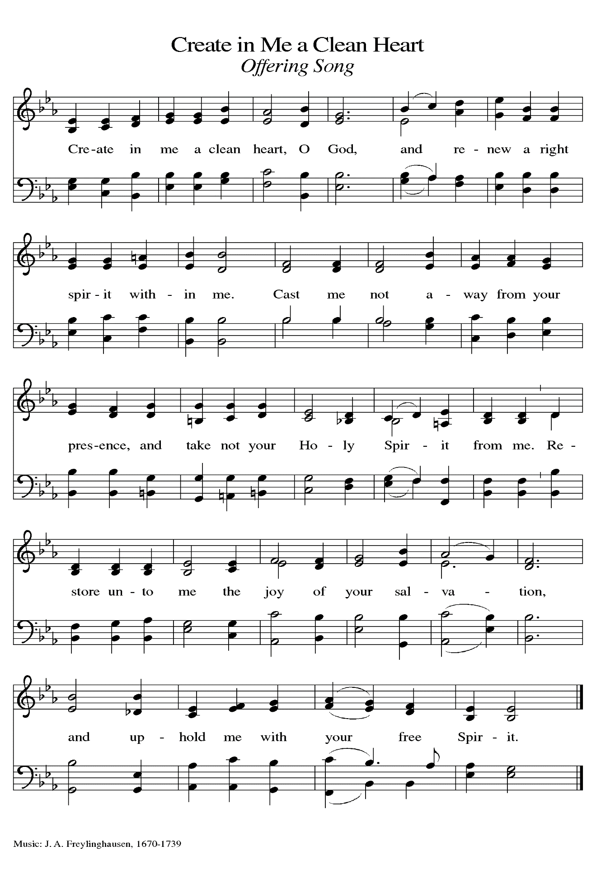
THE OFFERTORY PRAYER

A: Let us pray. Gracious Father,

C: In humble obedience Your Son endured suffering, rejection, and death on the
cross. As He emptied Himself for us, so we bring You the sacrifice of our praise
and thanksgiving. By this holy Sacrament, conform us daily to the mind of Christ.
We ask this in the name of Jesus the Lord. Amen.

THE GREAT THANKSGIVING

P: The Lord be with you.

C: And also with you.

P: Lift up your hearts.

C: We lift them to the Lord.

P: Let us give thanks to the Lord our God.

C: It is right to give Him thanks and praise.

P: It is our joy and destiny to praise You, Lord Go, for in wondrous love You cast
stars into space, and in meek obedience Your Son surrendered to cruel nails.
With lovingkindness You called Your people in Abraham, and in covenant with Moses
You bound up Your life in theirs.
Through exile You stayed close to them bearing the fullness of grace and truth.
Your Son Jesus faced rejection, cruelty, and death, yet in resurrection You exalted
Him, and in sending Your Spirit You shed glory on all people.
Hosanna is our cry, Blessed One.
Your Son comes on a donkey in Your name.
As Jesus entered Jerusalem to bear our sorrows and suffer for our sings, enter our
hearts and confront our waywardness today.
Send Your Spirit upon us, that we may be Your Son’s crucified and risen Body.
Send Your Spirit on this bread that it may be living Bread, and on this wine that it
may be the cup of salvation, that together they may be for us the Body and
Blood of Your Son, Jesus Christ,
Who in the night ... “Do this for the remembrance of Me.”
As often as we eat ... we proclaim the Lord’s death until He comes.

C: Christ has died. Christ is risen. Christ will come again.

P: Humble God, Your Son did not exploit His status but emptied Himself.
Pour out Your Spirit on all who are exploited, in world or church, on all who are
humbled, by state or employer or family member, on all who are emptied
of hope, faith, or love.
As You highly exalted Your Son Who had become a slave, highly exalt Your
children who suffer for righteousness, or grieve those they have cherished,
or bend the knee to one who does not honor them.
Fill the earth with Your justice and peace, until every heart shall sing and every
tongue confess that You are the joy of their desiring, Father, Son, and Holy Spirit, ever one God, in all ages forevermore.

C: Amen!

THE LORD’S PRAYER

P: Baptized into Christ’s death that we might share in the resurrection, let us pray for the
fulfillment of this mystery as Jesus taught us:

C: Our Father in heaven, hallowed be Your name.
Your Kingdom come, Your will be done on earth as in heaven.
Give us today our daily bread, and forgive us our sins, as we forgive
those who sin against us.
Save us from the time of trial, and deliver us from evil.
For the Kingdom, the power, and the glory are Yours, now and forever.
Amen.

INVITATION TO THE MEAL

P: Return to God with all your heart. Receive bread for the journey, drink for the desert.
Blessed are those who are called to the Supper of the Lamb. God’s holy gifts for God’s
holy people. Come, for all is now ready.

The assembly is seated

THE DISTRIBUTION
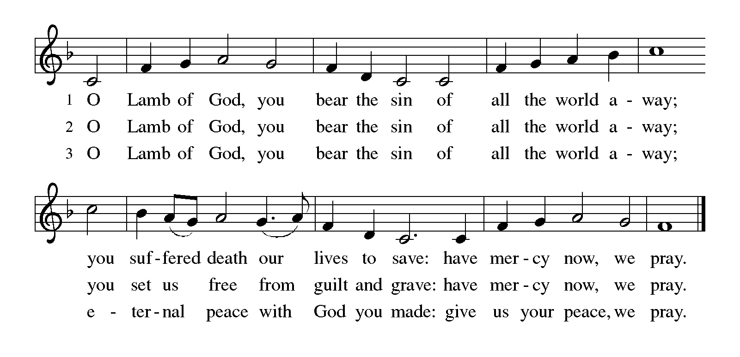
HYMNS DURING DISTRIBUTION 353 Were You There?
338 Beneath the Cross of Jesus
349 Ah, Holy Jesus
As you are able please rise

THE POST-COMMUNION BLESSING

P: The Body and Blood of our Lord Jesus Christ strengthen you and keep you in His grace.
C: Amen.

THE POST-COMMUNION PRAYER

A: Let us pray. Heavenly Father, by His death on the cross Your Son freed us from the
bondage to sin and death. Watch over Your Church, and all who celebrate these Holy
Mysteries. In this Sacrament, give us Food for our journey from death to life. Grant
this through Christ our Lord.

C: Amen.
SENDING

THE BENEDICTION

P: Almighty God: Father, Son, and Holy Spirit bless you now and forever.

C: Amen.

RECESSIONAL HYMN 347 Go to Dark Gethsemane

The congregation faces the cross as it leaves

THE DISMISSAL

A: Reconciled to God through Christ, let us go out into the world in peace.

C: Thanks be to God!

THE POSTLUDE

To God Alone Be Glory

The Meditation is from Thomas McGonigle, O.P., in Homilies for the Christian People,
ed. Gail Ramshaw (New York: Pueblo, 1989), 252.

The Greeting, Prayers, Peace, and Dismissal are adapted from Sundays and Seasons.
Copyright 2001 Augsburg Fortress.

The Prayers, Introduction to the Lord’s Prayer, and Invitation to the Meal are adapted from
Prayers for Sundays and Seasons. Year A. Peter J. Scagnelli. (Chicago: Liturgy
Training Publications, 1998) 40-41.

ANNOUNCEMENTS

Please remember to mail your offering to the Church Office at 818 Franklin Street, Michigan City, IN 46360. Another alternative is to give on-line through Tithe.ly. Please see your closure letter for information on how to set up a Tithe.ly account.

St. Paul Members are reminded to have a loved one contact the office if you are hospitalized. Many times, the Pastor doesn’t know someone is in the hospital. If you call and leave a message, please tell us which hospital the patient is at.

ANNIVERSARIES: Marvin & Diane Dirks (3/24); Larry & Judy Litchford (3/26)

PRAYER CONCERNS: Debbie Martin, Erica McMahan, Sue Koziel, Jana Thomas, Margie Torres, Jayla Jacobi, Jim Gleason, Ronwynn Jones, Chris Jones, Mark Tannehill, Joan Seifert, Virginia Murray, Brian Wiseman, Jary Tannehill and Sue Granacki.

OFFICE HOURS: Libby will be in the office on Mondays, Wednesdays,
and Fridays; volunteers will cover Tuesdays and Thursdays.

Monday & Wednesday 8:00 a.m. – 5 p.m.
Tuesday & Thursday 9:00 a.m. – 12:00 p.m.
Friday 8:00 a.m. – 12:00 p.m.

If you are listening to the worship broadcast on the radio and would like to watch the Sunday morning service live stream follow these steps:

(1) If you have You Tube available on your TV, search for
St. Paul Lutheran Church Michigan City, IN.

(2) The direct link on the computer is
https://www.youtube.com/channel/UC5AIPNaKr3QN50984jGOa1g.

(3) This link is also on the main page of the church’s website in
the church section and will continue to be posted weekly on the St.
Paul Facebook page.

And it will always be available on the radio broadcast Sunday mornings at 11:00 a.m.
on WEFM (95.9), and on the local cable access station #99 for the previous week’s
service on Sundays at 4:00 p.m. and the current service on Wednesdays at 7:00 p.m. and
Fridays at 8:30 p.m.

The approved and signed minutes of the December 28, 2023 and January 25, 2024 Church Council Meetings are on the table at the back of the church in the Narthex. Please take a copy with you as you go.

To send e-mail to the church office, please use the following addresses:
Pastor Mark Reshan: seniorpastor@stpaulmichigancity.com
Church Office Secretary (Libby Pollock): churchsecretary@stpaulmichigancity.com
Church Treasurer (Karen Fleming): finance@stpaulmichigancity.com

The Good News Newsletter: If you have an article or anything you want included in The Good News please send it to the following e-mail address: splcgoodnews@gmail.com. Pastor Pamela Thiede will be using this e-mail address to assemble The Good News each month. The deadline for getting information to Pastor Pamela will be the 20th of each month.

Worship Attendance: March 13, March 16 and 17, 2024:
6:00 p.m. 26
4:00 p.m. 25
9:00 a.m. 54
TOTAL 105

LOOKING FOR IDEAS

We’d like to continue to highlight a different mission each month. We are looking for suggestions! If you volunteer somewhere or have a mission that is close to your heart, please let Paul or Lora Brooks know so we can set up a month to support that cause! Paul: (219) 221-0254, paulbrooks@gmail.com; or Lora: (260) 701-1586, loralmartin15@gmail.com.

March’s Local Monthly Mission will be the Service League of Michigan City. The Service League loans medical equipment to Michigan City residents as they recuperate at home. Some of the items they loan include bathroom and safety aids, wheelchairs, and knee walkers. Residents can also go each month to pick up adult briefs and bed pads free of charge. If you wish to support this month’s mission, please place your donation in the offering plate marked for the Service League.

ACTIVITIES, EVENTS & MEETINGS
MARCH 2024 continued

Saturday, March 23, 2024 @ 4:00 p.m. Palm/Passion Saturday Worship Service

Sunday, March 24, 2024 @ 9:00 a.m. Palm/Passion Sunday Worship Service

Tuesday, March 26, 2024 @ 4:00 p.m. Bell Choir Rehearsal

Wednesday, March 27, 2024 @ 10:00 a.m. God’s Purls/St. Paul Room
@ 4:00 p.m. Choir Rehearsal
Thursday, March 28, 2024 @ 10:00 a.m. Senior Communion with luncheon to
follow immediately after/St. Paul Room
Friday, March 29, 2024 @ 7:00 p.m. Good Friday/The Passion According to St.
John
Saturday, March 30, 2024 @ 7:00 p.m. The Great Vigil of Easter/The First
Communion of Easter

Sunday, March 31, 2024 @9:00 a.m. The Resurrection of Our Lord

MESSAGE:
Please consider supporting the pop machine in the hallway between the kitchen and the St. Paul Room in the basement as we look to move out existing drinks and add in new ones! All pop is 75 cents and all proceeds go to the Capital Improvement Fund. We are currently working with the vendor as Mountain Dew has been stocked but the machine is saying to choose another selection. Hoping to have that issue resolved soon. Thank you for your support!

Paul Brooks
Member of Church Council

2024 Financial Stewardship

Weekly Church Operating Needs (x 2 weeks): $ 14,475.00
March 9 - 10, and March 16 – 17, 2024

General Fund (including General Memorials): $ 9,385.00

Overage/Shortage: —- $ 5,090.00

Restricted Income (not including Memorials)
Supports IK Synod & Church wide Ministries: $ 158 .00

Ministries in our Community/Congregation: $ ——--

Capital Fund: $ 346.00

