THE DAY OF PENTECOST
Sunday, May 19, 2024

(Peter’s) world has just been turned upside down. He had just had all his doors blown off their hinges and when the Israelites asked him, “What shall we do?” I do not believe he gave them a three-step prescription to fill. I believe he told them how to prepare for a holy hurricane.
“Reorient your lives.” That is the truth of what he told them, knowing full well that was what would happen the moment Jesus came to live in them. Forget everything you ever thought you knew about who is in charge in this world. Get ready to revise all your notions about what makes someone great, or right, or worthy of your attention. If you think you know which way is up, think again. If you think you know how things should turn out in the end, get ready to be wrong.
This Jesus I have been telling you about is one surprise feast after another. You cannot second-guess him. All you can do is love him and let him love you back, any way he sees fit. Sometimes it is so strong it can scare you to death. You want to know what you should do? Repent, return, revise, reinvent yourself.
Then go get born again, by water and the Spirit. Walk into the river of death with him, and while you are down there let the current carry away everything that stands between you and him. Then, when all your own breath is gone, let him give you some of his. Take his breath inside of you. Let it save your life, and when he rises, rise with him, understanding that your life is no longer your own.
You died down there. You are borrowing his life now. Let someone make the sign of the cross on your forehead to remind you of that, and join the community of those who call themselves his body, because they believe his heart beats in every one of them.
Then receive the Holy Spirit. That is, breathe. Deeply. Receive your life as a gift invisible as air, and prepare to be astonished by all the forms that breath can take. Under the power of the Holy Spirit, shy people have been known to step onto platforms and say audacious things. Cautious people have become daredevils, frugal people have become philanthropists and people who used to be as sour as dill pickles have become rich with friends.
There is no limit to what the Holy Spirit can do. You just cannot hold your breath, that’s all. You have to keep breathing, keep paying attention, keep responding to whatever crazy idea you come up with next. Some people call it intuition. Others call it inspiration. Forever and ever, the church has called it Holy Spirit.

Barbara Brown Taylor

Erik, King of Sweden, martyr, died 1160

Erik is considered the patron saint of Sweden. As king of that nation, he tried to bring peace in the region, and to spread Christianity in Scandinavia. He was also known for his attempts to make fair laws and to protect those who were poor or sick.

In the Name of Jesus

GATHERING

PRELUDE

THE EASTER ACCLAMATION

P: Christ is risen! Alleluia!

C: Christ is risen indeed! Alleluia!

ANNOUNCEMENTS

As you are able please rise

A LITANY FOR PENTECOST

P: In the name of the Father and of the Son and of the Holy Spirit.

C: Amen.

P: The Spirit of the Lord fills the world!

C: Alleluia! Alleluia!

P: Come, Holy Spirit, fill the hearts of Your faithful:

C: And kindle in us the fire of Your love.

P: Come, Holy Spirit, fill the hearts of Your faithful:

C: And kindle in us the fire of Your love.

P: The Spirit of the Lord fills the world!

C: Alleluia! Alleluia!

THE PROCESSIONAL HYMN 786 O Holy Spirit, Enter In

The congregation faces the cross as it enters

THE GREETING AND PRAYER OF THE DAY

P: Alleluia! Christ is risen!

C: Christ is risen indeed! Alleluia!

P: The grace of our Lord Jesus Christ, the love of God, and the communion of the Holy
Spirit be with you all.

C: And also with you.

P: Let us pray. Mighty God, You breathe life into our bones and Your Spirit brings truth
to the world. Send us this Spirit, transform us by Your truth, and give us language to
proclaim Your Gospel, through Jesus Christ, our Savior and Lord, Who lives and reigns
with You and the Holy Spirit, one God, now and forever.

C: Amen.

The assembly is seated

WORD

FIRST READING Acts 2: 1-21

Originally Pentecost was a Jewish thanksgiving-type festival celebrated seven weeks after Passover. On this particular Pentecost, however, the Holy Spirit is poured out upon the entire community of believers just as Jesus had promised and the scriptures had prophesied. Empowered by the Spirit, the entire community bears witness to God’s activity in multiple languages.

When the day of Pentecost had come, they were all together in one place. ²And suddenly from heaven there came a sound like the rush of a violent wind, and it filled the entire house where they were sitting. ³Divided tongues, as of fire, appeared among them, and a tongue rested on each of them. ⁴All of them were filled with the Holy Spirit and began to speak in other languages, as the Spirit gave them ability.
⁵Now there were devout Jews from every nation under heaven living in Jerusalem. ⁶And at this sound the crowd gathered and was bewildered, because each one heard them speaking in the native language of each. ⁷Amazed and astonished, they asked, "Are not all these who are speaking Galileans?
⁸And how is it that we hear, each of us, in our own native language? ⁹Parthians, Medes, Elamites, and residents of Mesopotamia, Judea and Cappadocia, Pontus and Asia, ¹⁰Phrygia and Pamphylia, Egypt and the parts of Libya belonging to Cyrene, and visitors from Rome, both Jews and proselytes, ¹¹Cretans and Arabs — in our own languages we hear them speaking about God's deeds of power." ¹²All were amazed and perplexed, saying to one another, "What does this mean?" ¹³But others sneered and said, "They are filled with new wine."
¹⁴But Peter, standing with the eleven, raised his voice and addressed them, "Men of Judea and all who live in Jerusalem, let this be known to you, and listen to what I say. ¹⁵Indeed, these are not drunk, as you suppose, for it is only nine o'clock in the morning. ¹⁶No, this is what was spoken through the prophet Joel:
¹⁷'In the last days it will be, God declares,
that I will pour out My Spirit upon all flesh,
and your sons and your daughters shall prophesy,
and your young men shall see visions,
and your old men shall dream dreams.
¹⁸Even upon My slaves, both men and women,
in those days I will pour out My Spirit; and they shall prophesy.
¹⁹And I will show portents in the heaven above
and signs on the earth below, blood, and fire, and smoky mist.
²⁰The sun shall be turned to darkness
and the moon to blood, before the coming of the Lord's great and glorious day.
²¹Then everyone who calls on the name of the Lord shall be saved.'

The Word of the Lord.

Thanks be to God.

THE PSALM: Psalm 104: 24-35 Read responsively

²³People go forth to their work
and to their labor until the evening.

²⁵O LORD, how manifold are Your works!
In wisdom You have made them all; the earth is full of Your creatures.

²⁶Yonder is the great and wide sea with its living things too many to number,
creatures both small and great.

²⁷There move the ships, and there is that Leviathan,
which You have made for the sport of it.

²⁸All of them look to You
to give them their food in due season.

²⁹You give it to them; they gather it;
You open Your hand, and they are filled with good things.

³⁰You hide Your face, and they are terrified;
You take away their breath, and they die and return to their dust.

³¹You send forth Your Spirit, and they are created;
and so You renew the face of the earth.

³²May the glory of the LORD endure forever;
may the LORD rejoice in all His works.

³³He looks at the earth and it trembles;
He touches the mountains and they smoke.

³⁴I will sing to the LORD as long as I live;
I will praise my God while I have my being.

³⁵May these words of mine please Him;
I will rejoice in the LORD.

SECOND READING Romans 8: 22-27

By pouring the Holy Spirit into our hearts, God gives us the promised first fruit of eternal life so that we await God’s future in hope. In the meantime, the Spirit also intercedes for us by carrying the prayers of our weak human hearts to God.

²²We know that the whole creation has been groaning in labor pains until now; ²³and not only the creation, but we ourselves, who have the first fruits of the Spirit, groan inwardly while we wait for adoption, the redemption of our bodies. ²⁴For in hope we were saved. Now hope that is seen is not hope. For who hopes for what is seen? ²⁵But if we hope for what we do not see, we wait for it with patience.
²⁶Likewise the Spirit helps us in our weakness; for we do not know how to pray as we ought, but that very Spirit intercedes with sighs too deep for words. ²⁷And God, Who searches the heart, knows what is the mind of the Spirit, because the Spirit intercedes for the saints according to the will of God.
The Word of the Lord.

Thanks be to God.

As you are able please rise

THE VERSE (sung twice)
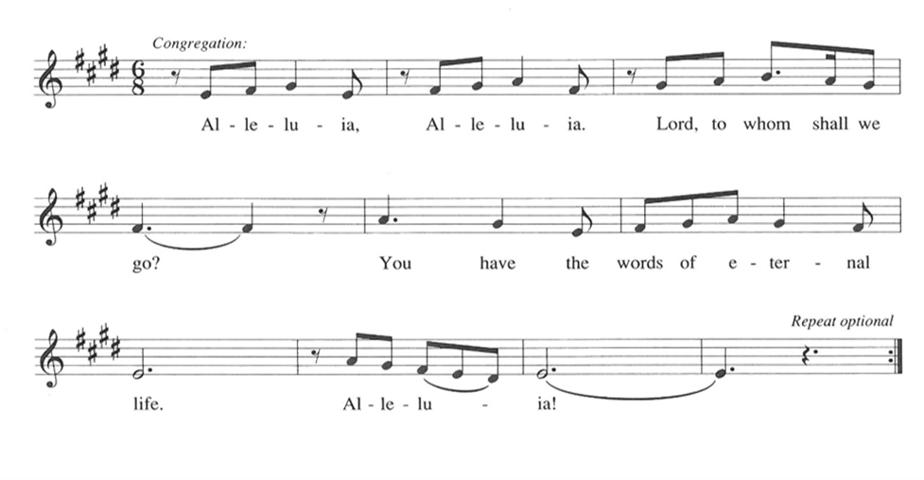

THE HOLY GOSPEL John 15: 26–27; 16: 4b–15

When speaking to his disciples before his death, Jesus referred to the Holy Spirit as "the Helper" and described the difference the Spirit would make in their lives and in the world.

P: The Holy Gospel according to St. John, the fifteenth and sixteenth chapters.

C: Glory to You, O Lord!

Chapter 15

²⁶When the Advocate comes, Whom I will send to you from the Father, the Spirit of truth Who comes from the Father, He will testify on My behalf. ²⁷You also are to testify because you have been with Me from the beginning.
Chapter 16

^{4b}"I did not say these things to you from the beginning, because I was with you. ⁵But now I am going to Him Who sent Me; yet none of you asks Me, 'Where are You going?' ⁶But because I have said these things to you, sorrow has filled your hearts.
⁷Nevertheless I tell you the truth: it is to your advantage that I go away, for if I do not go away, the Advocate will not come to you; but if I go, I will send Him to you. ⁸And when He comes, He will prove the world wrong about sin and righteousness and judgment: ⁹about sin, because they do not believe in Me; ¹⁰about righteousness, because I am going to the Father and you will see Me no longer; ¹¹about judgment, because the ruler of this world has been condemned.
¹²I still have many things to say to you, but you cannot bear them now. ¹³When the Spirit of truth comes, He will guide you into all the truth; for He will not speak on His own, but will speak whatever He hears, and He will declare to you the things that are to come.
¹⁴He will glorify Me, because He will take what is mine and declare it to you. ¹⁵All that the Father has is Mine. For this reason I said that He will take what is Mine and declare it to you.

P: The Gospel of the Lord.

C: Praise to You, O Christ!

The assembly is seated

THE SERMON

Silence for reflection follows the sermon

As you are able please rise

THE HYMN OF THE DAY NSB 80 Spirit of the Living God (x2)

THE NICENE CREED

A: God has made us His people through our Baptism into Christ. Living together in trust
and hope, we confess our faith.

C: We believe in one God,
the Father, the Almighty,
maker of heaven and earth,
of all that is, seen and unseen.

We believe in one Lord, Jesus Christ,
the only Son of God,
eternally begotten of the Father,
God from God, Light from Light,
true God from true God,
begotten, not made,
of one Being with the Father.
Through Him all things were made.
For us and for our salvation
He came down from heaven;
by the power of the Holy Spirit
He became incarnate from the virgin Mary, and was made man.
For our sake He was crucified under Pontius Pilate;
He suffered death and was buried.
On the third day He rose again
in accordance with the Scriptures;
He ascended into heaven
and is seated at the right hand of the Father.
He will come again in glory to judge the living and the dead,
and His kingdom will have no end.

We believe in the Holy Spirit, the Lord, the giver of life,
Who proceeds from the Father and the Son.
With the Father and the Son He is worshiped and glorified.
He has spoken through the prophets.
We believe in one holy catholic and apostolic Church.
We acknowledge one Baptism for the forgiveness of sins.
We look for the resurrection of the dead,
and the life of the world to come. Amen

THE PRAYER OF THE CHURCH

A: Filled with the Holy Spirit, let us pray for the Church, the newly baptized, the world,
and all who long for God’s creative Breath and life.

A: That the Church might be enlivened and strengthened in its mission of declaring Your
mighty deeds of power, we pray:

C: Come, Holy Spirit!

A: That the discord of terror, violence, and destruction in the world might be silenced,
especially between Israel and the Palestinians, and all people renewed by God’s ways
of peace, we pray:

C: Come, Holy Spirit!

A: That we in this congregation might testify to Jesus in this week with courage, power,
and in truth, we pray:

C: Come, Holy Spirit!

A: That those who offer help and healing might bring God’s wholeness to the addicted,
the dying, the hurting, and the sick, especially . . . we pray:

C: Come, Holy Spirit!

A: That those celebrating birthdays, especially Charles Thomas, Sr; Sally Timm; and
Charles Ponder, Sr; and anniversaries, especially Clay and Kimberly Payne may
grow in grace this day and every day and be filled with grace for the days ahead, we
pray:

C: Come, Holy Spirit!

A: That together with all who have loved and served You in Your Church on earth,
especially Erik, King of Sweden, martyr, whom we commemorate this Day we may
be brought to the joys of heaven, we pray:

C: Come, Holy Spirit!

P: Hear our prayers, gracious God, and grant all that we need to live as your Spirit-filled
people, through Your Son, Jesus Christ our Lord.

C: Amen.

MEAL

THE PEACE

P: The peace of the risen Lord be with you always.

C: And also with you.

The assembly is seated

THE OFFERING

THE VOLUNTARY The Lord’s My Shepherd (Brother James’ Air) by G. James
St. Paul Senior Choir

As you are able please rise

THE PRESENTATION OF THE GIFTS 465 As the Grains of Wheat

THE OFFERTORY PRAYER

A: Let us pray. God of glory,

C: You open Your hand, and all creation is filled with good things. From Your great
bounty we offer You these gifts. Receive them for the sake of Your Son, Jesus
Christ. By this holy Sacrament, ignite in us the Fire of Your life and love. We ask
this in the name of Jesus the Lord. Amen.

THE GREAT THANKSGIVING

P: The Lord be with you.

C: And also with you.

P: Lift up your hearts.

C: We lift them to the Lord.

P: Let us give thanks to the Lord our God.

C: It is right to give Him thanks and praise.

P: God of surprises, Your Spirit brooded over the waters at creation and lived among
Your chosen people in wilderness, exile, and promised land.
Your Spirit filled Mary’s womb at the moment of Jesus’ conception and came upon
Him like a dove at His Baptism.
When Christ died on the cross Your power raised Him from the tomb on the third
day, and that same evening He breathed Your forgiving grace on those who
had deserted Him.
On the Day of Pentecost You sent Your Spirit upon the fearful disciples, filling
them with fire, with power, with wonder and joy, and making them Your
Church.
God of comfort and strength, we look to Your Holy Spirit to be with us in sorrow
and in contentment, in crisis and in abiding stillness.
Come among us now through the power of Your Spirit, that we may be transformed
into Your image, and that these gifts of bread and wine may become for us
the Body and Blood of Your Son Jesus Christ,
Who, in the night ... “Do this for the remembrance of Me.”
As often as we eat ... we proclaim the Lord’s death until He comes.

C: Christ has died. Christ is risen. Christ will come again.

P: God of dreams and prophecy, send down upon us Your gifts of wisdom, knowledge,
and faith; of healing, discernment, and interpretation, that Your Church may
be built up in the likeness of Your Son.
Let anyone who is hungry find in You the Bread of Life, and anyone who is
thirsty find in You rivers of Living Water.
Speak Your Word to all who are alone and in fear or despair, and let each one
of Your children hear Your voice in their own language, whether that
language be science, work, or play.
Make holy Your groaning creation, that Your universe may breathe Your breath
and be filled with Your life anew, that we may love what You love, and
do what You would do,
Father, Son, and Holy Spirit ever one God.

C: Amen!

THE LORD’S PRAYER

P: Because in Christ we have received the Spirit of adoption, as daughters and sons of God
we dare to pray:

C: Our Father, Who art in heaven, hallowed be Thy Name.
Thy Kingdom come, Thy will be done on earth as it is in heaven.
Give us this day our daily bread, and forgive us our trespasses as we forgive
those who trespass against us.
And lead us not into temptation but deliver us from evil.
For Thine is the Kingdom, and the power, and the glory, forever and ever.
Amen.

INVITATION TO THE MEAL

P: Alleluia! Christ our paschal Lamb has been sacrificed. Therefore, let us keep the Feast.
Blessed are those who are called to the Supper of the Lamb. God’s holy gifts for God’s
holy people. Come, for all is now ready.

The assembly is seated

THE DISTRIBUTION Lamb of God

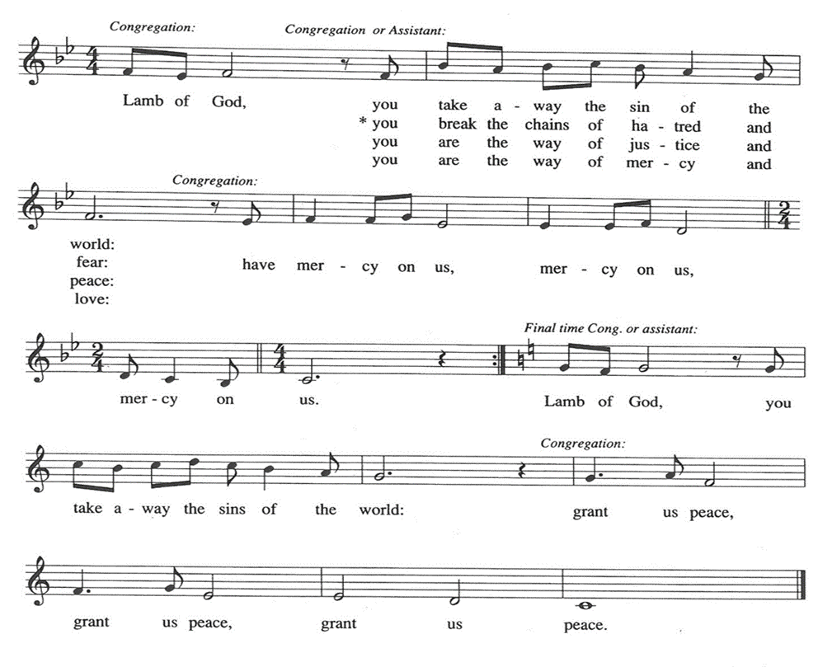

HYMN DURING DISTRIBUTION 400 God of Tempest, God of Whirlwind

ELW 396 Spirit of Gentleness

NSB 81 Spirit Song

NSB 102 Wind of the Spirit
As you are able please rise

THE POST-COMMUNION BLESSING

P: The Body and Blood of our Lord Jesus Christ strengthen you and keep you in His grace.

C: Amen.

THE POST-COMMUNION PRAYER

A: Let us pray. God of glory, may the Spirit You sent upon Your Church to begin the
teaching of the Gospel continue to work in the world through all who have received
this heavenly Food; through Jesus Christ our Lord.

C: Amen.
SENDING

THE BENEDICTION

P: May God the Father Who raised Christ from the dead open to you the gate of everlasting
life.

C: Amen.

P: May God the Son Who burst from the grave give you joy as you celebrate His
resurrection.

C: Amen.

P: May God the Holy Spirit Who brought you to birth in Baptism fill you with strength
and peace.

C: Amen.

P: Almighty God: Father, Son, and Holy Spirit bless you now and forever.

C: Amen.

THE SENDING SONG NSB 18 Bring Forth the Kingdom

THE DISMISSAL

A: Alleluia! Go and tell the News that Christ is risen!

C: Christ is risen indeed! Alleluia!

POSTLUDE Breathe St. Paul Praise Band
(Marie Barnett)

To God Alone Be Glory

The Meditation is from Pulpit Resource. William Willimon, ed. (Inver Heights, MN:
Logos Productions, 2003) 48.

ANNOUNCEMENTS

Please remember to mail your offering to the Church Office at 818 Franklin Street, Michigan City, IN 46360. Another alternative is to give on-line through Tithe.ly. Please see your closure letter for information on how to set up a Tithe.ly account.

St. Paul Members are reminded to have a loved one contact the office if you are hospitalized. Many times, the Pastor doesn’t know someone is in the hospital. If you call and leave a message, please tell us which hospital the patient is at.

Birthdays: Charles Thomas, Sr. (5/25); Sally Timm (5/30);
Charles Ponder, Sr. (5/30)

Anniversaries: Fred & Judy LaBorn (5/19); Clay & Kimberly Payne (5/29)

PRAYER CONCERNS: Judith Miller, Nolan Wilson,Karen Keller, Marsha Kenney, Grace Romine, Debbie Martin, Margie Torres, Ronwynn Jones, Chris Jones, Mark Tannehill, Joan Seifert, Brian Wiseman, Jary Tannehill, Sue Granacki, Kathy Stein and Pastor Charlie Streitelmeier.

OFFICE HOURS: Libby will be in the office on Mondays, Wednesdays,
and Fridays; volunteers will cover Tuesdays and Thursdays.

Monday & Wednesday 8:00 a.m. – 5 p.m.
Tuesday & Thursday 9:00 a.m. – 12:00 p.m.
Friday 8:00 a.m. – 12:00 p.m.

If you are listening to the worship broadcast on the radio and would like to watch the Sunday morning service live stream follow these steps:

(1) If you have You Tube available on your TV, search for
St. Paul Lutheran Church Michigan City, IN.

(2) The direct link on the computer is
https://www.youtube.com/channel/UC5AIPNaKr3QN50984jGOa1g.

(3) This link is also on the main page of the church’s website in
the church section and will continue to be posted weekly on the St.
Paul Facebook page.

And it will always be available on the radio broadcast Sunday mornings at 11:00 a.m.
on WEFM (95.9), and on the local cable access station #99 for the previous week’s
service on Sundays at 4:00 p.m. and the current service on Wednesdays at 7:00 p.m.
and Fridays at 8:30 p.m.

The approved and signed minutes of the February 22 and March 21, 2024 Church Council Meetings are on the table at the back of the church in the Narthex. Please take a copy with you as you go.

To send e-mail to the church office, please use the following addresses:

Pastor Mark Reshan: seniorpastor@stpaulmichigancity.com

Church Office Secretary (Libby Pollock): churchsecretary@stpaulmichigancity.com

Church Treasurer (Karen Fleming): finance@stpaulmichigancity.com

The Good News Newsletter: If you have an article or anything you want included in The Good News please send it to the following e-mail address: splcgoodnews@gmail.com. Pastor Pamela Thiede will be using this e-mail address to assemble The Good News each month. The deadline for getting information to Pastor Pamela will be the 20th of each month.

Worship Attendance:
Saturday, May 11, 2024 @ 4:00 p.m. 31
Sunday, May 12, 2024 @ 9:00 a.m. 61
TOTAL 92

IT’S TIME FOR A NEW DIRECTORY

As I get closer to the end of my first draft I find that some of the numbers I’ve called to check in with folks have been disconnected. If you know of anyone in the directory that has a new phone number or address please let me know by sending me an email or call the church office in the next couple weeks and let me know. I look forward to hearing from you as soon as you’re able.

Libby Pollock
Church Secretary

Our annual spring congregational meeting will take place on Sunday, May 19 at 10:00 in the St. Paul Room. There will be two main agenda items: the proposed budget for the 2024-2025 fiscal year; and a report on the sale of the school building.

Next Sunday’s lessons are Isaiah 6: 1-8; Psalm 29; Romans 8: 12-17; John 3: 1-17 for those who of you who like to study them in advance.

The Mission of the Month for May

May’s mission of the month is Dolly Parton’s Imagination Library of
LaPorte County. Dolly Parton’s Imagination Library is dedicated to inspiring a love of reading by gifting books each month to children from birth to age five, free of charge, through funding shared by Dolly and local community partners in the United States, Canada, United Kingdom, Australia and Republic of Ireland. Any child within LaPorte County who is under the age of 5 can sign up. Some of the books Leah has received are “The Little Engine That Could,” “Llama Llama Red Pajama,” “The Very Hungry Caterpillar’s First Summer,” and her favorite, “Goodnight Gorilla.” Please consider helping to foster a love of reading in young kids in our community by donating to the Imagination Library. Checks can be made out to the church and marked for the Imagination Library and placed in the offering plate.

2024 Financial Stewardship

Weekly Church Operating Needs (x 2 weeks): $ 13,850.00

May 4-5; May 11-12, 2024
General Fund (including General Memorials): $ 8,784.00

Overage/Shortage: —- $ 5,066.00

Restricted Income (not including Memorials)
Supports IK Synod & Church wide Ministries: $ 320.00

Ministries in our Community/Congregation: $ 200.00

Capital Fund: $ 306.00

Memorials
General Fund $ 5,300.00

ACTIVITIES, EVENTS & MEETINGS
MAY 2024

Saturday, May 11, 2024 @ 4:00 p.m. Ascension Worship Service

Sunday, May 12, 2024 @ 9:00 a.m. Ascension Worship Service

Monday, May 13, 2024 @ Noon Choir Rehearsal

@1:00 p.m. Hope Circle/Green Room

@ 1:00 p.m. Worship & Music Committee Mtg./Luther House

Tuesday, May 14, 2024 @ 7:00 p.m. Estuary/Luther House

Wednesday, May 15, 2024 @ 9:15 a.m. Bible Study/Luther House

@10:00 a.m. God’s Purls/St. Paul Room

Saturday, May 18, 2024 @ 4:00 p.m. Vigil and Day of Pentecost Worship Service

Sunday, May 19, 2024 @ 9:00 a.m. Vigil and Day of Pentecost Worship Service

@ 10:00 a.m. Congregational Spring Meeting & Potluck in
St. Paul Room
Monday, May 20, 2024 @ 2:00 p.m. Finance Committee Mtg./Luther House

@3:00 p.m. Executive Board Mtg/Luther House

Wednesday, May 22, 2024 @ 9:15 a.m. Bible Study/Luther House

@10:00 a.m. God’s Purls/St. Paul Room

@5:30 p.m. Church Council Mtg./St. Paul Room

Thursday, May 23, 2024 @ 4:00-10:00 p.m. GIVE-BACK at Galveston Steakhouse

Saturday, May 25, 2024 @ 4:00 p.m. Holy Trinity Worship Service

Sunday, May 26, 2024 @ 9:00 a.m. Holy Trinity Worship Service

Monday, May 27, 2024 OFFICE IS CLOSED FOR MEMORIAL DAY

Wednesday, May 29, 2024 @10:00 a.m. God’s Purls/St. Paul Room

COMING SOON!

The Emita II Give Back Night is fast approaching! Join us for a lakeshore cruise on the Emita II on Tuesday, June 4, 2024. The boat leaves the dock at 6:00 p.m. so please arrive a bit early. Tickets are $35.00 per person and children 3 years of age or younger are free. $10.00 goes directly back to the church. No coupon is required.

This particular cruise will be opened to the general public on Wednesday, May 22 which means if you want to go for the Give Back you would need to book your reservation no later than Tuesday, May 21st. The more tickets we sell before May 22 the better the Give Back will be for our congregation. This has the potential to be our largest give back of the year, and I hope to keep it annually. We need a good turn out for this to happen.

The link for making a reservation is:

https://tinyurl.com/mtk3ach6

If you have any issues or concerns with the site or with using a credit card online, you are invited to contact Paul Brooks as soon as possible at:

paulbrooks@gmail.com or by phone at (219) 221-0254

and he will help you with the process. Whether you have ridden the Emita before or it’s your first time, join us for great views of the sunset, our lakeshore, our light house and beach, and surrounding areas. We hope to see you there!

Paul Brooks

Thank$ for $haring

Thank you to all who participated in the Give-Back at Leed’s Public House on April 10, 2024. The church received $200.00 as a result of the event. This month, we will see you again at Galveston on Thursday, May 23! Here are two coupons: one for you and one for a friend.

