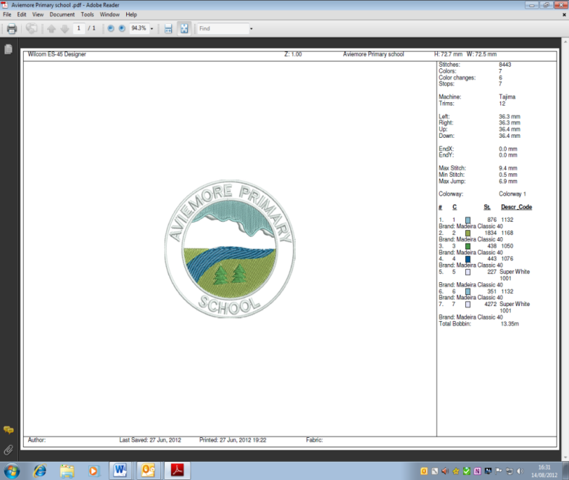**AVIEMORE PRIMARY SCHOOL/ELC NEWSLETTER**

***Vision:*** *Always Learning, Always Growing, Always Positive*

*ELC: Playing and Learning Together*

**Welcome back to school and nursery following the festive break. We are learning from home for the start of this term but hope to see everyone back with us as soon as it is safe.**

**Learning This Term**

****This term the topic focus for all classes will be Scotland for the first few weeks back to encompass Burns Night and then we will move on to studying a historical context. P1 will be learning about the Stone Age, P2 and P3 will be learning about the Picts, P2/3 will be comparing housing from the past and present and P3/4 will be exploring Scottish Castles! In the upper school P4/5 and P5 will be learning about the Vikings and P6 and P7 will be learning about World War II.

For more details please see your child’s Termly Planner which also has other dates for your diary on the school website - [www.aviemoreprimary.co.uk](http://www.aviemoreprimary.co.uk) available from Friday 15th January.

**Online Learning**

A weekly grid of learning activities covering all areas of the curriculum will be posted on your child’s Google Classroom every Monday morning. Your child can post on their class stream to share completed activities with the whole class or submit work privately to their teacher. (See attachment to Latest News for details on how to do this.) We know that online learning can be challenging and families have different pressures and commitments so please don’t feel that you have to complete all activities. We would advise that you focus on Literacy, Numeracy and Health&Wellbeing. ***The only activity that is mandatory is registration using the Google Form posted each morning.***

Children in P1-4/5 will have a video from their teacher and children in P5-7 will be invited to join a weekly class ‘Meet’. We will also have weekly assemblies either via ‘Meet’ or videos. We are trialling other forms of engagement over the next week to maximise pupil-staff contact. We are aware that children often arrange their own ‘Meets’ with friends. This is a great way to stay in touch but please be aware that staff are often not involved in these meetings so please supervise your child carefully whilst online.

Our nursery/ELC children all continue to have access to their normal Google Classrooms depending on which group they are in (Woodland/Seashore) and our staff team will post videos and activities for your children to do if they wish. Feel free to post pictures of your child completing these activities. There is no pressure to take part in these activities and in nursery you are not required to register either. Remember your child learns best through playing, interacting and exploring.

Please get in touch with us if you require any kind of support with learning, internet connection/devices or pastoral support for your child. We are happy to help and support any way we can.

**Keyworker/Vulnerable Children**

A reminder that school and nursery are only open at the moment to children classed as vulnerable or children of keyworkers. Please only send your child to school if you have no alternatives available. Children may bring a book/activity to school for down-time from online learning. School lunches are available. Please wear masks at drop off/collection time. Children can wear uniform but it is not required during this time. Staff will be supervising children on a rota basis and your child’s teacher will not be able to offer feedback on online learning during their day in school.

**Staffing Update**

We are very sorry to be saying goodbye to Mrs Cathy Carmichael at the start of February. Cathy has been a member of staff at Aviemore Primary School for an incredible 25 years, firstly in the nursery provision at the old school site and most recently as a Pupil Support Assistant. We have benefited hugely from her skills and experience, particularly in the early years and in supporting children with English as an additional language. Cathy is leaving us to move to Edinburgh to be near her daughter and to take up full time Granny duties! We will miss Cathy hugely but wish her all the best for her future.

Mrs Cherry Donaldson has started in her new role as PSA this term. We welcome her to our team. Last term we also appointed Miss Anna Metcalfe to the role of PSA, based in our nursery and Mrs Lisa Peters and Miss Natasha Peters to the role of Out of School Care Auxiliaries. We look forward to Anna, Lisa and Natasha joining us when their PVG checks are completed.

Mrs Emma Wright has joined the teaching staff in our ASG. The Scottish Government awarded us 2 days a week of additional teacher time to support the recovery from Covid. Emma will work across all the primary schools in our area and will be in Aviemore 2 out of every 3 Mondays. Emma will support Health and Wellbeing in the upper school.

**Nursery/ELC 1140 Update**

We are hoping to move to an 1140 hours provision at some point this term. We are waiting for the PVG checks for the above employees do this and will keep you up to date.

**Fundraising in term 2**

A thank you to everyone who contributed to our fundraising efforts in term 2. We collected 138 boxes for Blythswood Shoebox Appeal and raised £252 for Children in Need.

**Event this term**

****We will be celebrating World Book Day (4th) and Comic Relief (19th) this term. As there is uncertainty about the rest of this term we will make plans nearer the time and let you know what will be happening.

**Parent/Carer Appointments**

We were due to have parent/carer consultations last term at our usual time in November. These were not able to go ahead due to Covid and we decided to issue interim reports instead. We usually would have issued interim reports in February and hoped to have our alternative parent/carer consultations at some point this term instead. We will be meeting (online!) as a staff over the next couple of weeks to agree a format and timings of these given the latest lockdown and will keep you up to date.

**Dates for your Diary**

**Jan**

6th    School/nursery open for vulnerable children and children of keyworkers.

11th   New term begins learning online.

**Feb**

1st   Provisional date for school/nursery to return as normal – to be reviewed.

15th/16th Holidays

17th In-service day

**March**

4th      World Book Day

19th     Comic Relief

**School closes for the Easter holidays on Thursday 1st April**

**and reopens on Monday 19th April**



***Our Values***

*Aviemore ELC*

*Values are…*

*Inclusion*

*Everyone works together*

*Making friendships*

*Opportunities to play and learn*

*Respecting everyone*

*Exploring new things*

***Our Values***

*Aviemore Primary*

*Values are:*

*Inclusion*

*Everyone learning and happy*

*Motivated*

*Open-minded*

*Respectful, resilient and responsible*

*Exploring new things*

Miss E MacCallum

Headteacher 15th January 2021