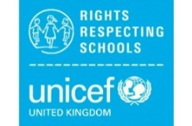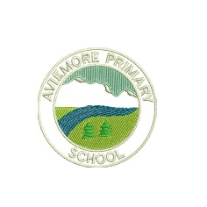**Aviemore Primary’s Right of the Fortnight**

The *Rights of the Fortnight and Global Goals* for Term 1 (2021-22) are:

**Week beginning 17th August 2021**-

Article 2:

All children have all these rights, no matter who they are, where they live, what language they speak, what their religion is, what they think, what they look like, if they are a boy or girl, if they have a disability, if they are rich or poor, and no matter who their parents or families are or what their parents or families believe or do. No child should be treated unfairly for any reason.

ALL Global Goals- These refer to ALL people everywhere of ALL ages.

**Week beginning 30th August 2021**-

Article 19:

Governments must protect children from violence, abuse and being neglected by anyone who looks after them.

Link to SDG 3- Ensure healthy lives and promote well-being for all at all ages

**Week beginning 15th September 2021** -

Article 20:

Every child who cannot be looked after by their own family has the right to be looked after properly by people who respect the child’s religion, culture, language and other aspects of their life.

Link to SDG 1- No Poverty

(1.4- By 2030, ensure that all men and women, in particular the poor and the vulnerable, have equal rights to economic resources, as well as access to

basic services, ownership and control over land and other forms of property, inheritance, natural resources, appropriate new technology and financial services, including microfinance.)

**Week beginning 27th September 2021**-

Article 22:

Children who move from their home country to another country as refugees (because it was not safe for them to stay there) should get help and protection and have the same rights as children born in that country.

Link to SDG 11- Sustainable cities and Communities

(11.1 By 2030, ensure access for all people to adequate, safe and affordable housing and basic services and upgrade slums)