Aviemore Primary’s SDG (Sustainable Development Goal) and Right of the Fortnight
Term 2 (2023-2024) 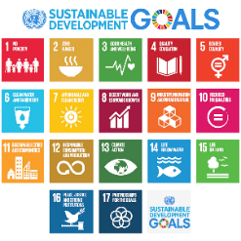

Week beginning 23rd October 2023-
SDG 5- Gender inequality
Link to UNCRC- Article 2 (no discrimination)
Link to SHANARRI- Respected, Included

Week beginning 6th November 2023 –
SDG 6- Clean Water and Sanitation
Link to UNCRC- Article 24 (Health, Food, Water, Environment)
Link to SHANARRI- Safe, Healthy

Week beginning 20th November 2023-
SDG 7- Affordable and clean energy
Link to UNCRC- Article 27 (food, clothing, safe place to live)
Link to SHANARRI- Safe, Healthy, Included

Week beginning 4th December 2023
SDG 8- Decent work and Economic Growth
Link to UNCRC- Article 32 (Protection from harmful work)
Link to SHANARRI- Healthy, Active, Nurtured, Achieving, Respected, Responsible, Included

Week beginning 18th December 2023
SDG 9- Industry, Innovation and Infrastructure
Link to UNCRC Article 27 (food, clothing, safe place to live)
Link to SHANARRI- Safe, Responsible

RESOURCES
SCOTDEC resources/activities:
- Explore the GGs booklet
- Explore the GGs Activities
- SDG worksheets
- SDG passport
These can all be found on Share point- General- 3.2 -RRS -SDGS
(I also have 2 hardcopies of the resource in my office if needed.)

