Aviemore Primary School/ELC
Planning the Outcomes of Learning – Termly Organiser
Session: 2023-24 Term: Autumn
Class: P1/2 Teacher: Ms Millar
Topic: All about me – Families and Homes
Skills: The ‘Animal Explorers’ support us with skills: The Focused Fox, The Curious Cat, the Ready rabbit, Parker the Problem Solver, The Calm Horse, The Painter Penguin and more to be introduced.
This Autumn term P1/2 are going to learn through a mix of child led, adult initiated and adult directed experiences. We are going to spend time on our class topic as well as making sure we have plenty time for play and our own projects. We will work indoors and outdoors. We will be working in the garden every week too.  Dates for the diary  August  14th In-service Day  15th School and nursery return  18th Assembly – Miss MacCallum – Vision, Values and Aims  18th Open event – meet the new teacher  25th Assembly – Mrs McMaster - SHANARRI  September  1st Assembly – Pupil Groups  8th Assembly – P5 and P6 sharing learning  11th and 12th In-service Days  15th Assembly – House Groups  (Launch enterprises – Osprey Foodbank collection and Capercaillie Shoebox Appeal)  22nd Assembly – Stage assemblies  (lower and upper school)  27th Flu immunisations  29th Star Assembly  October  3rd House Treat  6th Harvest Assembly  6th School and nursery close for October holidays and reopen on Monday 23rd October. | Curricular Areas  Literacy  Listening & Talking  - active listening and turn taking, discussion and thinking time  - story mapping and verbal retelling  - ‘Poem of the Week’ with Makaton,  Writing  - ‘Foundations of Writing’ drawing to tell stories (for some) and building a sentence (for some)  - personal accounts of events.  - Talk for Writing Story mapping/sequencing.  - strategies for spelling – ‘Hear it and say it! Stretch it and count it!’  - trying by ourselves, using our word wall and phonics charts to help us  Reading  - daily stories  - choosing books - library visits / library corner  - weekly group reading book - oral language development and retelling stories (wordless books for some)  - reading environmental print – signs and labels  - simple punctuation  - tricky / common words  Phonics  - simple phonics code - following ‘Wraparound Phonics’  - letter and sounds recognition using songs / actions  - sounding out and blending  - rhyme, songs, games, stories  Handwriting  - daily fine motor activities to develop pencil grip and scissor skills  - shape and direction  - writing on the line (for some)  Mathematics and Numeracy  - counting songs – ordering and number recognition  - recognise patterns of number using dice, tens frames and numicon.  - grouping and place value  - addition and subtraction  - measure – time – learning days of the week, months of the year, daily routines  - symmetry  - 2D shape/pattern  Health & Wellbeing  Mental, Emotional, Social and Physical wellbeing  - feelings and emotions – how they affect me and others around me – using ‘Mind Up’ resource  - Resilient Kids programme (for some)  Physical Education, Physical Activity and Sport  - listening games  - organization and safety  - focus and attention, movement, sequences, awareness of body, direction/speed, taking turn and taking part  - gymnastics  Food and Health  - eating socially with others for snack and lunch  - tasting new things from our garden safely – How do we know this is safe to eat?  - Weekly cooking / baking in small groups with produce from the garden  - Harvest Festival  - independently washing hands  Planning for choices and change  - making choices around play, taking part in learning activities  - begin to talk about my interests, skills and abilities  - Visits from people in the school who help us  Relationships, Sexual Health and Parenthood  - Values: being gentle and kind  - what makes a good friend , sharing resources, respect and friendships  - working cooperatively  - Class charter – linked to UN rights of the child  - High 5 Strategies  Science  - Observation  - Sorting  - Living and non-living  Social Studies  - Our Class / Playground Charter  - UNCRC  - All about me - families and homes – using ‘Seeds for Change’ resource  - weekly outdoor learning over four weeks – our local environment  - caring for the school environment  - introducing the Global Goals for Sustainable Development/Rights of the Child  Technologies  - Materials/textiles - Reduce/reuse/recycle – design and construct models  - Logging on to and using the Chromebook  Expressive Arts  Music  - rhythm and clapping games / songs and moving the body to music  Art  - patterns, shapes, printing  - mark making  - sketchbooks and how to use them  - artist investigations throughout session  Drama  - role play – families and homes UNCRC  Dance  - moving the body in expressive ways  RME  - Rights of the Child linked to stories on the importance of rights respecting behaviours e.g. kindness, respect  - values, fair/unfair, sharing/caring  - Mini Harvest Festival celebrating the rewards of the school garden  French  - Greetings and introductions
Opportunities for Personal Achievement

- P1/2 Class Star of the Week certificates at weekly assembly
- Class Crystals
- Star Writer
- Opportunities to earn house points across the school
- Postcards home
- Star assembly certificates from head teacher and house captains
- Profile Folder
- Sharing wider achievement

Class Charter

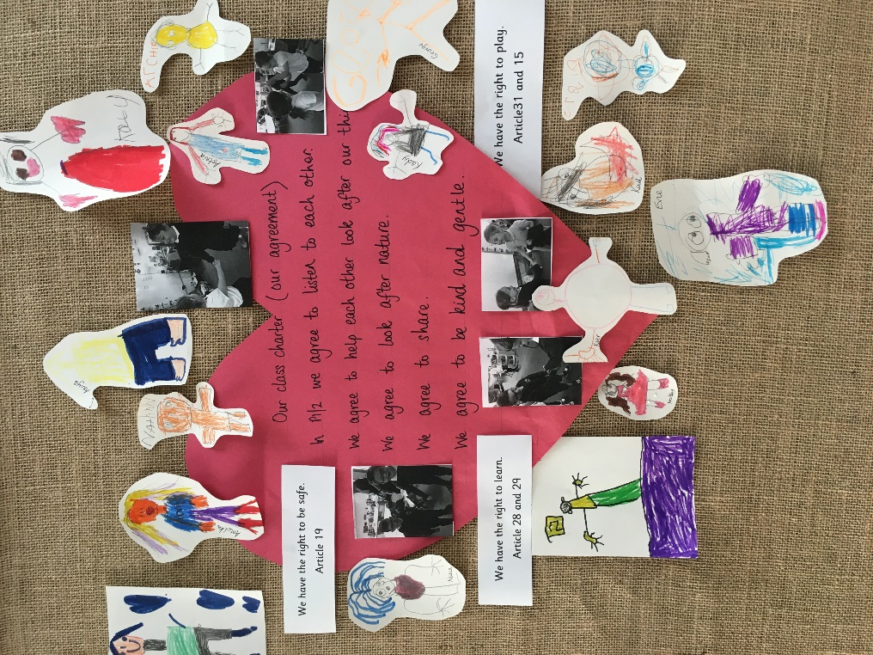

In P1/2 we agree to listen to each other.
We agree to help each other look after our things.
We agree to look after nature.
We agree to share.
We agree to be kind and gentle.

