Atmos accused of violations in fatal Lewisville explosion
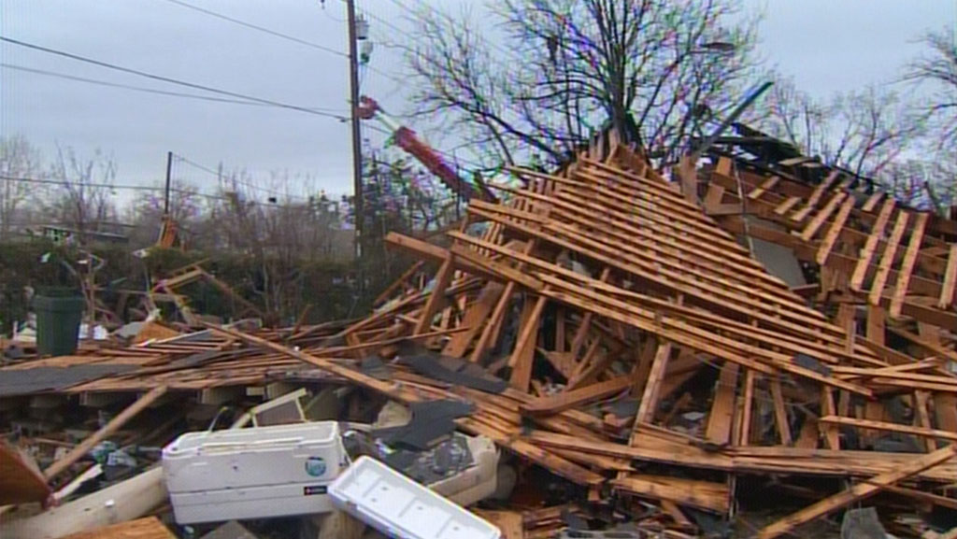

by BRETT SHIPP
WFAA
Posted on December 2, 2013 at 10:00 P.M.
NEWS 8 INVESTIGATES
LEWISVILLE — The State of Texas is accusing Dallas-based Atmos Energy of violating safety rules in connection with a fatal house explosion in Lewisville last January.
A report released by the Texas Railroad Commission on September 5 alleges Atmos could have not only helped prevent the leak that caused the explosion, but could have done more to make sure that gas never entered into the house that blew up.
The Texas Railroad Commission's Pipeline Safety Division is accusing Atmos of violating five safety regulations that may have played a key role in the fatal blast.
And while the allegations are serious, questions are being raised as to whether Atmos will suffer any consequences at all.
On January 11, utility crews working for Texas New Mexico Power struck a four-inch Atmos gas main while drilling a hole to install a power pole.
More than two hours after the line was struck, a house just 60 feet away filled with gas and exploded, killing 55-year-old Scott Deahl.
While Deahl's family is suing Texas New Mexico Power for striking the gas line, Atmos Energy is being blamed for violating numerous safety protocols that may have contributed to the fatal explosion.
The Texas Railroad Commission, which regulates the oil and gas industry in Texas, issued the report, which was just obtained by News 8.
Don Deaver, a pipeline safety expert who worked for Exxon for more than 33 years, interpreted the Texas Railroad Commission report. It alleges that procedures to prevent the damage to begin with were not available or followed.
"Atmos should have been there that day,” said Deaver. “Atmos or (one of its representatives) should have been there to do it. You've got to be there to see it on a real-time basis. The law has said that for a long time.”
The report also says Atmos did not have a valve necessary to shut down the gas flow. The gas line was punctured at 10 a.m. The house exploded two-and-a-half hours later at 12:30 p.m. Atmos crews finally stopped the flow of gas at 4:49 p.m. — almost seven hours after the line was first struck.
"If they had valves at a reasonable location, this incident would not have happened... this death would not have occurred,” Deaver said.
The third allegation is that an emergency plan was not implemented correctly. The report found that Atmos’ follow-up investigation was not performed effectively, and that Atmos Energy did not coordinate efforts with emergency officials directed toward protecting the public.
While Lewisville firefighters evacuated homes downwind of the leak that day, no one told Deahl — the man in the house 60 feet away — that gas could migrate underground.
"Gas follows the path of least resistance, and it can go quite a ways,” Deaver explained. “Typically it goes through sewer lines, and that's its first choice."
That's exactly what happened in McKinney in 2008. Another Atmos gas line was ruptured during an excavation. More than an hour passed and no homes were evacuated when gas migrating through sewers found its way into two homes and exploded.
One person was killed, two others were injured. Attorney Clay Miller said his client was just yards away from the ruptured gas line and was not told to evacuate.
"He was never warned. No one ever knocked on his door and said there was a leak,” Miller said. “No one ever said 'you may need to evacuate your house.’ He was given no warning."
Atmos President John Paris told the public at the time, "Atmos is obligated to learn and prevent this in the future."
Despite being cited by the state for six alleged safety violations in the McKinney explosion, Atmos was never fined. Atmos was sued and settled, but the amount of the settlements has not been disclosed.
In the Lewisville case, Atmos denies responsibility.
"This was an avoidable mistake by the construction crew that ultimately caused the loss of life at a nearby residence,” said Atmos spokeswoman Jennifer Ryan. “Atmos Energy deeply regrets that these events took place."
As for the alleged violations, Atmos has "requested an extension to gather and provide the Texas Railroad Commission with accurate information from the investigation," Ryan said, adding that Atmos "continues to work closely with area first responders to review and improve our emergency response procedures."
Efforts to contact the family of the victim for a response to the alleged violations against Atmos have been unsuccessful. Their attorney, Randy Mathis, declined to comment because they are in the middle of settlement negotiations with Texas New Mexico Power.
TNMP has been fined by the Texas Railroad Commission $500 for having an expired gas line locator ticket.
E-mail bshipp@wfaa.com

