Introduction
In this Pandas challenge, I was tasked to analyze the data for the most recent fantasy game Heroes of Pymoli.
This report presents insights derived from the game's purchasing data file as well as noticeable trends.

Player Count
There are 576 unique players in this database who purchased 780 items.

Purchasing Analysis (Total)
Table 1

Purchase Analysis (Item)
Number of Unique Items | Average Item Price | Number of Items Purchased | Total Revenue
183 | $3.05 | 780 | $2,379.77

Gender Demographics
Table 2
Table 2

Gender Demographics
Gender | Number of Players | Percent of Players
Male | 484 | 84.03%
Female | 81 | 14.06%
Other/Non-Disclosed | 11 | 1.91%

Purchasing Analysis (Gender)
Table 3

Purchase Analysis (Gender)
Gender | Purchases | Total Revenue | Average Sale (Gender) | Average Sale (Person)
Male | 652 | $1,967.64 | $3.02 | $4.07
Female | 113 | $361.94 | $3.20 | $4.47
Other/Non-Disclosed | 15 | $50.19 | $3.35 | $4.56

Age Demographics
Table 4

Age Demographics
Age Groups | Number Purchased | Percent Purchased of Total Sales
<10 | 17 | 2.95%
10-14 | 22 | 3.82%
15-19 | 107 | 18.58%
20-24 | 258 | 44.79%
25-29 | 77 | 13.37%
30-34 | 52 | 9.03%
35-39 | 31 | 5.38%
40+ | 12 | 2.08%

Top Spenders (Player)
Table 5

Top Five Spenders (Player)
Player Name | Purchased | Average Purchase Price | Total Revenue
Lisosia93 | 5 | $3.79 | $18.96
Idastidru52 | 4 | $3.86 | $15.45
Chamjask73 | 3 | $4.61 | $13.83
Iral74 | 4 | $3.40 | $13.62
Iskadarya95 | 3 | $4.37 | $13.10

Top Spenders (sorted on number purchased by age)
Table 6

Top Spenders by Age Group
Age Groups | Purchased | Average Price | Total Revenue | Average Purchase Price
20-24 | 365 | $3.05 | $1,114.06 | $4.32
15-19 | 136 | $3.04 | $412.89 | $3.86
25-29 | 101 | $2.90 | $293.00 | $3.81
30-34 | 73 | $2.93 | $214.00 | $4.12
35-39 | 41 | $3.60 | $147.67 | $4.76
10-14 | 28 | $2.96 | $82.78 | $3.76
<10 | 23 | $3.35 | $77.13 | $4.54
40+ | 13 | $2.94 | $38.24 | $3.18

Most Popular Items
Table 7

Most Popular Items (Top 5)
Item ID | Item Name | Purchased | Price | Revenue
178 | Oathbreaker, Last Hope of the Breaking Storm | 12 | $4.23 | $50.76
145 | Fiery Glass Crusader | 9 | $4.58 | $41.22
108 | Extraction, Quickblade Of Trembling Hands | 9 | $3.53 | $31.77
82 | Nirvana | 9 | $4.90 | $44.10
19 | Pursuit, Cudgel of Necromancy | 8 | $1.02 | $8.16

Most Profitable Items
Table 8

Most Profitable Items
Item ID | Item Name | Purchased | Price | Revenue
178 | Oathbreaker, Last Hope of the Breaking Storm | 12 | $4.23 | $50.76
82 | Nirvana | 9 | $4.90 | $44.10
145 | Fiery Glass Crusader | 9 | $4.58 | $41.22
92 | Final Critic | 8 | $4.88 | $39.04
103 | Singed Scalpel | 8 | $4.35 | $34.80
Observable Trends
- Oathbreaker, Last Hope of the Breaking Storm, Nirvana and Fiery Glass Crusader are among the top five of being the most popular and profitable items.
- The two top spenders per items are within the age groups 35-39 and under 10. (See table 6)
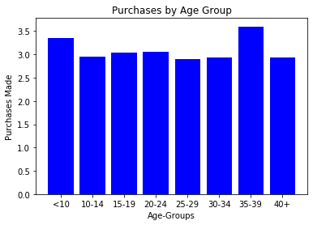
- The age group 20-24 buy far more items than any other age group, but as seen above spend less per item than other groups (See Table 4).
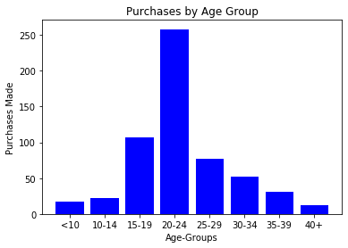
- 84% of the players are male, and Females and gender “Other” spend more per item than their male counter-part (See Table 3).

