FOR IMMEDIATE RELEASE

Nicole Tito’s “Estes Method and EVPs: The Search for Ghostly Voices” Now Available Worldwide on Amazon
Chicago, IL—September 1, 2023—Paranormal investigator with over two decades of experience, Nicole Tito, announces the global release of her book, Estes Method and EVPs: The Search for Ghostly Voices. Drawing from her extensive firsthand involvement in more than 100 investigations nationwide, Nicole offers a compelling exploration into the realms of the Estes Method, Electronic Voice Phenomena (EVP), and modern ghost hunting equipment. This book showcases her fascinating paranormal evidence while presenting an informed, analytical perspective on the subject.
Going beyond the sensationalism often associated with ghost hunting, Estes Method and EVPs: The Search for Ghostly Voices, delves deep into the processes of collecting, reviewing, and interpreting paranormal evidence, discerning fact from fiction. Far more than a mere compilation of ghost stories, this comprehensive guide caters to seasoned investigators as well as curious enthusiasts, presenting a thoughtful approach to the subject matter.
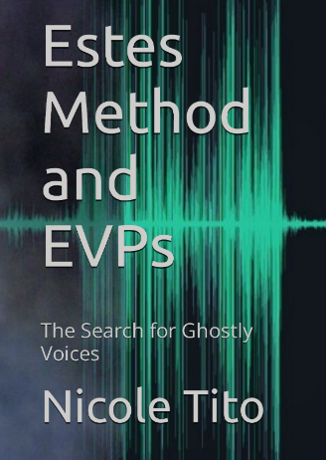
In the pages of the book, readers will explore the groundbreaking Estes Method, a technique employed by paranormal investigators to establish direct communication with spirits. They will also discover the phenomenon of EVP, where voices and inexplicable sounds are captured on electronic devices.
Availability:
Estes Method and EVPs: The Search for Ghostly Voices can be purchased in both eBook and paperback formats on Amazon worldwide. Additionally, readers can acquire autographed and personalized copies directly from the author via her official website, www.ghostly-voices.com.
For those interested in obtaining a copy or learning more about Nicole’s paranormal adventures and evidence, please contact:
Nicole Tito
Organization: Ghostly-Voices
Website: www.ghostly-voices.com
Email: ghostlyvoices11@gmail.com
Phone: (773) 450-1985

