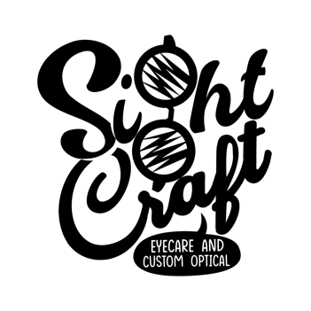

SightCraft Eyecare and Custom Optical

540 Northwood Rd

West Palm Beach, FL 33407

Phone 561-931-4114| Fax 561-931-4130

info@sightcrafteye.com www.sightcrafteye.com

Contact Lens Exam Policy

Thank you for choosing SightCraft Eyecare and Custom Optical for your contact lens care. Our mission is to ensure the health of your eyes and take care of all of your contact lens needs. Please read our Contact Lens Exam policy, sign, and date the bottom. By signing, you agree with our contact lens policies and agree to pay for in full any contact lens-related fees.

The evaluation fee includes the doctor’s professional time, including (1) initial evaluation (2) follow-up visits within the first 90 days, and is determined by the type of lenses prescribed and the difficulty of the fit. Patients will incur additional charges for medical exams (red eye, abrasions, stuck lenses, etc.). If an initial evaluation fee needs to be changed due to switching the type of contact lens, you will be charged the difference in the evaluation fees between the original evaluation cost and the final evaluation cost.

I understand that I must adhere to proper lens care, good personal hygiene, scheduled lens replacements, and an annual eye exam. I understand there are risks associated to wearing contact lenses, such as eye irritation, infection, possible corneal injury, and vision loss, if I exceed the wearing schedule prescribed by my optometrist or do not care for my lenses properly.
Please be advised that a contact lens prescription will only be released after a contact lens evaluation has been performed. Additional charges, determined by the doctor, will incur if the visits are missed and extend beyond the 90 days.

Contact lens examination fees, as with all other professional fees, are non-refundable and due at the time of service.

The contact lens prescription may not be released under these circumstances:

- There is potential harm to the patient’s ocular health.
- The prescription has expired, or it has been 12 months from the date of the comprehensive eye examination.
- Final determination of the contact lens prescription has not yet been made and further monitoring is needed.

I have read and understand the Contact Lens Exam policy. All my questions have been answered and I know where to obtain copies of the above information. I understand that my compliance with the Contact Lens Exam policy is of the utmost importance in the health of my eyes.

_______________________________ _______________________________
Patient/ Guardian Print Name Patient/ Guardian Signature & Date

