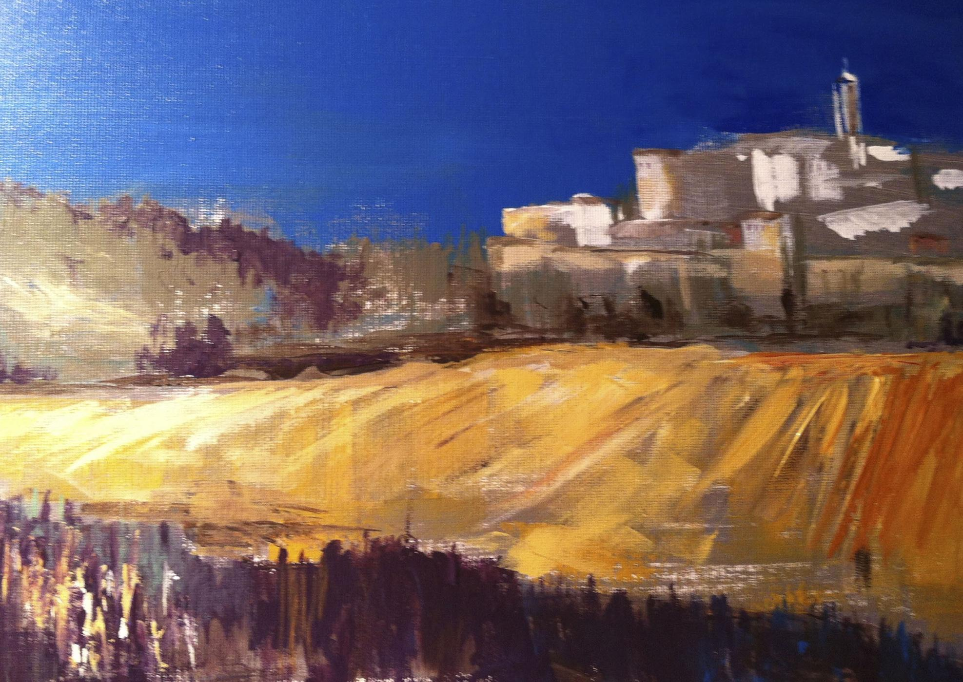
Artist Statement

“When I paint I see life as a harmonious symphony that has played for centuries timeless and alive, constantly engaged in new creations and I am the instrument that will dance with the piece to tell a story.

I like portraying the infinite possibilities of the impact humans and nature have on each other as part of a balance, as nature is always defining our architecture, fashion, design, origin and culture, and creating the most marvelous and contradictory realities.
.
I want the viewer to perceive more than meets the eye when they experience my paintings, to be able to look at a piece of art and transcend to the smell of the mud, taste the salt in the water, feel the glare of the sun and listen to the breeze in the leaves.

They say impressionists were masters of light. I have discovered it is so much more…”
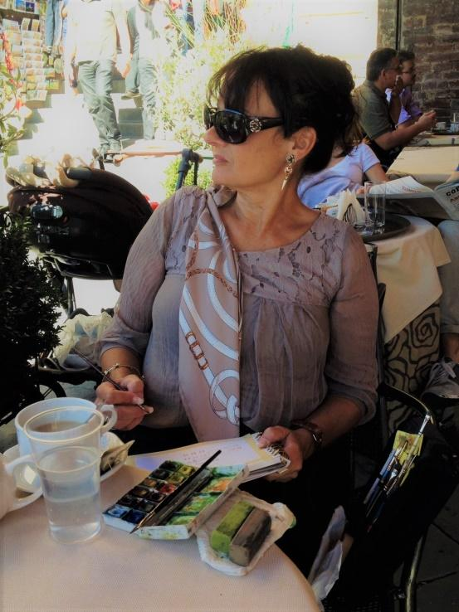

TISHA WOOD
BIOGRAPHY

Tisha Wood is a neo-impressionist artist whose life journey displays a strong palette knife stroke in oil and acrylic, as well as a delicate brush when painting plein-air with watercolors. Her signature work, graceful shapes and sultry colors, captures the sensitivity of an encounter with a person or place to bring you into that moment on canvas.

LIFE & INFLUENCE

Born in Nice, France her childhood was nurtured with the love for the vistas of her family’s origin “the isle of beauty,” Corsica. Her father, the writer Dr. Charles Balesi, was often assigned to Chicago, Il, where Wood was able to enjoy all the benefits of an obsession with the Chicago Art Institute at a young age. In her early years as a painter, Tisha received her formal art training through the Beaux Arts and as a protégé of the highly acclaimed Vermont artist Lillian Kennedy. Today Tisha Wood is part of the international Franco-American artist scene, delivering exquisite exhibits in both countries.

ARTIST'S WORK
2019:
- Piece donation to the 31st Annual Snowball Gala Chicago, Il. To help raise money for the Pediatric and Adolescent HIV & AIDS Programs at Ann & Robert H. Lurie Children’s Hospital of Chicago. January 2019.
- “Beyond the Light”. Watergate Gallery Annual Exhibit, Washington D.C. May 2019
- City Hall at Quenza Corsica, France. July 2019.
- City Hall at Miomo, Corsica France. July 2019.
- “Journey to the Kankakee”. A one woman exhibit for the 150th birthday of Frank Lloyd Wright at The Bradley House, Kankakee, Il. September 2018.
- “A Veteran’s Pallet”. A two-day fine art workshop for veterans imparted next to the renowned Master in the Arts, painter Lillian Kennedy. The Clear Path for Veterans in Chittenango, N.Y. Sept, 2018
- SmithKlein Gallery in Boulder, Colorado.
- The Musée Villa Ramelli-Gaspari Corsica, France,
- The St Julien Hotel for their One-Woman Exhibit.
- Wood was the Artist in Residency 2016 at the Ragdale Foundation Chicago, Il.
- The Bolder Boulder race artist in 2017.

