PACKING LIST FOR CORSICA

For your trip, you will only be able to bring one carry-on bag and a backpack!
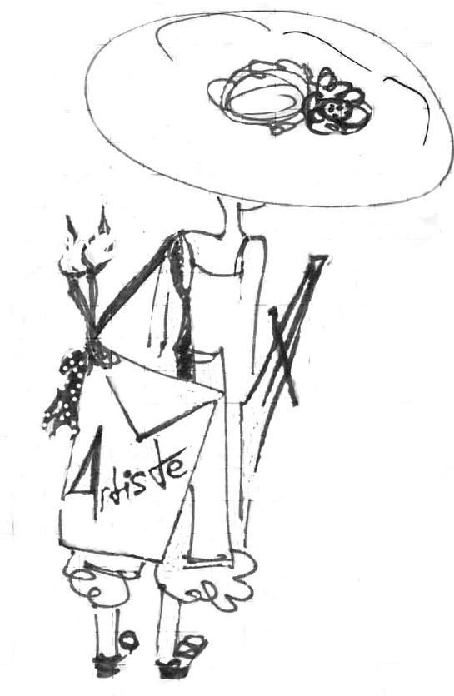
Oh yes you can do this…..

These are your essentials in clothing:

2 Jeans or light material comfortable travel slacks / peddle pushers
1 pair comfortable shorts or skorts
One comfortable skirt
One summer dress (optional)
5 comfortable light tops
1 light painting shirt
Light rain jacket
Light sweater/cardigan
1 bathing suit & coverup
1 pair of comfortable lightweight evening shoes
1 pair of comfortable lightweight walking/sneakers
1 pair lightweight water shoes
Personal meds (Refer to your health requirements page)
Toiletries in carry-on sizes only
Do not include any shampoos, conditioners, body soaps or aerosol sprays. These are easily accessible on site.
PACKING LIST FOR CORSICA
(CONTINUED)

Art Supplies to Pack

Note: palette knife sets, portable easels and liquid paints must be received at tisha’s office for transport by July 20th! All other supplies, including your brushes and canvases, will be carried by you in your carry-on.

NOTE: Your accommodations will only have washers (soap will be provided); not dryers

