**BORED AT HOME?**

**Is it possible to have fun while staying safe out there?**

We are well into the summer now and many of us are going stir-crazy. Most are feeling the urge and need to get out of the house to feel a sense of normalcy, to have fun, and enjoy life again, yet, the big COVID19 cloud still hangs above our heads reminding us that it’s no longer safe to enjoy popular, social activities in the same manner we once did before the pandemic. This doesn’t mean, however, that we need to stay in our house and yard always-and-forever.

Here are a few safer, New Jersey, family-friendly events and activities you might want to venture out to enjoy, (depending on your comfort level), as long as you follow all safety guidelines to social distance and properly wear your mask over your nose and mouth.

**DRIVE-IN MOVIES**

Stay in the comfort and safety of your car while enjoying a few hours out, watching a great movie or two with others (also in their cars).

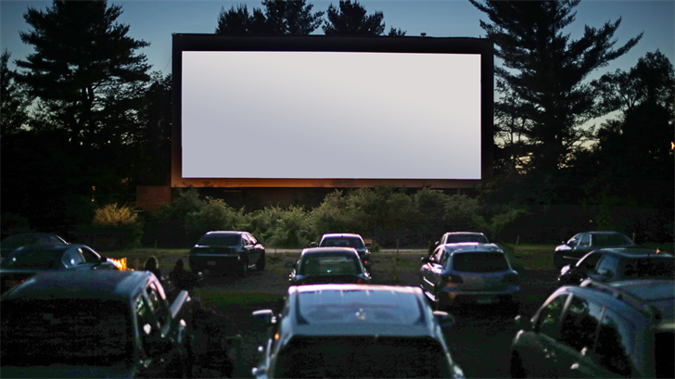

<http://newjersey.news12.com/story/42185669/guide-drivein-and-outdoor-movie-events-around-new-jersey>

**Boxcar Drive-In Movies** [**https://www.boxcarapp.com/movies**](https://www.boxcarapp.com/movies)

**Multiple locations throughout New Jersey**

This is a downloadable app originally designed to help you find parking spots, now, it is an app to let you know where you can view drive-in movies. At these events, they also partner with local dining establishments to provide movie goers food and beverages. Locations are throughout New Jersey.

**Carpool Theatre** [**https://montclairfilm.org/events/carpool-theater/**](https://montclairfilm.org/events/carpool-theater/)

**9 Cherry Lane in West Orange, NJ**

Drive-In event for the weekend of Friday, July 24th to Sunday, July 26th. $30 per vehicle will offer you a showing of The Lego Movie, Willy Wonka and the Chocolate Factory, or the Fight. Feel free to bring your own food since no concessions will be offered there. Safety protocols will be emailed upon online ticket purchase.

**Delsea Drive-In Theatre** [**https://www.delseadrive-in.com/**](https://www.delseadrive-in.com/)

**2203 S Delsea Dr, Vineland, NJ 08360**

Movies and filmed concerts (like Blake Shelton & Gwen Stefani & Trace Adkins on July 25th) are presented Thursdays through Sundays. Tickets and food must be purchased online and safety guidelines of social distancing and mask wearing are enforced when you leave your vehicle to use the restroom or pick up food at the concession stand. Tickets are approximately $12 with processing fee per person for double features and $20 plus fee for a food permit.

**Demarest Farms** [**https://demarestfarms.com/**](https://demarestfarms.com/)

**244 Wiermus Rd, Hillsdale, NJ 07642**

Pick-Your-Own Farm, Haunted Orchard, food stand and more offering Drive-In Movie Nights for your safe entertainment. Face coverings are required when outside your vehicle, social distancing is enforced, and purchases are to be made in advance, online, including food and beverages from the concession stand. Movies will be offered through August 29th and most are already sold out so get your tickets now.

**Warwick Drive-In Theatres** [**https://www.warwickdrivein.com/**](https://www.warwickdrivein.com/)

**5 Warwick Turnpike, Warwick, NY 10990**

Open every night, rain, or shine, and offering double features at $12 for adults, $8 for kids 4-11 and FREE for those under 4. Safety precautions are well taken care of. All purchases are made through an app or their website, only one customer is allowed at a time at the concession stand, and social distancing as well as mask-wearing rules are enforced.

**FARMS**

Be one with nature while visiting some of New Jersey’s working farms. Enjoy the outdoors while social distancing. It’s a great opportunity to absorb some good vitamin D, some fresh air, and picking some healthy fruits and vegetables!

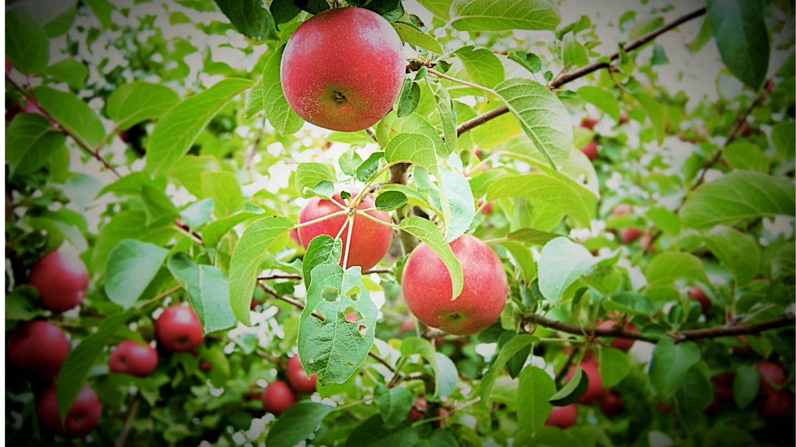

**Alstede Farms** [**https://www.alstedefarms.com/**](https://www.alstedefarms.com/)

**1 Alstede Farms Lane, Chester, NJ 07930**

Large farm with much to do and explore. You can spend your day here picking-your-own fruits and vegetables, shopping in their store, visiting the hen house, the cider mill and the farm stands, or finding your way through the maze, then enjoying some wine at their vineyard, or learning all about farm life and conservation programs. Many new COVID19 safety guidelines are always enforced such as mask wearing and social distancing, special hours for at-risk seniors, and handwashing & sanitizing stations throughout.

**Cherry Grove Farms** [**https://www.cherrygrovefarm.com/**](https://www.cherrygrovefarm.com/)

**3200 Lawrenceville Rd. Lawrenceville, NJ 08648**

500-acre dairy farm with milking parlor, creamery, and store. Visit the cows, enjoy a variety of cheeses, have a picnic in the gardens, and shop to your heart’s content while adhering to the safety protocols of mask wearing, social distancing, limited number of customers-at-a-time in the store, and hand washing.

**Demarest Farms** [**https://demarestfarms.com/**](https://demarestfarms.com/)

**244 Wiermus Rd, Hillsdale, NJ 07642**

Pick your own apples, peaches, and pumpkins at this farm. To keep you safe, reservations are now required, and everything must be purchased online. Proper social distancing is enforced, and masks must always be worn properly. You will be assigned a time and specific area for picking, after washing your hands at one of their convenient stations throughout the farm. The cost is $5 per person (2yrs and over) to enter and $12 per 10lb bag. Also offered here are Drive-In Movie Nights, Haunted Orchards around Halloween, and Orchards of Lights in December.

**DiMeo Farms and Blueberry Patch** [**https://www.dimeofarms.com/**](https://www.dimeofarms.com/)

**3101 Nesco Rd, Hammonton, NJ 08037**

104-year old, upscale, organic blueberry farm where you can purchase blueberry plants to take care of at home or stroll the grounds to pick-your-own. Enjoy choosing your best blueberries on their picturesque nature trails with music and occasional wildlife. Picking is by appointment only, 7days a week from 10am to 6pm.

**Farm in Harmony** [**https://www.thefarminharmony.com/**](https://www.thefarminharmony.com/)

**231 Brainards Rd, NJ 08865**

Corn maze and farm shoppe selling mostly specialty, handmade goods. Every year, the maze honors veterans and this year’s design is of the Huey Helicopter. Purchase your tickets online for $7/person and enjoy maneuvering your way through the path. The maze opens September 7th through November 11th, Wednesdays through Sundays, 11am to sunset.

**Norz Hill Farm & Market** [**https://norzhillfarm.com/**](https://norzhillfarm.com/)

**116 S. Branch Rd. Hillsborough, NJ 08844**

Visit this farm and learn about farm-life. Enjoy produce from their store and multiple festivals throughout the summer and fall weekends. Scare-Farm and a Halloween Maze will be ready for your enjoyment September 12th – November 7th, and the Egg Shed and Meat Sales from November through the winter months. In response to COVID19, masks must be worn, and designated, social distancing waiting areas have been placed in the Market where you will be assigned a personal shopper.

**Orchard View Lavender Farm** [**https://www.orchardviewlavenderfarm.com/**](https://www.orchardviewlavenderfarm.com/)

**101 Karrsville Rd. Port Murray, NJ 07865**

Visit this beautiful lavender farm and shop with incredibly soothing fragrances. Enjoy yoga classes or sunsets overlooking the farm, or shop in their store with homemade soaps, essential oils, teas and more. For your safety, hand washing is required before entering, masks must be worn, and only 5 customers will be allowed in the shop at one time.

**Stormwind Alpacas** [**http://www.stormwindalpacas.com/**](http://www.stormwindalpacas.com/)

**1862 Jacksonville-Jobstown Rd, Columbus, NJ 08022**

Make an appointment to spend time with this farm’s alpacas. Enjoy walking through their gardens or their store where you can purchase alpaca yarn or handmade products made of alpaca wool like mittens, scarves, blankets and more.

**VonThun’s Farm & Market** [**https://vonthunfarms.com/**](https://vonthunfarms.com/)

**505 Ridge Rd, Monmouth Junction, NJ 08852**

With fields in Brunswick and Washington, enjoy picking berries, walking through sunflower fields, and making your way through fun Fall mazes. With fields open for your berry-picking enjoyment from 10am to 5pm, you will need a reservation, a mask, and clean hands to make use of your pre-paid $3 picking pass. Containers are offered in pints, quarts, and buckets, and range from $6 to $35 each.

**FAIRS & OTHER OUTDOOR EVENTS**

Looking for something different and exciting, you might want to consider the following.

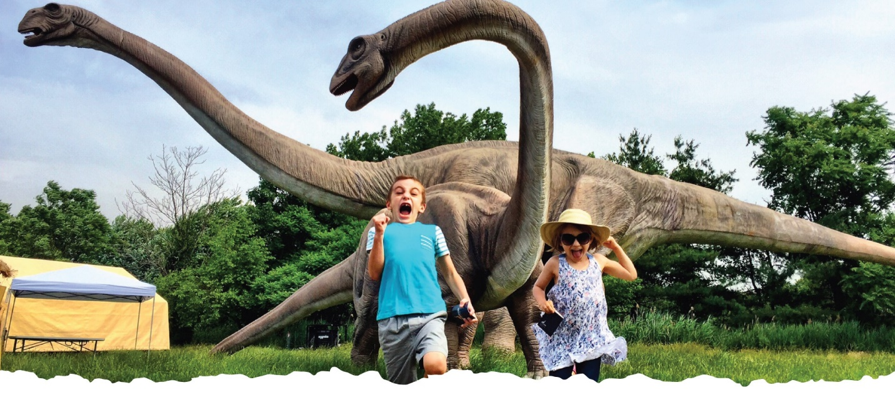

<https://jerseydinos.com/about/>

**Brookhollow Barnyard** [**https://brookhollowsbarnyard.com/**](https://brookhollowsbarnyard.com/)

**301 Rockaway Valley Rd, Boonton, NJ 07005**

Exciting drive-though and/or walk-through farm where you can admire the animals from the safety of your car for $15/car or walk-though while adhering to all protocols and rules at $5/person. Special events like a corn maze and zombie hayride will also be offered around Halloween.

**Field Station Dinosaurs** [**https://jerseydinos.com/**](https://jerseydinos.com/)

**Overpeck County Park, Fort Lee Road, Leonia, NJ 07605**

Starting August 15th through October 31st, enjoy this one-of-a-kind family attraction where dinosaurs come to life, thanks to robotics, on the banks of a scenic creek and forested park. Participate in games and activities, walk the relaxing trails, and have fun watching the exhibits and shows, which are all included in your pre-paid day pass or dinosaurs-after-dark pass. Check out their special events as well where you can meet professional paleontologists, geologists, and more.

**Shakespeare Theatre of New Jersey** [**http://www.shakespearenj.org./PublicHealthUpdate.html**](http://www.shakespearenj.org./PublicHealthUpdate.html)

**36 Madison Avenue, Madison NJ 07940**

Although this theatre’s 2020 planned performances have been rescheduled for 2021, they will be offering a few plays on their backyard stage starting July 30th. Tickets are $20 and must be purchased in advance for the 4:30pm or 7pm shows. Seating pods will be arranged, and masks are always required.

**Surflight Theatre Show & Ice Cream Parlor** [**https://www.surflight.org/showplace**](https://www.surflight.org/showplace)

**201 Engleside Avenue, Beach Haven, NJ 08008**

Performances and great ice cream, coffee and pastries are offered here in their outdoor, tented parlor. With exciting cabaret shows like Annie Get Your Gun, Phantom of the Opera, and Sound of Music, to name a few, it’s an experience you will not forget. To enjoy some great food and a show, you must reserve your table in advance at $5 per person. For your safety, the waitstaff and performers are tested regularly, wear masks, and social distance, while the establishment is cleaned often and thoroughly.

We hope you get to experience and enjoy one, a few, or more of the options above, when you are ready, however, please remember that the only way we can stop this pandemic is by following all safety guidelines at all times. If you need additional, outdoor activity ideas, don’t forget about our zoos, beaches, hiking & biking trails, lakes, picnic areas and playgrounds. (link to those articles)

Stay safe, wear a mask, and always adhere to social distancing rules, or stay home!

*\*\*\* As always, since information is often changing, please make sure to confirm all activities on the business’ website before attending.\*\*\**