CELEBRATE DINO FEST VIRTUALLY
with the Newark Museum
September 12th, from 10am to 6pm

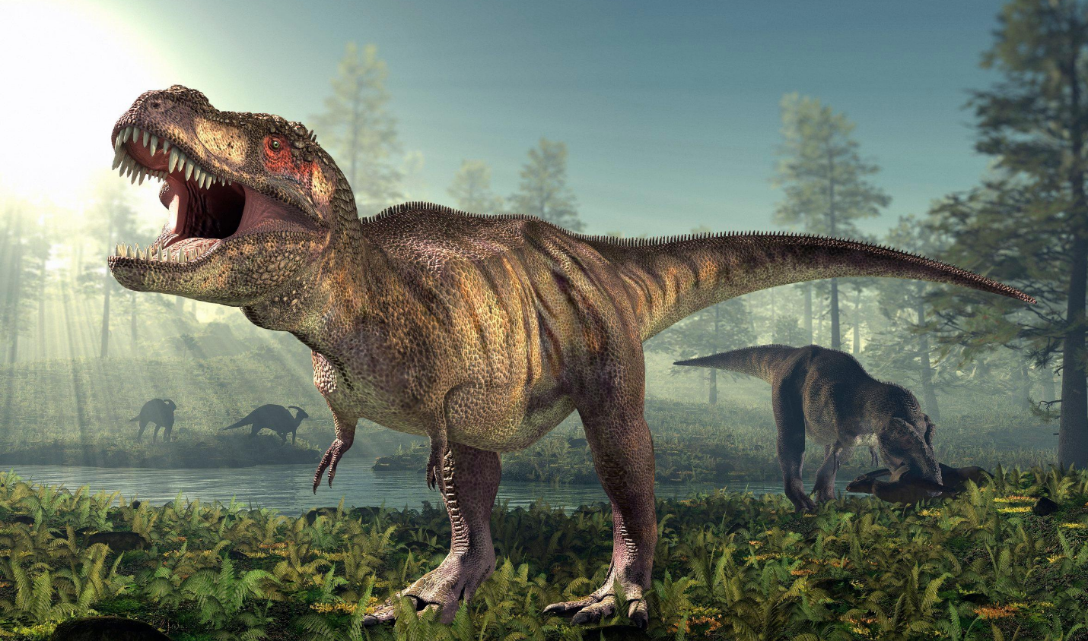
Does your child love dinosaurs? Do they miss walking through the halls of prehistoric exhibits to admire these creatures from our distant past? If so, you won’t want to miss this day-long, virtual event, presented by the Newark Museum, called Dino Fest. Filled with fun, interactive activities from 10am until 6pm, you and your child will be able to play, see, learn, and ask experts all your dino-related questions, from the safety and comfort of your home, virtually through Zoom and Facebook Live.
The schedule-of-events is as follows:
10am – 10:45am Storytime at Field Station - Click here to register for the Zoom session with special dinosaur stories and songs.
https://zoom.us/meeting/register/tJIlcuisrDwiGtXLBMT7DuEvkXvKBtjgHlpq

11am – noon Dinosaur Art - Click here to register for the Zoom session with drawing and special effects lessons from the experts on Zoom and Facebook Live.
https://zoom.us/webinar/register/WN_FFHU6NGdTs2NZTBB6mv7Dg

1pm – 2pm Dinosaurs Rock! - Click here to register for the Zoom session to see, learn and ask questions about authentic, museum-quality specimens, presented up-front, on your screen.
https://us02web.zoom.us/webinar/register/WN_eEswwGwrQV-RHPbKOU4mfA
For more information, visit www.DinosaursRock.com. The Facebook event can be found on @dinosaursrockevents.

2:30pm – 3:30pm Virtual Tour of the Dinosaur Exhibits at the North Carolina Museum of Natural Sciences - Click here to register for the Zoom session to virtually walk through the halls of our planet’s past at this out-of-state museum.
https://zoom.us/webinar/register/WN_GnxFkzBdQPaa_jLD51_wcg
For more information visit https://naturalsciences.org. The Facebook event can be found on @naturalsciences.

4pm – 4:45pm Eyes of the Wild - Click here to register for the Zoom session to see and learn all about current, modern-day, live animals, known as dinosaur descendants.
https://us02web.zoom.us/webinar/register/WN_sTy4a_chQ-yrQJcmy2d1Jw

5pm – 6pm Dino Party! - Click here to register for the Zoom session to celebrate the conclusion of this wonderful Prehistoric Day with dance, music, and dinosaur puppets.
https://zoom.us/meeting/register/tJAsdOGprTkvHN0dyrSD7HcRNXhK2qvT-qEw

Enjoy this wonderful, virtual event, September 12th from 10am to 6pm, and don’t forget to check out other fun, online events and experiences offered through the Newark Museum. Their full list of options can be found here. https://www.newarkmuseumart.org/nmoaathome

