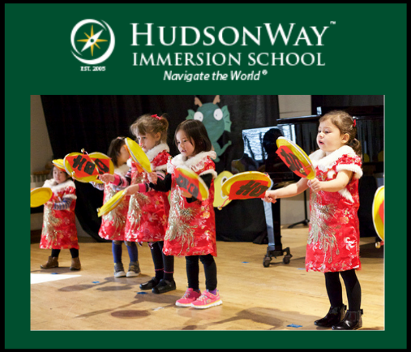
HudsonWay Immersion School
https://hwis.org/
Address: 249 Bebout Avenue Stirling, NJ 07890
Phone: (908) 598-8088

As parents, our goal is to give our children the best opportunities to support their future success. As careers are becoming increasingly competitive, wouldn’t it be a great advantage to be fluent in another language? Could this added skill broaden our children’s understanding of others and open them up to additional opportunities? Now in Stirling, NJ there is an independent school, HudsonWay Immersion School, (www.hwis.org) that for over a decade has been doing just that….ensuring that children develop flexible minds, cultural awareness and literacy in TWO languages – English and either Mandarin Chinese or Spanish.
What is an immersion program? Unlike language schools, which expose children to a foreign language for only about a 45-minute session, immersion programs provide instruction in the target language (Mandarin or Spanish) for a majority of the day to teach the core subjects such as math, science, or social studies. In fact, in preschool, when children so effortlessly absorb new information, HudsonWay’s model exposes the students to their target language 90% of their instructional time. This intensive exposure ensures children develop advanced language proficiency skills while making their brains smarter.
Could such a program confuse a student or deter them from properly developing the required skills in their main language? On the contrary, test results show that HudsonWay Immersion School students “outperformed gifted and talented public-school students, as well as students from independent schools nationally, in all subjects.” * Learning a second language actually enhances English skills through the development of meta-linguistic awareness, the ability to understand how languages work.”
“The key”, says Sharon Huang, Executive Founder of HudsonWay Immersion School, “is to start early. Although it is never too late to learn a new skill, younger children are uniquely gifted at acquiring language. This immersion experience at a young age, will greatly develop the students’ cognitive skills, social skills, cultural knowledge, language proficiency, and executive function which are all linked to academic success. Why not enable your children to benefit in all these ways that develop skills important for the 21st century while their brains are developing?
HudsonWay Immersion School offers preschool starting at age 2 ½ and continues through grade 6 with expansion to grade 8 in the future. If ensuring your child has an advantage is important to you, this is surely a “must” on your consideration list.
Registration is underway now for the 2019-2020 school year. To assist you in answering all your questions, HudsonWay Immersion School will be holding two upcoming Open House Info Sessions:
Friday, January 11th at 9am
Friday, February 1st at 9am
Please contact the school at (908) 598-8088 or visit www.hwis.org to make your reservation for the session and tour
Additionally, as a fabulous introduction to the school, why not also have your child join them for Summer Camps with two-week themes such as:
June 24-July 3: Under the Sea
July 8 – 19: Junior Chef
July 22-August 2: HudsonWay Olympics

Each 2-week-long camp will offer students age-appropriate education and perspective about our world. Campers will be grouped by age and language ability to better develop cultural appreciation and language skills. Their daily schedule will include immersive activities such as “science, geography, literature, cooking, art, music, and outdoor play.” *
We all want the best for our children.
Why not start them on a path to “Navigate the World”? *
Call the school now at (908) 598-8088 to schedule your tour, then allow your child to explore our world and all the wonders it has to offer, to all those who are ready and able to embrace it.

* Information or quote taken directly or indirectly from HudsonWay Immersion School’s website

