WELCOME TO
THE CHURCH OF THE STRAITS
Pastor David Wallis

September 11, 2022 10:30 a.m.

Welcome and Announcements

Green Prayer Cards may be filled out with your joys/prayers/concerns. Ushers will collect them during prayer time.

*Call to Worship screen
“Shine Jesus Shine”

*Prayer of Confession
In our brokenness Lord, you see such potential. You proclaim that “in all things you work for the good of those who love you.” We proclaim your promise for us, in Jesus’ name, Amen! (Romans 8:28)

*Gloria Patri #623

*Hymn #477
“Stand Up, Stand Up for Jesus”

First Scripture Reading pg. 550
Psalm 34:17-19
Liturgist – Ann Hayes

Children’s Time

Sharing our Joys and Concerns
Silent Prayer and Pastoral Prayer
The Lord’s Prayer
Our Father, who art in heaven, hallowed be thy name. Thy kingdom come, thy will be done on earth as it is in heaven. Give us this day our daily bread. And forgive us our trespasses as we forgive those who trespass
against us. And lead us not into temptation,
but deliver us from evil. For thine is the kingdom, and the power, and the glory forever. Amen.

*Affirmation of Faith in Song screen
“I Will Sing”

Giving our Tithes and Offerings
Offertory
Doxology #625
*Prayer of Dedication

Second Scripture Reading pg. 1186
Hebrews 4:14-16

Sermon “A Bunch of Broken Pieces
Make a Beautiful Picture!”

Communion see insert

*Hymn #574
“If My People’s Hearts Are Humbled”

*Benediction

Special Music “The Minstrel Boy”
Les Jackson, Jeff & Sharolyn Metternich

Please join us for refreshments after the service in Fellowship Hall.
Everyone is welcome

How to become a Christian
- Admit to God that you have done things that oppose His desires for you.
“For all have sinned and fall short of the glory of God.”
Romans 3:23
- Acknowledge Jesus Christ as God’s only solution to your condition.
“Jesus answered, “I am the way and the truth and the life. No one comes to the Father except through me.”
John 14:6
- Ask God to forgive your sins and invite Jesus into your life.
“Yet to all who received him, to those who believed in his name, he gave the right to become children of God.”
John 1:12

What to Pray
“Lord Jesus, I need you. Thank you for coming to earth, living an unblemished life, and dying on the cross for my sins. I open the door of my life and receive you as Savior and Lord of everything I do. Make me the kind of person you want me to be.”

What to Do
Go to God in prayer daily.
Read God’s word daily.
Open your life to other Christian friends.
Worship God weekly at church.

If God is speaking to you this morning and you desire to receive Jesus Christ as your Savior and Lord, or desire prayer for a particular matter, we invite you to the front of the sanctuary at the close of the service where Pastor Dave and/or others will be glad to pray and talk with you.

THE CHURCH OF THE STRAITS STAFF
307 N. Huron Street • P.O. Box 430
Mackinaw City, MI 49701
231-436-8682 Office
906-282-7409 Pastor Dave’s cell
www.thechurchofthestraits.com cotsoffice@yahoo.com
Minister Pastor David Wallis
Youth Director Shannon Cooley
Head Ushers Todd Kohs and Carl Strieby
Organist/Pianist Loretta Martinek
Clerk Laura Jackson
Treasurer Donna Falor
Financial Secretary Laura Jackson
Secretary Judy Churchill

Nursery is open for 1st grade and younger.

Liturgists in Coming Weeks:
Sept. 18 10:30 am Bill Marvin
Sept. 25 10:30 am Sylvia Truman
Oct. 2 10:30 am Ann Hayes
Oct. 9 10:30 am Tom Jones
Oct. 16 10:30 am Julie Burnett

Sunday Worship Attendance

09/04/22 9:00 am 67
09/04/22 11:00 am 90 park
09/05/21 9:00 am 47
09/05/21 11:00 am 100 park

Flowers: If you wish to have flowers on the Altar for any occasion, please contact the church office at 436-8682.

Hearing Devices are available from the sound booth. Please turn the device off and return it to the sound booth after the service.

The Mission of The Church of the Straits
To worship God faithfully
To grow together spiritually
To serve Jesus Christ and
our neighbor joyfully
… in the power of God’s Spirit.

CHURCH CALENDAR
September 11 – 18, 2022

SUN 9-11 3:00 pm AA
6:00 pm Prayer Group

MON 9-12 3:00 pm Women’s Bible Study

WED 9-14 12:30 pm Bell Choir Practice
2:00 pm Bible Journaling

SAT 9-17 9:00 am Men’s Group

SUN 9-18 9:30 am Adult/Youth Sun School
10:30 am Traditional Worship
11:30 am Listening Session
3:00 pm AA
6:00 pm Prayer Group

ANNOUNCEMENTS

Dear Congregation,
This week you will be receiving a document and letter that relates to what is going on in the United Methodist Church and how the BOG thinks we should respond. There is a split that is taking place in the denomination and we are in the middle of it. We will be sharing this document with the membership and having two listening sessions to determine what we want to do. The listening sessions are scheduled for September 18th after church and Thursday, September 22nd at 7:00 pm. A vote will take place Sunday, October 2nd after the worship service. Hope to see you there!

“Parting is such sweet sorrow”
Please plan to attend a good-bye and Godspeed reception following the September 25th service, honoring our friends and neighbors, Jim and Judy Churchill. We reluctantly send them downstate & to Arizona, thinking of all they have contributed to our church, both as members and in their roles as Office Administrator & Custodian.
Get the Kleenex ready, folks!
~ Sue O’Dwyer and Shannon Cooley

The Bliss Pioneer Memorial Church in Bliss at the corner of Pleasantview Rd and Sturgeon Bay Road will hold it’s 59th Annual Church Service on today, September 11th at 2:00 pm. Pastor Paul Halcraft of the Bliss Missionary Service will have the message and our own Jim Stevens will provide special music and lead the congregational hymns. The historical church, which is 119 yrs old, only has 2 scheduled services a year

PRAYER REQUESTS
Please pray for the following persons from our prayer cards: Brooke, Marcia Wyderko, Tina Swenson, Nicholas D’Agostino, Corey Robertson, Michelle Truman, Carl Mogg, Steve Warmke, June Daniels, Ron Ostrus, John Deitwhiller, Mike Lawandus, Gary Brooks, Leslie McCracken, Bill Ptashnik, Kimberly Holbern, Todd Stokes, Barbara King, Bailey Cameron, Jim Nord, Mike Churchill, Lisa Bennett, Katy Stone, Mike Beck, Joe Cain, Alane Bergstrom, Michelle Windsor, Kait Dill, Travis Hunt, Jerry Harper, Dave Krueger, Freda Hudson, Patty Soper, Nancy Hinsman, Anna Bennett, Evelyn Canales, Landon Masters, Alvina Williams, JoAnn Rinehart, Joanne Wallin, Peter Larson, Agatha Anderson, Linda Gilsman, Ricki Caswell, Irene Rasmussen, Casey Holsinger, Katie Roberts, Leslie Sherman, John Delis, Rick Pauley, Mary Marquis, Chuck Adkins, Adam Greenly, Jimmy Wilkins, Janet Schaefer, Candace Krueger, Dennis Howell, Dan Bushman, Jim Beadle, our Military and All First Responders.

Nikki Haneczek

LET US THEREFOE COME BOLDLY TO THE

.

Welcome to Our Service

The Church of the Straits
Covenant Order of Evangelical Presbyterians (ECO)
and
United Methodist
Federated

THRONE OF grace,THAT WE MAY FIND

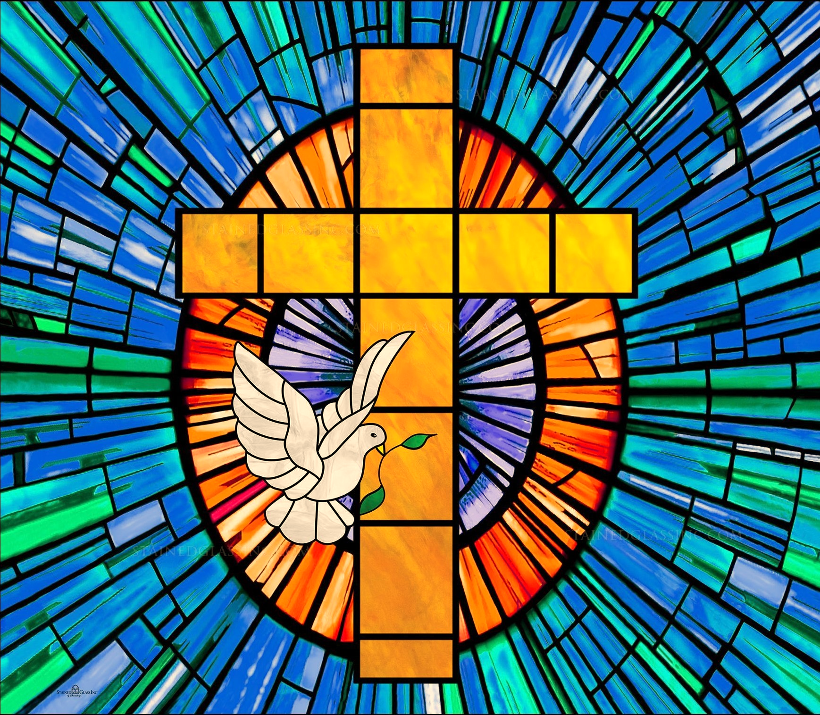

MERCY IN TIME OF NEED. HEBREWS 4:16

