

Non-Profit Org.

U.S. Postage

PAID

Mackinaw City

Michigan 49701

Permit No. 1

United Methodist and ECO Presbyterian

**The Church of the Straits**

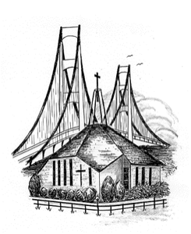

P.O. Box 430 * Mackinaw City, MI 49701

Return Service Requested

It amazes me how God teaches us every day about how to live our lives. We are either listening or we aren’t. Anyways, the other day I was sitting on the edge of my bed getting dressed and I thought to myself. I want to wear my blue button-down shirt. So I go to my closet and there is my shirt all clean and wrinkle free. Suddenly the Holy Spirit says to me you also can turn on a light switch and it comes on or you can go to the refrigerator and there is food. You have a roof over your head. A wonderful wife and many friends who love and care for you. Then the Holy Spirit says, “I have given you all of this. You trust me with everyday things why don’t you trust me with everything in your life?” First, I want to say that God has given us everything we need, but do we tell him thank you very often? With the New Year here I want to encourage you to be more grateful to God for what he has given you.  
 Second, I want to share a few scriptures to help us remember what God has told us about trusting Him. Proverbs 3:5 says, “Trust in the Lord with all your heart; do not depend on your own understanding.” I think sometimes we think the problems at hand are beyond what God can handle but that is our own minds and maybe even Satan telling us that. We must have faith that God can do anything and will do everything we need him to do. Philippians 4:6 says, “Don’t worry about anything; instead, and pray about everything. Tell God what you need, and thank him for all he has done.” That scripture sums up how we need to be. Now we have to have the faith to do that. I think if we will follow his instructions we will be in the place where we need to be. Remember these verses when you are in doubt of what God can do in your life, and **be grateful** for everything, even the everyday things.

**Mike’s Musings**

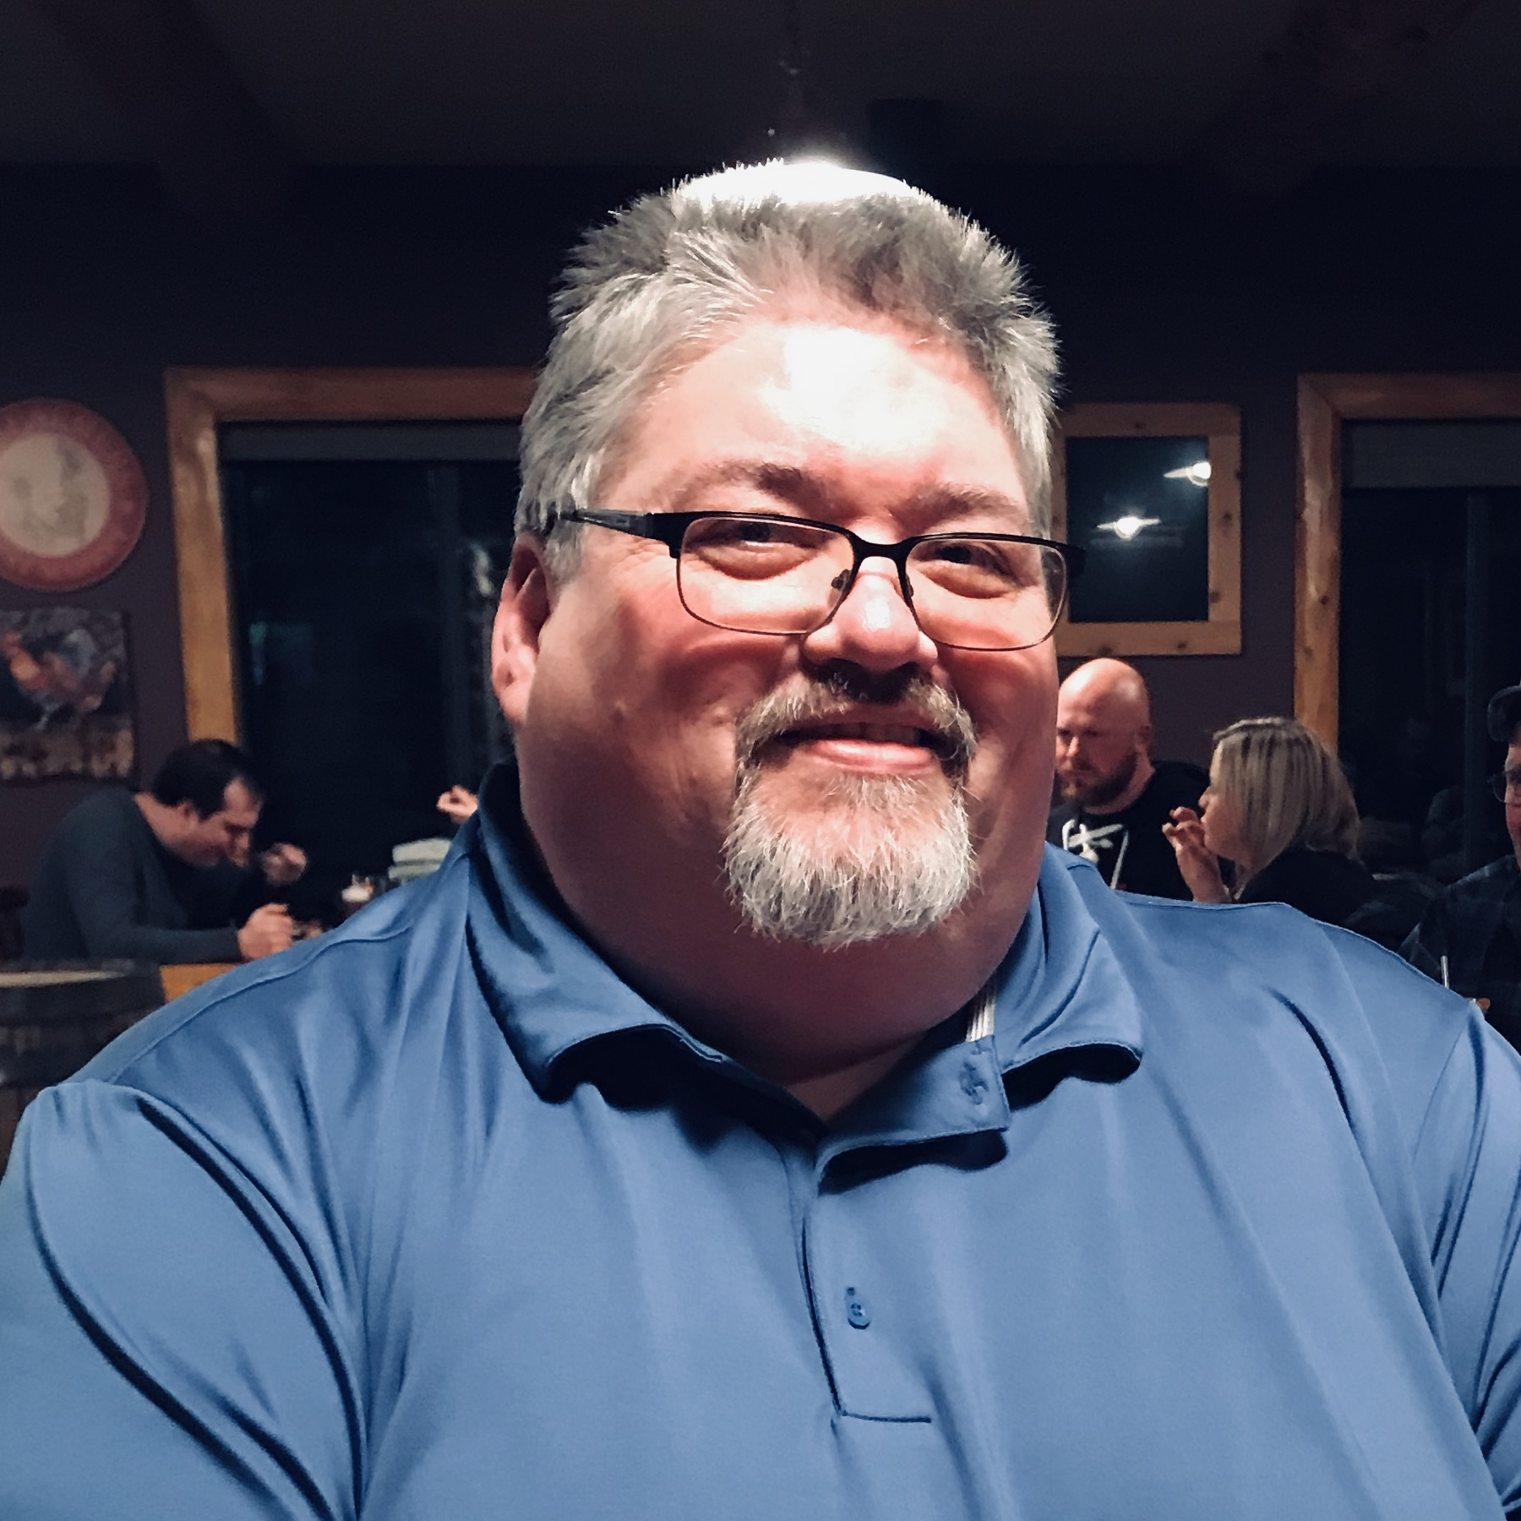

**Pinecrest Fellowship** is the first Tuesday of each month from 2-3 pm. There will be a short devotional, prayer and refreshments. Everyone is welcome to come and visit with the residents.





**Sponsor a basket for someone special!**The Willing Workers are making baskets filled with love to be delivered this winter to shut-ins. You can sponsor a basket by donating to the Willing Workers. Thank you ♥♥

**Our house sold fast** and we’re



settling into the Parsonage. Our

new mailing address is:

PO Box 863, Mackinaw City  
Give us a few weeks to get un-  
packed, then stop by!   
 ♥ ♥ Jim & Judy Churchill

**Operation Christmas Child**We’ve received notification that our boxes were sent to The Philippines and Columbia. Please continue to keep the children who will receive these boxes of love in your prayers. Now is a great time to start filling the box for next November’s Big Packing Party.  
 January ideas – Hats, gloves, scarves. If you are a   
 knitter of crocheter – put those scraps of yarn to   
 good use!

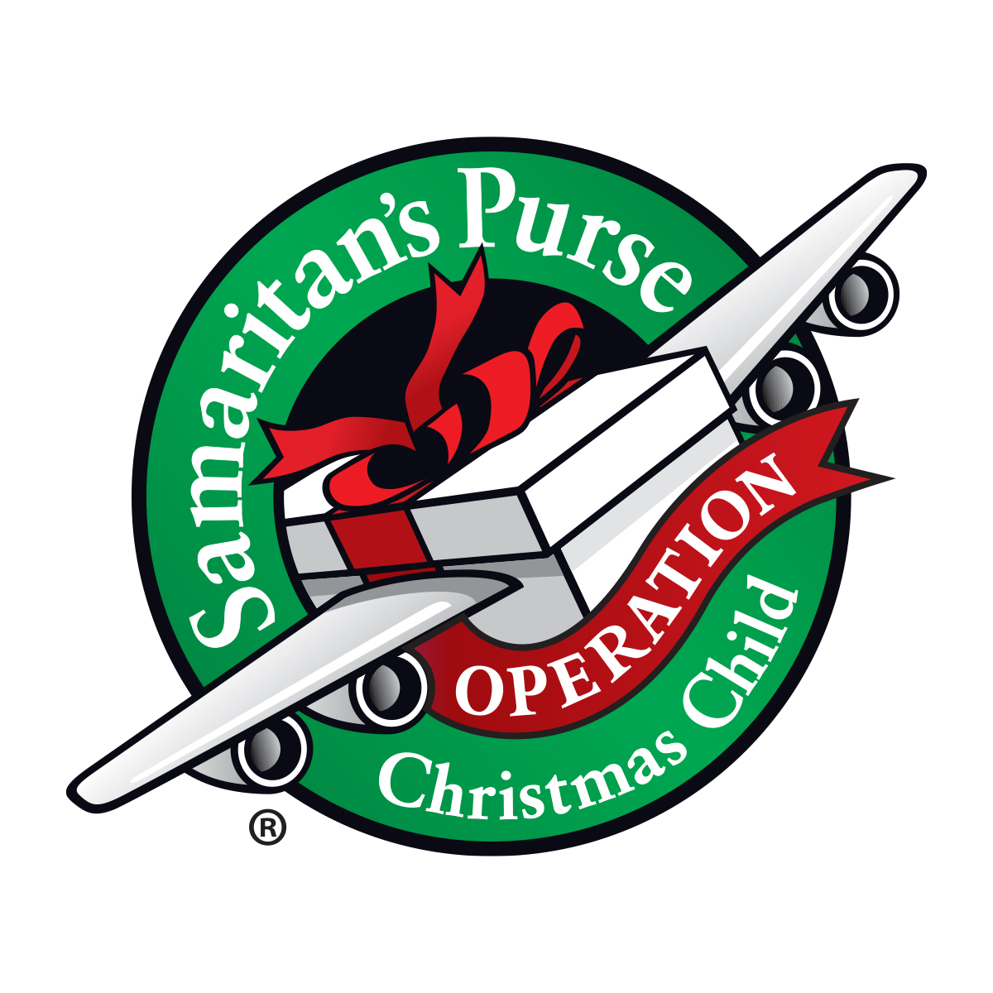

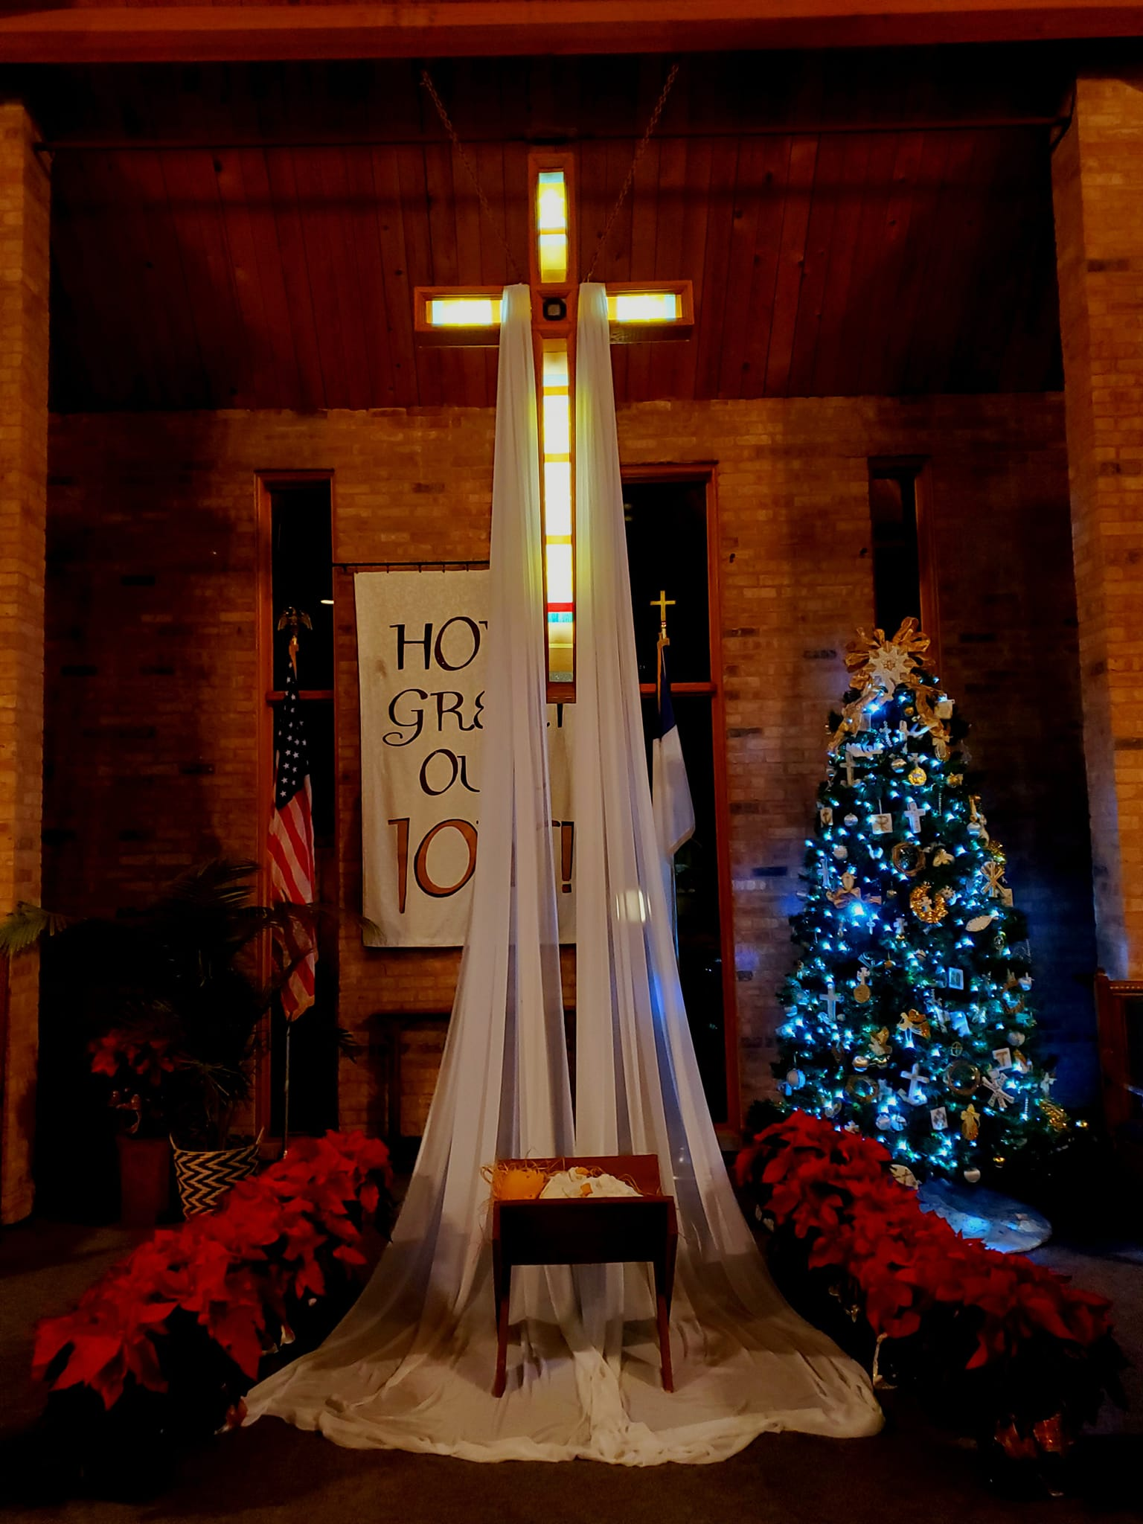

**Christmas Eve** our cross was draped in tender beauty. Poinsettias surrounded the manger ***given in loving memory of***:

Our Parents *by Dave & Pat  
 Hubbard*

Archie M. Falor and Roger   
 M. Falor *by Donna   
 Falor and family*

Andrew Hawver *by PaPa   
 & Gram (Don & Jan Hawver)*

John Kirk, David and Beverly Miller *by Deb and   
 Dutch Miller*

Tom Limberg *by Elizabeth Limberg and family*

Clinton and Ruth Bennett, David and Beverly Miller   
 *by the Bennett Family*

Dick Moehl, Mike Moehl and Tom Moehl *by   
 Margaret & Sarah*

Nancy and Dick Campbell *by Ric*

Ron Cooper and Tom Peters *by Mary Lou Peters, the   
 Kelleys and the Coopers*

Rosie Spencer, Sophie and Norris Coffman, Elsie   
 LaPointe, Juanita Bonter, Robert Heilman, Linda   
 Charboneau, Isabelle Potter *by Nelson and Rose   
 LaPointe*

Dave Parker, Ilah and Richard Johnson, Roy and   
 Betty Livingston, Jim Johnson and Tom Ball *love   
 Barb*

Dr. Kurt Grebe, Frederick”Fritz” Grebe and Phillip   
 Grebe *by the Grebe Family*

Roy Prillwitz *by Georgia and children*

***And in honor of:***

Ann Kirk, Forrest Miller (as he celebrates his 1st   
 birthday December 23rd) *by Deb & Dutch Miller*

Pastor Dave and Lisa Wallis *by anonymous*

Judy and Jim Churchill *by anonymous*

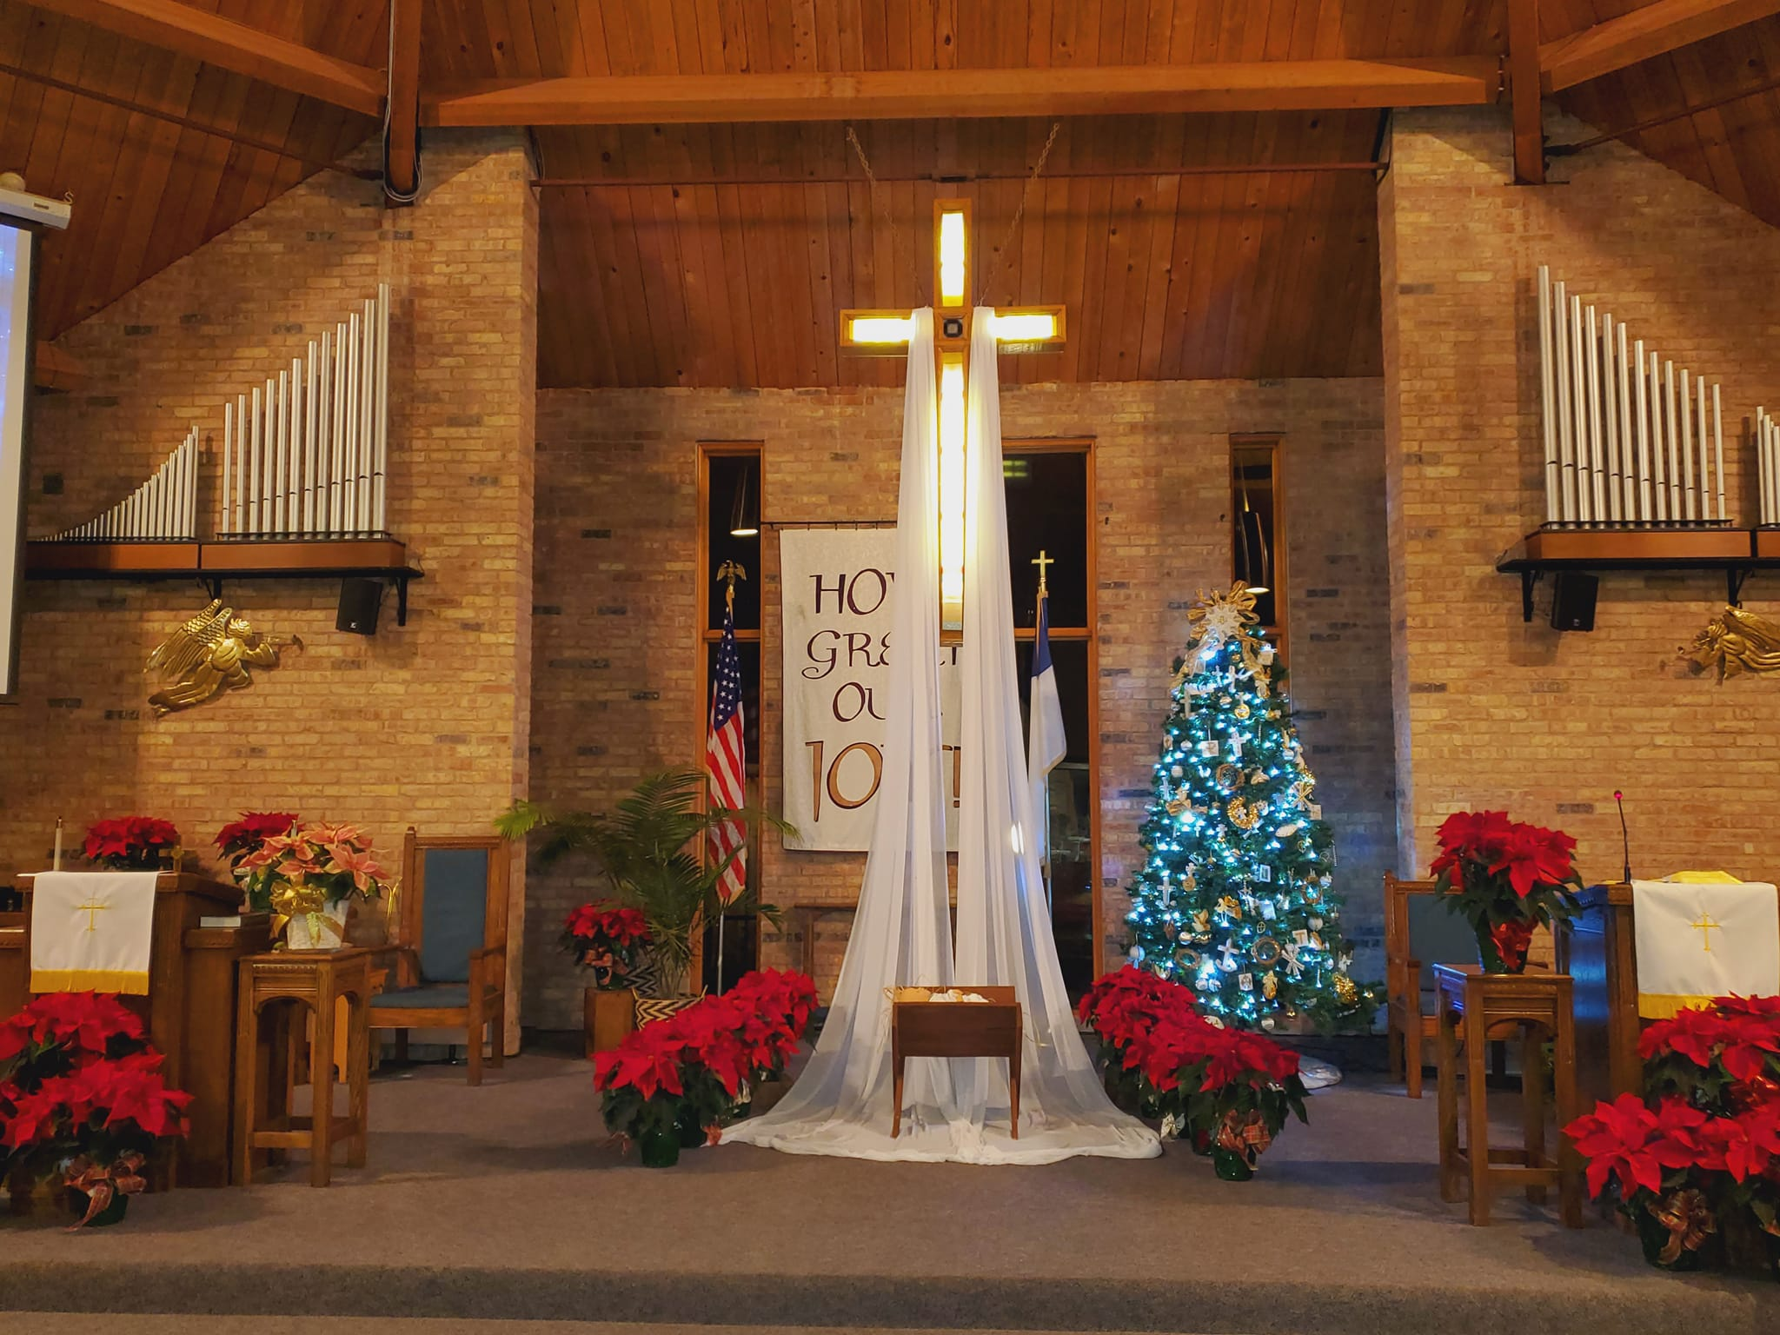

*Pictures courtesy of Jennifer Cole*



**A Prayer for Epiphany**

*O Lord Jesus Christ, heavenly King, thank you for bringing both Jews and Gentiles to hear your voice. Enable us to follow your holy Word, as those from the East followed the leading of a star. Give us grace to confess your holy name. Rule us by your Spirit, so that the joys of your birth may increase in us. Hear our prayers and cries. Accept our offerings, which you yourself have given us: the gold of our faith, the incense of our prayers, and the myrrh of our contrite hearts. Deliver us from the destructive ways of sin, and lead us in the ways of peace and in the paths of righteousness. Grant us all, when this life is done, a participation in the joys of the Year of Jubilee in heaven, where we shall praise and serve you and the Father who live and reign in unity with the Holy Spirit, now and forever. Amen.* ~Wilhelm Loeh (adapted)

We extend our sympathy to the families of those who have entered the Church Triumphant:

Duane Darrow, who passed away December 15,   
 2021

Dorothy Churchill, Jim’s mom, who passed away  
 December 23, 2021

Colleen Durant, who passed away December 27,   
 2021



**Happy Holidays from SARM**I hope that everyone had a very Merry Christmas and a Happy New year. It has been a fun filled month for SARM, starting with Youth Ministry Sunday Christmas cookie decorating on December 12th. Then on the 19th was our Third Annual Coats for Kids shopping trip where we join with the local Salvation Army to provide winter jackets to needy children in Cheboygan and Emmett Counties. SARM was able to purchase 38 winter jackets and three pairs of snow pants along with coats that were donated at the church collected 43 winter jackets for children in need!!! WOW, I am so incredibly proud of the youth and this congregation. These winter coats are making a huge difference in the lives of children in our community!

Looking forward: Change for a Change - January through March, SARM will be collecting inexpensive or handmade hats, mittens, gloves and socks for the Mackinaw City Elementary. There will be a bin outside of the SARM room for donations. If you have any questions, please don’t hesitate to contact me at the Church of the Straits. This time of year I always feel a bit nostalgic thinking about childhood Christmas past with family and friends. It fills my heart with joy to know the children that are participating in the youth group will have these wonderful memories to look back on.

Much love and God bless,

Shannon Cooley, Youth Director

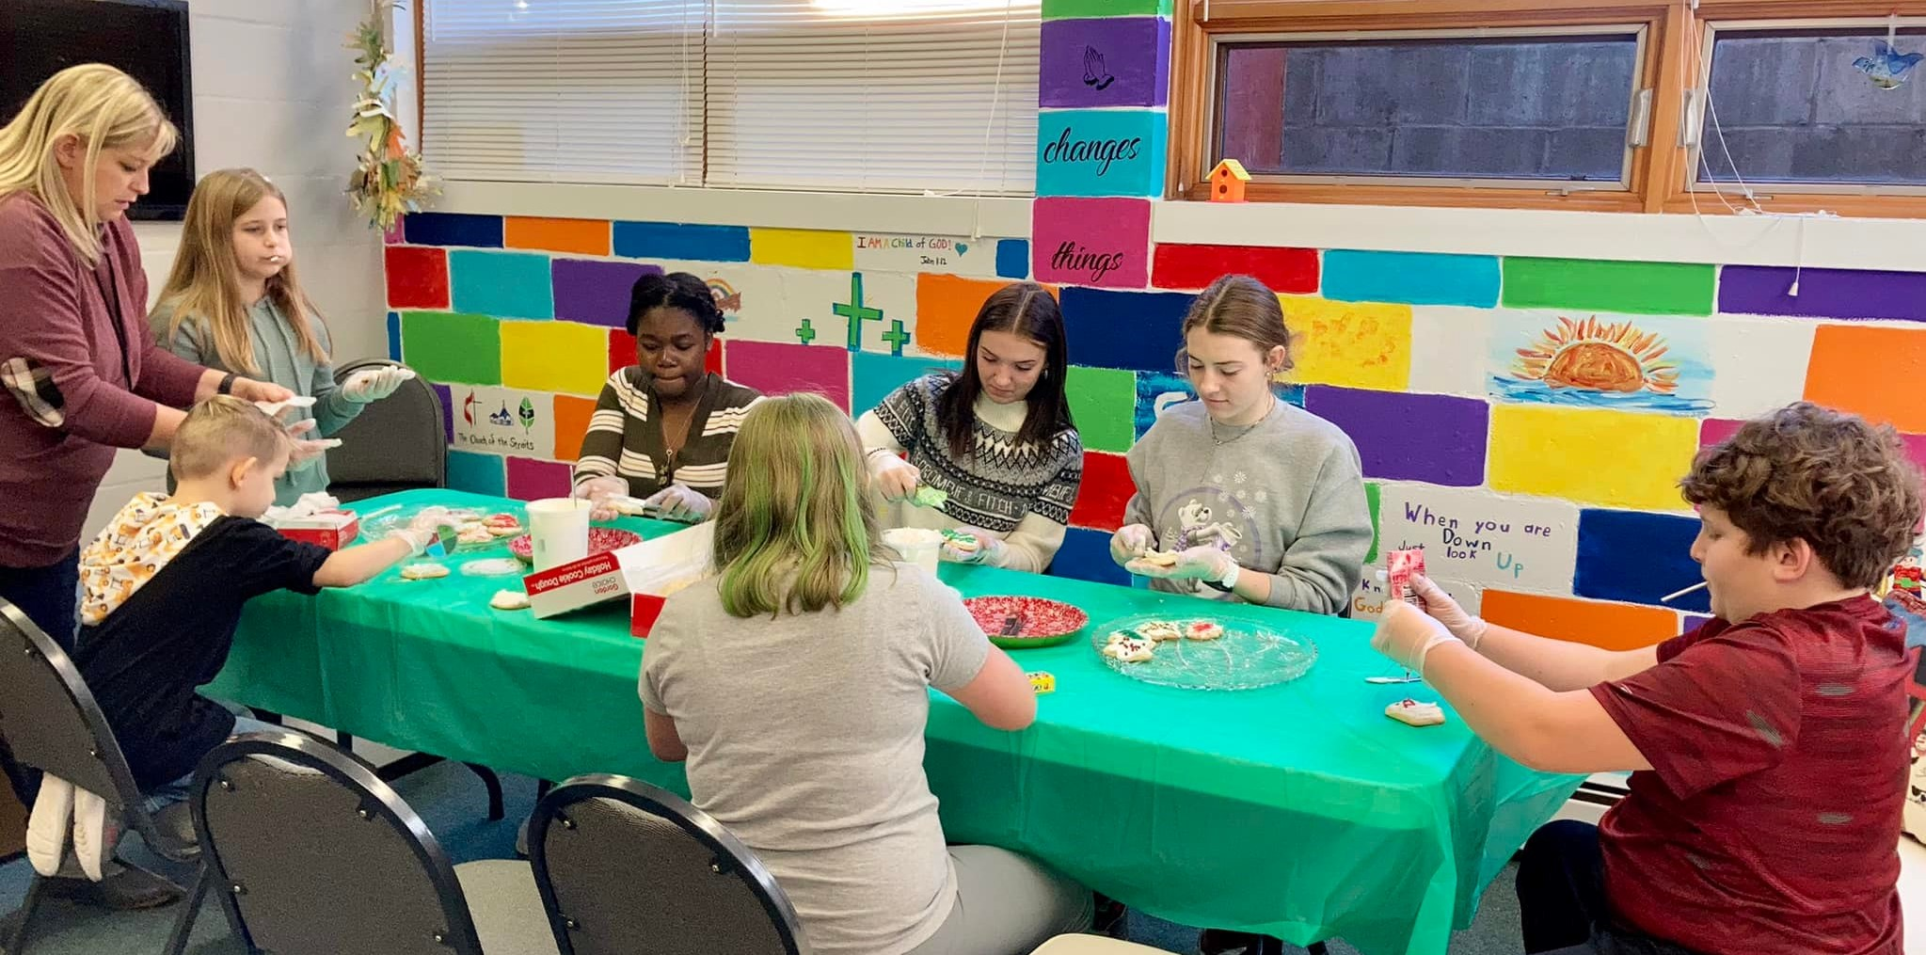

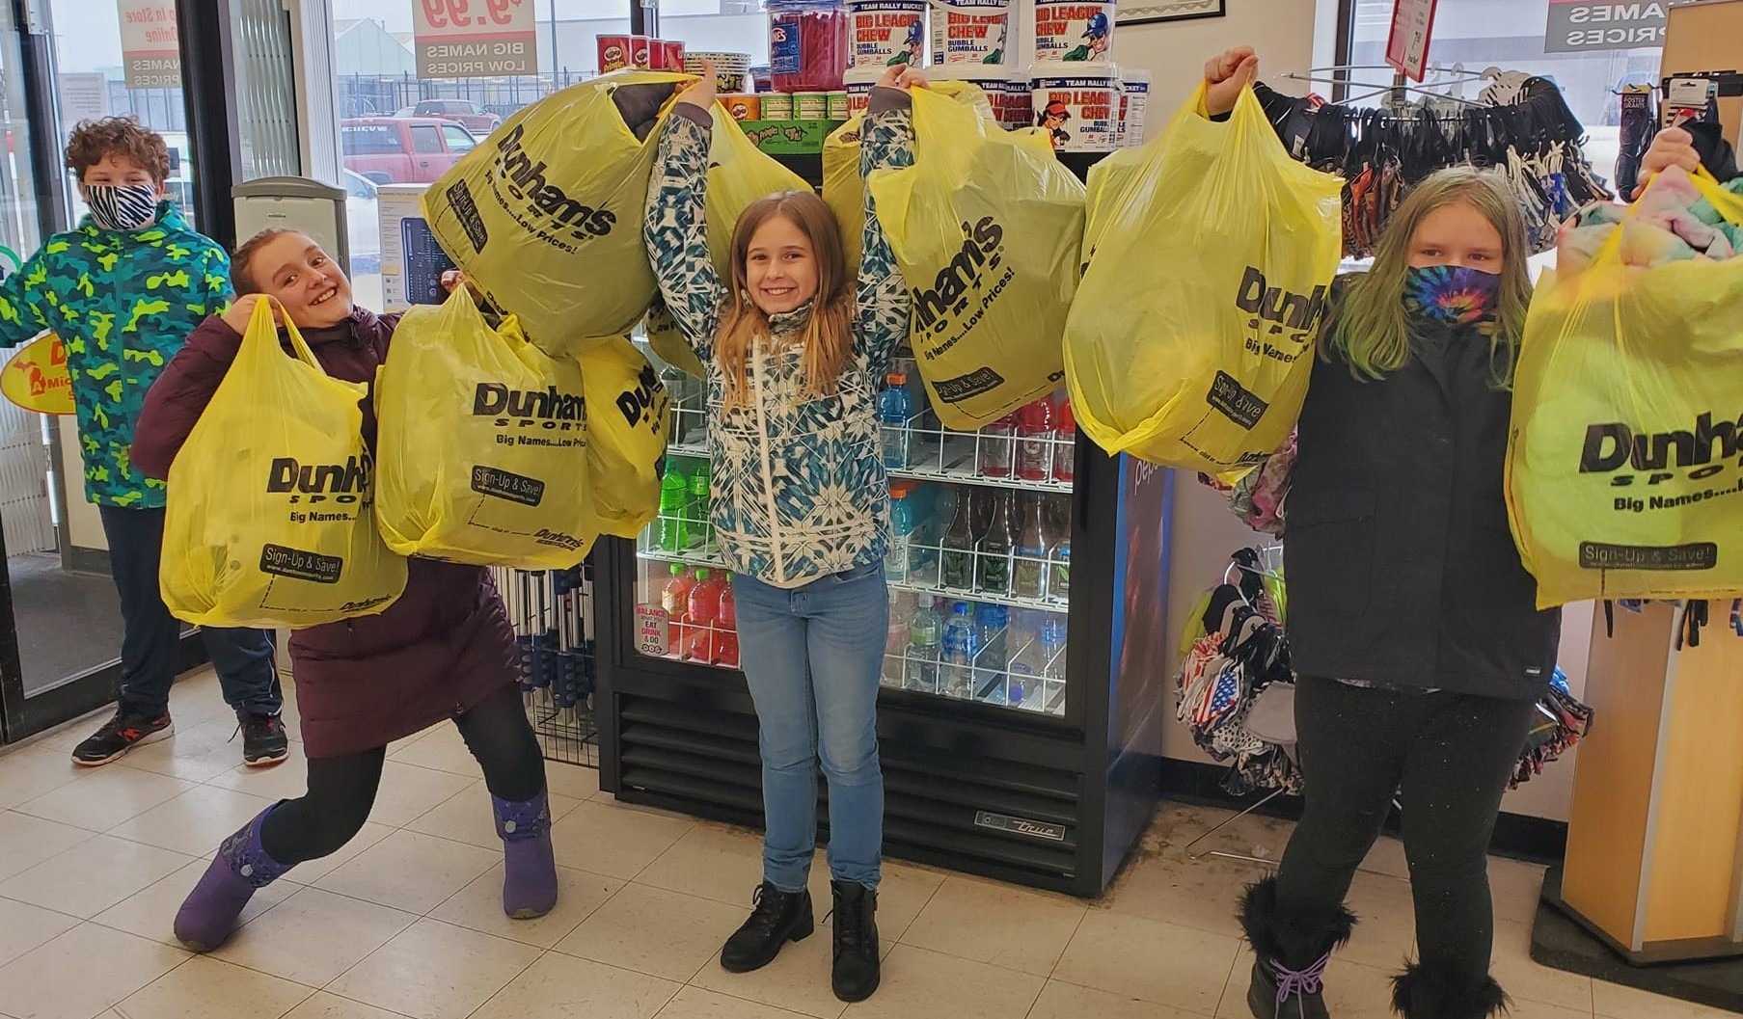

Holiday Fun:  
Cookie Decorating  
Coat Shopping  
Pizza Lunch

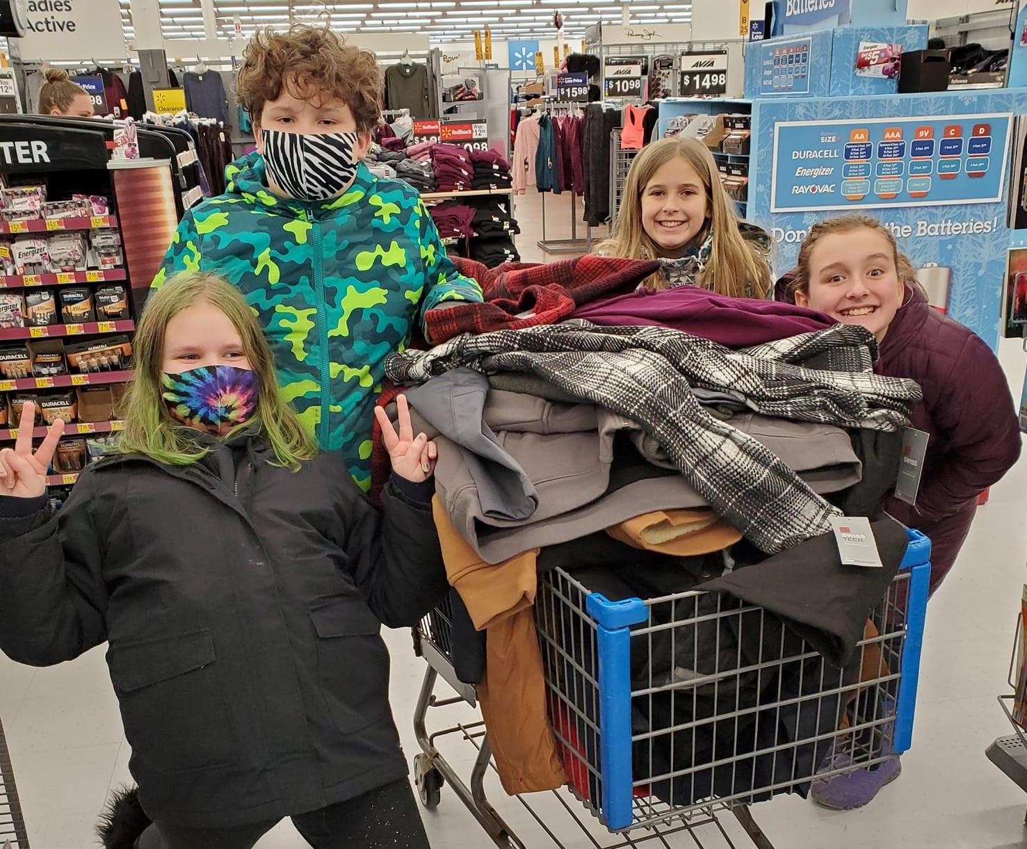

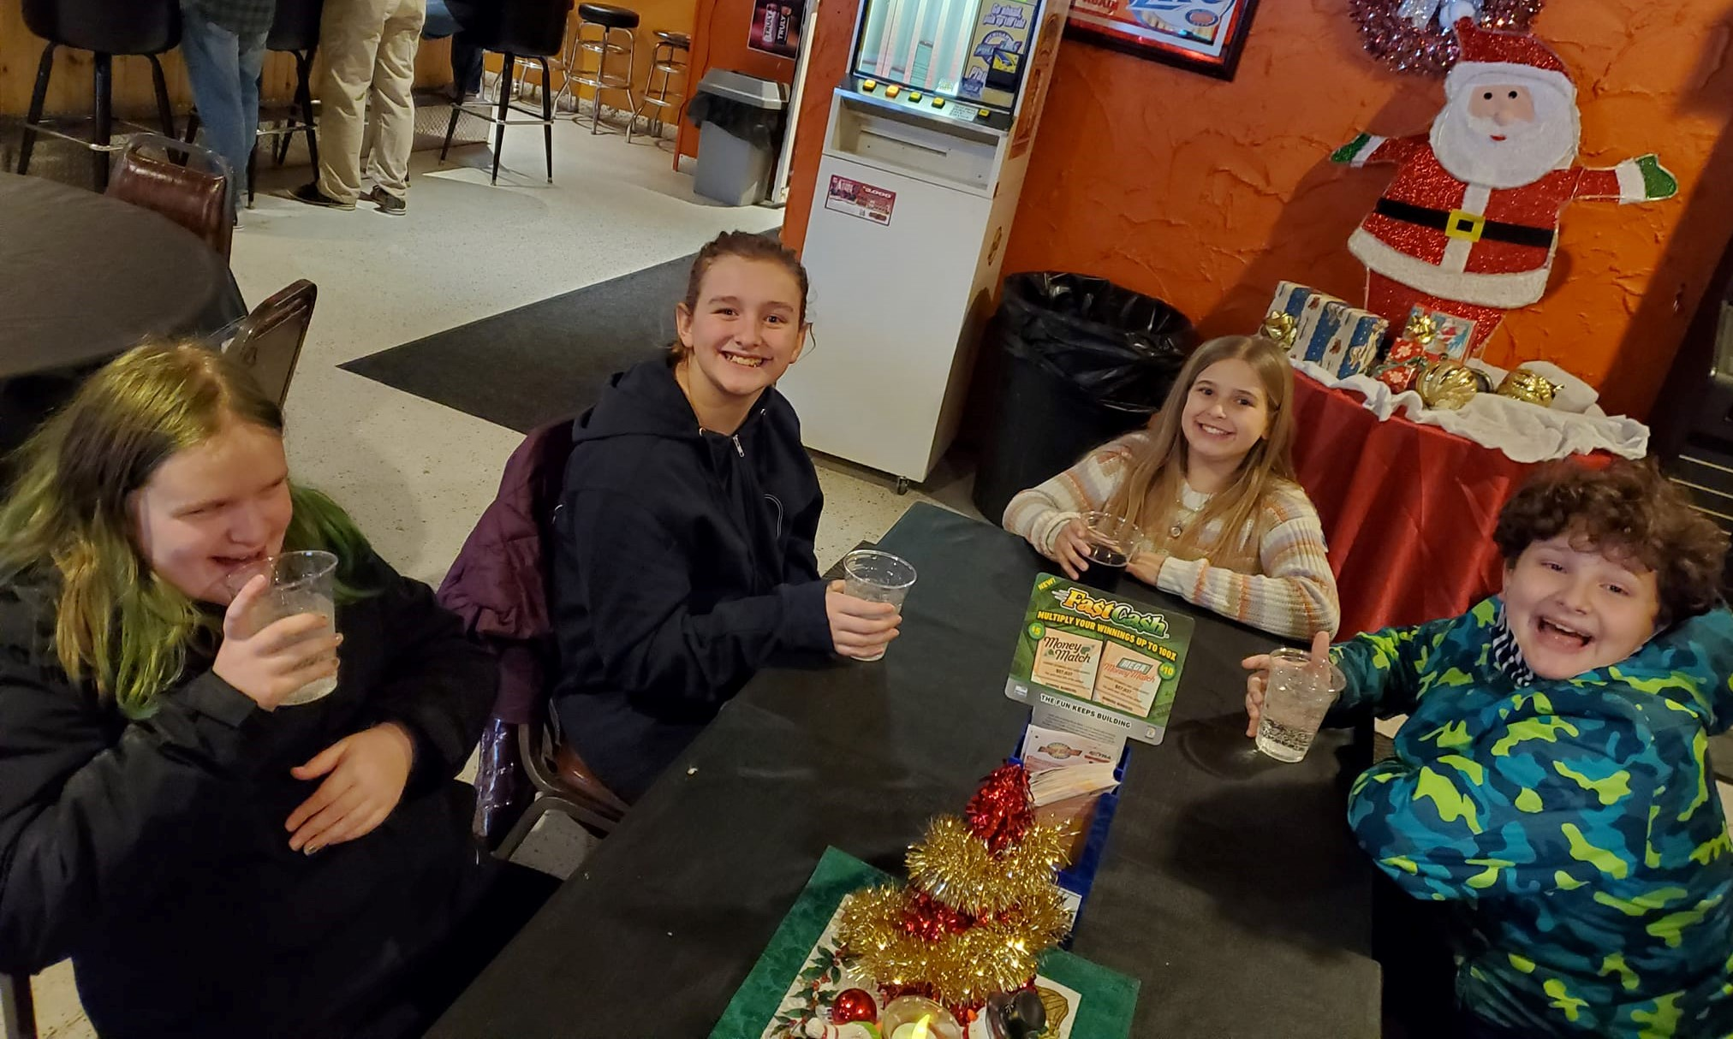



Straits Talk Newsletter  
**January 2022**



Minister Pastor David Wallis  
 Youth Director Shannon Cooley

Head Ushers Todd Kohs and Carl Strieby

Organist Loretta Martinek

Treasurer Donna Falor  
 Financial Secretaries Janet Schaefer and Katie  
 Strittmatter

Clerk Laura Jackson

Secretary Judy Churchill

Office Phone: 231 436-8682   
Office Hours – M-Th 9am-2pm

**Pastor’s cell: 906 282-7409 *no longer a parsonage phone**

E-mail – Pastor – [davidloveslisa87@gmail.com](mailto:davidloveslisa87@gmail.com)

Church office – [cotsoffice@yahoo.com](mailto:cotsoffice@yahoo.com)

Church website – [www.thechurchofthestraits.com](http://www.thechurchofthestraits.com)

The Mission of The Church of the Straits  
To worship God faithfully  
To grow together spiritually

To serve Jesus Christ and

our neighbor joyfully

…in the power of God’s Spirit.

**OUR WORSHIP SCHEDULE**

Traditional Worship 10:30 a.m.

Adult/Youth Sunday School 9:30 a.m.

* * * * * * * * * * * * * * * * * * * * * * * * * * * * * * * * *

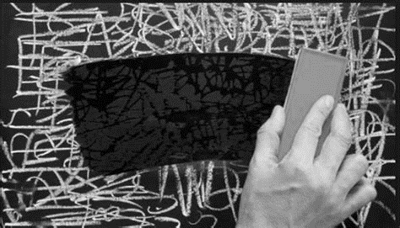

Remember those little screens you could draw on when you were a kid! They were red and had little dials on the bottom and you could create something. Every time you messed up you could move that lever across and erase it (or shake the screen). Then you started all over.

Perhaps you remember another thing from our younger years called the typewriter. The problem with the old typewriters is that when you made a mistake it was hard to cover it up. You could use the erase tape or liquid to cover up your mistake, but it was still there. What an amazing invention to have the computer with word-processing that allowed erasure with no residue and later spellcheck to correct wrong words.

Now we are entering a New Year and with it a new start. Perhaps it’s not a clean slate because we drag last year into the new year because life doesn’t just start over every year. But it gives us a new starting point, something like a new year for the sports team or the business or whatever. We can learn from the previous year and not make the same mistakes this next year. Try to keep the good and throw out the bad.

There is another thing we can learn from a New Year or a new start. We need a reminder of the One who is “making all things new”! (Revelation 21:5) We need a reminder of the One who says, “his compassions never fail. They are new every morning.” (Lamentations 3:22b-23) We need a reminder of the One who says, “For we know that our old self was crucified with him so that the body of sin might be rendered powerless, that we should no longer be slaves to sin…now if we died with Christ, we believe that we will also live with him” (Romans 6:6-8).

These texts all remind us of the old and the new. When we ask God to forgive us our sin he throws it “as far as the east is from the west” (Psalm 103:12). It’s a new start! I don’t have to repeat the same old thing over and over again with the same result. I don’t have to just cover up my mistakes, my sin, because he has wiped it completely away (not like the old typewriter). In Christ, he indeed is making us new!

So go into this New Year with the attitude that God is making us new. He is transforming us, he has forgiven us and he has equipped us for whatever is ahead. It’s new, it’s exciting, it’s God doing a new thing in us. Let him and you will be glad you did. Happy New Year!!!

Love ya,

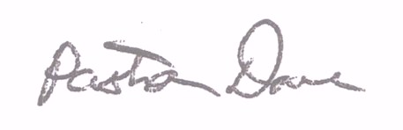

Pastor Dave