

Non-Profit Org.

U.S. Postage

PAID

Mackinaw City

Michigan 49701

Permit No. 1

United Methodist and ECO Presbyterian

**The Church of the Straits**

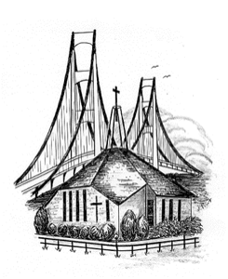

P.O. Box 430 * Mackinaw City, MI 49701

Return Service Requested

Summer is here. Growing up my summer was always a time of rest from school. It wasn’t a time we didn’t do things; no, summer was filled with adventure and plenty of play as a child. Now I live in a resort town, and I watch how people who are on vacation spend their time. I would think they come to a town like Mackinaw City to relax and get away from the hustle and bustle of their everyday lives, but on the contrary. I see people stuck on their phones, and I see people in camp grounds huddled around their T.V.’s. Is this really getting away and resting? Just like me as a child they don’t know how to rest.  
 When God created the world, he took time off to rest, giving us an example to follow. We too need a time of rest. God calls that time the Sabbath. Genesis 2:2-3 says, “By the seventh day God had finished the work he had been doing; so on the seventh day he rested from all his work. Then God blessed the seventh day and made it holy, because on it he rested from all the work of creating that he had done.”  
 I want you to think about how you rest. In life we have so many things that keep us from finding rest. Many times we think we are resting, but our minds are churning with thoughts of what we are not getting done. My wife Donna is the hardest worker I know. She has so much to do because I can’t do much in way of housework or cooking or much of anything. She just finishes one job and goes to the next job. She often asks how she ever got anything done while she was teaching. She inspires me to do more, but I want to inspire her to take time out and rest.   
 Working hard is great, but God said it was good to rest. Part of resting is remembering that tomorrow is another day and what you don’t get done today will be there. Trusting God to give us rest is a key factor in rest. Matthew 11:28-30 says, “Come to me, all you who are weary and burdened, and I will give you rest. Take my yoke upon you and learn from me, for I am gentle and humble in heart, and you will find rest for your soul. For my yoke is easy and my burden is light.” God also says through Isaiah 26:3 this, “You will keep in perfect peace those whose minds are steadfast, because they trust in you.”  
 Sometimes it’s not work that keeps us from resting, but it is our thoughts. In Philippians 4: 6-7 it says, “Do not be anxious about anything, but in every situation, by prayer and petition, with thanksgiving, present your requests to God. And the peace of God, which transcends all understanding, will guard your hearts and minds in Christ Jesus.” With all the bad things happening in the world it is hard to find rest from thoughts of what is happening around us, but God has an answer for that too. John 16:33 says, “I have told you these things, so that in me you may have peace. In this world you will have trouble, but take heart! I have overcome the world.”   
 So if you are having trouble resting, don’t. Stop and make time to rest, trust that the Lord has it all worked out and wants you to rest. Remember all the things that are left undone will be there tomorrow. It can wait. Enjoy a day of rest.

**Mike’s Musings**



**Operation Christmas Child**We’ve gathering items to fill boxes in November. These are just suggestions – look for items on sale or clearance!  
June is clothes month! Socks, underwear, shirts, shoes, sandals, sun dresses, etc.. Also, we can always use: activity pads, note pads, coloring books and items for older boys.



“One of my favorites in my shoebox was white socks because in the orphanage you get bad quality socks that always stink and have holes in them.”–Timur, Central Asia

One child in Grenada was delighted to find his shoebox packed with underwear in his exact size. His family was so poor that they could not afford to buy this for him.



**Exciting News!!**COS Evangelism Committee   
says it’s time for a new   
pictorial church directory. It   
will be like the last one with  
St. Anthony’s parish as well.  
Our “shoot” days will be:  
 Thurs. August 18, 2 - 8:30 pm  
 Friday, August 19, 2 - 8:30 pm  
 Saturday, August 20, 10:30 am - 4 pm  
If these dates don’t work for you, pictures will be taken at St. Anthony’s from 2 – 8:30 pm on:   
 M, T, W, August 15, 16, 17   
Our church directory will not be complete without YOU! Everyone who is photographed will receive a complementary 8x10 portrait and a directory! We want members, non-members and summer attendees in our new directory!  
Sue O’Dwyer will be making appointments following church in Fellowship Hall.



We extend our sympathy to the families of those who have entered the Church Triumphant:

Katie Darrow, who passed away June 11, 2022.

**Low impact exercise classes** are starting on Monday, June 27th. They will be held on Mon & Fri from 8 - 9 am. This is a set of "walking" exercises that start with a warm up & end with a cool down (no floor exercises).

Our Tai Chi classes will be held on Tuesdays from 9 - 10 am. No previous experience needed as we will be starting with the basics.

Both classes are good for your heart, stress relief, not to mention fun & fellowship. Bring a water with you & wear comfortable clothing.

We will be meeting in the Parish Hall at St. Anthony's & there is no charge for either class. The classes are open to anyone in the community & beyond. Questions, contact Marcia Wyderko 810 844-4193. Hope to see you!

**VBS is coming!!**



VBS is August 8th – 12th from 9am – noon with the Friday Parent Program from 12-12:30 pm.

Our theme this year will be **SonRiseNational Parks!**   
 Come to a land of invigorating power and beauty where there is nothing between you and God’s big sky! Kids will enjoy the thrills of daily treks where they can face extreme challenges and learn to depend on the promises of Jesus. VBS is open to age 4 – to those going into 7th grade. **Pre-registration is encouraged! Please call the office 231-436-8682.

VBS Sunday will be July 17th. Instead of asking for specific craft items or specific food items, we’ve found we can get exactly what is needed and avoid duplicates or missed items if we take donations. Thank you in advance for supporting our community VBS program! If you have any questions, please contact Ranger Judy in the church office 231.436.8682. Thanks!

**S.A.R.M. Happenings in June**

Summer is in the air with the warmer weather. SARM got to cool down Youth Ministry Sunday, June 12th with a sweet treat at Dairy Queen . We began our day with a trip to Old School Park, where we had a lesson on “the Armor of God”. Then off for the first “Sunday Sundae” of the summer. June 26th we went miniature golfing at Animal Tracks. Fun was had by all.

July starts a new “Change for a Change”. We will be raising money and collecting items for the AA Crisis Pregnancy Center in Cheboygan. I am asking that we do not pick up formula this year, due to the formula shortage. Other items are greatly appreciated, such as diapers, burp rags, wipes, and bottles.

Also in July - what we’ve all been waiting for… the Big Ticket Festival in Gaylord. SARM will be hosting a picnic at the festival July 9th. Any COS adult or youth attending BTF on Saturday is invited to join us for a picnic lunch (2:00 pm) at the Festival! For more   
information please contact Shannon Cooley at COS.  
Much love and God bless

Shannon Cooley, Youth Director

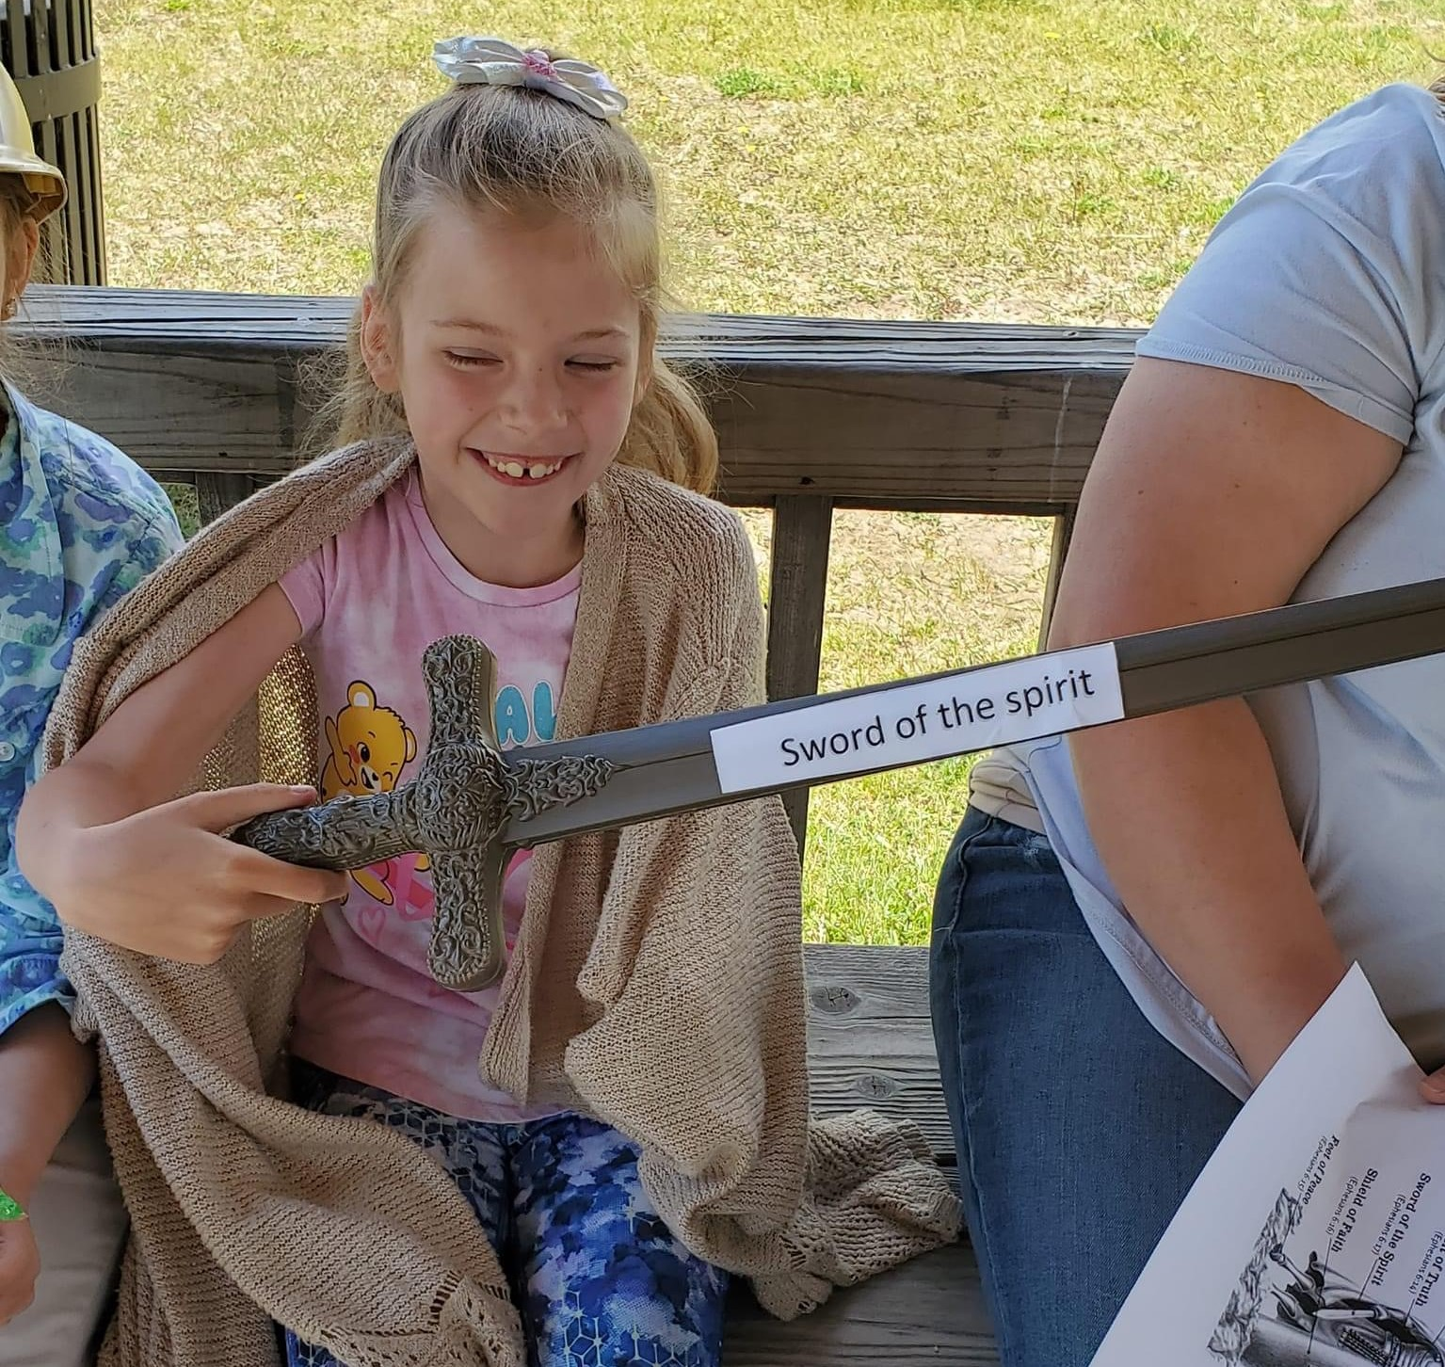

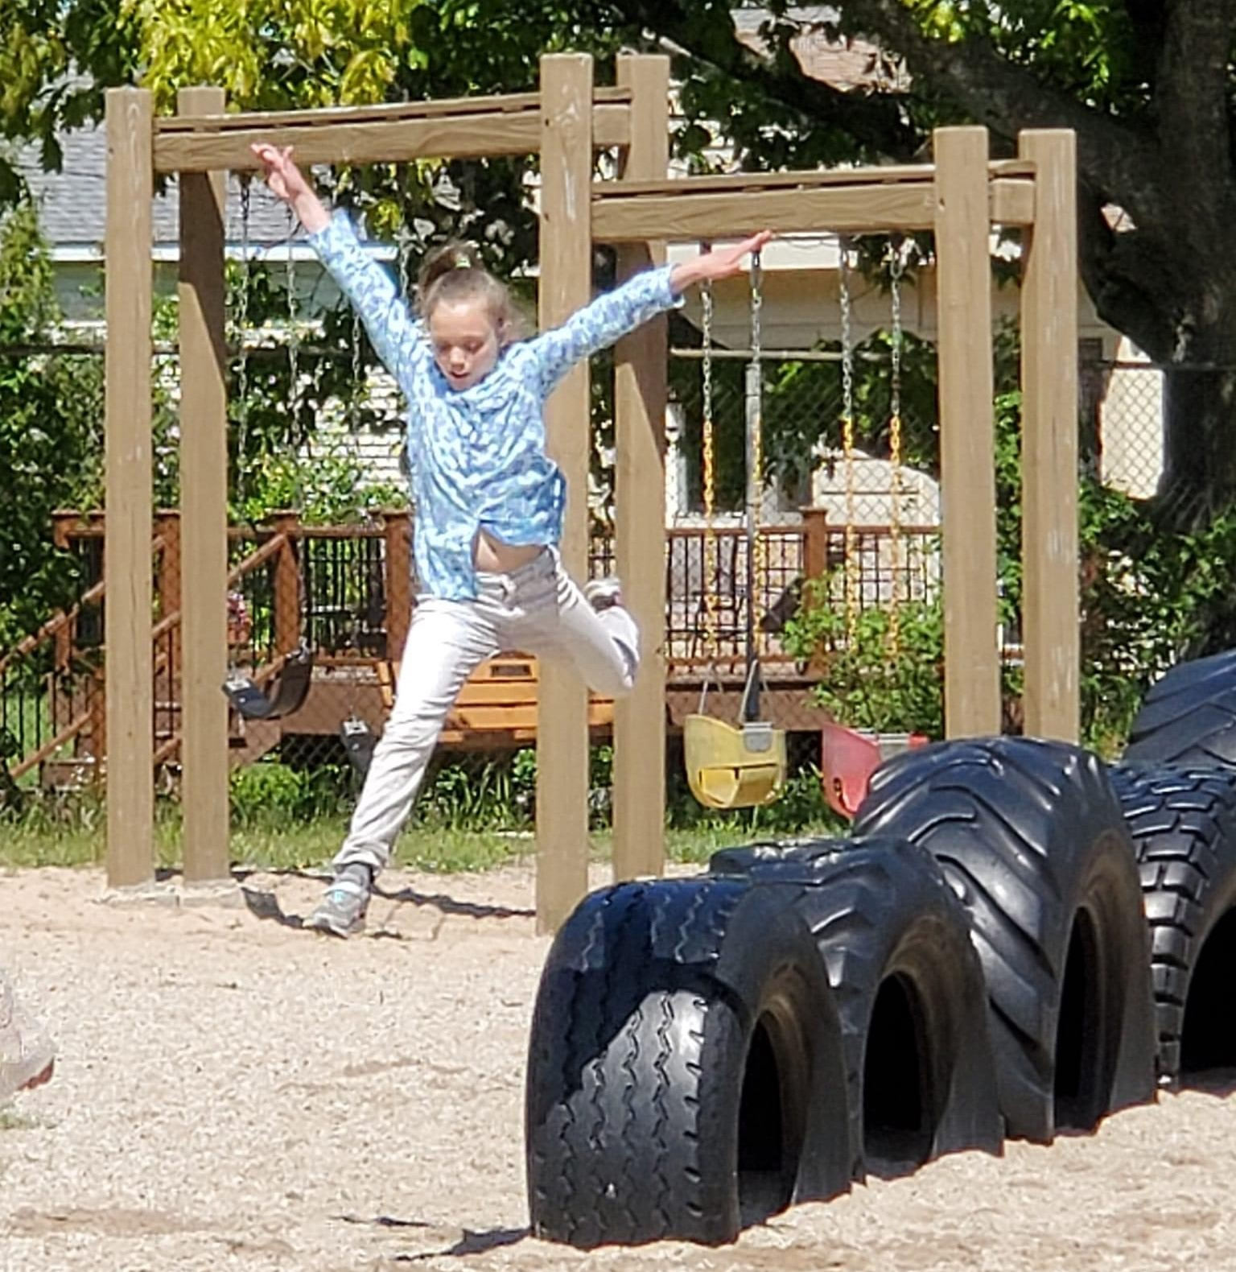

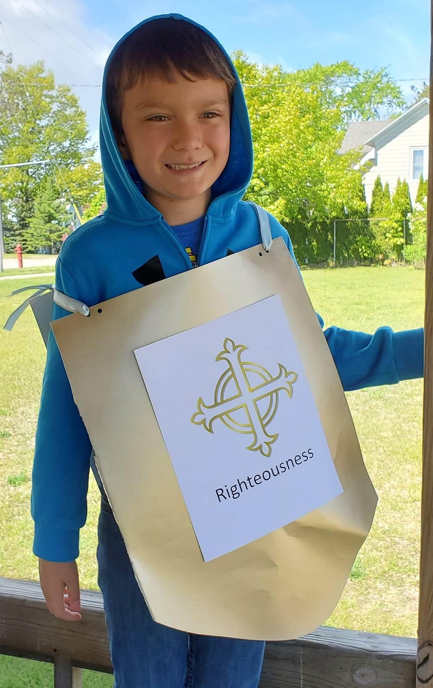

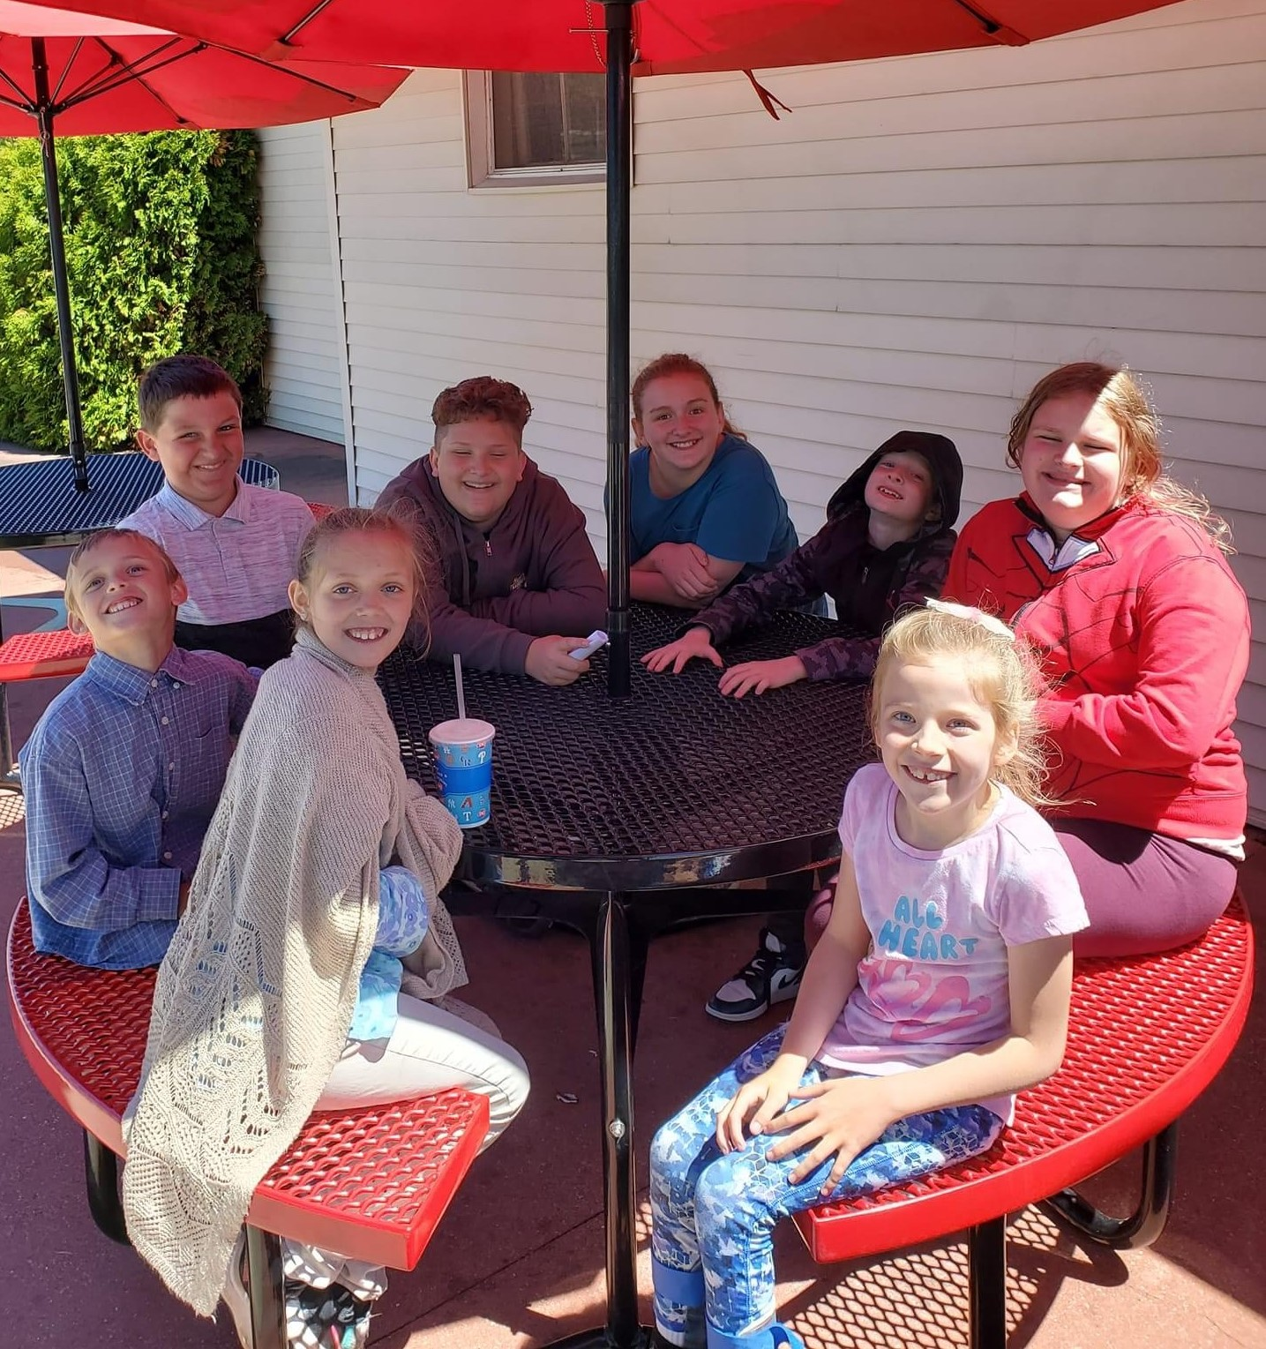

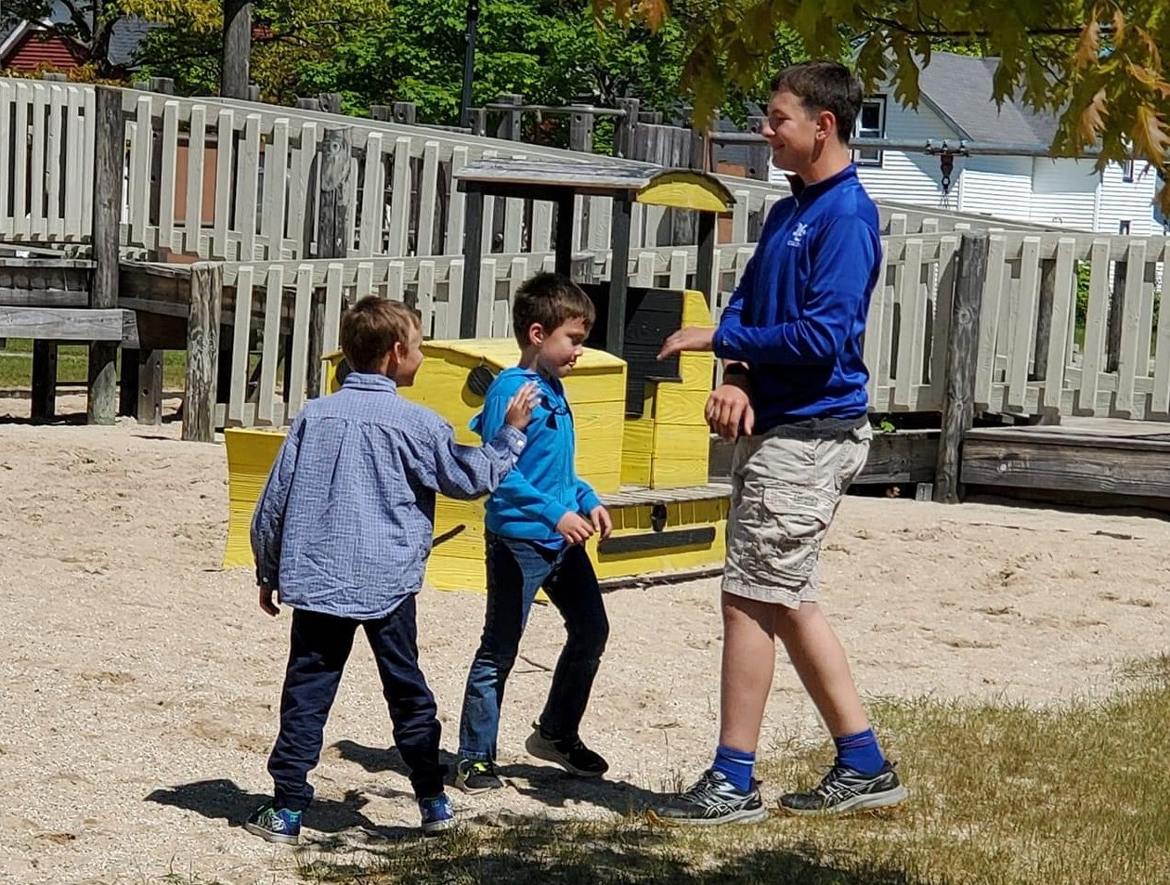

**Hooray for VBS!**



For many churches, vacation Bible school is a summer highlight. The event leads to lasting memories and changed hearts. It also sparks laughter. Maybe you’ve seen VBS humor online, such as the quote, “I’m tired, I mean like … Vacation Bible School kind of tired!” Another post reads, “You know you’re obsessed with VBS when… you’re excited about cardboard on the side of the road.” And anyone with an earworm at week’s end can relate to this meme: “My parents hid my VBS CD. It’s for the best.”  
 For hungry young learners, snacks make an especially big impression. One excited preschooler shared that she enjoyed “juice and Billy Graham crackers” at VBS. Another boy raved about the first day saying, “We heard stories and drew pictures. Then we went to play, and when we came inside, God had juice and cookies waiting for us!”

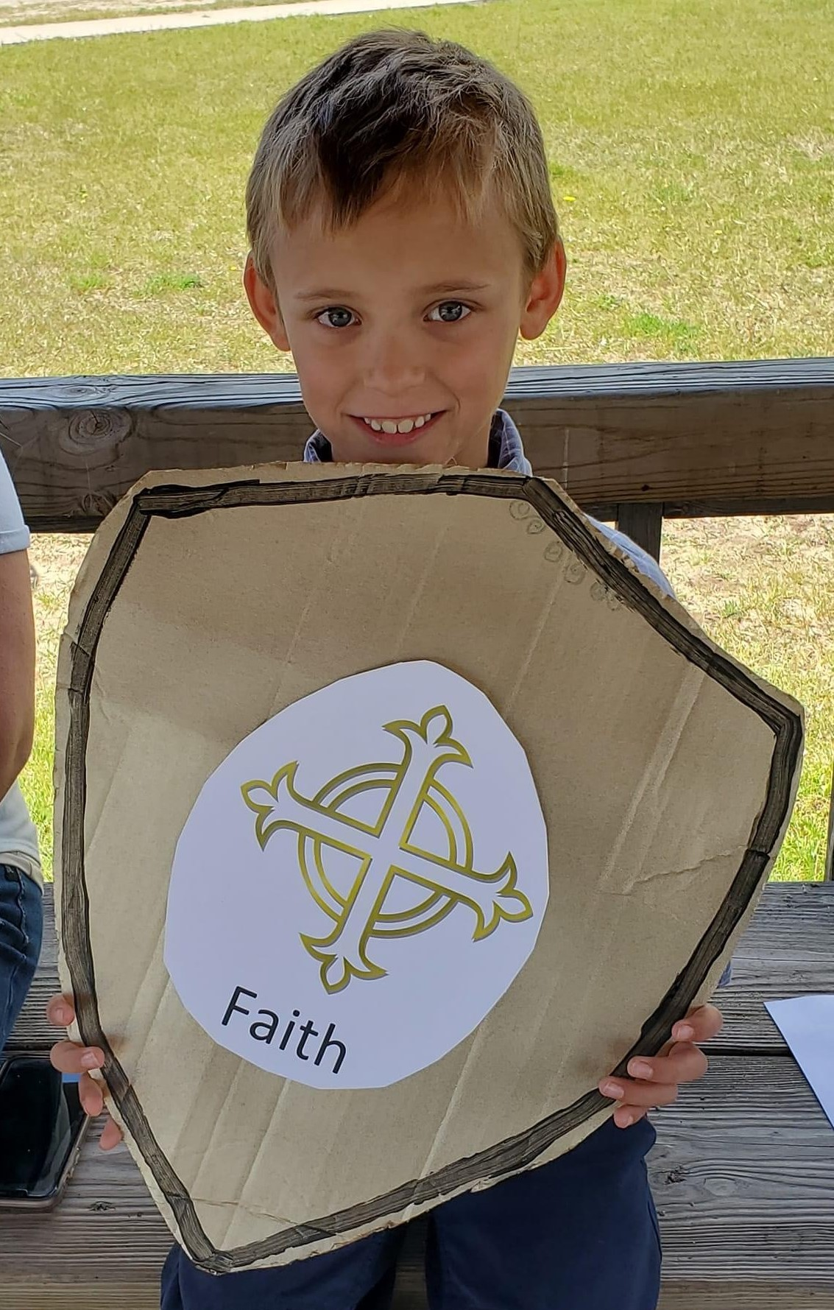

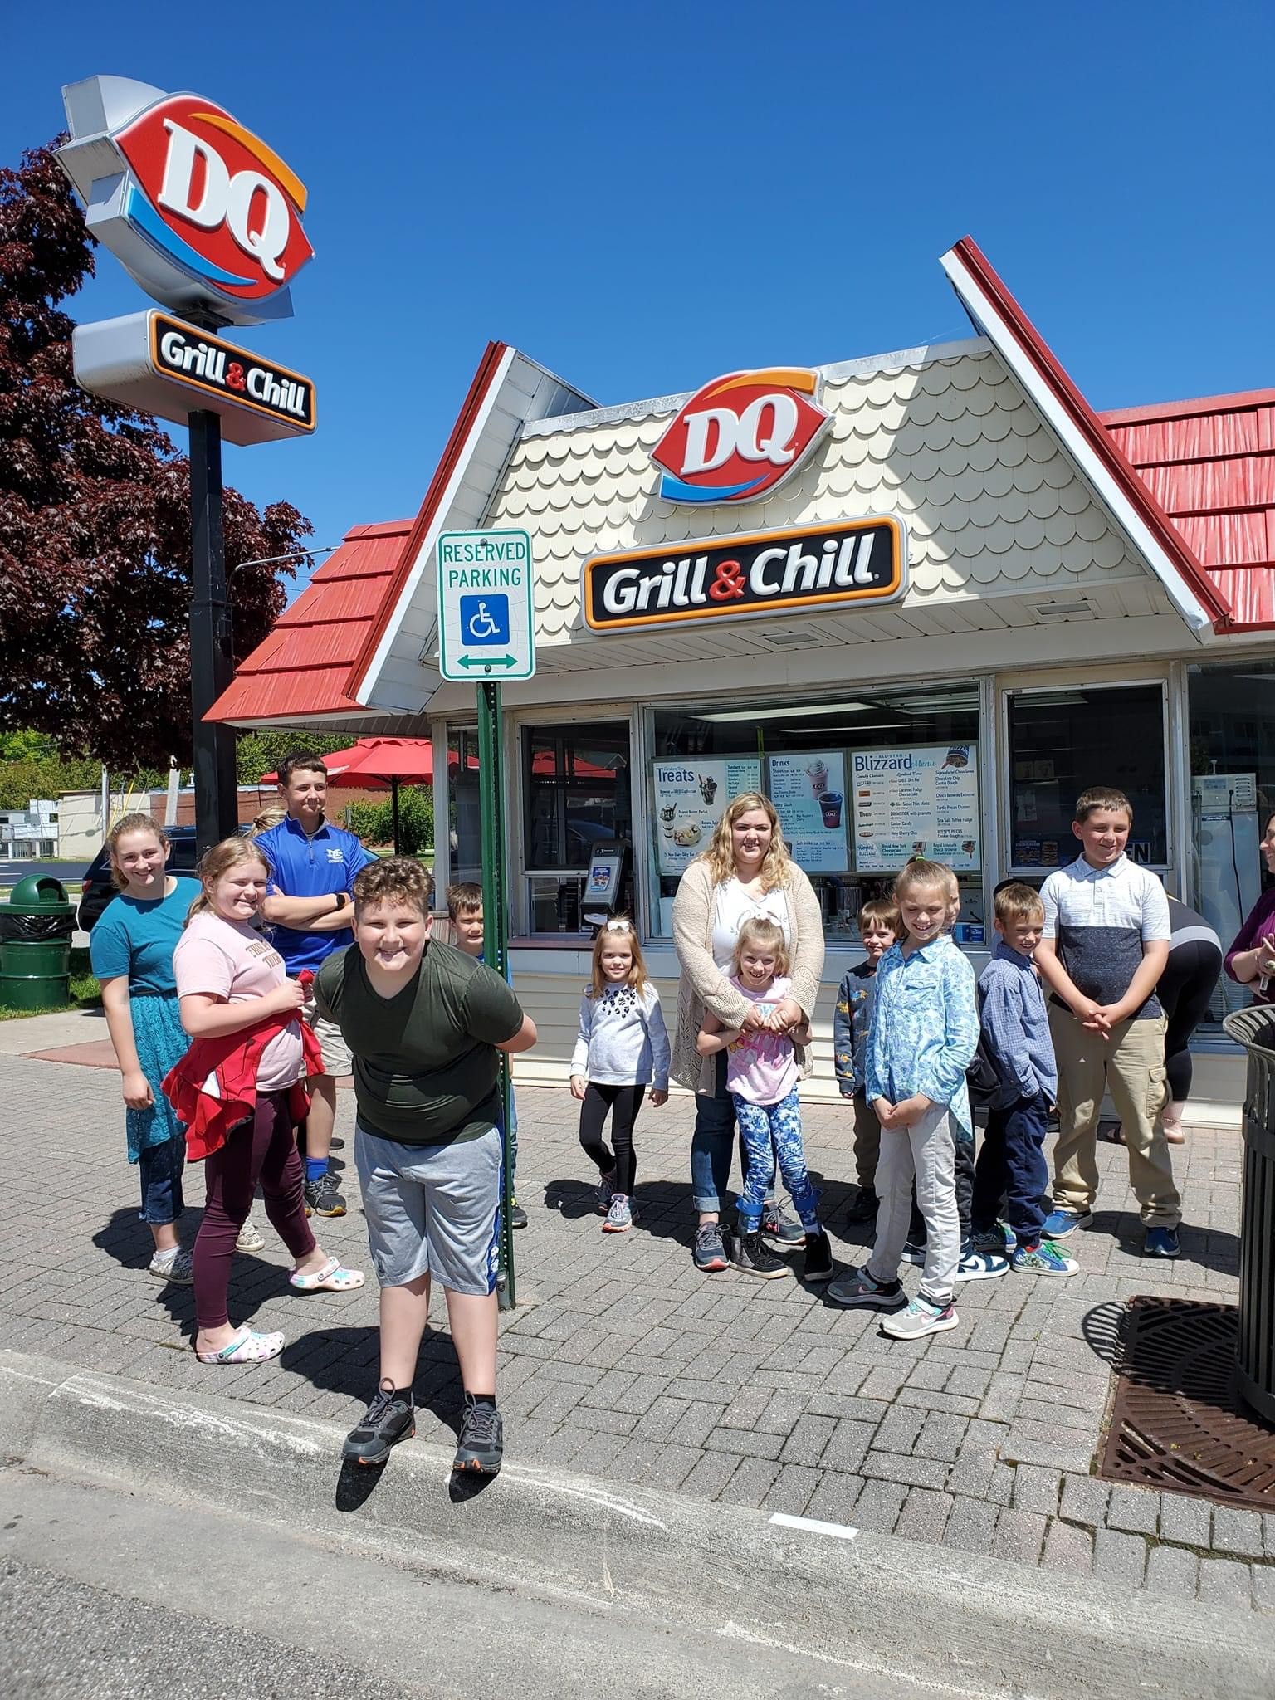

Straits Talk Newsletter  
**July 2022**



Minister Pastor David Wallis  
 Youth Director Shannon Cooley

Head Ushers Todd Kohs and Carl Strieby

Organist Loretta Martinek

Treasurer Donna Falor  
 Financial Secretary Laura Jackson

Clerk Laura Jackson

Secretary Judy Churchill

Office Phone: 231 436-8682   
Office Hours – M-Th 9am-2pm

**Pastor’s cell: 906 282-7409 *no longer a parsonage phone**

E-mail – Pastor – [davidloveslisa87@gmail.com](mailto:davidloveslisa87@gmail.com)

Church office – [cotsoffice@yahoo.com](mailto:cotsoffice@yahoo.com)

Church website – [www.thechurchofthestraits.com](http://www.thechurchofthestraits.com)

The Mission of The Church of the Straits  
To worship God faithfully  
To grow together spiritually

To serve Jesus Christ and

our neighbor joyfully

…in the power of God’s Spirit.

**OUR WORSHIP SCHEDULE**

**\*\*Summer Worship at 10:00 a.m.**

**Sunday June 26 – August 28**

* * * * * * * * * * * * * * * * * * * * * * * * * * * * * * * *

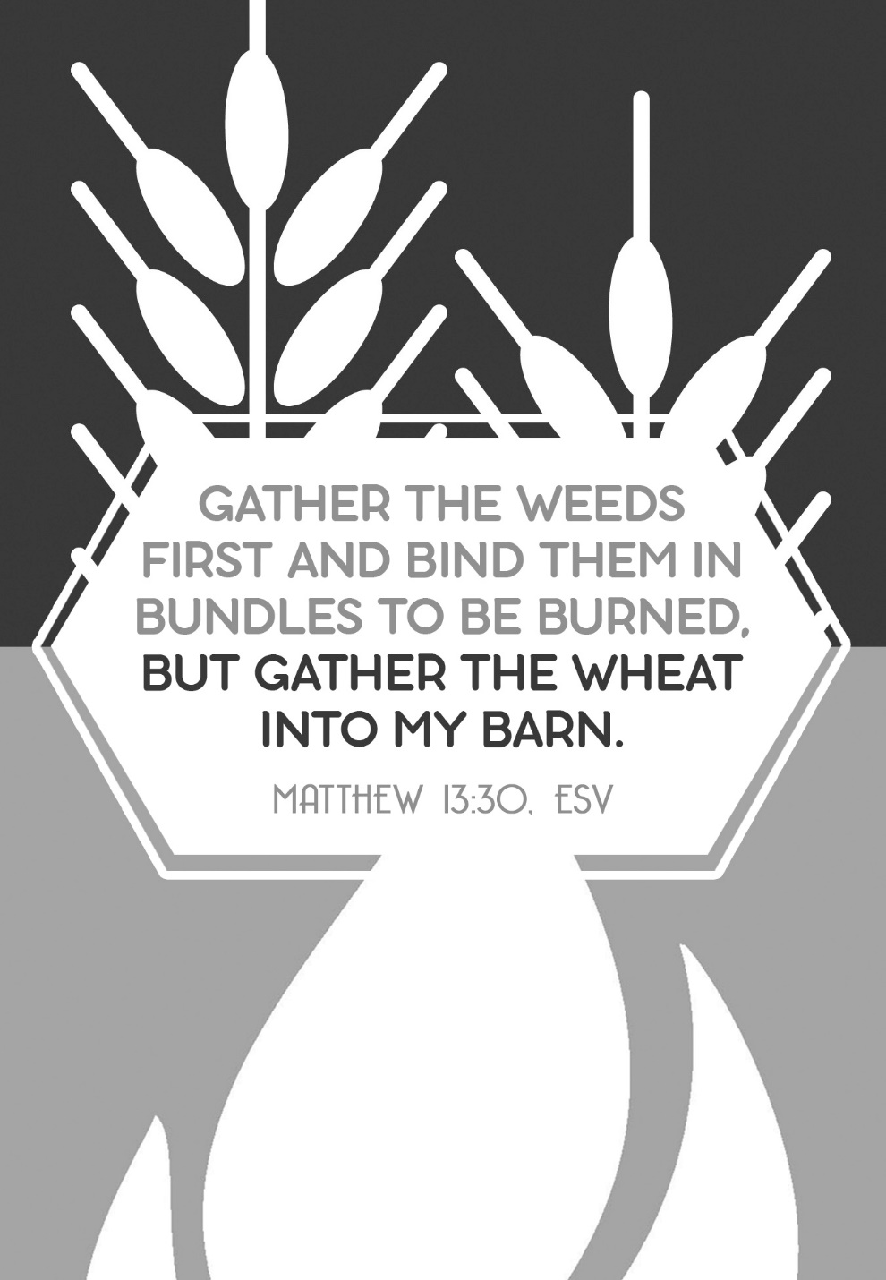

There is an interesting thing that is occurring at our house this late spring that we have witnessed for the first time at our new home. There are a couple flower beds in the front and back of the house that Lisa doesn’t know what flowers are there because they are just now growing their greenery. She has an idea on some of them but not all of them. We moved in last September and many of the flowers had run their course for the season at that point.   
  
Some of the things growing in the flower bed may be nothing more than weeds. We’ll find out soon enough. It reminds me of a text from Scripture that addresses this very thing. Matthew 13:25-30 says this, *“The kingdom of heaven is like a man who sowed good seed in his field, but while everyone was sleeping, his enemy came and sowed weeds among the wheat, and went away. When the wheat sprouted and formed the heads, then the weeds also appeared. The owner’s servants came to him and said, ‘Sir, didn’t you sow good seed in your field? Where then did the weeds come from? ‘An enemy did this’, he replied. The servants asked him, ‘Do you want us to go and pull them up?’ ‘No,’ he answered, ‘because while you are pulling the weeds, you may root up the wheat with them. Let both grow together until the harvest. At the time, I will tell the harvesters: First collect the weeds and tie them in bundles to be burned, then gather the wheat and bring it into the barn.”*  
  
This text indicates that it is sometimes hard to determine early on which are the weeds and which are the wheat (or in our case, the flowers). Let them grow and soon enough we will be able to tell them apart. We may able to hide who we really are for a season but time and maturity will soon show who are seeds planted and grown by God through a personal relationship with Jesus Christ, and which seeds are not of God.   
  
In Christ, you are a beautiful flower that eventually blossoms as you grow. There is a difference between a beautiful flower (or wheat head in full bloom) and a weed that is growing in your garden. Let God work in your life and even though you may at times be surrounded by weeds, let the beauty of God blossom in your life in Christ so that others can differentiate between a child of God and a person who is only of this world, a weed that will be plucked and burned.  
  
God loves you, let him shine in you!  
  
I love you too,

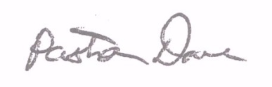

Pastor Dave