War Story and Family Loss
By Nancy Thompson Wyatt

World War II was horrible for the families back home and my family was no exception. I am fortunate that I did not have to endure the angst, worry and grief that my grandparents and their sons must have felt.
My grandparents, William Albert and Grace Ann Thompson, had 7 boys. Three of the boys attended the US Military Academy at West Point just prior to the war. When Japan bombed Pearl Harbor, the two oldest boys had graduated and were ready to go fight. They were Paul Singer Thompson and Jack Pershing Thompson. The other son, William, was still at the Academy
My father, Robert T Thompson, sought an appointment to West Point, but couldn’t pass the physical. After the bombing on Pearl Harbor he joined the Army in Oklahoma, was assigned to the Field Artillery and attended Officers Candidate School. After several months of training, he was shipped to North Africa in November 1943.
So now, three of the Thompson boys were actively involved in WWII.
Unfortunately, my father’s brothers, Pershing and Paul were killed in 1943, and 1944 respectively. Pershing in a plane crash in the \North Atlantic and Paul by a land mine in France.
My grandparents were beside themselves with grief and left their home in Stigler, OK for a brief respite in Muskogee, OK hoping the change of environment would help them through the healing process.
At this point in time, my father, Robert, had already been sent to North Africa, Italy, and was currently in the South of France, heading toward Germany. My grandparents requested that he be sent home, but the request was too late. He was disappeared near Remiremont, France on September 22, 1944 and listed as “Missing in Action”. (See MIA Letter attached) Now my grandparents had lost two sons and one was missing.
Later they received word that Robert had been transferred to several different German POW camps, and by Dec 1, 1944, entered Oflag 64 in Szubin, Poland. He was there with over 1400 other American officers and was able to receive and send letters from time to time. LTC John K. Waters, son-in-law of General George S. Patton, was one of the senior officers in the camp.
But the worry continued, as on Jan 21, 1945, the Germans’ decided to abandon the camp, due to the Russians marching west toward Germany. My father was one of the many soldiers who left the camp during one of the coldest winters in Europe. They had inadequate clothing, poor footwear and no suitable nourishment along the way. Of course, the letters had to stop too. The soldiers slept in barns, haybales, and with animals for warmth. At this point, my father decided to write his own account of each day of the march. He was brief in his account and listed the date, how many kilometers they marched, and what they had to eat, if anything. This “Long March” lasted over six weeks until they arrived in Hammelburg, Germany. (See pages from his diary)

My grandparents were trying their best to get information about my father. My grandmother, Grace, wrote a letter to Beatrice Patton, wife of General George Patton asking for any information about the POWs. Grace was aware that Beatrice’s son-in-law, John K. Waters, was one of the senior officers in the same camp. (See Beatrice’s response)
Thankfully, the war ended and my father made his way to Le Havre, France to catch a ship back to the States.
My poor grandmother was a Gold Star mother x 2. We have one of the pins in our possession. Once I asked my father about the pin and he couldn’t respond. The grief of losing two brothers was never left him. I saw that look in his eyes only a few times in my life, and when it happened, I couild never forget the heaviness in the room. (See picture of Gold Star)
Post Script:
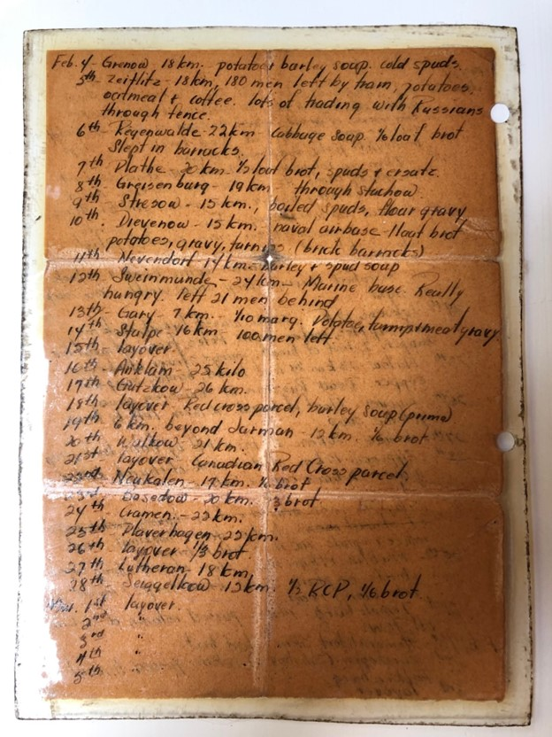
In summary, the Thompson’s and the Water’s still have a friendship. George Patton Waters, son of John K. Waters is a Council Member on the Polish American Foundation for the Commemoration of POW Camps in Szubin, and I am a board member on the Friends of Oflag 64. Time goes on and the two organizations are working to preserve those difficult WWII memories by establishing a museum at the location of the POW camp in Poland.
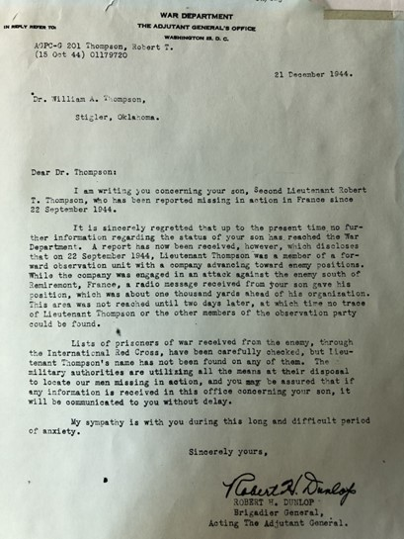

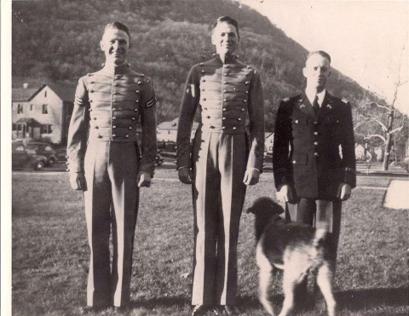
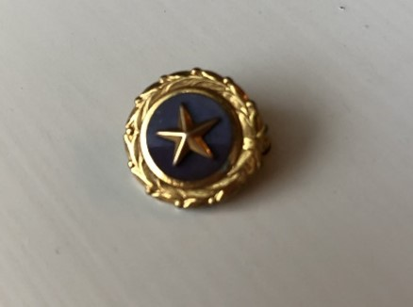
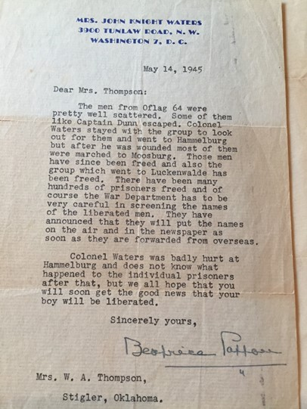
Pershing, William, and Paul Thompson

