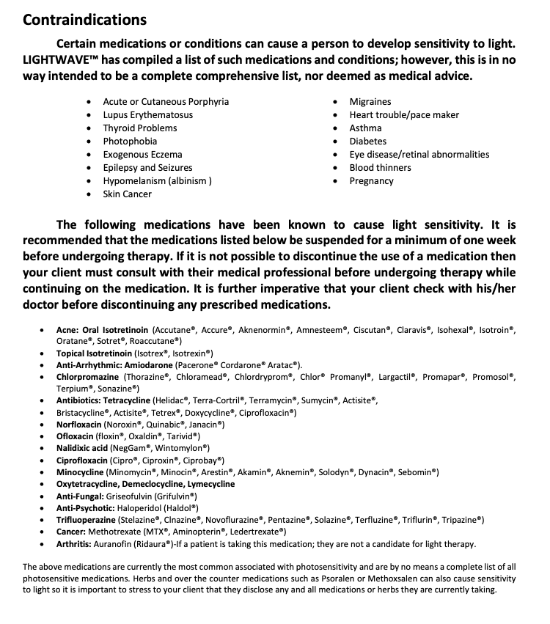
LED Lightwave Therapy Consent Form
Do you attest to the best of your knowledge that you do not have any relevant contraindications listed above?

Name: ________________________________________________________________________

Signature: _____________________________________________________________________

Date: __________________________

