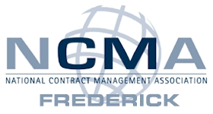
Welcome! The NCMA Frederick Chapter appreciates your interest in wanting to volunteer. We are always looking for new volunteer members. Please complete the application below and the information you provide will assist us in placing you in an appropriate volunteer opportunity that will match your skills and interests. Please print clearly or type your information and email completed form to contact@frederickncma.org

General Information
Name: _____________________________________________________________________
Mailing Address: _____________________________________________________________
Telephone: Home - _______________________ Work - _____________________________
Cell - _________________________ E-mail: ____________________________
Employer: ____________________________________ Current NCMA Member: Y N
Previous Volunteer Experience: __________________________________________________
____________________________________________________________________________
____________________________________________________________________________
What is your availability to volunteer (weekdays, weekends, mornings, afternoons, evenings)?
____________________________________________________________________________
____________________________________________________________________________
Skills and Abilities - Please indicate which skills and abilities you would be interested in sharing with us.

- Advertising | - Computer Skills
- Data Entry | - Meeting Planning
- Host an NCMA event | - Photography
- Public Speaking | - Publishing, newsletters, posters, etc.
- Registration table at events | - Soliciting sponsors
- Teaching/Training | - Website design and maintenance
- Other: ________________

