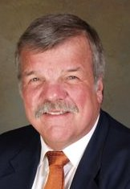

Dave Carlstrom
President and CEO
Air Serv International

Dave Carlstrom is an international aviation executive with twenty-five years of industry experience, including seventeen years as Director of Marketing for Fairbanks International Airport (Alaska). His educational credentials include a B.S. (Electrical Engineering, Cornell University), an MA (New Testament Studies, Gordon-Conwell Theological Seminary), and an MBA (Marketing, University of Washington). An instrument-rated private pilot, Dave and his wife, Nancy (a well known author of children’s books), live in Seattle, Washington, and are active members of Bethany Presbyterian Church.

