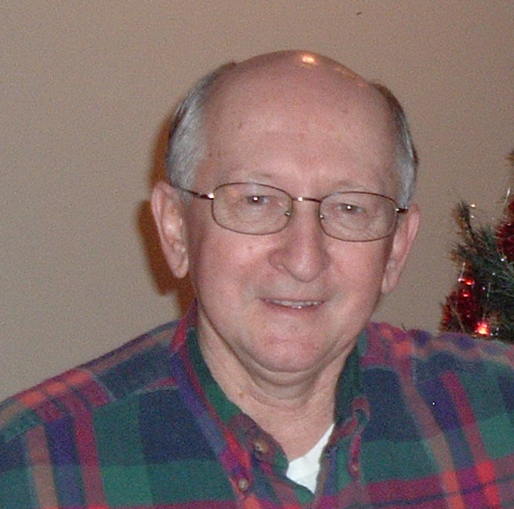
RICHARD L TRICE
HeliMission USA

Richard L. Trice was born in Greensburg, PA., July 1941. He has been married to Eleanor Betts for 45 years.

Richard has served as US Field Representative/Director for HeliMission USA since September 2004.
Helimission is a member of EAA and IAMA (International Association of Missionary Aviation.)

Richard graduated from California State University in PA and taught math two years. He was a Boy Scout Executive for seven years, when he was called to ministry in 1973. Richard attended Elim Bible Institute, Lima, NY. He was on staff as registrar and Christian Education instructor through 1978. Other ministries Richard has been involved in include: assistant pastor in Avon, NY and Jeannette, PA; helped start new churches in NY and PA; served as pastor in Phoenix, NY and Gouverneur, NY. Other positions Richard has held include elder, treasurer, and church boards in NY and PA.

Richard has served 25+years in Christian leadership by the grace of God and with the loving support of my wife and family.

Richard was ordained through Elim fellowship and local church in 1978 for pastoral and missionary services-
1991 lead a mission team through Team World Outreach to Russia, ministered in schools and children’s eye hospital for 3 weeks

2004 Assisted in Emergency Relief service after the 12/26/04 Tsunami in Banda Aceh, Indonesia for 3 weeks with our International relief team located in Trogen, Switzerland, www.helimission.ch.

Contact Information:
E-mail: helimission-usa@rochester.rr.com or rtrice@rochester.rr.com
Phones: Office (585)624-5509
Cell (585)245-1906
Home address: 35 Picture Book Park, West Bloomfield, NY 14585
Home Phone: (585)582-6277

