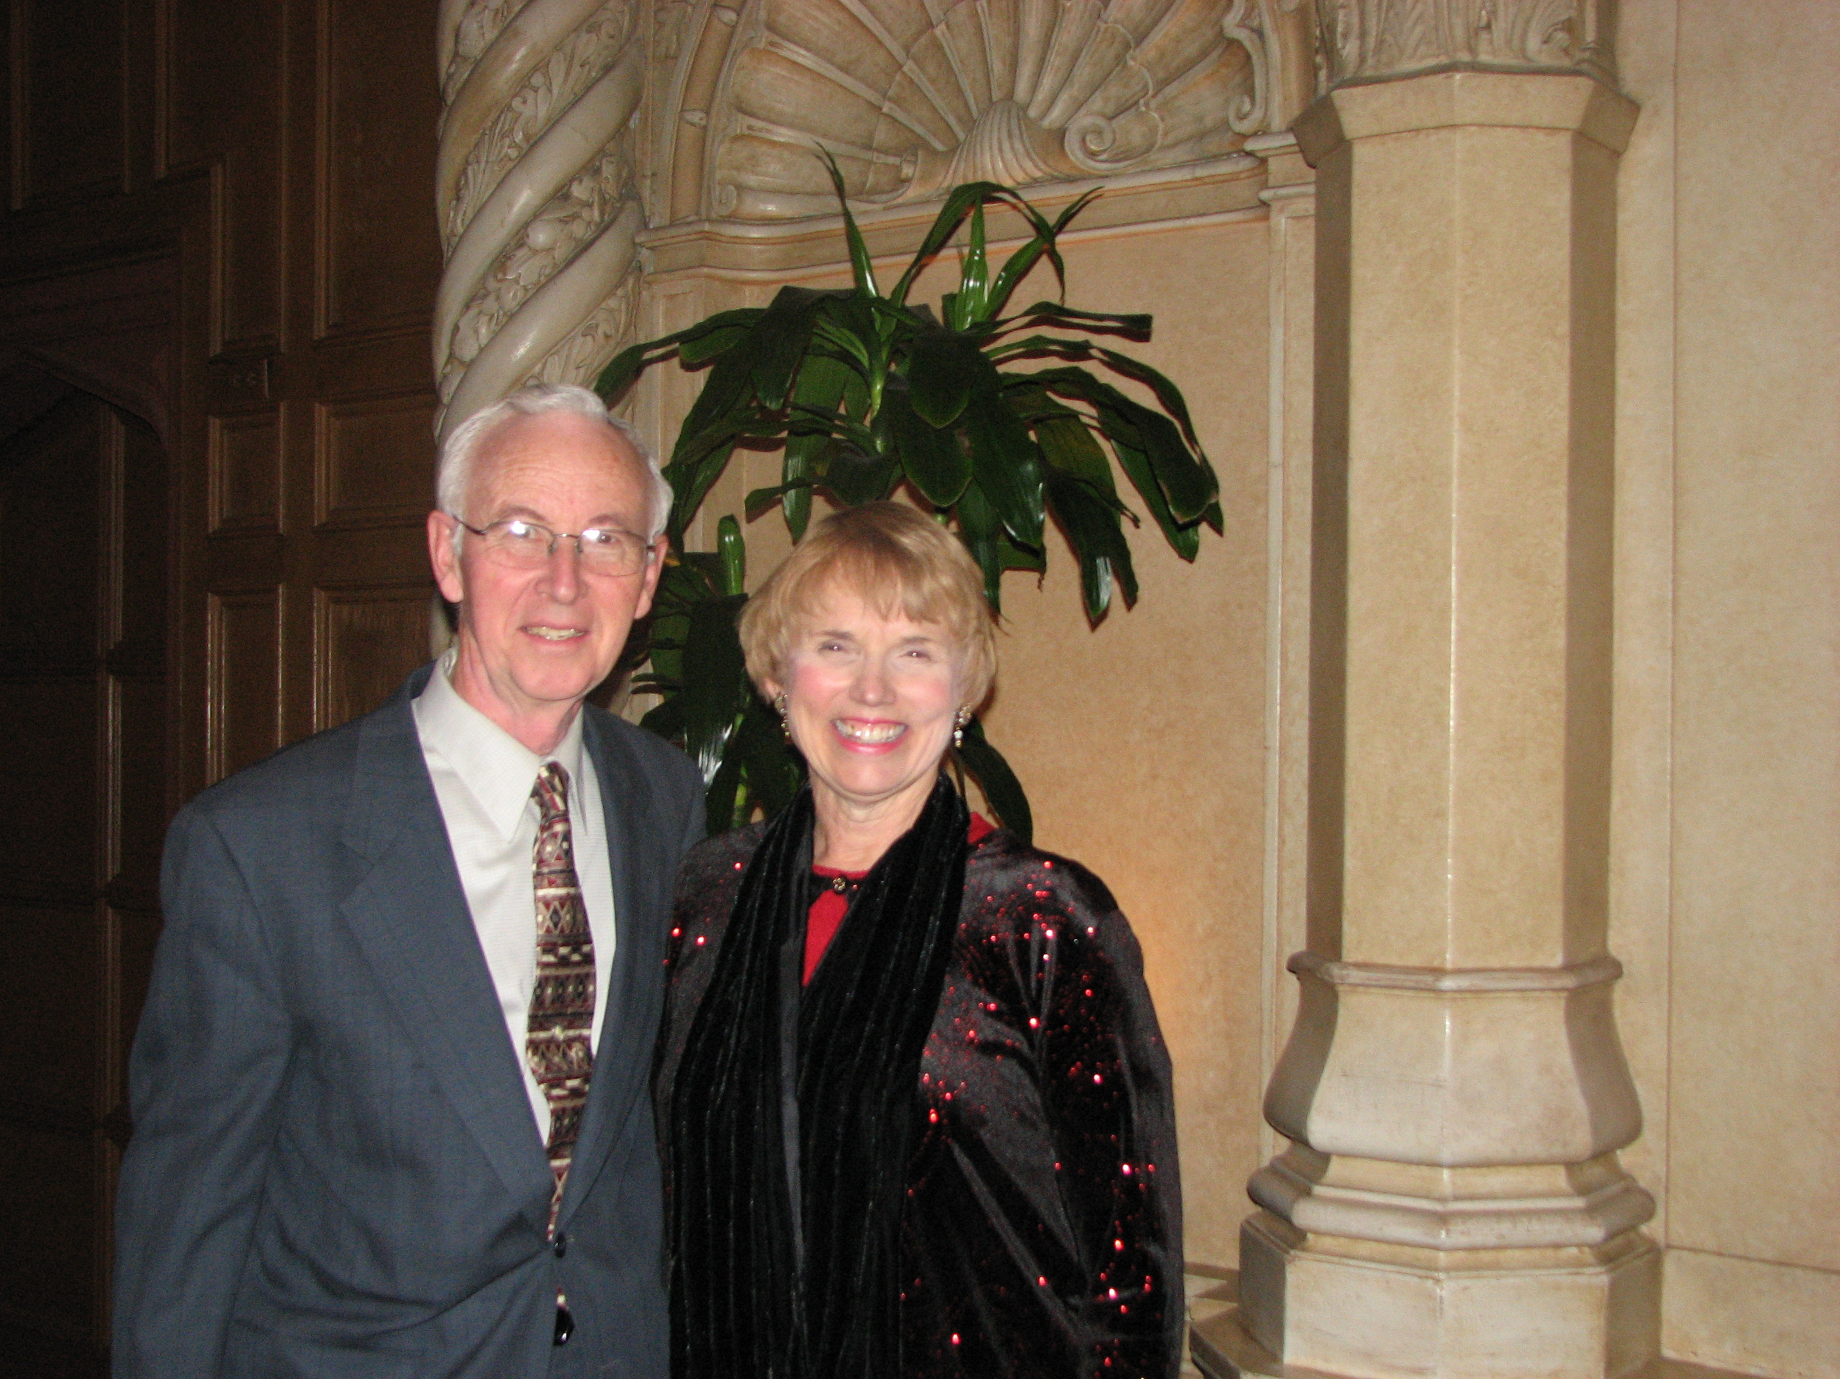
Dietrich Buss
Author: Giving Wings to the Gospel
50th anniversary history of MAF

I was born to German Liebenzell missionary parents in 1939. Our family spent WWII in Japan, but moved out of Tokyo to the now well-known summer resort of Karuizawa. With the defeat of Japan, most of the stranded German nationals were repatriated to Germany. German missionaries, however, joined the then-arriving American missionaries and assisted in conducting large-scale open-air evangelistic rallies. Our family migrated first to the United States, and then to Canada in 1952. The latter was due to the fact that my parents had come from East Germany and the gloomy prospect of returning to the Russian-occupied zone led my father to accept a pastorate to a German-speaking congregation in Saskatchewan. Canada.

With the return of my father and younger brothers to Japan in 1955, I joined my oldest brother in Wheaton, Illinois in 1957. I was graduated from Wheaton Community High school the following spring. I attended Biola College in Los Angeles and was graduated as an Education major in 1963. I received the M.A. in Social Science from California State University, Los Angeles, in 1966. In the meantime, I started teaching at Culter Academy in Los Angeles. From 1966-2005, I served as Professor of History and Geography at Biola University. My wife Miriam Epp Buss and I were married in 1966. The Lord blessed us with three children: Eric (1970), Julie (1972) and Natalie (1974). I continued with graduate studies at Claremont University where I received the Ph.D. in American History in the year of the nation’s bicentennial, 1976. From 1977-2002 I served as chair of the History Department. During those years we developed a thriving Social Science Secondary Education program.

In 1983, I assisted Mission Aviation Fellowship in launching an oral history. This led to my writing the 50th anniversary history of MAF that Baker Books published in 1995 under the title of Giving Wings to the Gospel. While this work began as a history of MAF-US, it expanded to a full-fledged history of the sister MAFs including MAF-UK, MAF-Australia-New Zealand, and MAF-South Africa. The project gave me opportunity to interview most of MAF’s founders, including Betty Greene. I was drawn to her amazing story and subsequently had the privilege of joining her in completing her autobiography, titled Flying High. As an MAF representative at Authors Corner, I am pleased to address both the Larger MAF story (Giving Wings to the Gospel) and Betty Greene’s biography.

