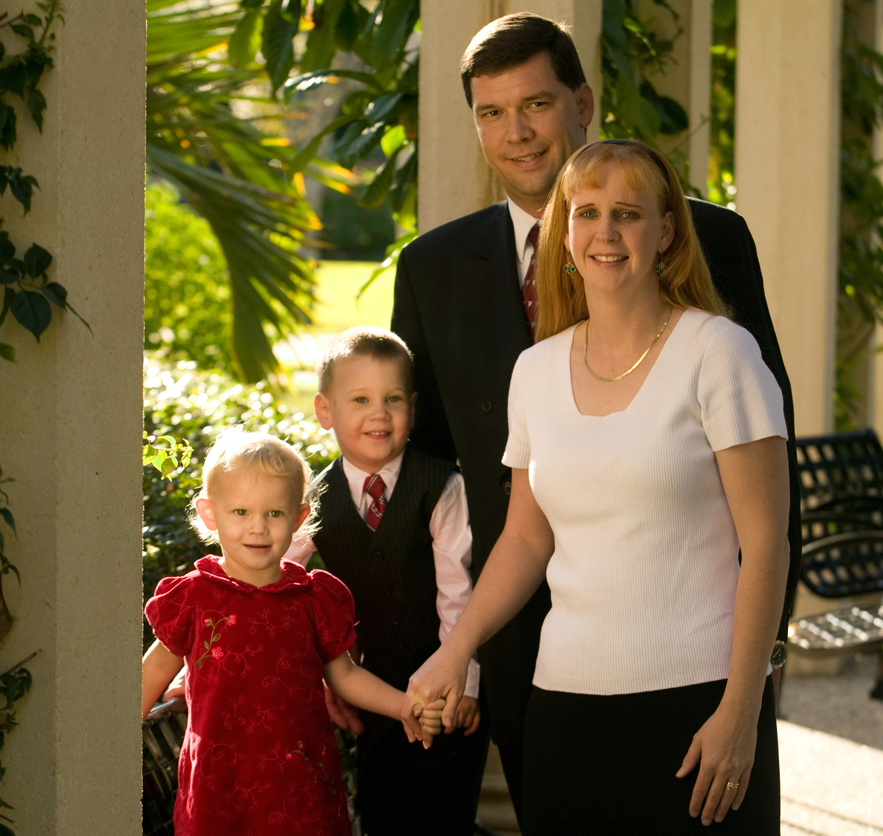
Philip Karnes
Missionary Flights International
Philip Karnes

Born: Portland, Or
Raised: West Palm Beach, FL
Education: Bob Jones University
Ministry: Missionary Flights International
Family: Wife and two children
Church: West Pines Baptist Church

Philip was born into a Pastors family. He moved several times while young. Eventually his family settled in West Palm Beach, FL. Philip accepted Christ as his savior at the age of 9 but did not understand what a remarkable relationship there is to be had with Jesus until he was 21.
Philip learned to fly while in high school achieving his private pilot certificate shortly after graduating. He then attended Bob Jones University where he met his future wife. While at Bob Jones he studied aircraft maintenance, airport management, and completed his flight training through instrument, commercial, and multiengine ratings. Philip married after college and now has two children a boy (4) and a girl (2). Philip worked eight years in aircraft maintenance before surrendering to the Lord and joining Missionary Flights International (M.F.I.). Philip has now been full time with M.F.I. two years.

