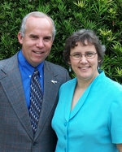
Roger and Judy Sands
MFI

Roger and Judy Sands joined the MFI staff in the summer of 2003. Roger received his aircraft maintenance training at Missionary Maintenance Services in Ohio. After graduating from MMS, Roger and Judy and their two sons moved to the South Pacific Island of Yap. After serving in Micronesia for three years, they moved to Florida to join the MFI staff.

Roger is the Assistant Chief of Maintenance on the MFI flight line and Judy works in the MFI office. Their son Dwight has just graduated from Bob Jones University, and their son Matt has completed his freshman year there. You can keep up to date with the sands by visiting www.sandsislandhopper.org

