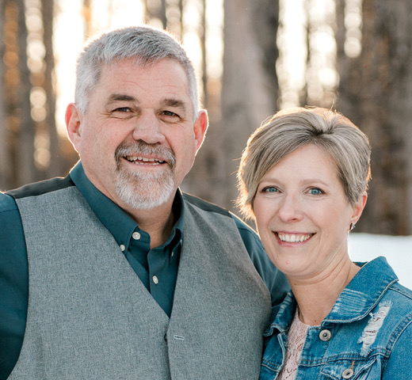
The Garrison’s
Wendell and Heather Garrison
SOAR International Ministries

Heather and I met at a camp in Colorado in 1999. She was married at the time but in 2000 her husband passed away from cancer. My first wife had passed away from cancer nine years prior. Those losses, God working in our hearts and five praying couples brought us together. We were married in March of 2002 and began searching for where God might take us and our daughter Emily who was 11 years old.

The summer of 2002 our family ventured to Houston, British Columbia Canada to explore a Native Bible Camp run by UIM International. God then placed on our hearts the desire to join UIM in 2004 and become the directors of Rock Nest Ranch Bible Camp. We moved to Houston, BC in September of 2005 and directed Rock Nest Ranch until December of 2019.

During our time at Rock Nest Ranch, we became familiar with many mission organizations and were introduced to SOAR International Ministries. In January of 2017 I journeyed to Russia with SOAR for one of their Stuff a Stocking distributions. I witnessed the impact God was making in the lives of orphans through SOAR International.

In 2019, after fourteen years of serving and building, a new Lodge at Rock Nest Ranch was completed. At the same time, God opened the door for us to explore a change in ministry to SOAR International. We asked some of those same couples mentioned above to pray with us about this possible change in ministry. After a busy summer at camp in September of 2019 we felt God moving us to join SOAR in Kenai, Alaska.

We arrived in Kenai on June 29, 2020 to begin the journey that God was leading us on. This change would move Heather and I and our two younger kids Cy, age 16 and Sadie, age 15 back to the US. Our oldest daughter, Emily, would remain in BC with her new husband.

We have now been with SOAR for two years and are starting to settle into ministry roles, make new friends, and building community again. The SOAR staff has warmly welcomed us into the SOAR family and we are learning the many ways that SOAR comes alongside and serves the pastors and orphans in Russia and Abkhazia.

Recently, I (Wendell), had the opportunity to travel to Moldova to help with the refugees coming out of Ukraine. SOAR sent both myself and my cousin Mark to explore the needs of the refugees and how SOAR could help in Moldova and possibly in Ukraine. I was encouraged by God’s Church in Moldova and how they have responded to the needs of the refugees. SOAR will continue to seek God’s leading both in Moldova and Ukraine.

