**Choosing us as your Support Coordinator**

You can request “Support Base”   
as your preferred provider during  
 your planning meeting.

You can also choose us by   
requesting this from your current   
Support Coordination provider or   
via the participant portal.

It’s is your choice and control…

Referrals received by the National   
Disability Insurance Agency will be processed by us within 2 days.

Enquiries about our Support   
Coordination can be made by   
emailing us:

support@supportbase.com.au

Or by calling: 0477 426 111

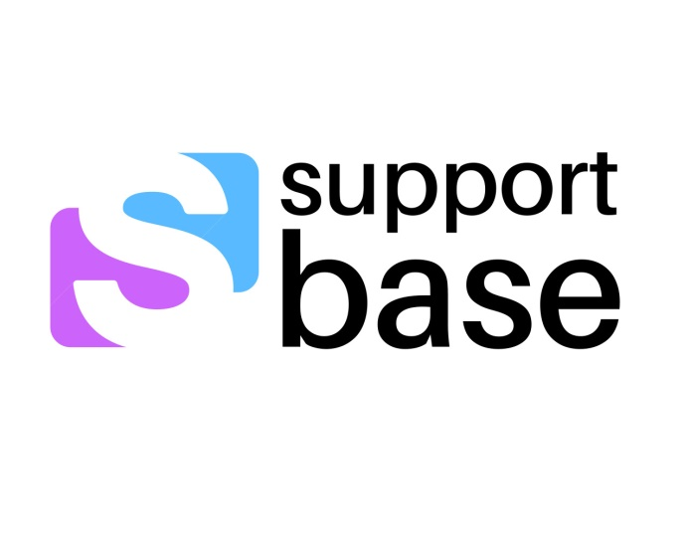For more information about or services including Support Coordination

Contact Us 

  
 0477 426 111

   
 support@supportbase.com.au

   
 supportbase.com.au  
   
   
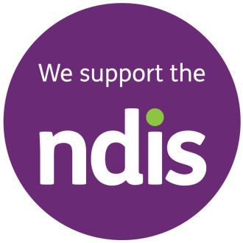

  



* **Support Coordination**
* **Specialist   
  Support Coordination**

**What is Support Coordination ?**

NDIS (National Disability Insurance   
Scheme) is Australia’s national   
scheme for people with disabilities

• Participants of the NDIS will receive access to funds through an NDIS   
approved plan.

• Support Coordination is a capacity building support included in some   
plans to enable participants to make  
the most of their NDIS plan.

• *Support Base* is a registered   
provider to deliver ‘Support   
Coordination’ and ‘Specialist Support Coordination’ under the  
NDIS.

**What does a Support Coordinator do ?**

We will assist you to improve your understanding of the NDIS and your plan

• Provide guidance on how to access the NDIS portal

• Support you to implement your NDIS plan and monitor your budget

• Help you understand service agreements

• Help you to connect with community, mainstream and funded supports

• Build your skills and confidence so that you can become more independent and potentially coordinate your own supports in the future

• Attend meetings if you require support with understanding funding and the NDIS

• Work with you to review your support requirements and goals for future plans

• Prepare you for your next planning meeting.

**What you can expect from us:**

• Once the NDIA or your current Support Coordinator informs us that you have chosen “Support Base” as your preferred provider, we can then make contact with you

• We will organise to meet with you to discuss how we can work together and provide you with the information you need in order to implement your plan

• Support Coordination is delivered independently from all other available services and we refer you to the services and providers of your choice.

**Privacy & Confidentiality:**

*The information that you share with “Support Base” will be kept private and any records will be stored securely by “Support Base” as per our privacy policy.  
You can ask to see your records at any time, and we will support you through this process.*