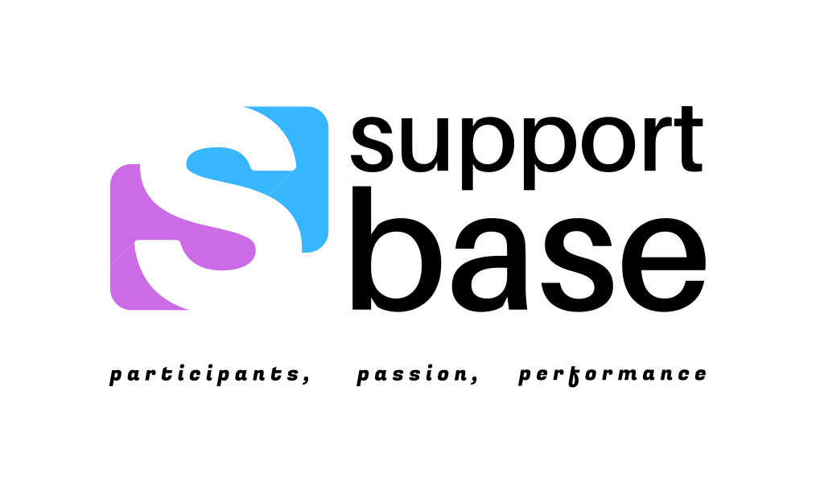



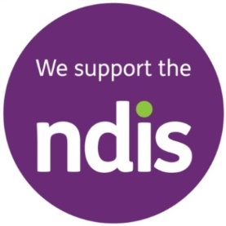 

**Mental Health, Autism and Intellectual Disability specialists**

* **Simple**
* **Quick**
* **Effective**
* **MOBILE Service**
* **INDEPENDENT and friendly**
* **Support Coordination / Specialist Support Coordination**

**Steven - 0477 426 111  
 Get more from your NDIS plan ! We do real time service fees   
 giving you more value from your Support Coordination !  
 For more information - w: supportbase.com.au   
 e: support@supportbase.com.au  @supportbase.com.au**