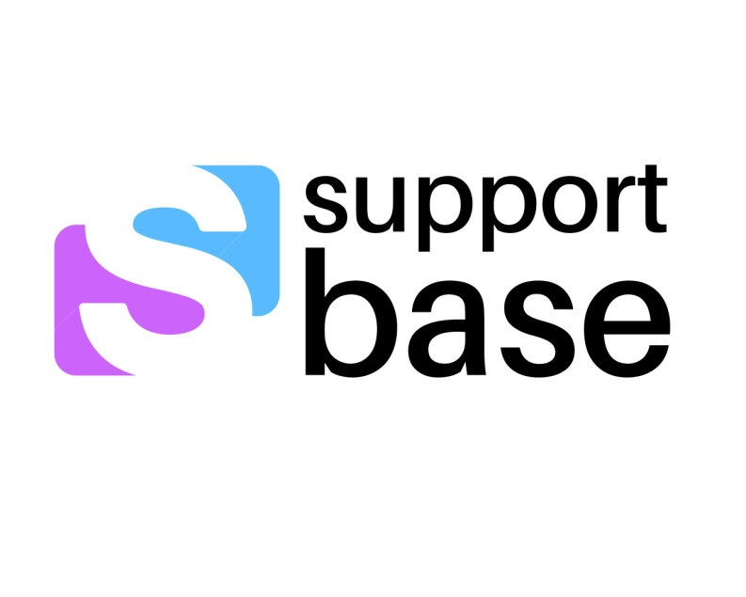**Privacy Policy**

Support Base is a private consultancy

that supports and endorses the National

Privacy Principles contained in the Privacy

Amendment Act 2000 (Private Sector).   
It will comply with these principles   
whenever personal information as defined by the Act is collected.   
The Australian Privacy Principles (APPs) are pertinent to this private practice to cover the collection, storage and use of sensitive information such as name, date of birth, health, place, photographs and addresses.  
Support Base acknowledges and respects the privacy of all children, students, Participants, families and Alliances. In accordance with the National Privacy Principles:

* Support Base will only collect personal information from you with your prior knowledge and consent.
* Support Base will only use personal information provided by you for the purposes for which it was collected.
* Support Base will not disclose your personal information to a third party without your consent.
* Support Base will not disclose your personal information to other institutions and authorities except if required by law or other regulation.
* Support Base will remove personal information from our records when it is no longer required (except where archiving is required).

Support Base will have processes and policies to protect the personal information that we have under our control from:

* Unauthorised access
* Improper use
* Altercation
* Unlawful or accidental destruction and accidental loss

Support Base will only communicate with you through your choice of communication (email, telephone, messages, faxing or the use of the Australian Interpreting Services when deemed necessary by the Participant or their representative.  
Support Base will create both a paper-based and electronic file to manage your data and these are securely kept under a password security code at Support Base. The electronic data system is a cloud based secure application called CareView.  
  
Support Base will keep all forms, rosters, NDIS Participant Plans, Individual Care Plans, Individual Education Support Plans, Emergency Information Plans and any financial documents safely and securely with Password Protection at all times.  
Support Base will ensure that all information is accurate, complete and updated at all times. It is your responsibility to inform Support Base of any changes to information that impact on the care, support and assistance given to the Participant.  
  
Any feedback listed on Support Base’s website has been listed with permission from the Participant. Recordings, videos, photographs or footage of attendance at events will not be taken without the express written consent of the Participant or their representative.

If you believe you privacy has been breached please contact [support@supportbase.com.au](mailto:support@supportbase.com.au)