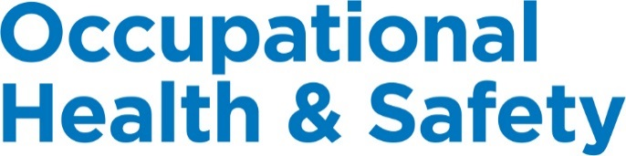

Manitoba

© 2018, Workplace Safety & Prevention Services (WSPS). All rights reserved.
All text, logos, illustrations, graphics, images, designs, the arrangement of information and other content in this publication are protected by copyright and other intellectual property rights. No part of this publication may be reproduced, distributed, displayed, broadcasted, stored in a retrieval system, transmitted in any form or by any means, electronic, mechanical, photocopied, recorded or otherwise, or otherwise exploited in any manner, without the prior written permission of Workplace Safety & Prevention Services (WSPS).
The information contained in this reference material is distributed as a guide only. It is generally current to the best of WSPS’s knowledge as at the revision date, having been compiled from sources believed to be reliable and to represent the best current opinion on the subject. No warranty, guarantee, or representation is made by WSPS as to the absolute correctness or sufficiency of any representation contained in this reference material. WSPS assumes no responsibility in connection therewith; nor can it be assumed that all acceptable safety measures are contained in this reference material, or that other or additional measures may not be required in particular or exceptional conditions or circumstances. Under no circumstances shall WSPS, its affiliates, or any of its respective partners, officers, directors, employees, agents or representatives be liable for any damages, whether direct, indirect, special or consequential damages for lost revenues, lost profits, or otherwise, arising from or in connection with this document.
Workplace Safety & Prevention Services (WSPS) and the above logos and marks are a Trademark of Workplace Safety & Prevention Services (WSPS). © WSPS, 2016. All Rights Reserved.
While WSPS does not undertake to provide a revision service or guarantee accuracy, WSPS shall be pleased to respond to your individual requests for information, at any time.

Provincial Appendix - Manitoba
Overview | The Provincial Occupational Health & Safety Act(s) and associated regulations set a minimum standard for worker health and safety. This appendix outlines the specific requirements based on legislation and regulations for Manitoba.  DQ or OJ Franchisee is committed to the health and safety of our employees, volunteers, visitors, suppliers and customers, customers, workplace and environment. It is important to understand that this appendix supports the Essential Elements Final.docx. Additional safety programs focused on hazard and risk specific programs, safe work practices and best practices will ensure we have a comprehensive program specific to our company.  We are committed to review our programs annually and make every effort to have the most up to date information for our workers.

Keys | Communicate Post / Display Review / Update  Link to other information Information / Training

Document Control | Effective Date: January 2019 Approved By:

Table of Contents
Workplace Violence and Harassment Prevention 3
Posted Health & Safety Materials Requirements 4
Joint Occupational Health & Safety Committee / Health & Safety Representative 5
First Aid Requirements 7
Injury/Incident Reporting and Investigation Requirements 9
Return to Work 10
Working Alone Requirements 12
Resources 13

Workplace Violence and Harassment Prevention
Overview | DQ or OJ Franchisee will be proactive in its prevention of workplace violence or harassment of any kind. We are committed to providing a work environment in which all workers are treated with respect and dignity.

Legislation | Workplace Safety and Health Regulation Part 10 – Harassment  Workplace Safety and Health Regulation Part 11 – Violence in the Workplace

Definitions | Workplace Violence means the attempted or actual exercise of physical force against a person; and any threatening statement or behavior that gives a person reasonable cause to believe that physical force will be used against the person.  Harassment means objectionable conduct that creates a risk to the health of a worker; or severe conduct that adversely affects a worker's psychological or physical well-being.

Procedure | See Workplace Violence and Harassment Prevention in the Essential Elements Final.docx for further information.

Employer Responsibilities | A risk assessment must be performed in any workplace in which a risk of injury to employees from violence arising out of their employment may be present. This assessment must be carried out in consultation with the Committee, Representative, or employees at the workplace.  A workplace violence and harassment prevention policy must be developed, in consultation with the Committee Representative/employees, implemented, and must ensure that employees comply with the policy. The policy shall be posted in a conspicuous location in the workplace.  The employer must inform employees who may be exposed to the risk of violence or harassment of the nature and extent of the risk. This includes information related to the risk of violence from persons who have a history of violent behaviour and whom employees are likely to encounter in the course of their work. Record keeping requirements.

Resources | Preventing Violence in the Workplace Guide – SAFE Work Manitoba  Preventing Harassment in the Workplace Guide – SAFE Work Manitoba  Workplace Violence and Harassment Prevention – Occupational Health & Safety Program – Canada

Posted Health & Safety Materials Requirements
Overview | The following information and materials must be made available to all employees and will be posted in a common area on the Health & Safety Bulletin Board.

Materials to Post on Health & Safety Bulletin Board | 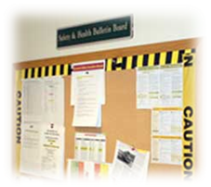  - Workplace Safety and Health Act  - Health and Safety Policy Statement  - Workplace Violence and Harassment Policy Statement  - Hurt at Work Poster  - Workplace Health Hazard Regulation, WHMIS Regulation, Workplace Safety Regulation, First Aid Regulation, Workers Working Alone Regulation, Workplace Safety and Health Committee Regulation, Hearing Conservation and Noise Control Regulation  - Post current inventory of hazardous products used on site  - Safety Data Sheets (may be inserted in a binder)  - Occupational health and safety information prepared by the Ministry of Family Services and Labour, Workplace Safety and Health Branch as appropriate. These include Guidelines and Alerts.  - Evacuation Plan and Emergency Services and Numbers  - Workplace Health and Safety Committee or Representative - names and work locations of members  - Post warning signs in noise hazard areas  - Post signs indicating where first aid kits are available and the names and work locations of certified first aiders  - Applicable Reports including:  - Workplace Health and Safety Committees or Representative - workplace health and safety inspections, meeting minutes – the three most recent meeting minutes shall be posted  - Health and/or safety assessments/surveys  - Improvement Orders, Compliance Reports, Inspections (Inspection Reports must remain posted for 7 days or until compliance has been achieved. Inspection Reports that contain Orders related to the WHSC or Workplace HS Representative must be posted for 12 months)  - Workplace incident summaries  - Other information applicable to the workplace – other inspections, articles on relevant workplace issues

Roles & Responsibilities | Health & Safety Coordinator or designate will be responsible for the following:  - Ensuring the most current information is available at each location.  - Update the Checklist for Posted Health and Safety Materials as necessary.  Managers will be responsible for the following:  - Ensuring the most current information is available to all employees.  - Posting any materials as outlined on the Checklist for Posted Health and Safety Material.  - Complete check list provided signing off and forwarding to Health & Safety Coordinator or designate.  The content of the information will be reviewed and maintained to ensure that it is current.

Resources | Posted Health & Safety Material Checklist  Hurt at Work (Poster)
Workplace Safety & Health Committee (WSHC) / Health & Safety (HS) Representative
Overview | To ensure designated WSHC Members receive consistent recognized training in occupational health and safety and to support the effectiveness of the Internal Responsibility System.

Legislation | A Workplace Safety & Health Committee (WHSC) must be established for each workplace where at least 20 of the employer’s workers are regularly employed, and for any other individual workplace or class of workplace designated by written order of the director. Workplace Safety and Health Act, Section 40 – 41.3  Worker Health & Safety Representative is required between 5 and 19 workers.

Responsibilities | - The receipt, consideration and disposition of concerns and complaints respecting the safety and health of workers.  - Participation in the identification of risks to the safety or health of workers or other persons, arising out of or in connection with activities in the workplace.  - The development and promotion of measures to protect the safety and health and welfare of persons in the workplace, and checking the effectiveness of such measures.  - Co-operation with the occupational health service, if such a service has been established within the workplace.  - Co-operation with a safety and health officer exercising duties under this Act or the regulations.  - The development and promotion of programs for education and information concerning safety and health in the workplace.  - The making of recommendations to the employer or prime contractor respecting the safety and health of workers.  - The inspection of the workplace at regular intervals.  - The participation in investigations of accidents and dangerous occurrences at the workplace.  - The maintenance of records in connection with the receipt and disposition of concerns and complaints and the attendance to other matters relating to the duties of the committee.

Training Requirements | SAFE Committee Basics (2-day course)  An overview on the rights and responsibilities of people in the workplace for: meetings, hazard recognition and control, inspections and right to refuse situations. This course is useful for employees, employers and managers of workers.  Members of a committee are entitled to take educational leave equivalent to two normal working days for the purpose of attending workplace safety and health training programs, seminars or courses of instruction provided by the Workplace Safety and Health Branch or as agreed to by the workplace safety and health committee.  See https://www.safemanitoba.com/Education/Pages/Events.aspx for the listing of available training courses through SAFE Work Manitoba.  Workplace Safety & Health Committee Training Course includes:  - Internal Responsibility System (IRS)  - Where to find information about health and safety law  - Roles and responsibilities of committee members  - How to identify health and safety hazards  - Hazard identification and control measures  - How to conduct workplace inspections  - When to conduct incident investigations

Meeting Minutes | Complete and submit meeting minutes directly to SAFE Work Manitoba at cominutes@gov.mb.ca or by fax to Winnipeg at (204) 948-2209, or Brandon at (204) 726-6749.  Please ensure the following information is included in your minutes:  - Meeting date  - Workplace address or committee number  - Names of employer co-chair and worker co-chair (at top of the form where all members are to be listed)  Post Meeting Minutes on your Health & Safety Bulletin Board.

Resources | Setting up a Workplace Safety and Health Committee (or Worker Representative) Guide – SAFE Work Manitoba  Worker Right to Refuse Flowchart  Health & Safety Committee – Essential Elements Final.docx

First Aid Requirements
Overview | 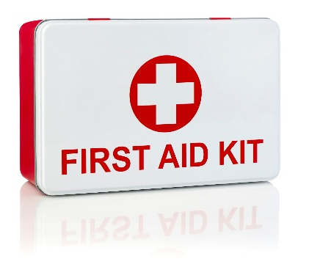  First Aid is an essential part of any health and safety system. Although we strive to eliminate workplace injuries and illnesses, it recognizes that the potential exists for these to occur.  We will protect the health, safety and well-being of its employees, volunteers, guest and visitors. Anyone injured or ill in the workplace shall be provided with the utmost care. Prompt and proper first aid will be administered by a certified First Aid Attendant.

Legislation | Workplace Safety and Health Regulation Part 5 – First Aid

Training | At a minimum, we will ensure that at least one Certified First Aid Attendant will be available during every shift. A list of Certified First Aid Attendants, along with a copy of their current certification, will be posted on the Health & Safety Bulletin Board or near the first aid kits.  A copy of the list of First Aid Attendants must also be provided to the committee or representative.  Standard First Aid with Level A CPR is a 2 day course and is valid for 3 years.  See First Aid Program in the Essential Elements Final.docx for further information.

First Aid Log | All first aid treatment given to a worker must be entered in the First Aid Log. Each case that is referred for further medical treatment must also be entered. The confidentiality of personal medical information must be maintained. First Aid Logs must be kept for at least 5 years.

First Aid Attendants | First Aid Attendants must record all reported signs and symptoms of injuries and exposures to contaminants found at your location using the Hazard Response Form. If an injury is more severe or beyond the training of the First Aider, the First Aiders is responsible for referring the worker to seek additional medical attention.

Reporting Requirements | For any injury or illness requiring first aid, a First Aid Report must be filled out along with an Injury and Incident Analysis Checklist.  The first aid attendant will be required to record in the Injury Incident Analysis Report, all treatment given to an employee. Should the injury/illness be serious enough that medical attention is required, an Incident Injury Investigation Report will be completed and provided to the location manager and HS Coordinator. The Injury/Incident Investigation Report will record the circumstances surrounding the incident as described by the injured employee. Specifically, the report must include:  - The name of the worker.  - The name and qualifications of the person giving first aid.  - A description of the illness or injury.  - The first aid given to the worker.  - The date and time of the illness or injury was reported.  - Where at the work site the incident occurred.  - The work-related cause of the incident.

First Aid Area | DQ or OJ Franchisee ensures that first aid services, first aid equipment, supplies and the first aid room required by the OHS Regs. are:  - Located near or at the work site they are intended to serve.  - Available and accessible during all working hours.  - Maintained in a clean, dry and serviceable condition.  - Contained in a material that protects the contents from the environment.  - Clearly identified as first aid equipment and supplies.  The following are also required:  - Signs indicating the location of first aid services, equipment and supplies are posted at conspicuous places.  - Emergency communication system is in place for workers to summon first aid services.  First Aid Kits Required  # workers employed at workplace # kits that must be provided at workplace  24 or fewer 1  25 to 50 2  51 to 75 3  76 or more 4  Please see the first aid kit inventory list for minimum content requirements.

Resources | First Aid – SAFE Work Manitoba  Injury/Incident Reporting and Investigation Requirements  First Aid - Essential Elements Final.docx

Injury/Incident Reporting and Investigation Requirements
Overview | There are legal requirements in all provinces under the Provincial Health & Safety Act(s) and Workers Compensation Boards for employers to record and report:  - Where a person is killed or critically injured at a workplace.  - Where a person is disabled from performing his or her work or requires medical attention because of an accident, explosion, fire or incident of workplace violence.  - If an employer is told that a worker has an occupational illness or that a claim for an occupational illness has been filed with the WCB.

Legislation | Workers’ Compensation Act

Definitions | An "accident" means a chance event occasioned by a physical or natural cause; and includes a wilful and intentional act that is not the act of the worker, any event arising out of, and in the course of, employment, or thing that is done and the doing of which arises out of, and in the course of, employment, and an occupational disease, and as a result of which a worker is injured.

Reporting | The Workers Compensation Act requires employers to provide the WCB with a fully completed Employers’ Report of Injury (Form 2) within five (5) business days of becoming aware of a workplace accident.  Report the injury to the Workers Compensation Board within five (5) business days of:  - the day of the injury; or  - the day you became aware of the injury.  Complete an Employers’ Report of Injury (Form 2), and send the information by phone, online, fax or mail.  Phone 204-954-4100 within Winnipeg  1-800-362-3340 (toll-free) outside Winnipeg  Fax 204-954-4999 within Winnipeg  1-877-872-3804 (toll-free) outside Winnipeg  Online http://www.wcb.mb.ca/incident-reporting  Mailing Address The Workers Compensation Board of Manitoba 333 Broadway Winnipeg, MB R3C 4W3

Investigation | All imminent danger or work refusal situations will be investigated in accordance with the Injury/Incident Reporting and Investigation Policy.  The Workplace Safety and Health Committee or Representative shall investigate accidents, dangerous occurrences and refusals to work as per Section 43 of the Act  The employer shall retain the report for 5 years after the serious injury or incident.

Administrative Penalties | Under the Workers’ Compensation Act, the employer has a number of obligations. To ensure compliance, the WCB may levy administrative penalties.  An employer may be levied a penalty for violations of the following responsibilities:  - Reporting injuries in a timely manner ($225)  - Not interfering with, intimidating or coercing workers not to report an injury ($450)  Every person who contravenes a regulation may be subject to a $225 administrative penalty. In general, a person who is not a worker is liable to pay up to $7,500 if the person commits an offence under the Act or regulations.

Resources | Injury and Incident Analysis Checklist  Worker Incident Report (Form 3)  Employer’s Incident Report (Form 2)  Resources Final.docx  Injury/Incident Reporting and Investigation (Pg. 63)

Return to Work
Overview | Return to Work is sometimes referred to as disability management program, modified work program, alternate duties program or claims management program.

Legislation | Workers’ Compensation Act

Responsibilities | Employer  - Ensure employees are aware of reporting requirements.  - Report the injury/illness to the WCB within five (5) days of the day of the incident or within five (5) days of the day the employee advised the employer, whichever is sooner.  - Complete Employer’s Incident Report Form 2  - If an employee misses time from work as a result of work-related injury, the WCB must be notified by phone, fax or mail.  - Ensure the employee gets proper medical attention.  - Ensure the employee has advised their doctor that this will be a claim with the WCB.  - Re-employ employees you have employed for at least twelve (12) continuous months before the date of their injury or illness.  - Advise the WCB when the injured employee returns to work following an absence due to a workplace injury.  Employee  - Seek timely and appropriate health care to treat the injury/illness.  - Take all reasonable action to prevent the loss of earnings resulting from an injury/illness.  - Complete Worker Incident Report Form 3 and send it to the WCB.  - Obtain medical attention, as necessary.  - Follow the advice and treatment plan from the health care provider. WCB benefits may be stopped if the employee does not follow the doctor’s prescribed treatment plan.  - Maintain ongoing communication with WCB and employer to help plan for return to work.  - Maintain a positive attitude about returning to work when appropriate. Understand the benefits of accepting appropriate work during the rehabilitation process so that the focus can be shifted from disability to regained abilities.  Health Care Provider  - Provide information to the WCB regarding the injured worker's health care.  - Complete a Doctor’s First Report on the injury/illness and forward to the WCB.  - Treat the injury and keep the injured worker well-informed on how he/she can help their own recovery.  - Maintain regular contact with WCB and the employer to update on the injured worker’s progress and to help in planning the return to work.  Workers’ Compensation Board  - Inform the employer as to what to expect through the Return to Work process.  - Inform injured worker and the employer of expected actions  - Inform injured worker of rights and obligations  - Provide more information upon request  - Monitor the injured worker’s activity, progress, and cooperation with the employer.  - Obtain and clarify functional abilities information  - Help resolve difficulties and disputes  - Provide ergonomic and/or mediation services and/or site visits to help the injured worker and the employer through the process.  - Make decisions on all claim-related and compliance issues

Resources | Injury/Incident Reporting and Investigation Requirements  Worker Incident Report (Form 3)  Employer’s Incident Report (Form 2)

Working Alone Requirements
Overview | When an employee works alone or in isolation, DQ or OJ Franchisee must identify the risks arising from the conditions and circumstances of the employee’s work in consultation with the employees when there is no Workplace Safety and Health Representative.

Legislation | Occupational Health and Safety Regulation, Part 4 Section 4.20.1 – 4.23 – Working Alone or In Isolation

Definition | Working alone means the performance of any work function by an employee who:  - Is the only employee for that employer at any workplace at any time  - Is not directly supervised or another person designated as a manager at any time.  Working in isolation means working in circumstances where assistance is not readily available in the event of injury, ill health or emergency.

Employer Responsibilities | - Must develop and implement safe work procedures to eliminate or reduce the identified risks to employees working alone or in isolation.  - Train employees in the safe work procedures.  - Ensure that employees comply with the safe work procedures.  A copy of the safe work procedures must be posted in a conspicuous location in the workplace. In addition, the procedures must be reviewed and revised not less than every three (3) years or sooner, if circumstances at a workplace changes in a way that poses a risk to the safety and health of an employee working alone or in isolation.

Resources | Working Alone – General Information (ccohs.ca)  Working Alone – Essential Elements Final.docx

Resources
Overview | Some of the samples and templates referred to in this document follow this section. Other forms can be found in the Resource section of the Occupational Health & Safety Program – Canada (Resources Final.docx).  Posting Health & Safety Materials  Posted H&S Material Checklist 15  Hurt at Work (Poster) 17
Work Site Health & Safety Committee/Health & Safety Representative
Worker Right to Refuse Flowchart) 18
Injury & Incident Forms
First Aid Kit Requirements 19
Injury/Incident Analysis Checklist 21
Worker Incident Report 25
Employer’s Incident Report 27

Posted Health & Safety Material Checklist
Material | Location | Links | Date Posted
Workplace Safety and Health Regulation | Health & Safety Bulletin Board | http://web2.gov.mb.ca/laws/regs/current/217.06.pdf
The Workers Compensation Act | Health & Safety Bulletin Board | http://web2.gov.mb.ca/laws/statutes/ccsm/w200e.php
Health and Safety Policy Statement | Health & Safety Bulletin Board
Workplace Violence and Harassment Prevention Policy Statement | Health & Safety Bulletin Board
Hurt at Work Poster | Health & Safety Bulletin Board  First Aid Kit | https://www.wcb.mb.ca/sites/default/files/resources/4331_WCB_Hurt_at_Work_Poster_Web.pdf
First Aid Regulation (Part 5 of the Workplace Safety and Health Regulation)  Include a list of all certified First Aiders in the workplace along with a copy of their certificate | Health & Safety Bulletin Board  First Aid Kit | https://www.safemanitoba.com/topics/Pages/First%20Aid.aspx
WHMIS Regulation  Post inventory of hazardous products on site | Health & Safety Bulletin Board | http://www.gov.mb.ca/labour/safety/whmis_2015.html
Safety Data Sheets (SDS)  To be stored in an easily accessible area near where the chemicals are being used, must be most current version available from supplier | SDS Binder
Emergency Services and Numbers  Examples: 911 (if available), fire, police, ambulance, poison control centre, WCB Inspector, Ministry of Environment, Utilities, Internal contact numbers, Numbers specific to workplace, i.e. Chemical Spill Clean-up Contractor | Primary Telephones  Health & Safety Bulletin Board
Evacuation Plan | Health & Safety Bulletin Board
Workplace Safety and Health Committee (WSHC) or Representative  Post names committee members | Health & Safety Bulletin Board | https://www.safemanitoba.com/Roles/Pages/Workplace-Safety-and-Health-Committee-Member.aspx
Health & Safety Explanatory Materials  Examples: SafeWork Manitoba Guidelines and Bulletins | Health & Safety Bulletin Board (optional) | Guidelines:  https://www.safemanitoba.com/Resources/Pages/ResourceTypes.aspx?ResourceType=Guides  Bulletins:  https://www.safemanitoba.com/Resources/Pages/ResourceTypes.aspx?ResourceType=Bulletins
Other Reports relevant to workplace  Examples:  - Management and Committee health and safety inspections  - Committee Meeting Minutes  - Health and safety assessments and surveys  - Orders  - Workplace Incident summaries | Health & Safety Bulletin Board

Occupational Health & Safety Department | Workers’ Compensation Board
Workplace Safety and Health  200-401 York Avenue  Winnipeg MB R3C 0P8  http://www.gov.mb.ca/labour/safety/  Winnipeg: 204-957-SAFE (7233)  Toll-free: 1-855-957-SAFE (7233)  You can also report unsafe work by email:  wshcompl@gov.mb.ca | Workers Compensation Board of Manitoba  333 Broadway Street  Winnipeg MB R3C 4W3  Telephone: (204) 954-4321 or  Toll-Free: 1-800-362-3340  Fax: (204) 954-4999 or Toll-Free: 1-877-872-3804  http://www.wcb.mb.ca
SAFE Work Manitoba
16 - 363 Broadway
Winnipeg MB R3C 3N9
http://safemanitoba.com/
Winnipeg: 204-957-SAFE (7233)

Toll-free: 1-855-957-SAFE (7233)

https://www.wcb.mb.ca/sites/default/files/resources/4331_WCB_Hurt_at_Work_Poster_Web.pdf

Worker Right to Refuse Flowchart
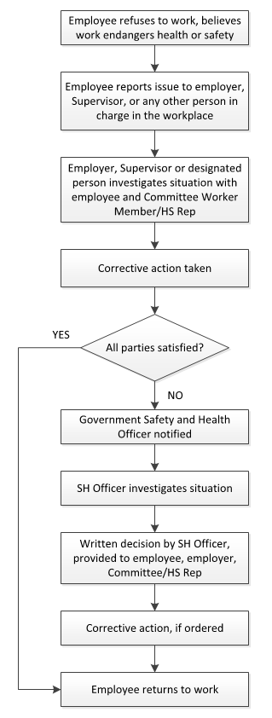

First Aid Kit Requirements

Supply | Qty
A recent edition of a first aid manual | 1
Pair of impervious disposable gloves | 1
Disposable resuscitation mask (with a one-way valve) | 1
Disposable cold compress | 1
Safety pins (one dozen) | 1
Splinter forceps | 1
Bandage scissors (12 cm) | 1
Antiseptic swabs | 25
Waterless hand cleaner | 1
Waterproof waste bag | 1
Dressings (each item to be sterile and individually wrapped in order to maintain sterility)
Surgical gauze pads (7.5 cm squares) | 16
Pads (7.5 cm by 10 cm) non-adhesive | 4
Adhesive dressings, 2.5 cm wide | 32
Large pressure dressings | 2
Triangular bandages (1 m each) | 3
Conforming bandages (10 cm each) | 2
Elastic adhesive bandage roll (7.5 cm) | 1
Tensor bandage rolls (7.5 cm) | 2

Injury/Incident Analysis Checklist
This checklist can be used in conjunction with the Injury/Incident Investigation Report
Background Information
Job Title of Employee
Department of Employee
Age Range of Employee
Male or Female |  |  |  | M F
Employee's Supervisor
Location (where the event took place)
Day of Event (Monday, Tuesday, etc.)
Date of event (dd/mm/yr)
Time of Event (include AM or PM)
Date of Investigation (dd/mm/yr)
Date of Return to Work – Full Duty (dd/mm/yr)
Date of Return to Work – Modified Duty (dd/mm/yr)
Incident Type
Near Miss |  |  | Yes No | Occupational Injury |  |  | Yes No
Hazard |  |  | Yes No | Violence/Harassment |  |  | Yes No
Occupational Health Hazard |  |  | Yes No | Occupational Illness |  |  | Yes No
Environmental Release |  |  | Yes No | Damage |  |  | Yes No
Other |  |  |  | Describe:
Injury Details
Critical injury |  |  | Yes No | Fatal Injury |  |  | Yes No
Non-Critical Injury |  |  | Yes No | Exposure to health hazards |  |  | Yes No
No injury or exposure |  |  | Yes No
Full Time Employee | Yes No | Part Time Employee |  |  | Yes No | Student/Seasonal |  | Yes No
Contractor | Yes No | Temporary Staff |  |  | Yes No | Volunteer |  | Yes No
Other |  |  |  | Describe:
Treatment Received
None
First Aid Required
Health Care Required
Time Loss Injury
Number of days lost
Has the Employee had a previous similar injury/disease? |  |  |  | Yes No
Returned to full duty? |  |  |  | Yes No
Returned to modified work? |  |  |  | Yes No
Form 7 Required? |  |  |  | Yes No
Damages
Property Damage |  |  | Yes No | Machinery/Equipment Damage |  |  | Yes No
Tool Damage |  |  | Yes No | Product Damage |  |  | Yes No
Materials Damage |  |  | Yes No | No Damage |  |  | Yes No
Root Causes
Performance Specifications:  - Are safe work policies/procedures in place? Are they adequate?  - Are instructions from Management creating an unsafe work environment? |  |  |  | Adequate Inadequate  Describe:

Task Interference:  - Enough time allotted to complete the task safely  - Equipment in proper working condition and available?  - Policies/procedures that are currently in place contributed to this hazardous event?  - Staffing issues?  - Inappropriate body position for the task |  |  | Adequate Inadequate  Describe:
Consequences:  - Discipline practiced for unsafe acts?  - Positive consequences for unsafe acts (e.g. rushing to get the job done quickly)  - Injury/illness occurring from tasks |  |  | Adequate Inadequate  Describe:
Feedback:  - Lack of communication (positive or negative) between Employees, team leaders and supervisors  - Improper motivation (feedback/ rewards/recognition reinforcing unsafe acts)  - Employees not reporting similar injuries/illnesses  - Employees not advising Supervisors of potential hazards |  |  | Adequate Inadequate  Describe:
Knowledge/Skill:  - Demonstrated lack of skill/knowledge?  - Failure to use prescribed personal protective equipment?  - Are Supervisors aware this hazardous event could occur (Supervisor and Employees trained on this hazard)?  - Failure to follow established procedures?  - Inadequate training? |  |  | Adequate Inadequate  Describe:
Individual Capacity:  - Stress  - Workload  - Rushing to complete tasks  - Staffing/Scheduling issues  - Unsuitable loading/lifting |  |  | Adequate Inadequate  Describe:
People/Behavioural Factors:  - Improper motivation  - Leadership or supervision issues  - Unauthorized use of equipment  - Failure to control, monitor or secure hazard  - Disabling safety devices or bypassing barrier/guards  - Operating at improper speed  - Abuse or misuse  - Horseplay  - Other |  |  | Yes No  Yes No  Yes No  Yes No  Yes No  Yes No  Yes No  Yes No  Describe:
Equipment Factors:  - Inadequate ventilation  - Defective tools, equipment or material  - Lack of adequate safety devices, barriers, or guards  - Inadequate warning systems  - Inadequate tools/equipment  - Inappropriate PPE  - Wear and tear of equipment  - Hazardous energy not controlled  - Other |  |  | Yes No  Yes No  Yes No  Yes No  Yes No  Yes No  Yes No  Yes No  Describe:
Materials Factors:  - Property damage caused by spilled materials  - Handling of raw materials  - Handling of products  - Handling/use of hazardous chemicals  - Handling of biological agents  - Supplier issues when sending product  - Manual material handling issues – lifting, carrying, pushing, pulling  - Mechanical material handling issues – handcarts, forklifts  - Other |  |  | Yes No  Yes No  Yes No  Yes No  Yes No  Yes No  Yes No  Yes No  Describe:
Environment Factors:  - Hazardous environment – air quality, leak or spill  - Presence of combustibles, fire or explosion hazard  - Temperature extreme  - Radiation hazard (non-ionizing)  - Noise hazard  - Poor lighting  - Congested area, blocked exits/stairways, disorder  - Condition of floors (e.g. slippery)  - Poor ventilation  - Hazards in product storage area  - Other |  |  | Yes No  Yes No  Yes No  Yes No  Yes No  Yes No  Yes No  Yes No  Yes No  Yes No  Describe:
Process Factors:  - Poor layout or ergonomic design  - Engineering issues  - Purchasing issues  - Staff schedules/patterns  - Physical condition of work area not inspected  - Maintenance issues/records  - Other |  |  | Yes No  Yes No  Yes No  Yes No  Yes No  Yes No  Describe:
Incident Event Type (Type of Contact)
Struck by object | Yes No |  | Struck against object | Yes No
Caught in – nip points | Yes No |  | Caught on snagged | Yes No
Caught between - crushed | Yes No |  | Voluntary motion | Yes No
Lifting | Yes No |  | Falls | Yes No
Overexertion | Yes No |  | Electricity | Yes No
Temperature extremes | Yes No |  | Radiation | Yes No
Noise | Yes No |  | Chemical Substance | Yes No
Vibration | Yes No
Other |  |  | Yes No Describe:
Injury/Illness Assessment
Has an event like this happened before in this job?  Rare – once/year  Occasional – once/month  Common – once/week |  | Yes No
Do you think this could happen again?  Rare – once/year  Occasional – once/month  Common – once/week |  | Yes No

Injured Body Part
Finger/Hand/Wrist  Arm/Elbow  Chest | Shoulder  Neck  Head/Face | Upper/Lower Back  Hip/Thigh  Knee |  | Lower Leg  Ankle/Foot  Other, Describe:
Nature of Injury
Sprain/Strain  Crushing/Bruising | Cuts/Lacerations  Fractures |  | Scratches/Abrasions  Falls |  | Other, Describe:

Worker Incident Report (Form 3)
https://www.wcb.mb.ca/worker-incident-report 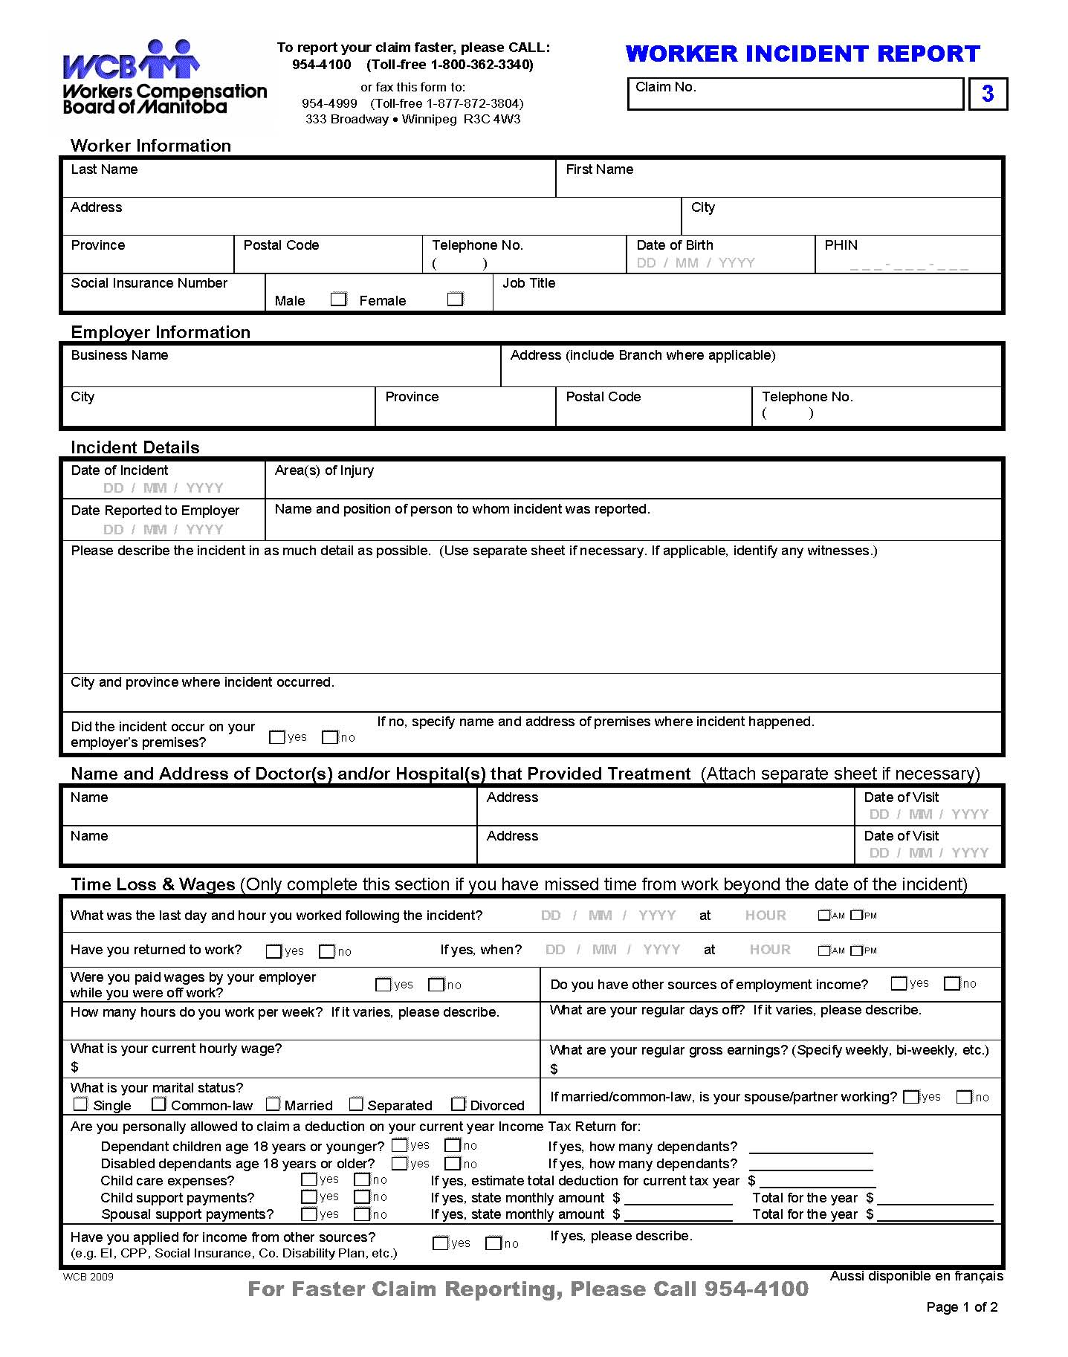

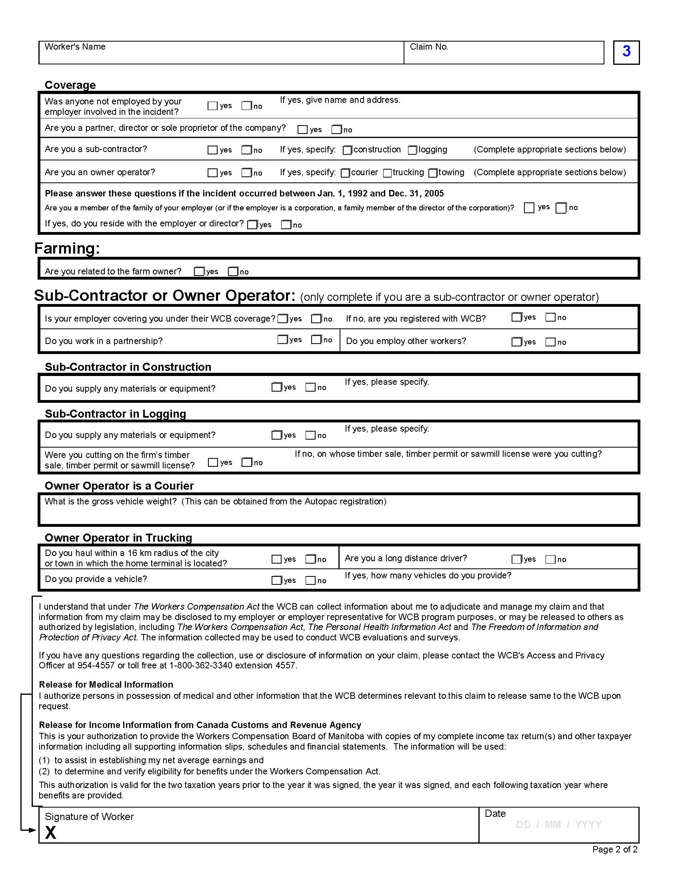

Employer’s Incident Report (Form 2)
https://www.wcb.mb.ca/employer-incident-report 