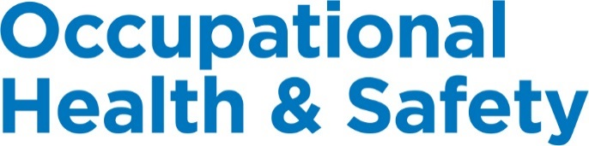

New Brunswick

© 2018, Workplace Safety & Prevention Services (WSPS). All rights reserved.
All text, logos, illustrations, graphics, images, designs, the arrangement of information and other content in this publication are protected by copyright and other intellectual property rights. No part of this publication may be reproduced, distributed, displayed, broadcasted, stored in a retrieval system, transmitted in any form or by any means, electronic, mechanical, photocopied, recorded or otherwise, or otherwise exploited in any manner, without the prior written permission of Workplace Safety & Prevention Services (WSPS).
The information contained in this reference material is distributed as a guide only. It is generally current to the best of WSPS’s knowledge as at the revision date, having been compiled from sources believed to be reliable and to represent the best current opinion on the subject. No warranty, guarantee, or representation is made by WSPS as to the absolute correctness or sufficiency of any representation contained in this reference material. WSPS assumes no responsibility in connection therewith; nor can it be assumed that all acceptable safety measures are contained in this reference material, or that other or additional measures may not be required in particular or exceptional conditions or circumstances. Under no circumstances shall WSPS, its affiliates, or any of its respective partners, officers, directors, employees, agents or representatives be liable for any damages, whether direct, indirect, special or consequential damages for lost revenues, lost profits, or otherwise, arising from or in connection with this document.
Workplace Safety & Prevention Services (WSPS) and the above logos and marks are a Trademark of Workplace Safety & Prevention Services (WSPS). © WSPS, 2016. All Rights Reserved.
While WSPS does not undertake to provide a revision service or guarantee accuracy, WSPS shall be pleased to respond to your individual requests for information, at any time.

Provincial Appendix - New Brunswick
Overview | The Provincial Occupational Health & Safety Act(s) and associated regulations set a minimum standard for worker health and safety. This appendix outlines the specific requirements based on legislation and regulations for New Brunswick.  DQ or OJ Franchisee is committed to the health and safety of our employees, volunteers, visitors, suppliers and customers, customers, workplace and environment. It is important to understand that this appendix supports the Essential Elements Final.docx. Additional safety programs focused on hazard and risk specific programs, safe work practices and best practices will ensure we have a comprehensive program specific to our company.  We are committed to review our programs annually and make every effort to have the most up to date information for our workers.

Keys | Communicate Post / Display Review / Update  Link to other information Information / Training

Document Control | Effective Date: January 2019 Approved By:

Table of Contents
Workplace Violence and Harassment Prevention 3
Posted Health & Safety Materials Requirements 3
Joint Occupational Health & Safety Committee / Health & Safety Representative 4
First Aid Requirements 6
Injury/Incident Reporting and Investigation Requirements 8
Return to Work 11
Working Alone Requirements 13
Resources 14

Workplace Violence and Harassment Prevention
Overview | DQ or OJ Franchisee will be proactive in its prevention of workplace violence or harassment of any kind. We are committed to providing a work environment in which all workers are treated with respect and dignity.

Legislation | New Brunswick does not have specific workplace violence and harassment legislation.  The Government of New Brunswick is proposing changes to General Regulation 91-191. The amendments relate to workplace violence and harassment. (May 2018)

Resources | Workplace Violence and Harassment Prevention – Essential Elements Final.docx

Posted Health & Safety Materials Requirements
Overview | The following information and materials must be made available to all employees and will be posted in a common area on the Health & Safety Bulletin Board.

Materials to Post on Health & Safety Bulletin Board | 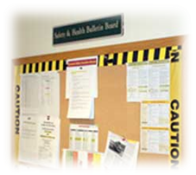  - Occupational Health and Safety Act  - Health and Safety Policy Statement  - Workplace Violence and Harassment Policy Statement  - WHMIS Regulation  - Post current inventory of controlled products used on site  - Safety Data Sheets (may be inserted in binder)  - Occupational health and safety information prepared by WorkSafeNB as appropriate. These include Guidelines and Alerts.  - Evacuation Plan and Emergency Services and Numbers. In accordance with the First Aid Regulation, an emergency communication procedure must be posted. This procedure must include how to contact assistance, provide directions to the workplace and instructions on how emergency services can access the place of employment.  - Joint Health and Safety Committee or Representative – names and work locations of members  - Post warning signs in high hazard areas e.g. noise  - Post signs indicating where first aid kits are available and the names and work locations of certified first aid providers.  - “When an Accident Happens” Poster  - Applicable Reports including:  - Joint Health and Safety Committee members names, meeting minutes  - Health and/or safety assessments/surveys  - Orders and/or reports issued by WorkSafeNB  - Workplace incident summaries

Roles & Responsibilities | Health & Safety Coordinator or designate will be responsible for the following:  - Ensuring the most current information is available at each location.  - Update the Checklist for Posted Health and Safety Materials as necessary.  Managers will be responsible for the following:  - Ensuring the most current information is available to all employees.  - Posting any materials as outlined on the Checklist for Posted Health and Safety Material.  The content of the information will be reviewed and maintained to ensure that it is current.

Resources | Posted Health & Safety Material Checklist  When an Accident Happens (Poster)
Joint Health & Safety Committee (JHSC) / Health & Safety (HS) Representative
Overview | To ensure designated JHSC Members receive consistent recognized training in occupational health and safety and to support the effectiveness of the Internal Responsibility System

Legislation | Any workplace in New Brunswick that regularly employs 20 or more workers requires a Joint Health and Safety Committee.  Any workplace which regularly employs no less than 5 but no more than 19 workers requires a Health and Safety Representative.

Responsibilities | - Identifying health and safety concerns.  - Making recommendations to correct health and safety concerns.  - Monitoring the corrective action taken.  - Creating awareness of the importance of health and safety to all employees.  - Ensuring that health and safety education training programs are established and maintained.  - Helping resolve questions arising from the right to refuse dangerous work.  - Investigating the causes of accidents to prevent re-occurrence.  - Becoming familiar with the Occupational Health and Safety Act and regulations.  - Maintaining a positive and enthusiastic attitude toward the practice of health and safety.  - Undertaking any activities as prescribed by legislation.

Training Requirements | JHSC Core Training Program (3-Days)  This 3-day program will provide the Joint Health and Safety Committee (JHSC) members with the essential training necessary for them to function effectively as JHSC members.  The course calendar is available on http://www.worksafenb.ca/workshops  At least two committee members — one representing the employer and one representing workers — must be chosen for special training as Co-Chairs. Joint Health and Safety Committee Co-Chairs play a key role on the committee. They also have specific authority and responsibilities under the Occupational Health and Safety Act. The Co-Chairs must have the core training.  The employer may wish all committee members to have the training. The employer shall ensure the necessary time and resources are given to the committee members for training in their duties and responsibilities.  Joint Health & Safety Committee Training Course will include:  - Internal Responsibility System (IRS)  - Where to find information about health and safety law  - Roles and responsibilities of committee members  - How to identify health and safety hazards  - Hazard identification and control measures  - How to conduct workplace inspections  - When to conduct incident investigations

Meeting Minutes | Complete and submit meeting minutes directly to WorkSafeNB.  - Northwest (includes counties of Carleton, Madawaska, Restigouche* and Victoria) JHSCNW-CMHSNO@ws-ts.nb.ca  - Northeast (includes counties of Gloucester, Northumberland and Restigouche** JHSCNE-CMHSNE@ws-ts.nb.ca  - Southwest (includes counties of Charlotte, Kings, Saint John, Sunbury and York) JHSCSW-CMHSSO@ws-ts.nb.ca  - Southeast (includes counties of Albert, Kent, Queens and Westmorland) JHSCSE-CMHSSE@ws-ts.nb.ca  - *Aroostook, Drummond, Grand Falls, Kedgwick, Perth-Andover, Plaster Rock, St. Quentin **Atholville, Tide Head  Post Meeting Minutes on your Health & Safety Bulletin Board.

Resources | Five Steps to an Effective JHSC – WorkSafeNB  Joint Health and Safety Committees – WorkSafeNB  Minutes of Joint Health & Safety Committee  Worker Right to Refuse Flowchart  Health & Safety Committee – Essential Elements Final.docx

First Aid Requirements
Overview | 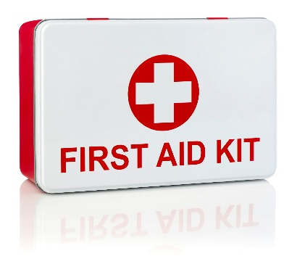  First Aid is an essential part of any health and safety system. Although we strive to eliminate workplace injuries and illnesses, it recognizes that the potential exists for these to occur.  We will protect the health, safety and well-being of its employees, volunteers, guest and visitors. Anyone injured or ill in the workplace shall be provided with the utmost care. Prompt and proper first aid will be administered by a certified First Aid Attendant.

Legislation | First Aid Regulation 2004-130

Training | At a minimum, we will ensure that at least one Certified First Aid Attendant will be available during every shift. A list of Certified First Aid Attendants, along with a copy of their current certification, will be posted on the Health & Safety Bulletin Board or near the first aid kits.  Standard First Aid with Level A CPR is a 2 day course and is valid for 3 years.  The minimum level of training consists of:  - 10 compulsory modules and any 2 of 5 elective modules of the Workplace Standard First Aid Course as set out in Schedule B  - Minimum of 16 hours of classroom and practical training  Training may be provided by:  - St. John Ambulance  - Canadian Red Cross Society  - Any other agency that provides first aid training that meets the minimum level of training described above and is approved by the Chief Compliance Officer  The training certificate shall be:  - Entitled “The First Aid Workplace Certificate”  - Signed and dated by an official of the agency  - Stated that the course in respect of which the certificate is issued is the Workplace Standard First Aid Course  See First Aid Program in the Essential Elements Final.docx for further information.

First Aid Log | All first aid treatment given to a worker must be entered in the First Aid Log. Each case that is referred for further medical treatment must also be entered. The confidentiality of personal medical information must be maintained. First Aid Logs must be kept for at least 5 years.

First Aid Attendants | First Aid Attendants must record all reported signs and symptoms of injuries and exposures to contaminants found at your location using the Hazard Response Form. If an injury is more severe or beyond the training of the First Aider, the First Aider is responsible for referring the worker to seek additional medical attention.  First Aid Attendant Requirements (Schedule A of the First Aid Regulation)  # of Workers/Shift Place of Employment with No High Hazard Work Place of Employment with High Hazard Work  1 N/A Personal (P) type first aid kit  2-19 1 first aid kit 1 first aid provider 1 first aid kit 1 first aid provider  20-49 1 first aid kit 1 first aid provider 2 first aid kits 2 first aid providers  50-99 2 first aid kits 2 first aid providers 2 first aid kits 2 first aid providers  100-199 2 first aid kits 2 first aid providers, one of whom must have access to the first aid room 1 first aid room 3 first aid kits 3 first aid providers, one of whom must have access to the first aid room 1 first aid room  200 or more 3 first aid kits 3 first aid providers, one of whom must have access to the first aid room 1 additional first aid provider & 1 additional first aid kit for each additional increment of 1-100 workers 1 first aid room 4 first aid providers, one of whom must have access to the first aid room 1 additional first aid provider & 1 additional first aid kit for each additional increment of 1-100 workers 1 first aid room

Reporting Requirements | For any injury or illness requiring first aid, a First Aid Report must be filled out along with an Injury and Incident Analysis Checklist.  The first aid attendant will be required to record in the Injury Incident Analysis Report, all treatment given to an employee. Should the injury/illness be serious enough that medical attention is required, an Incident Injury Investigation Report will be completed and provided to the location manager and HS Coordinator. The Injury/Incident Investigation Report will record the circumstances surrounding the incident as described by the injured employee. Specifically, the report must include:  - The name of the worker.  - The name and qualifications of the person giving first aid.  - A description of the illness or injury.  - The first aid given to the worker.  - The date and time of the illness or injury was reported.  - Where at the work site the incident occurred.  - The work-related cause of the incident.  Records shall be retained for a period of 5 years after the date on which it occurred.

First Aid Area | DQ or OJ Franchisee ensures that first aid services, first aid equipment, supplies and the first aid room required by the First Aid regulation are:  - Located near or at the work site they are intended to serve.  - Available and accessible during all working hours.  - Maintained in a clean, dry and serviceable condition.  - Post at conspicuous places at the location, signs indicating the location of first aid kits.  - Where posting a sign is not practicable, ensure all employees are informed of the location of first aid kits.  Please see the first aid kit inventory list for minimum content requirements.

Resources | When an Accident Happens (Poster)  Injury/Incident Reporting and Investigation Requirements  First Aid - Essential Elements Final.docx

Injury/Incident Reporting and Investigation Requirements
Overview | There are legal requirements in all provinces under the Provincial Health & Safety Act(s) and Workers Compensation Boards for employers to record and report:  - Where a person is killed or critically injured at a workplace.  - Where a person is disabled from performing his or her work or requires medical attention because of an accident, explosion, fire or incident of workplace violence.  - If an employer is told that a worker has an occupational illness or that a claim for an occupational illness has been filed with the WCB.

Legislation | Workers’ Compensation Act

Definitions | An “accident” can be one of the following:  A willful and intentional act, not being the act of the worker who suffers the accident; or a chance event or incident occasioned by a physical or natural cause; or a disablement caused by an occupational disease; or a disablement or disabling condition; all arising out of and in the course of employment.  It does not include the disablement of mental stress or disablement caused by mental stress, unless it is a result of an acute reaction to a traumatic event.  An “occupational disease” is any disease that is peculiar to or characteristic of a particular industrial process, trade or occupation, and which is declared to be an occupational disease by regulation.

Reporting | Provide immediate notice to WorkSafeNB, and the Joint Health & Safety Committee if an employee is injured resulting in:  - A loss of consciousness  - An amputation  - A fracture other than a fracture to fingers and toes  - A burn that requires medical attention  - A loss of vision in one or both eyes  - A deep laceration  - Admission to a hospital facility as an in-patient  - A fatality  In addition, notify WorkSafeNB immediately if either:  - An accidental explosion or an accidental exposure to a biological, chemical or physical agent occurs at a place of employment, whether or not a person is injured  - A catastrophic event or catastrophic equipment failure occurs at a place of employment that results, or could have resulted, in an injury  Within three (3) days of being notified of an injury or incident that may entitle an employee to compensation or medical aid, the employer shall notify WorkSafeNB in writing of the following, using Report of Accident or Occupational Disease (Form 67):  - The happening of the incident and nature of it  - The day and time the incident occurred  - The name and address of the employee who suffered an injury  - The place where the incident happened  - The name and address of the employee’s attending physician or surgeon, if any  - Any other particulars prescribed by regulation  In the event of an accident, injury or industrial disease for an employee performing work in New Brunswick, DQ or OJ Franchisee must:  - Provide or pay the cost of immediate transportation from the injury site to a medical treatment facility.  - Report the injury to WorkSafeNB, as per the timeframes indicated above.  A complete report of the accident must be made even if the injured worker(s) does not require medical attention. Along with the injured worker, complete an accident Report of Accident or Occupational Disease (Form 67) and ensure that the report is forwarded to the WorkSafeNB. If there is disagreement between you and your employee, you must still complete a Form 67 and forward it to WorkSafeNB immediately.  Please note: The employer and the employee must BOTH report the accident to WorkSafeNB.  WorkSafeNB Contact Information  Phone 1-800-222-9775  Fax 1-888-629-4722  Website http://www.worksafenb.ca  Mailing Address 1 Portland Street P.O. Box 160 Saint John NB E2L 3X9

Investigation | All imminent danger or work refusal situations will be investigated in accordance with the Injury/Incident Reporting and Investigation Policy.  The Joint Health and Safety Committee or Health and Safety Representative will investigate accidents and work refusals to work as per the Occupational Health and Safety Act.  WorkSafeNB has the right under the Workers’ Compensation Act to gather evidence and investigate workplace accidents if deemed necessary. Health and Safety Officers may visit the accident site to determine if there was a violation of the Occupational Health and Safety Act.  The employer shall retain all reports for 5 years after the serious injury or incident.

Administrative Penalties | If an accident is reportable under the OHS Act, and it is not reported, the employer may be charged with failing to comply with the requirements. If convicted, the employer would be liable to either:  - A fine of not more than $250,000  - Maximum six (6) months in prison  - Both of the above.

Resources | Injury and Incident Analysis Checklist  Report of Accident or Occupational Disease (Form 67)  Injury/Incident Reporting and Investigation – Essential Elements Final.docx

Return to Work
Overview | Return to Work is sometimes referred to as disability management program, modified work program, alternate duties program or claims management program.

Legislation | Workers’ Compensation Act

Responsibilities | Employer  - Ensure employees are aware of reporting requirements.  - Working with the injured employee, their health care providers and WorkSafeNB to develop an effective return to work plan.  - Making every effort to accommodate the injured worker if they have suffered a functional disability (as per provincial human rights legislation).  - Maintaining regular contact with the injured worker and WorkSafeNB.  - Advise WorkSafeNB when the injured employee returns to work following an absence due to a workplace injury.  Employee  - Seek timely and appropriate health care to treat the injury/illness.  - Keep appointments with health care providers (physicians, physical therapists, chiropractors, etc.)  - Ask health care providers to send reports to WorkSafeNB.  - Follow the treatment plans developed by the health care providers.  - Talk to their physician about their progress so they understand when they can return to work. Inform the adjudicator or case manager of any changes in their medical recovery.  - Talk to your employer regularly about their progress. Ask about a possible return to work date and whether suitable work can be found for them.  - Have regular contact with their adjudicator or case manager.  - Tell their adjudicator or case manager when their doctor tells them that they are fit to return to work. If they return to work early, make sure they understand and follow any work restrictions so their re-employment is safe for them and others.  - Advise WorkSafeNB if they stop working or need to change duties because of their injury.  - Keep receipts for expenses directly related to their workplace injury.  - Use their claim number when they write letters or call WorkSafeNB.  - Advise their adjudicator or case manager if they will be leaving the province or if they are moving out of the province.  - Participate fully in modified work accommodation made available by you and supported by their treating physician.  - Maintain ongoing communication with WorkSafeNB and employer to help plan for return to work.  - Maintain a positive attitude about returning to work when appropriate. Understand the benefits of accepting appropriate work during the rehabilitation process so that the focus can be shifted from disability to regained abilities.  Health Care Provider  - Provide information to WorkSafeNB regarding the injured worker's health care.  - Send their reports to WorkSafeNB as soon as possible.  - Help the injured employee understand what is wrong and what can be done to assist their recovery.  - Work together with the injured employee, their other health care providers and WorkSafeNB to develop an effective return to work plan.  Workers’ Compensation Board  - Inform the employer as to what to expect through the Return to Work process.  - Inform injured employee and the employer of expected actions  - Inform injured employee of rights and obligations  - Provide more information upon request  - Monitor the injured worker’s activity, progress, and cooperation with the employer.  - Obtain and clarify functional abilities information  - Help resolve difficulties and disputes  - Provide ergonomic and/or mediation services and/or site visits to help the injured worker and the employer through the process.  - Make decisions on all claim-related and compliance issues  - Provide ergonomic and/or mediation services and/or site visits to help the injured worker and the employer through the process.  - Make decisions on all claim-related and compliance issues

Resources | Injury/Incident Reporting and Investigation Requirements  Report of Accident or Occupational Disease (Form 67)

Working Alone
Overview | Any employee who works alone at any time will adhere to the code of practice.

Legislation | Working Alone Regulation 92-133

Employer Responsibilities | - Establish a code of practice to ensure, so far as is reasonably practicable, the health and safety of an employee who works alone at any time at a place of employment from risks arising out of, or in connection with, the work assigned. This code of practice shall include the following:  - Name, address, location and telephone number of the place of employment  - Name, address, location and telephone number of the employer  - Nature of business conducted at the place of employment  - Identification of the possible risks to each employee who works alone that arise out of or in connection with the work assigned  - Develop the procedures to be followed in order to minimize the risks identified above  - Provide details of the means by which an employee who works alone can secure emergency assistance and the employer can provide emergency assistance in the event of injury or other circumstances which may endanger the health and safety of the employee.  - Ensure that a copy of the code of practice is made readily available to an officer upon request.

Resources | Code of Practice for Working Alone Regulation, NB Reg 92-133  Working Alone – WorkSafeNB  Working Alone – General Information (ccohs.ca)  Working Alone – Essential Elements Final.docx

Resources
Overview | Some of the samples and templates referred to in this document follow this section. Other forms can be found in the Resource section of the Occupational Health & Safety Program – Canada (Resources Final.docx) .  Posting Health & Safety Materials  Posted H&S Material Checklist 15  When an Accident Happens (Poster) 17
Joint Health & Safety Committee/Health & Safety Representative
Worker Right to Refuse Flowchart 18
Minutes of the Joint Health & Safety Committee 19
Injury & Incident Forms
First Aid Kit Requirements 22
Injury/Incident Analysis Checklist 23
Report of Accident or Occupational Disease 27

Posted Health & Safety Material Checklist
Material | Location | Links | Date Posted
Occupational Health and Safety Act | Health & Safety Bulletin Board | http://laws.gnb.ca/en/ShowPdf/cs/O-0.2.pdf
Administration Regulation 84-26 | Health & Safety Bulletin Board | http://laws.gnb.ca/en/ShowPdf/cr/84-26.pd
General Regulation 91-191 | Health & Safety Bulletin Board | http://laws.gnb.ca/en/ShowPdf/cr/91-191.pdf
Code of Practice for Working Alone 92-133 | Health & Safety Bulletin Board | http://laws.gnb.ca/en/ShowPdf/cr/92-133.pdf
Workers’ Compensation Act | Health & Safety Bulletin Board | http://laws.gnb.ca/en/ShowTdm/cs/W-13//
Health and Safety Policy Statement | Health & Safety Bulletin Board
Workplace Violence and Harassment Prevention Policy Statement | Health & Safety Bulletin Board
When an Accident Happens Poster | Health & Safety Bulletin Board  First Aid Kit | http://www.worksafenb.ca/docs/WhenAccidntsHappen.pdf
First Aid Regulation 2004-130  Include a list of all certified First Aiders in the workplace along with a copy of their certificate | Health & Safety Bulletin Board  First Aid Kit | http://laws.gnb.ca/en/ShowPdf/cr/2004-130.pd
WHMIS Regulation 88-221  Post inventory of hazardous products on site | Health & Safety Bulletin Board | http://laws.gnb.ca/en/ShowPdf/cr/88-221.pdf
Safety Data Sheets (SDS)  To be stored in an easily accessible area near where the chemicals are being used, must be most current version available from supplier | SDS Binder
Emergency Services and Numbers  Examples: 911 (if available), fire, police, ambulance, poison control centre, WorkSafeNB Inspector, Ministry of Environment, Utilities, Internal contact numbers, Numbers specific to workplace, i.e. Chemical Spill Clean-up Contractor | Primary Telephones  Health & Safety Bulletin Board
- Evacuation Plan | Health & Safety Bulletin Board

Occupational Health & Safety Department and Workers’ Compensation Board
WorkSafeNB
Saint John - Head Office
1 Portland Street
P.O. Box 160
Saint John NB E2L 3X9
Telephone: (506) 632-2200
Toll-Free: 1-800-222-9775
Fax: (506) 632-6972
http://www.worksafenb.ca/

http://www.worksafenb.ca/docs/WhenAccidntsHappen.pdf
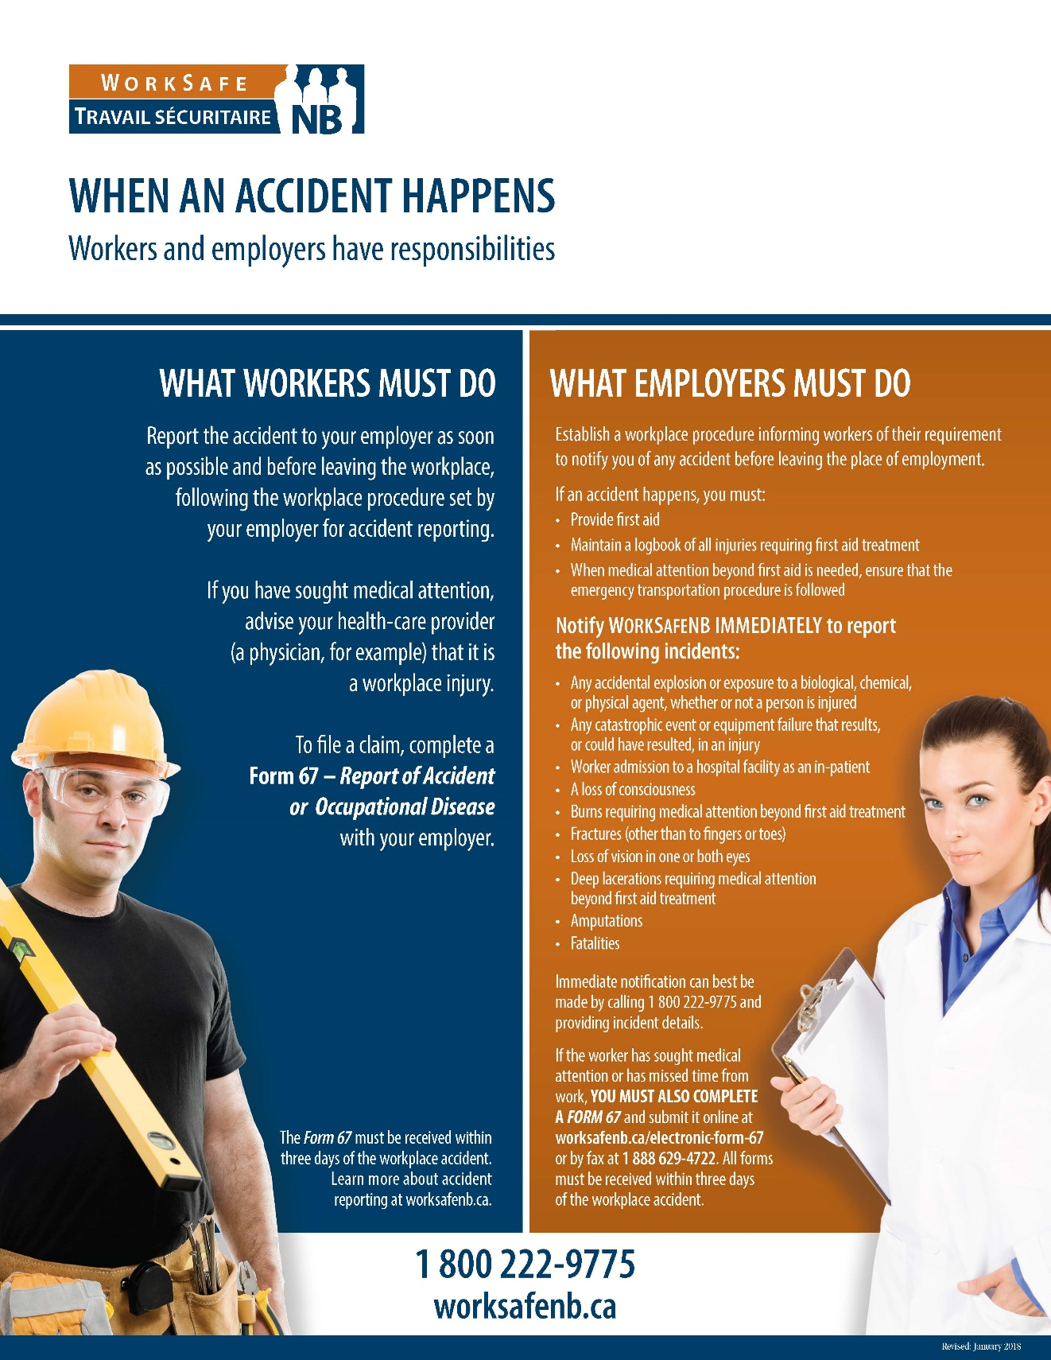

Worker Right to Refuse Flowchart
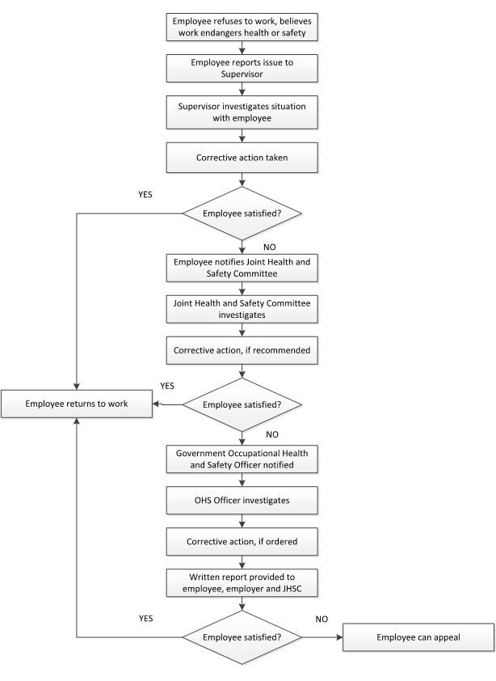

Minutes of Joint Health & Safety Committee
http://www.worksafenb.ca/docs/JHSCMinuteForm.pdf
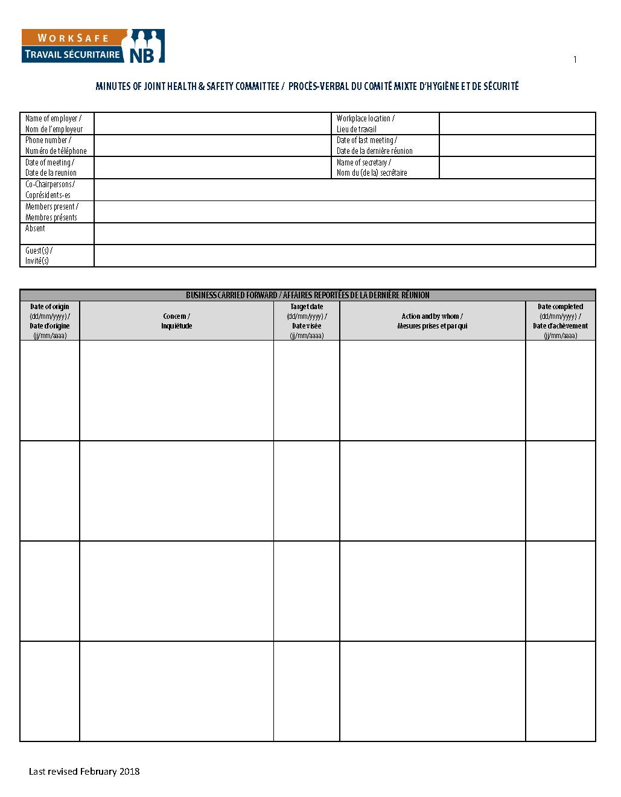
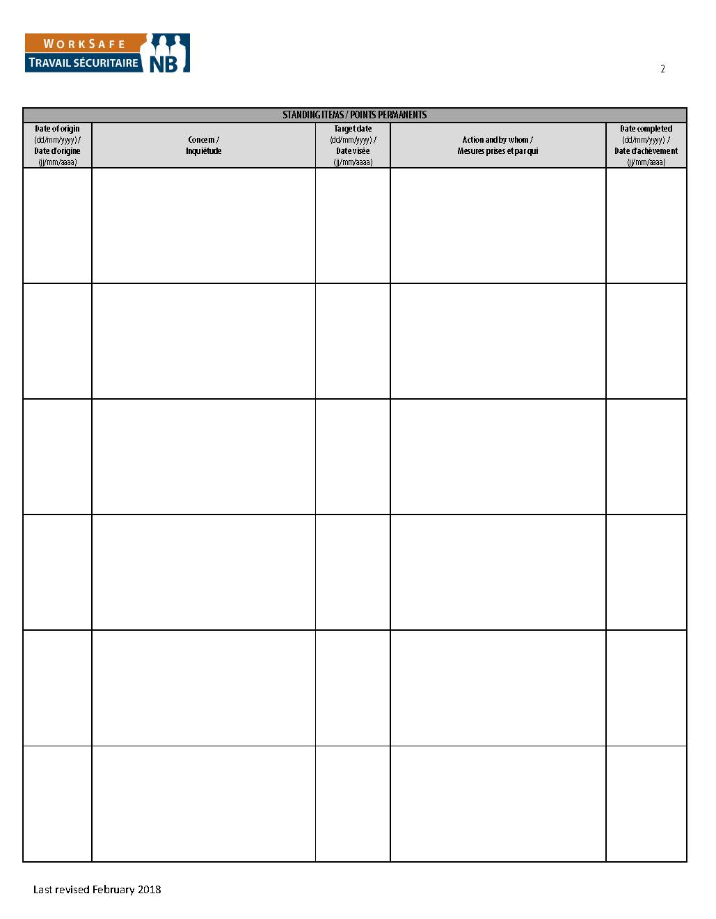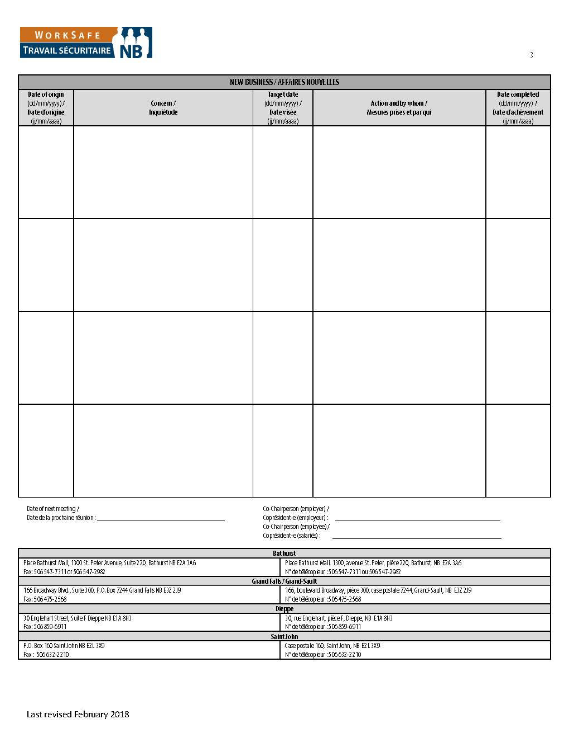

First Aid Kit Requirements
(Schedule C of the First Aid Regulation)
Supply | Qty
Standard first aid manual (English and French) | 1
Record book and pen or pencil | 1
Pair of stainless steel scissors (140 mm) | 1
Pair of tweezers | 1
Variety pack of safety pins | 1
Sterile adhesive strip bandages  (size to be determined by nature and hazard of work) | 24
Sterile gauze pads  (various sizes depending on the nature and hazard of work) | 12
Sterile gauze bandage rolls (75 mm × 9 m) | 2
Elastic bandages rolls (7.5 cm) | 2
Sterile compress dressings (100 mm × 100 mm) | 4
Triangular bandages (1 m) | 6
Adhesive tape rolls (25 mm × 9 m) | 2
Burn dressings  (various sizes depending on the nature and hazard of work) | 4
Abdominal dressings individually wrapped (20 cm × 25 cm) | 6
Antiseptic cleansing towelettes individually wrapped (14 cm × 19 cm) | 12
Individual packages of sugar | 6
Container of antiseptic disinfectant for the skin (not iodine) | 1
Water soluble burn treatment (55 g tube or more) | 1
Pair of Disposable gloves (latex or vinyl) | 6
Face shield with a one-way valve (disposable) | 1
Cotton tipped applicators package | 1
Hand wipes or 1 bottle of hand cleaner | 12
Shock blanket | 1
Several puncture resistant plastic bags

Injury/Incident Analysis Checklist
This checklist can be used in conjunction with the Injury/Incident Investigation Report
Background Information
Job Title of Employee
Department of Employee
Age Range of Employee
Male or Female |  |  |  | M F
Employee's Supervisor
Location (where the event took place)
Day of Event (Monday, Tuesday, etc.)
Date of event (dd/mm/yr)
Time of Event (include AM or PM)
Date of Investigation (dd/mm/yr)
Date of Return to Work – Full Duty (dd/mm/yr)
Date of Return to Work – Modified Duty (dd/mm/yr)
Incident Type
Near Miss |  |  | Yes No | Occupational Injury |  |  | Yes No
Hazard |  |  | Yes No | Violence/Harassment |  |  | Yes No
Occupational Health Hazard |  |  | Yes No | Occupational Illness |  |  | Yes No
Environmental Release |  |  | Yes No | Damage |  |  | Yes No
Other |  |  |  | Describe:
Injury Details
Critical injury |  |  | Yes No | Fatal Injury |  |  | Yes No
Non-Critical Injury |  |  | Yes No | Exposure to health hazards |  |  | Yes No
No injury or exposure |  |  | Yes No
Full Time Employee | Yes No | Part Time Employee |  |  | Yes No | Student/Seasonal |  | Yes No
Contractor | Yes No | Temporary Staff |  |  | Yes No | Volunteer |  | Yes No
Other |  |  |  | Describe:
Treatment Received
None
First Aid Required
Health Care Required
Time Loss Injury
Number of days lost
Has the Employee had a previous similar injury/disease? |  |  |  | Yes No
Returned to full duty? |  |  |  | Yes No
Returned to modified work? |  |  |  | Yes No
Form 7 Required? |  |  |  | Yes No
Damages
Property Damage |  |  | Yes No | Machinery/Equipment Damage |  |  | Yes No
Tool Damage |  |  | Yes No | Product Damage |  |  | Yes No
Materials Damage |  |  | Yes No | No Damage |  |  | Yes No
Root Causes
Performance Specifications:  - Are safe work policies/procedures in place? Are they adequate?  - Are instructions from Management creating an unsafe work environment? |  |  |  | Adequate Inadequate  Describe:

Task Interference:  - Enough time allotted to complete the task safely  - Equipment in proper working condition and available?  - Policies/procedures that are currently in place contributed to this hazardous event?  - Staffing issues?  - Inappropriate body position for the task |  |  | Adequate Inadequate  Describe:
Consequences:  - Discipline practiced for unsafe acts?  - Positive consequences for unsafe acts (e.g. rushing to get the job done quickly)  - Injury/illness occurring from tasks |  |  | Adequate Inadequate  Describe:
Feedback:  - Lack of communication (positive or negative) between Employees, team leaders and supervisors  - Improper motivation (feedback/ rewards/recognition reinforcing unsafe acts)  - Employees not reporting similar injuries/illnesses  - Employees not advising Supervisors of potential hazards |  |  | Adequate Inadequate  Describe:
Knowledge/Skill:  - Demonstrated lack of skill/knowledge?  - Failure to use prescribed personal protective equipment?  - Are Supervisors aware this hazardous event could occur (Supervisor and Employees trained on this hazard)?  - Failure to follow established procedures?  - Inadequate training? |  |  | Adequate Inadequate  Describe:
Individual Capacity:  - Stress  - Workload  - Rushing to complete tasks  - Staffing/Scheduling issues  - Unsuitable loading/lifting |  |  | Adequate Inadequate  Describe:
People/Behavioural Factors:  - Improper motivation  - Leadership or supervision issues  - Unauthorized use of equipment  - Failure to control, monitor or secure hazard  - Disabling safety devices or bypassing barrier/guards  - Operating at improper speed  - Abuse or misuse  - Horseplay  - Other |  |  | Yes No  Yes No  Yes No  Yes No  Yes No  Yes No  Yes No  Yes No  Describe:
Equipment Factors:  - Inadequate ventilation  - Defective tools, equipment or material  - Lack of adequate safety devices, barriers, or guards  - Inadequate warning systems  - Inadequate tools/equipment  - Inappropriate PPE  - Wear and tear of equipment  - Hazardous energy not controlled  - Other |  |  | Yes No  Yes No  Yes No  Yes No  Yes No  Yes No  Yes No  Yes No  Describe:
Materials Factors:  - Property damage caused by spilled materials  - Handling of raw materials  - Handling of products  - Handling/use of hazardous chemicals  - Handling of biological agents  - Supplier issues when sending product  - Manual material handling issues – lifting, carrying, pushing, pulling  - Mechanical material handling issues – handcarts, forklifts  - Other |  |  | Yes No  Yes No  Yes No  Yes No  Yes No  Yes No  Yes No  Yes No  Describe:
Environment Factors:  - Hazardous environment – air quality, leak or spill  - Presence of combustibles, fire or explosion hazard  - Temperature extreme  - Radiation hazard (non-ionizing)  - Noise hazard  - Poor lighting  - Congested area, blocked exits/stairways, disorder  - Condition of floors (e.g. slippery)  - Poor ventilation  - Hazards in product storage area  - Other |  |  | Yes No  Yes No  Yes No  Yes No  Yes No  Yes No  Yes No  Yes No  Yes No  Yes No  Describe:
Process Factors:  - Poor layout or ergonomic design  - Engineering issues  - Purchasing issues  - Staff schedules/patterns  - Physical condition of work area not inspected  - Maintenance issues/records  - Other |  |  | Yes No  Yes No  Yes No  Yes No  Yes No  Yes No  Describe:
Incident Event Type (Type of Contact)
Struck by object | Yes No |  | Struck against object | Yes No
Caught in – nip points | Yes No |  | Caught on snagged | Yes No
Caught between - crushed | Yes No |  | Voluntary motion | Yes No
Lifting | Yes No |  | Falls | Yes No
Overexertion | Yes No |  | Electricity | Yes No
Temperature extremes | Yes No |  | Radiation | Yes No
Noise | Yes No |  | Chemical Substance | Yes No
Vibration | Yes No
Other |  |  | Yes No Describe:
Injury/Illness Assessment
Has an event like this happened before in this job?  Rare – once/year  Occasional – once/month  Common – once/week |  | Yes No
Do you think this could happen again?  Rare – once/year  Occasional – once/month  Common – once/week |  | Yes No

Injured Body Part
Finger/Hand/Wrist  Arm/Elbow  Chest | Shoulder  Neck  Head/Face | Upper/Lower Back  Hip/Thigh  Knee |  | Lower Leg  Ankle/Foot  Other, Describe:
Nature of Injury
Sprain/Strain  Crushing/Bruising | Cuts/Lacerations  Fractures |  | Scratches/Abrasions  Falls |  | Other, Describe:

Report of Accident or Occupational Disease (Form 67)
http://www.worksafenb.ca/docs/form67.pdf
