Newfoundland and Labrador

© 2018, Workplace Safety & Prevention Services (WSPS). All rights reserved.
All text, logos, illustrations, graphics, images, designs, the arrangement of information and other content in this publication are protected by copyright and other intellectual property rights. No part of this publication may be reproduced, distributed, displayed, broadcasted, stored in a retrieval system, transmitted in any form or by any means, electronic, mechanical, photocopied, recorded or otherwise, or otherwise exploited in any manner, without the prior written permission of Workplace Safety & Prevention Services (WSPS).
The information contained in this reference material is distributed as a guide only. It is generally current to the best of WSPS’s knowledge as at the revision date, having been compiled from sources believed to be reliable and to represent the best current opinion on the subject. No warranty, guarantee, or representation is made by WSPS as to the absolute correctness or sufficiency of any representation contained in this reference material. WSPS assumes no responsibility in connection therewith; nor can it be assumed that all acceptable safety measures are contained in this reference material, or that other or additional measures may not be required in particular or exceptional conditions or circumstances. Under no circumstances shall WSPS, its affiliates, or any of its respective partners, officers, directors, employees, agents or representatives be liable for any damages, whether direct, indirect, special or consequential damages for lost revenues, lost profits, or otherwise, arising from or in connection with this document.
Workplace Safety & Prevention Services (WSPS) and the above logos and marks are a Trademark of Workplace Safety & Prevention Services (WSPS). © WSPS, 2016. All Rights Reserved.
While WSPS does not undertake to provide a revision service or guarantee accuracy, WSPS shall be pleased to respond to your individual requests for information, at any time.

Provincial Appendix - Newfoundland & Labrador
Overview | The Provincial Occupational Health & Safety Act(s) and associated regulations set a minimum standard for worker health and safety. This appendix outlines the specific requirements based on legislation and regulations for Newfoundland and Labrador.  DQ or OJ Franchisee is committed to the health and safety of our employees, volunteers, visitors, suppliers and customers, customers, workplace and environment. It is important to understand that this appendix supports the Essential Elements Final.docx. Additional safety programs focused on hazard and risk specific programs, safe work practices and best practices will ensure we have a comprehensive program specific to our company.  We are committed to review our programs annually and make every effort to have the most up to date information for our workers.

Keys | Communicate Post / Display Review / Update  Link to other information Information / Training

Document Control | Effective Date: January 2019 Approved By:

Table of Contents
Workplace Violence and Harassment Prevention 3
Posted Health & Safety Materials Requirements 4
Occupational Health & Safety Committee / Health & Safety Representative 5
First Aid Requirements 7
Injury/Incident Reporting and Investigation Requirements 9
Return to Work 12
Working Alone Requirements 15
Resources 16

Workplace Violence and Harassment Prevention
Overview | DQ or OJ Franchisee will be proactive in its prevention of workplace violence or harassment of any kind. We are committed to providing a work environment in which all workers are treated with respect and dignity.

Legislation | Occupational Health and Safety Regulations, Section 22

Definition | Workplace Violence is “the attempted or actual exercise by a person, other than a worker, of physical force to cause injury to a worker, and includes threatening statements or behaviour which gives a worker reason to believe that he or she is at risk of injury”.

Procedure | See Workplace Violence and Harassment Prevention in the Essential Elements Final.docx for further information.

Employer Responsibilities | Conduct a risk assessment of the workplace in which a risk of injury to workers from violence arising out of their employment may be present.  The risk assessment shall include the consideration of:  - Previous experience in the workplace  - Occupational experience in similar workplaces  - Location and circumstances in which work may take place  Where a risk of injury to workers from violence is identified by an assessment performed the employer shall:  - Establish procedures, policies and work environment arrangements to eliminate the risk to workers from violence  - Where elimination of the risk to workers is not possible, establish procedures, policies and work environment arrangements to minimize the risk to workers.

Resources | Workplace Violence Prevention – WorkplaceNL  Workplace Violence and Harassment Prevention – Essential Elements Final.docx

Posted Health & Safety Materials Requirements
Overview | The following information and materials must be made available to all employees and will be posted in a common area on the Health & Safety Bulletin Board.

Materials to Post on Health & Safety Bulletin Board | 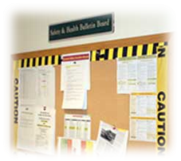  - Occupational Health and Safety Act and Regulations applicable to the workplace  - Code of Practice required pursuant to the Act and Regulations  - Health and Safety Policy Statement  - Workplace Violence and Harassment Policy Statement  - WHMIS Regulation  - Post current inventory of hazardous products used on site  - Safety Data Sheets (may be inserted in binder)  - Occupational health and safety information prepared by WorkplaceNL  - Emergency Evacuation Plan and Emergency Numbers - Emergency Numbers must be posted  - Occupational Health and Safety Committee or Representative - names and work locations of members  - Post warning signs in high hazard areas e.g. noise  - Post signs indicating where first aid kits are available and the names and work locations of certified first aid providers  - In You’re Injured at Work Poster  - Applicable Reports including:  - Health and/or safety assessments/surveys  - Orders, Compliance Notices, Notice of Appeals and/or decisions issued by the Regulatory Agency (a copy must be provided to the Committee or Representative)  - WorkplaceNL information as required  - Workplace incident summaries  - Other information applicable to the workplace – other Department of Government Service inspections, reports, articles on relevant workplace issues, information on rights and responsibilities, etc.

Roles & Responsibilities | Health & Safety Coordinator or designate will be responsible for the following:  - Ensuring the most current information is available at each location.  - Update the Checklist for Posted Health and Safety Materials as necessary.  Managers will be responsible for the following:  - Ensuring the most current information is available to all employees.  - Posting any materials as outlined on the Checklist for Posted Health and Safety Material.  - Complete check list provided signing off and forwarding to Health & Safety Coordinator or designate.  The content of the information will be reviewed and maintained to ensure that it is current.

Resources | Posted Health & Safety Material Checklist  If You’re Injured at Work (Poster)
Occupational Health & Safety Committee (OHSC) / Worker Health & Safety (WHS) Representative
Overview | To ensure designated OHSC Members receive consistent recognized training in occupational health and safety and to support the effectiveness of the Internal Responsibility System

Legislation | Locations with 10 or more workers shall establish an OHS Committee, locations with less than 10 shall have a WHS Representative or Designate.

Responsibilities | - Seek to identify aspects of the workplace that may be unhealthy or unsafe  - Participate in a workplace inspection required by the regulations to conduct  - Make recommendations to principal contractors, senior management, workers, self-employed persons and the assistant deputy minister or an officer for the enforcement of standards to protect the health, safety and welfare of workers in the workplace  - Receive complaints from workers as to their concerns about the health and safety of the workplace and their welfare  - Establish and promote health and safety educational programs for workers  - Maintain records as to the receipt and disposition of complaints received from workers as above  - Co-operate with the assistant deputy minister or an officer who is exercising his or her duties under the Act  - Perform those other duties and follow those procedures that may be prescribed by the regulations

Training Requirements | OHS Committee Certification Training (2-Days)  Training sessions consists of 2 days for OHS Committee members and/or WHS Representatives/Designates. Training provided must be from an approved provider through WorkplaceNL and training must be renewed every 3 years from the date of their certification.  Employees and management, who are not members of the OHS Committee, or who are not a WHS Representative, can participate in the training, as a means of improving their knowledge of occupational health and safety.  The training covers the following topics:  - Occupational health and safety legislation  - Internal responsibility system  - Due diligence and workers  - Right to refuse unsafe work  - Roles and responsibilities of OH&S committees and WH&S representatives and how both will operate  - An introduction to OH&S, the roles of stakeholders and other background material  - Hazard recognition, evaluation and control  - Workplace inspections, how to conduct workplace inspections and the role of workplace inspections in returning injured workers to the workplace  Once completed, a certificate will be issued to the participant from WorkplaceNL.  To register for Occupational Health & Safety Committee training visit http://www.workplacenl.ca/OHS_WHSCertificationTraining.whscc  Committee, Representative and Designate Requirements  Number of workers at each Workplace Committee, Rep or Designate Training Required  Owners/operators/partners only (i.e. no workers) None None  1 worker (no owners, operators, or partners at the workplace) None None  Combination of 2 – 5 persons (including owners/operators/ partners and workers) WH&S Designate or WH&S Representative 2 days for the Representative or Designate  6-9 workers excluding owners, operators or partners WH&S Representative 2 days for the Representative  10 or more workers (excluding owners, operators, partners) OH&S Committee 2 day training for Co-Chairs of the Committee  50 or more workers (excluding owners, operators, partners) OH&S Committee 2 day training for ALL Committee Members

Meeting Minutes | Post Meeting Minutes on your Health & Safety Bulletin Board.

Resources | OH&S Committees/WHS Reps/WHS Designates – WorkplaceNL  Occupational Health & Safety Minutes Report Form  Worker Right to Refuse Flowchart  Health & Safety Committee – Essential Elements Final.docx

First Aid Requirements
Overview | 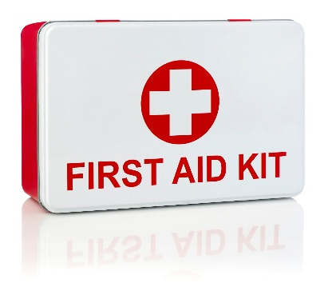  First Aid is an essential part of any health and safety system. Although we strive to eliminate workplace injuries and illnesses, it recognizes that the potential exists for these to occur.  We will protect the health, safety and well-being of its employees, volunteers, guest and visitors. Anyone injured or ill in the workplace shall be provided with the utmost care. Prompt and proper first aid will be administered by a certified First Aid Attendant.

Legislation | Occupational Health and Safety – First Aid Regulations

Training | At a minimum, we will ensure that at least one Certified First Aid Attendant will be available during every shift. A list of Certified First Aid Attendants, along with a copy of their current certification, will be posted on the Health & Safety Bulletin Board or near the first aid kits.  Each employee will receive training and instructions from his or her manager on our first aid procedures.  Training providers must be approved to issue certificates and deliver courses as required as per the OHS First Aid Regulations under the Occupational Health and Safety Act.  Standard First Aid with Level A CPR is a 2 day course and is valid for 3 years.  See First Aid Program in the Essential Elements Final.docx for further information.

First Aid Log | All first aid treatment given to a worker must be entered in the First Aid Log. Each case that is referred for further medical treatment must also be entered. The confidentiality of personal medical information must be maintained. First Aid Logs must be kept for at least 5 years.

First Aid Attendants | First Aid Attendants must record all reported signs and symptoms of injuries and exposures to contaminants found at your location using the Hazard Response Form. If an injury is more severe or beyond the training of the First Aider, the First Aider is responsible for referring the worker to seek additional medical attention.  First Aid Attendant Requirements  Number of Workers in Workplace Number of Trained First Aiders/Shift Valid Certificate Required*  Employee required to work alone One Emergency First Aid Certificate  2 – 14 One Emergency First Aid Certificate  15 – 199 One One (for each group of 25 of or more) Standard First Aid Certificate Emergency First Aid Certificate  200+ One One (for each group of 25 workers First Aid Attendant Emergency First Aid Certificate  *Unless an Officer directs that a higher certificate is necessary

Reporting Requirements | For any injury or illness requiring first aid, a First Aid Report must be filled out along with an Injury and Incident Analysis Checklist.  The first aid attendant will be required to record in the Injury Incident Analysis Report, all treatment given to an employee. Should the injury/illness be serious enough that medical attention is required, an Incident Injury Investigation Report will be completed and provided to the location manager and HS Coordinator. The Injury/Incident Investigation Report will record the circumstances surrounding the incident as described by the injured employee. Specifically, the report must include:  - Full name, age and occupation of the worker;  - Nature of the injury or illness;  - Short description of the cause of the injury or illness;  - Nature of the work in which the worker was engaged at the time of sustaining the injury or becoming ill, with date and time;  - Treatment given, with date and time;  - Disposition of the case stating whether the worker returned to work, was sent home or to a physician or hospital and means of transportation where applicable;  - Signature of the person making the entry; and  - For later completion, if necessary, total time lost, time on restricted work activity and whether or not a compensation claim was filed.  First Aid register reports shall be available for inspection by the OHS Committee or WHS Representative or by an Occupational Health and Safety Officer.  Records shall be retained for a period of 5 years after the date on which it occurred.

First Aid Area | DQ or OJ Franchisee shall post in a conspicuous location near the first aid kit:  - A written notice which outlines a policy and procedure for the reporting of injuries.  - The name of the employee in charge of the first aid kit  - The name and qualifications of each trained first aider  - An emergency procedure and telephone list to contact police, ambulance, fire station, hospital or physician.  At every workplace where there are more than 15 workers or where ordered by an Occupational Health and Safety Officer, a stretcher, blankets and splints shall be provided and maintained in good condition.  Please see the first aid kit inventory list for minimum content requirements.

Resources | If You’re Injured at Work (Poster)  Injury/Incident Reporting and Investigation Requirements  First Aid - Essential Elements Final.docx

Injury/Incident Reporting and Investigation Requirements
Overview | There are legal requirements in all provinces under the Provincial Health & Safety Act(s) and Workers Compensation Boards for employers to record and report:  - Where a person is killed or critically injured at a workplace.  - Where a person is disabled from performing his or her work or requires medical attention because of an accident, explosion, fire or incident of workplace violence.  - If an employer is told that a worker has an occupational illness or that a claim for an occupational illness has been filed with the WCB.

Legislation | Occupational Health and Safety Act and Workers’ Compensation Act

Definitions | “accident” is a chance event occasioned by a physical or natural cause, a willful and intentional act, not being the act of the worker, and disablement arising out of and in the course of employment.  “occupational disease” means a disease arising out of and directly related to an occupation.  “serious injury” means:  - a fracture of the skull, spine, pelvis, femur, humerus, fibula or tibia, or radius or ulna;  - an amputation of a major part of a hand or foot;  - the loss of sight of an eye;  - a serious internal hemorrhage;  - a burn that requires medical attention;  - an injury caused directly or indirectly by explosives;  - an asphyxiation or poisoning by gas resulting in a partial or total loss of physical control; or  - another injury likely to endanger life or cause permanent injury,  - but does not include injuries to a worker of a nature that may be treated through first aid or medical treatment and the worker is able to return to his or her work either immediately after the treatment or at his or her next scheduled shift.

Reporting | Department of Service Reporting Requirements  The Occupational Health and Safety Act and regulations require all accidents which resulted in serious injury or death or that had reasonable potential for serious injury must be reported immediately to the Assistant Deputy Minister.  The 24-Hour Accident Reporting Line Telephone number is (709) 729-4444.  DQ or OJ Franchisee must ensure these reports are made. If there is doubt as to whether an accident should be reported, we shall confirm by contacting the Accident Reporting Line.  Accidents that occur in the workplace must be reported if:  - it results in serious injury to a person or results in the death of a person; or  - that had, or continues to have, the reasonable potential of causing serious injury to or the death of a person  DQ or OJ Franchisee shall immediately notify:  - the assistant deputy minister of the Department of Service of the accident.  - OH&S Committee, WHS Representative or the WHS Designate, as applicable  The occupational diseases for which notification is required are:  - acute, sub-acute or chronic disease of an organ due to lead, arsenic, beryllium, phosphorus, manganese, cadmium mercury and their compounds or alloys;  - neoplasia of the skin or mucous membrane to tar, pitch, bitumen, mineral or cutting oils or paraffin, arsenic or a compound, product or residue of these substances;  - neoplasia of the renal tract in a worker employed in rubber-compounding, dyestuff manufacture or mixing, or in a laboratory;  - pneumoconiosis due to silica or silicate, including asbestos, talc, mica or coal;  - toxic jaundice, that is, jaundice due to tetra-chlorethane or nitro- or amido-derivatives of benzene or other hepato-toxic or haemato-toxic substances;  - neoplasia or a form of sickness due to internal or external exposure to ionizing radiation or electromagnetic radiation;  - poisoning by the anti-cholinesterase action of an organophosphorus or carbamate compound;  - a form of decompression illness;  - toxic anaemia, that is, anaemia due to trinitrotoluene, or another haematogenetic poison, including chronic poisoning by benzene;  - mesothelioma of the pleura or peritoneum;  - angiosarcoma of the liver;  - Reynaud’s phenomenon or vibration induced white finger disease; and  - occupational dermatitis.  Workers engaged in occupations resulting in occupational diseases referred to in this section are considered to be engaged in hazardous health occupations under the Act.  The Assistant Deputy Minister shall prescribe the kind and frequency of medical examinations required by workers engaged in hazardous health occupations or suffering from an occupational disease.  WorkplaceNL – Reporting Requirements  Wherever an injury may require medical aid or could result in a claim to the WorkplaceNL, the worker must complete a Worker’s Report of Injury – Form 6, and the manager must complete an Employer’s Report of Injury – Form 7. These forms describe the accident and must be filed with WorkplaceNL within three days (72 hours) of the accident.  Worker’s Report of Injury – Form 6  A worker is required to notify DQ or OJ Franchisee immediately of an injury which happened during the course of employment. If the worker is disabled for longer than one day, or of the worker does not miss work but needs medical, surgical or dental aid, the worker must complete and return a Worker’s Report of Injury – Form 6.  This form should be completed as soon as possible to avoid any undue delays in processing and adjudicating the claim.  Employer’s Report of Injury – Form 7  DQ or OJ Franchisee must complete and return an Employer’s Report of Injury – Form 7. Part I of the form is to be completed if the injured worker is only disabled for the day on which the injury occurred. Part I and II are to be completed if the worker is disabled for longer than the day on which the injury occurred.  If DQ or OJ Franchisee fails to notify WorkplaceNL of an injury, WorkplaceNL may charge the cost of the claim to the employer.  The forms should be mailed or faxed to WorkplaceNL  WorkPlaceNL Contact Information  Phone (709) 778-1000 or 1-800-563-9000  Fax (709) 778-1302 or 1-800-276-5257  Website www.workplacenl.ca  Mailing Address WorkplaceNL 146-148 Forest Road PO Box 9000 St. John’s, NL A1A 3B8

Investigation | The Department of Service, OHS Branch may choose to investigate a serious accident. The scene of a serious accident must not be disturbed except to attend to persons injured or killed and to prevent further injuries or property damage. Employees at the workplace have a legal duty to cooperate with an investigating officer and provide information related to the accident upon request.  The assistant deputy minister or an officer shall, where practicable, go to the scene of an accident reported under Section 54 and may make whatever inquiries that he or she considers necessary to determine the cause of an accident.  All imminent danger or work refusal situations will be investigated in accordance with the Injury/Incident Reporting and Investigation Policy.  The employer shall retain all reports for 5 years after the serious injury or incident.

Administrative Penalties | Failure to report a medical aid only claim within three days will result in a $100 penalty. Failure to report a lost-time claim within three days will result in a $200 penalty. All penalties are directly charged to the employer’s assessment account.

Resources | Injury and Incident Analysis Checklist  Worker’s Report of Injury (Form 6)  Employer’s Report of Injury (Form 7)  Injury/Incident Reporting and Investigation – Occupational Health & Safety Program – Canada (Resources Final.docx)

Return to Work
Overview | Return to Work is sometimes referred to as disability management program, modified work program, alternate duties program or claims management program.

Legislation | Workers’ Compensation Act

Responsibilities | Employer  - Ensure employees are aware of reporting requirements.  - Contact the worker as soon as possible after the injury occurs  - Send in an Employer’s Report of Injury – Form 7 within 72 hours to WorkplaceNL.  - Provide a copy of the Return to Work Plan Form to WorkplaceNL following health care providers’ assessment(s).  - Offer modified work/ease back to work during recovery period.  - Maintain communication throughout the period of the worker’s recovery or impairment  - Provide suitable and available employment  - Provide WorkplaceNL any information requested concerning the worker’s return-to-work.  - Pay the worker’s salary earned while performing suitable work.  - Establish an effective Disability Management Program  - Implement changes to prevent further injuries  Employee  - Seek timely and appropriate health care to treat the injury/illness.  - Report injury to the employer immediately.  - Visit a Doctor (Medical or Chiropractic) as soon as possible  - Send in a Worker’s Report of Injury – Form 6 to WorkplaceNL.  - Take reasonable steps to reduce/eliminate permanent impairment and loss of earnings from an injury  - Cooperate with WorkplaceNL and employer in the development and implementation of a return-to-work program  - Take an active role in the development of his/her own Return-To-Work Plan.  - Review the Return-To-Work plan with the employer.  - Accept suitable employment when identified.  - Maintain regular contact with WorkplaceNL Representative.  - Provide copies of all forms from the health care provider to the employer.  - Maintain a positive attitude about returning to work when appropriate. Understand the benefits of accepting appropriate work during the rehabilitation process so that the focus can be shifted from disability to regained abilities.  Health Care Provider  - Assess the condition of the injured worker.  - Complete Physician’s Report 8/10 and submit to WorkplaceNL. A copy must be provided to the worker to give to the employer.  - Provide the workplace parties and WorkplaceNL with functional abilities information.  - Provide the worker and WorkplaceNL with medical information.  - Identify the most appropriate method of treatment for the injury.  - Ensure the worker receives timely treatment.  - Ensure return to work is discussed throughout recovery.  - Send their reports to WorkplaceNL as soon as possible.  - Help the injured employee understand what is wrong and what can be done to assist their recovery.  - Work together with the injured employee, their other health care providers and WorkplaceNL to develop an effective return to work plan  WorkplaceNL  - Inform the employer as to what to expect through the Return to Work process.  - Pay the worker the appropriate compensation  - Provide advice and support  - Communicate with the workplace parties  - Ensure return to work plans are achieving the hierarchy of return to work priorities  - Monitor activities, progress and co-operation between workplace parties  - Proactively manage the medical rehabilitation of the worker, in consultation with the worker and the health care provider  - Address compliance issues (ie: obligation to co-operate, re-employ)  - Offer/provide dispute resolution  Re-Employment Obligation  DQ or OJ Franchisee must offer the worker suitable employment that is or becomes available throughout the period of the re-employment obligation. Employers obligated to re-employ their workers are obligated until the earliest of:  - two years after the date of injury  - one year after the worker is medically able to perform the essential duties of the pre-injury employment  - the date on which the worker reaches age 65  Employers who do not meet their co-operation and/or re-employment obligations will be subject to direct fines/penalties by WorkplaceNL. Workers who do not participate fully in the return-to-work efforts may have their benefits reduced, suspended or terminated.  Labour Market Re-Entry Assessment and Plan  WorkplaceNL provides labour re-entry assessments and plans for those workers who are unable to be re-employed with their employer. The cost of the labour market re-entry assessments and plans ultimately affects the employer’s experience, so early and safe return-to-work is the best option.

Resources | Injury/Incident Reporting and Investigation Requirements  Worker’s Report of Injury (Form 6)  Employer’s Report of Injury (Form 7)

Working Alone
Overview | Any employee who works alone at any time will adhere to the OHS regulations as well as policies and procedures outlined in in our Occupational Health & Safety Program – Canada.

Legislation | Occupational Health and Safety Regulations, Section 15

Definition | “Working alone or in isolation” is when a worker is working in a circumstance where assistance would not be readily available in the event an emergency, illness or injury situation.

Employer Responsibilities | Conduct a risk assessment where a worker is assigned to work alone or in isolation. Where hazards are identified, appropriate controls shall be implemented to eliminate, or where elimination is not practicable, minimize the risk associated with the hazard.  DQ or OJ Franchisee will also develop and implement a written procedure for checking in on the well-being of a worker assigned to work alone or in isolation. This will include:  Time interval between checks  Procedure to follow in case a worker cannot be contacted, including provisions for emergency response  Designate a person to establish contact with the worker at predetermined intervals and the results shall be recorded by that person  The written procedure shall be reviewed annually, or more if there is a change in work arrangements that may adversely affect a worker’s well-being or safety, or a report that the procedures are not working effectively.

Resources | Working Alone Guidelines – Service NL  Working Alone – General Information (ccohs.ca)  Working Alone – Essential Elements Final.docx

Resources
Overview | Some of the samples and templates referred to in this document follow this section. Other forms can be found in the Resource section of the Occupational Health & Safety Program – Canada (Resources Final.docx).  Posting Health & Safety Materials  Posted H&S Material Checklist 17  If You’re Injured at Work (Poster) 19
Occupational Health & Safety Committee/Health & Safety Representative
Worker Right to Refuse Flowchart 20
Occupational Health & Safety Minutes Report Form 21
Injury & Incident Forms
First Aid Kit Requirements 23
Injury/Incident Analysis Checklist 25
Worker’s Report of Injury 29
Employer’s Report of Injury 35

Posted Health & Safety Material Checklist
Material | Location | Links | Date Posted
Occupational Health and Safety Act | Health & Safety Bulletin Board | http://assembly.nl.ca/legislation/sr/statutes/o03.htm
Occupational Health and Safety Regulations | Health & Safety Bulletin Board | http://www.assembly.nl.ca/legislation/sr/regulations/rc120005.htm
Workplace Health, Safety & Compensation Act | Health & Safety Bulletin Board | http://www.assembly.nl.ca/Legislation/sr/statutes/w11.htm
Workplace Health, Safety & Compensation Regulations |  | http://assembly.nl.ca/Legislation/sr/regulations/rc961025.htm
Health and Safety Policy Statement | Health & Safety Bulletin Board
Workplace Violence and Harassment Prevention Policy Statement | Health & Safety Bulletin Board
If You’re Injured At Work Poster | Health & Safety Bulletin Board  First Aid Kit | http://www.whscc.nf.ca/download.aspx?ID=59027b91-0e11-418b-8cf6-bfefa63b1257
First Aid Regulation  Include a list of all certified First Aiders in the workplace along with a copy of their certificate | Health & Safety Bulletin Board  First Aid Kit | http://assembly.nl.ca/Legislation/sr/regulations/rc961148.htm
WHMIS Regulation  Post inventory of hazardous products on site | Health & Safety Bulletin Board | http://assembly.nl.ca/Legislation/sr/regulations/rc961149.htm
Safety Data Sheets (SDS)  To be stored in an easily accessible area near where the chemicals are being used, must be most current version available from supplier | SDS Binder
Emergency Services and Numbers  Examples: 911 (if available), fire, police, ambulance, poison control centre, Regulatory Agency Inspector, Ministry of Environment, Utilities, Internal contact numbers, Numbers specific to workplace, i.e. Chemical Spill Clean-up Contractor | Primary Telephones  Health & Safety Bulletin Board
Evacuation Plan | Health & Safety Bulletin Board
Occupational Health and Safety Committee or Representative  Post names and work locations of committee members | Health & Safety Bulletin Board
Health & Safety Explanatory Materials  Examples: OHS Division Bulletins, Alerts and Safety Guidelines; WorkplaceNL Publications | Health & Safety Bulletin Board (optional) | OHS Division:  http://www.servicenl.gov.nl.ca/ohs/  WorkplaceNL Publications:  http://www.workplacenl.ca/employers/publications.whscc
Other Reports relevant to workplace  Examples:  - Management and Committee health and safety inspections  - Committee Meeting Minutes  - Health and safety assessments and surveys  - Orders  - Workplace Incident summaries | Health & Safety Bulletin Board

Occupational Health & Safety Department | Workers’ Compensation Board
Occupational Health and Safety Branch, Service NL  28 Pippy Place  St John's NL A1B 3X4  Telephone: 1-800-563-5471  Serious Workplace Accident Reports: (709) 729-4444 (24 Hours)  http://www.gs.gov.nl.ca/ohs/ | WorkplaceNL  146 - 148 Forest Road  PO Box 9000  St John's NL A1A 3B8  Telephone: (709) 778-1000  Toll-Free: 1-800-563-9000  Fax: (709) 738-1714  Corner Brook  Telephone: (709) 637-2700  Toll-Free: 1-800-563-2772  http://www.workplacenl.ca

If You’re Injured at Work (Poster)
http://www.whscc.nf.ca/download.aspx?ID=59027b91-0e11-418b-8cf6-bfefa63b1257
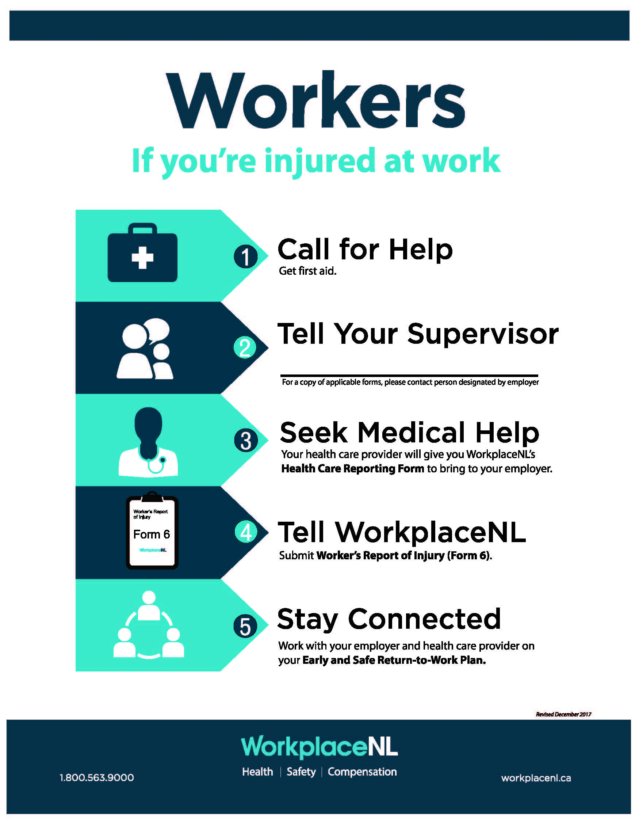

Worker Right to Refuse Flowchart
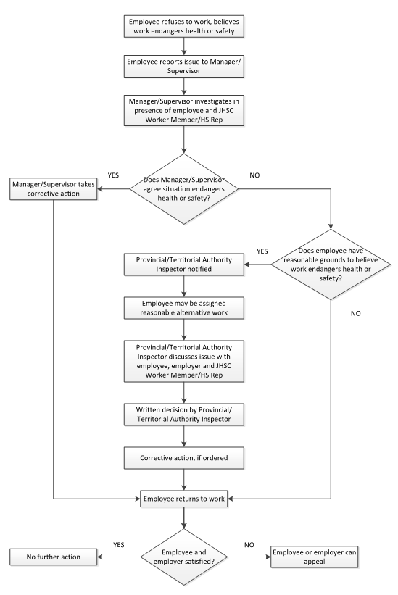

Occupational Health & Safety Minutes Report Form
http://www.workplacenl.ca/download.aspx?ID=8b120cb5-3a11-40f5-92ee-7846fcb9a00f
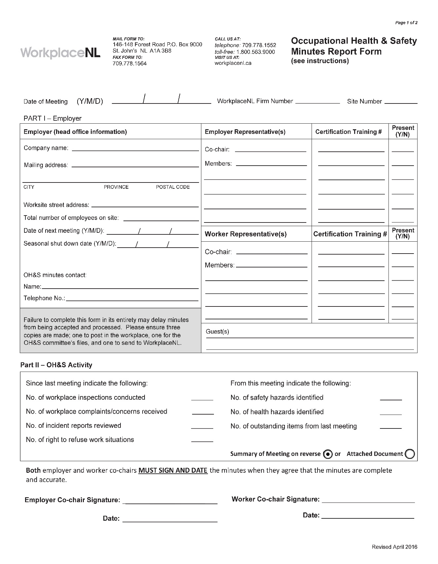

First Aid Kit Requirements

Supply | Qty
Emergency first aid safety oriented manual | 1
First aid record book | 1
Safety pins (assorted) | 12
Splinter tweezers, blunt nose | 1
A pair scissors — 4 inch | 1
Dressings (Each item to be individually wrapped to maintain sterility.)
Sterile bandage compresses, 4 inch by 4 inch | 6
Sterile adhesive dressings, 1 inch wide | 32
Sterile pads, 3 inch by 3 inch | 32
40 inch triangular bandages, 1 metre by 1 metre | 6
Antiseptic 4 ounce bottle of peroxide | 1
Adhesive tape 1 roll — 1 inch by 2 1/2 yards | 2
5 yards tubular finger bandage with applicator | 1
Fingertip dressings | 10
Knuckle pad dressings | 10

Injury/Incident Analysis Checklist
This checklist can be used in conjunction with the Injury/Incident Investigation Report
Background Information
Job Title of Employee
Department of Employee
Age Range of Employee
Male or Female |  |  |  | M F
Employee's Supervisor
Location (where the event took place)
Day of Event (Monday, Tuesday, etc.)
Date of event (dd/mm/yr)
Time of Event (include AM or PM)
Date of Investigation (dd/mm/yr)
Date of Return to Work – Full Duty (dd/mm/yr)
Date of Return to Work – Modified Duty (dd/mm/yr)
Incident Type
Near Miss |  |  | Yes No | Occupational Injury |  |  | Yes No
Hazard |  |  | Yes No | Violence/Harassment |  |  | Yes No
Occupational Health Hazard |  |  | Yes No | Occupational Illness |  |  | Yes No
Environmental Release |  |  | Yes No | Damage |  |  | Yes No
Other |  |  |  | Describe:
Injury Details
Critical injury |  |  | Yes No | Fatal Injury |  |  | Yes No
Non-Critical Injury |  |  | Yes No | Exposure to health hazards |  |  | Yes No
No injury or exposure |  |  | Yes No
Full Time Employee | Yes No | Part Time Employee |  |  | Yes No | Student/Seasonal |  | Yes No
Contractor | Yes No | Temporary Staff |  |  | Yes No | Volunteer |  | Yes No
Other |  |  |  | Describe:
Treatment Received
None
First Aid Required
Health Care Required
Time Loss Injury
Number of days lost
Has the Employee had a previous similar injury/disease? |  |  |  | Yes No
Returned to full duty? |  |  |  | Yes No
Returned to modified work? |  |  |  | Yes No
Form 7 Required? |  |  |  | Yes No
Damages
Property Damage |  |  | Yes No | Machinery/Equipment Damage |  |  | Yes No
Tool Damage |  |  | Yes No | Product Damage |  |  | Yes No
Materials Damage |  |  | Yes No | No Damage |  |  | Yes No
Root Causes
Performance Specifications:  - Are safe work policies/procedures in place? Are they adequate?  - Are instructions from Management creating an unsafe work environment? |  |  |  | Adequate Inadequate  Describe:

Task Interference:  - Enough time allotted to complete the task safely  - Equipment in proper working condition and available?  - Policies/procedures that are currently in place contributed to this hazardous event?  - Staffing issues?  - Inappropriate body position for the task |  |  | Adequate Inadequate  Describe:
Consequences:  - Discipline practiced for unsafe acts?  - Positive consequences for unsafe acts (e.g. rushing to get the job done quickly)  - Injury/illness occurring from tasks |  |  | Adequate Inadequate  Describe:
Feedback:  - Lack of communication (positive or negative) between Employees, team leaders and supervisors  - Improper motivation (feedback/ rewards/recognition reinforcing unsafe acts)  - Employees not reporting similar injuries/illnesses  - Employees not advising Supervisors of potential hazards |  |  | Adequate Inadequate  Describe:
Knowledge/Skill:  - Demonstrated lack of skill/knowledge?  - Failure to use prescribed personal protective equipment?  - Are Supervisors aware this hazardous event could occur (Supervisor and Employees trained on this hazard)?  - Failure to follow established procedures?  - Inadequate training? |  |  | Adequate Inadequate  Describe:
Individual Capacity:  - Stress  - Workload  - Rushing to complete tasks  - Staffing/Scheduling issues  - Unsuitable loading/lifting |  |  | Adequate Inadequate  Describe:
People/Behavioural Factors:  - Improper motivation  - Leadership or supervision issues  - Unauthorized use of equipment  - Failure to control, monitor or secure hazard  - Disabling safety devices or bypassing barrier/guards  - Operating at improper speed  - Abuse or misuse  - Horseplay  - Other |  |  | Yes No  Yes No  Yes No  Yes No  Yes No  Yes No  Yes No  Yes No  Describe:
Equipment Factors:  - Inadequate ventilation  - Defective tools, equipment or material  - Lack of adequate safety devices, barriers, or guards  - Inadequate warning systems  - Inadequate tools/equipment  - Inappropriate PPE  - Wear and tear of equipment  - Hazardous energy not controlled  - Other |  |  | Yes No  Yes No  Yes No  Yes No  Yes No  Yes No  Yes No  Yes No  Describe:
Materials Factors:  - Property damage caused by spilled materials  - Handling of raw materials  - Handling of products  - Handling/use of hazardous chemicals  - Handling of biological agents  - Supplier issues when sending product  - Manual material handling issues – lifting, carrying, pushing, pulling  - Mechanical material handling issues – handcarts, forklifts  - Other |  |  | Yes No  Yes No  Yes No  Yes No  Yes No  Yes No  Yes No  Yes No  Describe:
Environment Factors:  - Hazardous environment – air quality, leak or spill  - Presence of combustibles, fire or explosion hazard  - Temperature extreme  - Radiation hazard (non-ionizing)  - Noise hazard  - Poor lighting  - Congested area, blocked exits/stairways, disorder  - Condition of floors (e.g. slippery)  - Poor ventilation  - Hazards in product storage area  - Other |  |  | Yes No  Yes No  Yes No  Yes No  Yes No  Yes No  Yes No  Yes No  Yes No  Yes No  Describe:
Process Factors:  - Poor layout or ergonomic design  - Engineering issues  - Purchasing issues  - Staff schedules/patterns  - Physical condition of work area not inspected  - Maintenance issues/records  - Other |  |  | Yes No  Yes No  Yes No  Yes No  Yes No  Yes No  Describe:
Incident Event Type (Type of Contact)
Struck by object | Yes No |  | Struck against object | Yes No
Caught in – nip points | Yes No |  | Caught on snagged | Yes No
Caught between - crushed | Yes No |  | Voluntary motion | Yes No
Lifting | Yes No |  | Falls | Yes No
Overexertion | Yes No |  | Electricity | Yes No
Temperature extremes | Yes No |  | Radiation | Yes No
Noise | Yes No |  | Chemical Substance | Yes No
Vibration | Yes No
Other |  |  | Yes No Describe:
Injury/Illness Assessment
Has an event like this happened before in this job?  Rare – once/year  Occasional – once/month  Common – once/week |  | Yes No
Do you think this could happen again?  Rare – once/year  Occasional – once/month  Common – once/week |  | Yes No

Injured Body Part
Finger/Hand/Wrist  Arm/Elbow  Chest | Shoulder  Neck  Head/Face | Upper/Lower Back  Hip/Thigh  Knee |  | Lower Leg  Ankle/Foot  Other, Describe:
Nature of Injury
Sprain/Strain  Crushing/Bruising | Cuts/Lacerations  Fractures |  | Scratches/Abrasions  Falls |  | Other, Describe:

Worker’s Report of Injury (Form 6)
http://www.whscc.nf.ca/download.aspx?ID=8c098e64-7962-4bee-aa8a-deac86977df7

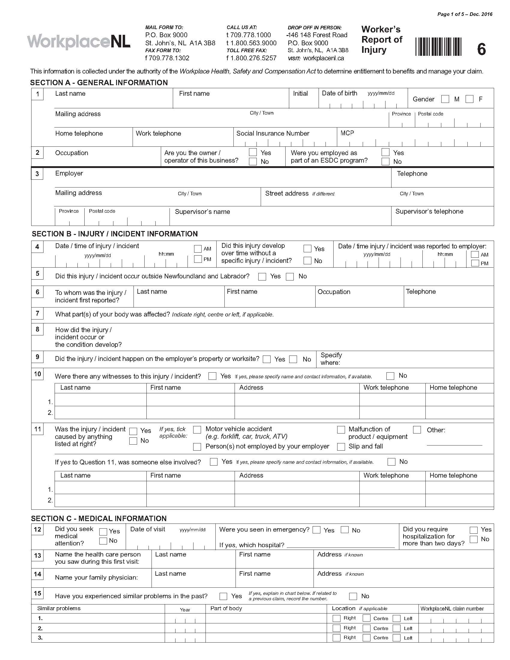

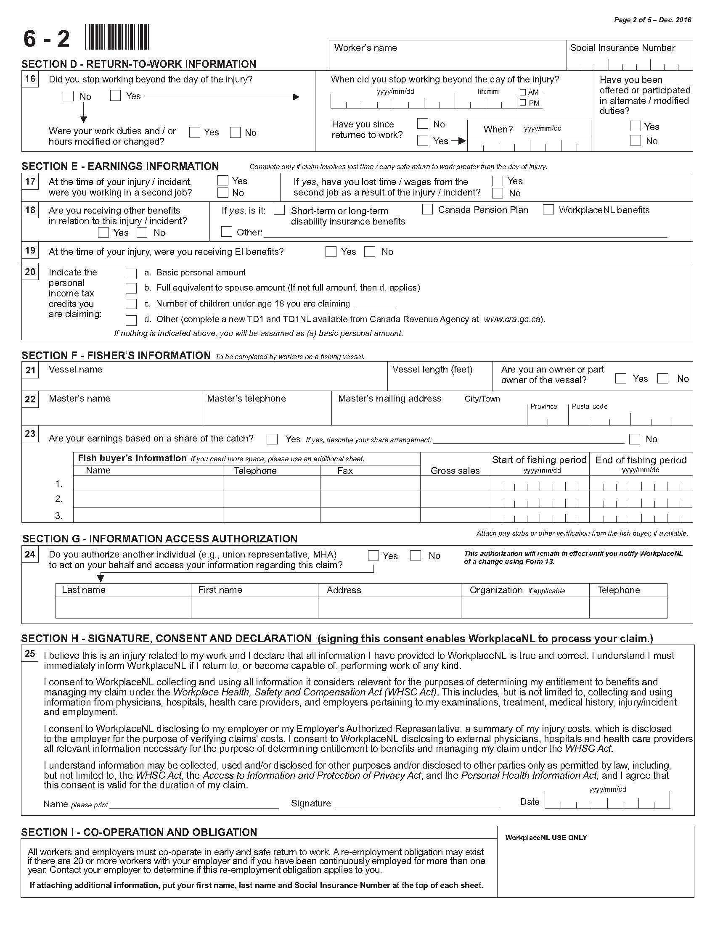

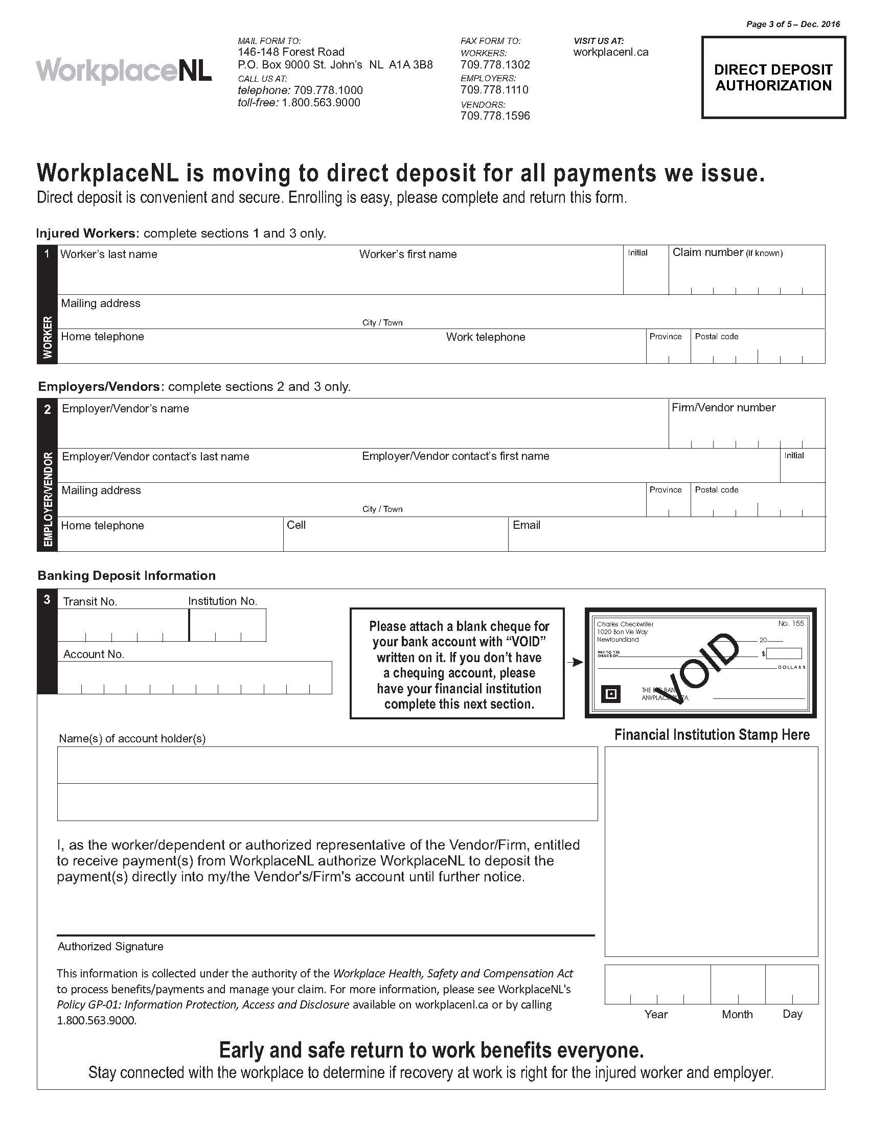
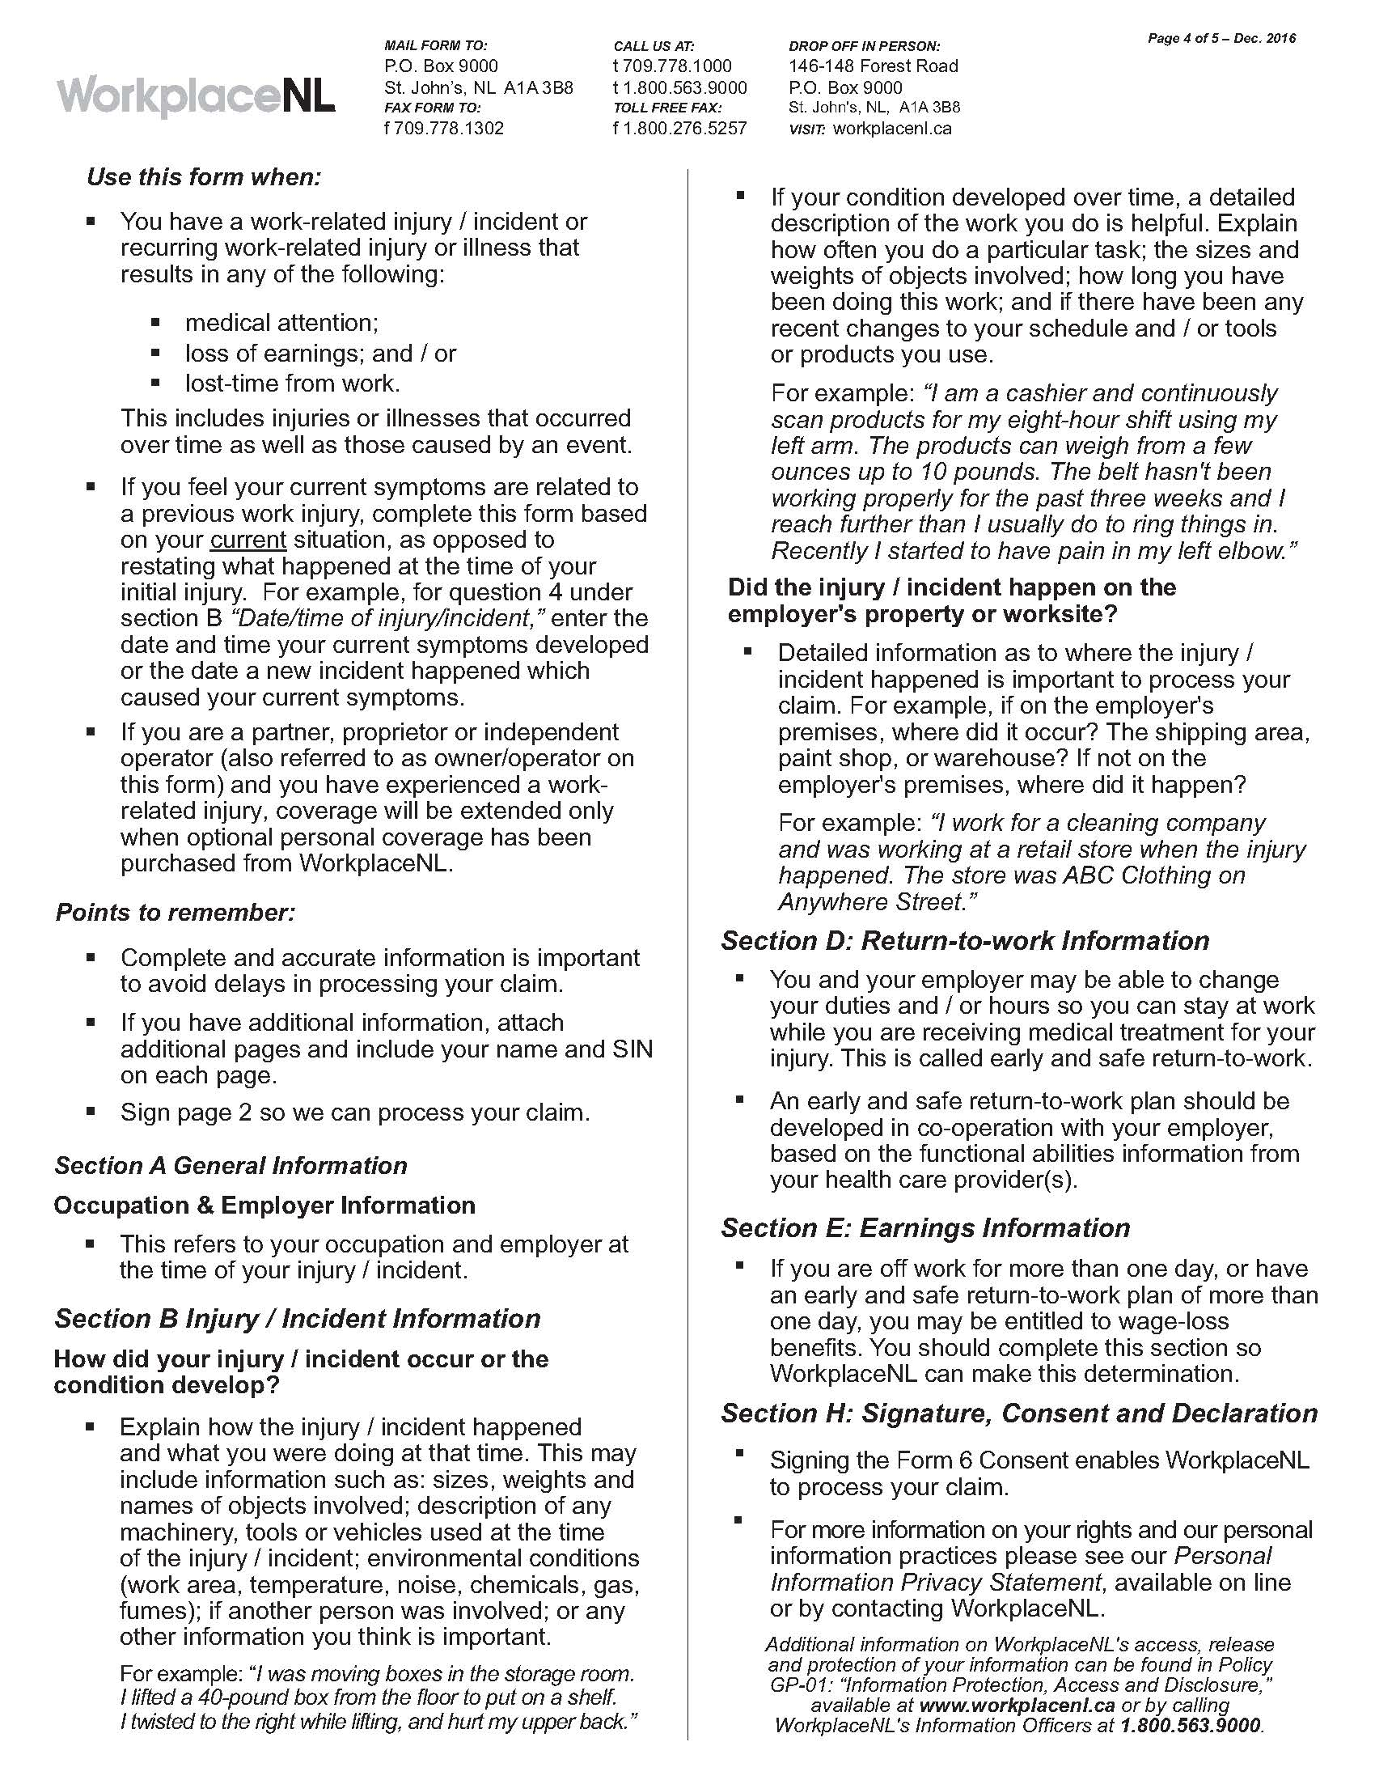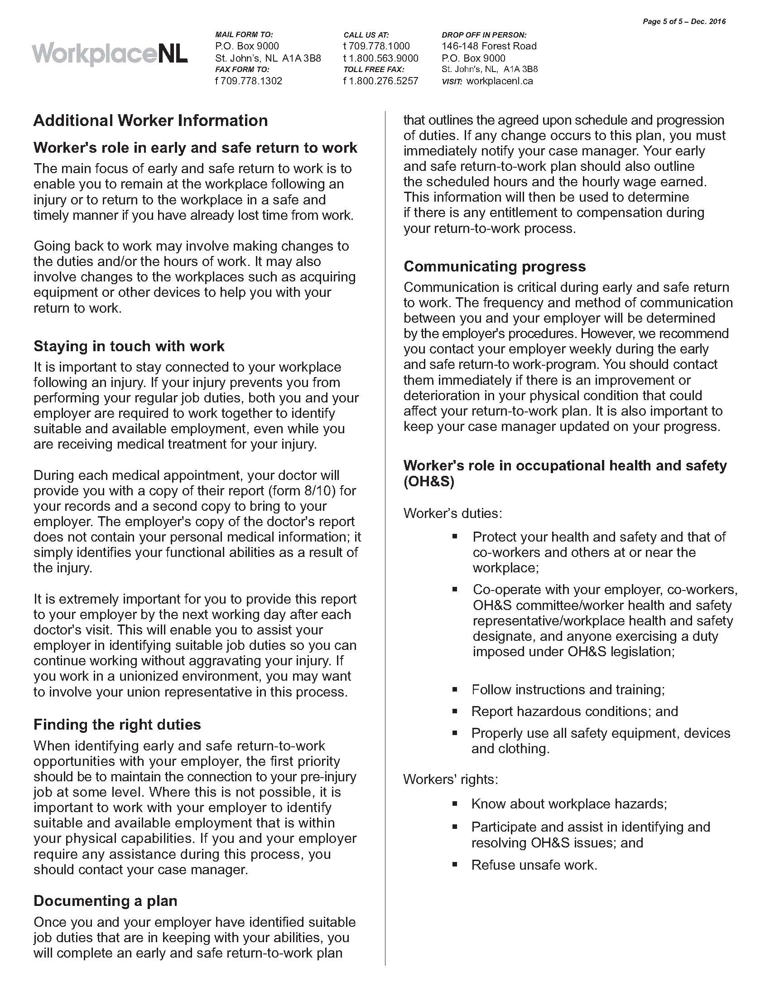

Employer’s Report of Injury (Form 7)
http://www.whscc.nf.ca/download.aspx?ID=05211c7d-3041-4aa2-a978-5e4d129ca6e7
