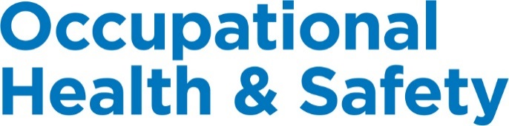

Ontario

© 2018, Workplace Safety & Prevention Services (WSPS). All rights reserved.
All text, logos, illustrations, graphics, images, designs, the arrangement of information and other content in this publication are protected by copyright and other intellectual property rights. No part of this publication may be reproduced, distributed, displayed, broadcasted, stored in a retrieval system, transmitted in any form or by any means, electronic, mechanical, photocopied, recorded or otherwise, or otherwise exploited in any manner, without the prior written permission of Workplace Safety & Prevention Services (WSPS).
The information contained in this reference material is distributed as a guide only. It is generally current to the best of WSPS’s knowledge as at the revision date, having been compiled from sources believed to be reliable and to represent the best current opinion on the subject. No warranty, guarantee, or representation is made by WSPS as to the absolute correctness or sufficiency of any representation contained in this reference material. WSPS assumes no responsibility in connection therewith; nor can it be assumed that all acceptable safety measures are contained in this reference material, or that other or additional measures may not be required in particular or exceptional conditions or circumstances. Under no circumstances shall WSPS, its affiliates, or any of its respective partners, officers, directors, employees, agents or representatives be liable for any damages, whether direct, indirect, special or consequential damages for lost revenues, lost profits, or otherwise, arising from or in connection with this document.
Workplace Safety & Prevention Services (WSPS) and the above logos and marks are a Trademark of Workplace Safety & Prevention Services (WSPS). © WSPS, 2016. All Rights Reserved.
While WSPS does not undertake to provide a revision service or guarantee accuracy, WSPS shall be pleased to respond to your individual requests for information, at any time.

Provincial Appendix - Ontario
Overview | The Provincial Occupational Health & Safety Act(s) and associated regulations set a minimum standard for worker health and safety. This appendix outlines the specific requirements based on legislation and regulations for Ontario.  DQ or OJ Franchisee is committed to the health and safety of our employees, volunteers, visitors, suppliers and customers, customers, workplace and environment. It is important to understand that this appendix supports the Essential Elements Final.docx. Additional safety programs focused on hazard and risk specific programs, safe work practices and best practices will ensure we have a comprehensive program specific to our company.  We are committed to review our programs annually and make every effort to have the most up to date information for our workers.

Keys | Communicate Post / Display Review / Update  Link to other information Information / Training

Document Control | Effective Date: January 2019 Approved By:

Table of Contents
Workplace Violence and Harassment Prevention 3
Posted Health & Safety Materials Requirements 4
Joint Health & Safety Committee / Health & Safety Representative 5
First Aid Requirements 7
Injury/Incident Reporting and Investigation Requirements 9
Ministry of Labour Written Notification Requirements 12
Return to Work 13
Working Alone Requirements 15
Resources 16

Workplace Violence and Harassment Prevention
Overview | DQ or OJ Franchisee will be proactive in its prevention of workplace violence or harassment of any kind. We are committed to providing a work environment in which all workers are treated with respect and dignity.

Legislation | Occupational Health & Safety Act Section 32

Definition | Workplace harassment is:  - Engaging in a course of vexatious comment or conduct against a worker in a workplace – behavior that is known or ought reasonably to be known to be unwelcome, or workplace sexual harassment.  Workplace sexual harassment is:  - Engaging in a course of vexatious comment or conduct against a worker in a workplace because of sex, sexual orientation, gender identity or gender expression, where the course of comment or conduct is known or ought reasonably to be known to be unwelcome, or  - Making sexual solicitation or advance where the person making the solicitation or advance is in a position to confer, grant or deny a benefit or advancement to the worker and the person knows or ought reasonably to know that the solicitation or advance is unwelcome.  Workplace Violence is:  - The exercise of physical force by a person against a worker, in a workplace, that causes or could cause physical injury to the worker;  - An attempt to exercise physical force against a worker, in a workplace, that could cause physical injury to the worker; and  - A statement or behaviour that’s reasonable for a worker to interpret as a threat to exercise physical force against the worker, in a workplace, that could cause physical injury to the worker.

Procedure | See Workplace Violence and Harassment Prevention in the Essential Elements Final.docx for further information.

Employer Responsibilities | The employer must prepare policies with respect to workplace violence and workplace harassment, develop and maintain programs to implement their policies, and provide information and instruction to workers on the contents of these policies and programs.  Workplace violence programs must include measures and procedures for:  - Summoning immediate assistance when workplace violence occurs or is likely to occur.  - Controlling risks identified in the assessment of risks.  Both workplace violence and workplace harassment programs must include measures and procedures for workers to report incidents of workplace violence/harassment and set out how we will investigate and deal with incidents or complaints.

Resources | Workplace Violence and Workplace Harassment – Ministry of Labour  Code of Practice to Address Workplace Harassment  Workplace Violence and Harassment: Understanding the Law  Workplace Violence and Harassment Prevention – Essential Elements Final.docx

Posted Health & Safety Materials Requirements
Overview | The following information and materials must be made available to all employees and will be posted in a common area on the Health & Safety Bulletin Board.

Materials to Post on Health & Safety Bulletin Board | 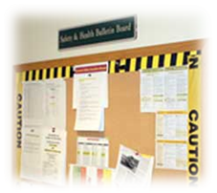  - Occupational Health & Safety Act  - Regulation 851, Industrial Establishments  - Ministry of Labour Employment Standards Act (ESA) Poster  - Ministry of Labour “Health and Safety at Work: Prevention Starts Here” Poster  - Health and Safety Policy Statement  - Workplace Violence and Harassment Policy Statement  - WHMIS Regulation 860  - Safety Data Sheets (may be placed in a binder)  - Occupational Health and Safety Explanatory materials, such as the MOL Guide to the Occupational Health & Safety Act  - WSIB Form 82 – In Case of Injury at Work Poster  - Regulation 1101, First Aid (Including a list of all certified first aiders)  - Emergency Services and Numbers (i.e. 911 or fire, police, ambulance; MOL; MOE; utilities; internal contact numbers)  Applicable Reports including:  - Joint Health & Safety Committee or Representative workplace health and safety inspections  - JHSC Member names and work locations  - JHSC meeting minutes  - Health and/or safety assessments/surveys  - Ministry of Labour orders  - Workplace incident summaries  - Other information applicable to the workplace – ie: traffic control, Transportation of Dangerous Goods, workplace incident statistics, MOL Guidelines, MOL Alerts

Roles & Responsibilities | Health &Safety Coordinator or designate will be responsible for the following:  - Ensuring the most current information is available at each location.  - Update the Checklist for Posted Health and Safety Materials as necessary.  Managers will be responsible for the following:  - Ensuring the most current information is available to all employees.  - Posting any materials as outlined on the Checklist for Posted Health and Safety Material.  - Complete check list provided signing off and forwarding to Health & Safety Coordinator or designate.  The content of the information will be reviewed and maintained to ensure that it is current.

Resources | Posted Health & Safety Material Checklist  In Case of Injury at Work (Poster)  Health & Safety at Work: Prevention Starts Here (Poster)
Joint Health & Safety Committee (JHSC) / Health & Safety (HS) Representative
Overview | To ensure designated JHSC Members receive consistent recognized training in occupational health and safety and to support the effectiveness of the Internal Responsibility System.  By law, at least one Management and one Worker Member on the Joint Health and Safety Committee (JHSC) are required to be ‘certified’ in health and safety for Part One and Part Two. Having the JHSC Members complete a workplace hazard analysis, identify the significant hazards, receive training on those hazards and then develop an action plan to control or minimize the hazards will fulfill their requirements of Certification Part Two.

Legislation | A Joint Health and Safety Committee is required at a workplace where 20 or more workers are regularly employed, or where a Ministry of Labour’s order is in effect under (toxic substance), or a designated substance regulation is applied.  Health and Safety Representatives will be in locations that have 6 to 19 employees.  Occupational Health & Safety Act Section 9.

Responsibilities | A JHSC Member or Representative will be responsible for the following:  - Identifying actual and potential workplace hazards  - Inspecting the workplace at least once a month or, if that is not practical, inspecting the workplace at least once a year and at least part of the workplace each month in accordance with a schedule agreed upon by the representative and the employer  - Being consulted about and being present at the beginning of health and safety-related testing in the workplace  - Making recommendations to the employer about health and safety in the workplace, and  - Participating in the first and second stage investigation of work refusals and inspecting workplaces when there are critical injuries or fatalities.

Training Requirements | In addition to internal training provided by our company, the Ministry of Labour (MOL) requires two (2) JHSC committee members to receive certification training when there are 20 or more employees.  For workplaces between 6 - 19 employees, basic training requirements for Health and Safety Representatives can be conducted using self-paced eLearning.  Certification Training  - Two JHSC members are to successfully complete the training requirements to qualify as Certified Members, one representing management and one representing workers.  - It is a legislated requirement to certify designated members of the JHSC as set out in the legislation.  - Designated JHSC members become fully certified by completing both Certification Part One (Basic Foundation Training) and Certification Part Two (Workplace Specific Hazards).  - Certification training is a training program recognized and approved by the Ministry of Labour (MOL).  - The employer determines Certification Part Two (Workplace Specific Hazards) training requirements for designated members.  - Upon completion of Certification Part One, the member will complete Certification Part Two within 6 months.  - Refresher training will be completed every 3 years.  Learning Objectives Certification Part One Training include: (3 Days)  - Understand the organization and contents of, and definitions in, the Occupational Health & Safety Act and the Internal Responsibility System.  - Understand important legislation regulations and hazards that affect the workplace.  - Describe the general duties and responsibilities of employer, supervisor and worker rights and responsibilities.  - Understand the duties and responsibilities of a Joint Health and Safety Committee (JHSC) and certified members.  - Describe the steps to follow after a fatality or critical injury.  - Understand the fundamentals of incident prevention and workplace inspections.  Learning Objectives Certification Part Two Training include: (2 Days)  - Minimum of 6 hazards relevant to the workplace  - Focuses on RACE methodology (Recognition, Assessment and Control of hazards, and Evaluation of the hazard controls)  Learning Objectives Certification Refresher Training include: (1 Day)  - Review topics of key concepts from Part One and Part Two Training, updates to legislation, standards, codes of practice and occupational health and safety best practices; and an opportunity for certified members to share and discuss best practices.  Best Practices  As a Best Practice, to ensure we are always in compliance and not short certified members on the JHSC due to turnover or internal promotion, we will always have at least 1 Management and 1 Worker Member(s) certified in Part One and Two at any time. It is a good idea to have a cross-section represented on the JHSC.

Resources | Workplace-Specific Hazard Training Confirmation (Form 3189A)  JHSC Certification Training Program Standard and Provider Standard  Guide for Health and Safety Committees and Representatives – MOL  Health and Safety Representatives (HSRs) – MOL  Occupational Health & Safety Act – JHSC Section 9  Worker Right to Refuse Flowchart  Health & Safety Committee – Essential Elements Final.docx

First Aid Requirements
Overview | 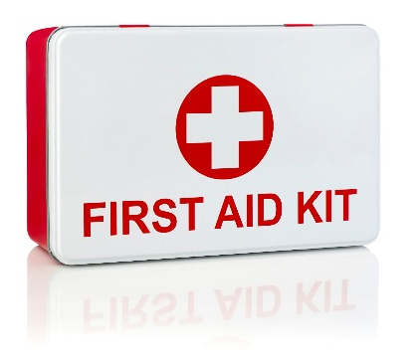  First Aid is an essential part of any health and safety system. Although we strive to eliminate workplace injuries and illnesses, it recognizes that the potential exists for these to occur.  We will protect the health, safety and well-being of its employees, volunteers, guest and visitors. Anyone injured or ill in the workplace shall be provided with the utmost care. Prompt and proper first aid will be administered by a certified First Aid Attendant.

Legislation | Workplace Safety and Insurance Act - Regulation 1101

Training | At a minimum, we will ensure that at least one Certified First Aid Attendant will be available during every shift. A list of Certified First Aid Attendants, along with a copy of their current certification, will be posted on the Health & Safety Bulletin Board or near the first aid kits.  Standard First Aid with Level A CPR is a 2 day course and is valid for 3 years.  See First Aid Program in the Essential Elements Final.docx for further information.

First Aid Log | All first aid treatment given to a worker must be entered in the First Aid Log. Each case that is referred for further medical treatment must also be entered. The confidentiality of personal medical information must be maintained. First Aid Logs must be kept for at least 5 years.

First Aid Attendants | First Aid Attendants must record all reported signs and symptoms of injuries and exposures to contaminants found at your location using the Hazard Response Form. If an injury is more severe or beyond the training of the First Aider, the First Aider is responsible for referring the worker to seek additional medical attention.

Reporting Requirements | For any injury or illness requiring first aid, a First Aid Report must be filled out along with an Injury and Incident Analysis Checklist.  The first aid attendant is required to record in the Injury Incident Analysis Report, all treatment given to an employee. Should the injury/illness be serious enough that medical attention is required, an Incident Injury Investigation Report will be completed and provided to the location manager and HS Coordinator. The Injury/Incident Investigation Report will record the circumstances surrounding the incident as described by the injured employee. Specifically, the report must include:  - The name of the injured person  - The name and qualifications of the person giving first aid;  - A description of the illness or injury;  - The first aid given to the worker;  - The date and time of the illness or injury was reported;  - Where at the work site the incident occurred;  - The work-related cause of the incident

First Aid Area | First Aid Area will be located within quick and easy access of all employees, and will be equipped with a First Aid Kit, a stretcher, and two blankets.  DQ or OJ Franchisee will ensure that first aid services, first aid equipment, supplies and the first aid room required by the First Aid regulation are:  - A notice board displaying the WSIB’s poster known as Form 82 (In Case of Injury at Work Poster)  - Valid first aid certificates of qualified trained workers are on duty  - An Inspection record with the most recent inspection date and signature  - The first aid attendant works in the immediate vicinity of the first aid area  - First aid areas shall be easily accessible for prompt treatment  - First aid kits shall be maintained in good condition and stocked at all times  - The first aid kit shall be large enough to view in plain view  Please see the first aid kit inventory list for minimum content requirements.

Resources | First Aid Requirements – WSIB  In Case of Injury at Work (Poster)  Injury/Incident Reporting and Investigation Requirements  First Aid - Essential Elements Final.docx

Injury/Incident Reporting and Investigation Requirements
Overview | There are legal requirements in all provinces under the Provincial Health & Safety Act(s) and Workers Compensation Boards for employers to record and report:  - Where a person is killed or critically injured at a workplace.  - Where a person is disabled from performing his or her work or requires medical attention because of an accident, explosion, fire or incident of workplace violence.  - If an employer is told that a worker has an occupational illness or that a claim for an occupational illness has been filed with the WCB.

Legislation | Occupational Health & Safety Act Part VII

Definitions | A “critical injury” is any injury that:  - Places life in jeopardy  - Causes unconsciousness  - Results in significant blood loss  - Involves the fracture of a leg or arm, but not a finger or a toe  - Involves amputating all or part of an arm or leg, but not a finger or a toe  - Consists of burns to a major portion of the body  - Causes the loss of sight in an eye  A “fatality” is a death.  An “occupational illness” is a condition that results from exposure in a workplace to a physical, chemical or biological event to the extent that the normal physiological mechanisms are affected and the health of the worker is impaired. It includes an occupational disease for which a worker is entitled to benefits under the Workplace Safety and Insurance Act, 1997.

Reporting | In accordance with the Occupational Health & Safety Act and the Workplace Safety & Insurance Act, all injuries and illnesses will be handled in the following manner.  If a fatality or critical injuries occurs, the following steps will be taken:  - The employer must immediately notify the the Ministry of Labour Health & Safety Contact Centre at 1-877-202-0008, the Joint Health & Safety Committee or Representative, police and the family. (Website: http://www.labour.gov.on.ca)  - Within 48 hours, the employer must also notify, in writing, the Ministry of Labour (MOL), giving the circumstances of the occurrence and any information that may be prescribed in regulations. (Refer to the Notice of Accident Form – Critical Injury Report to MOL.)  - If an incident, explosion or fire occurs and a worker is disabled or requires medical attention, the employer must notify the Joint Health & Safety Committee or Representative within four (4) days of the incident. This notice must be in writing and must contain any prescribed information under the regulations. (Refer to the Notice of Incident Form – Incident Fire Explosion or Illness Report to MOL.)  - If required this notice must also be given to the Ministry of Labour.

Other Reporting | - The employer will preserve the incident area to prevent further injury or damage and also to maintain it for investigation purposes.  - Emergency Response/Ambulance will be contacted and first aid treatment will take place as appropriate.  - The staff will receive support as needed through counseling or other means  - A WSIB Employers Report on Injury and Disease (WSIB Form 7) will be completed and submitted within three (3) days.  - A record of the incident will be kept on file including all investigation information, first aid information and copies of the completed WSIB Form 7 by the manager and copied to the Health & Safety Coordinator or designate.  - The manager will be responsible for maintaining contact with the injured/ill worker as described in the Return to Work Policies and Procedures.  - Progress on the Return to Work procedure will be copied to the Health & Safety Coordinator or designate.  Injuries requiring Health Care or Medical Aid, and Occupational Illness or Claims for Occupational Illness  Non-critical injuries include health care and first aid. This is any injury other than a death or critical injury.  - According to the WSIB, examples of covered health care costs include the following:  - Visits to doctors, physiotherapists, or chiropractors  - Prescription drugs  - Care provided by hospitals or other health facilities  - Eye glasses and prostheses  In the event of a health care or medical aid incident or occupational illness, the following steps will be taken:  - Emergency Response/Ambulance will be contacted and/or first aid treatment will take place as appropriate.  - The manager will contain the incident area to prevent further injury or damage and also to maintain it for investigation purposes.  - If the employer is told that a worker has an occupational illness or that a claim for an occupational illness has been filed with the WSIB, the employer must notify the MOL and the Joint Health & Safety Committee or Representative within four (4) days. This notice must be in writing and must contain any prescribed information. Refer to the Notice of Incident Form – Incident Fire Explosion or Illness Report to MOL.  - If a person is disabled from performing regular duties or develops an occupational illness, a report must be sent to the Ministry of Labour within four (4) days. The employer will prepare and deliver within 4 days to the Joint Health & Safety Committee or Representative a written description of the circumstances surrounding the injury/illness as prescribed by Regulation 851, Section (5).  - A WSIB Employers Report on Injury and Disease (WSIB Form 7) must be completed and submitted within three (3) days.  - A record of the incident will be kept on file including all investigation information, first aid information, and copies of the completed WSIB Form 7.  - The Manager will be responsible for maintaining contact with the injured/ill employee as described in the Return to Work Policies and Procedures.  - Progress on the Return to Work procedure will be copied to the Health & Safety Coordinator or designate.

Investigation | An investigation is legally required for critical injuries. For other losses the requirement is to complete a WSIB Form 7 for lost time and medical aid for injuries (according to the Occupational Health & Safety Act, Section 51 and 52).  Once permission is given by an inspector, the JHSC Worker Member shall investigate the incident scene and report his/her findings in writing to the Joint Health & Safety Committee or Representative, the Employer, and the MOL Director.  All incidents causing injury, however minor, must be reported to a manager/supervisor and to the Joint Health & Safety Committee or Representative.  All injuries/incidents are investigated as per our policy.

Administrative Penalties | The amount under the Act that an employer shall pay is $250; or if the employer’s failure to notify the Board as required exceeds 30 days in duration is $1,000.

Resources | Injury and Incident Analysis Checklist  Worker’s Report of Injury/Disease Form 6  Employer’s Report of Injury/Disease Form 7  Functional Abilities Form (FAF)  Injury/Incident Reporting and Investigation – Essential Elements Final.docx

Ministry of Labour Written Notification Requirements
Overview | The Occupational Health & Safety Act Requires employers to notify the Ministry of Labour whenever certain workplace injuries, illnesses, or fatalities occur.

Legislation | Occupational Health & Safety Act Part VII

Notice of Critical Injury or Fatality | The employer's written notice of a critical injury or fatality should include the following information,  - Name, address and phone number of the employer  - Type of business  - Name, address and phone number of the person who was killed or critically injured;  - Time and place of the occurrence;  - Description of the occurrence and the bodily injury sustained;  - Description of the machinery or equipment involved, if any;  - Names, addresses and phone numbers of all witnesses to the occurrence;  - Name, address and phone number of the physician, if any, by whom the person was or is being attended; and,  - Steps taken to prevent a recurrence.  This report must be sent to the MOL within 48 hours of the critical injury/fatality.

Notice of Occurrence or Occupational Illness | The employer's written notice of an accident, explosion or fire that disables a worker or which requires medical attention but is not a critical injury or fatality; or, a notice of an occupational illness, should include the following information,  - Name, address and phone number of the employer  - Type of business  - Name, address and phone number of the person suffering the injury or illness;  - Time and place of the occurrence;  - Description of the occurrence and the bodily injury or illness sustained;  - Description of the machinery or equipment involved, if any;  - Names, addresses and phone numbers of all witnesses to the occurrence;  - Name, address and phone number of the physician, if any, by whom the person was or is being attended for the injury or illness; and  - Steps taken to prevent a recurrence.  This report must be sent to the MOL within 4 days of the accident, explosion, fire or incident of Workplace Violence which disables a person from performing their regular duties. In the case of an Occupational Illness, the employer must submit the report within 4 days of being advised of the illness.

Record of Incident, Fire and Explosion | A written record of an incident, explosion or fire causing injury requiring medical attention but not disabling a worker from performing his or her usual work shall be kept in the permanent records and include particulars of,  - Nature and circumstances of the occurrence and the injury sustained;  - Time and place of the occurrence; and  - Name and address of the injured person

Resources | Notice of Accident Form – Critical Injury Report to MOL  Notice of Incident Form – Incident Fire Explosion or Illness Report to MOL

Return to Work
Overview | Return to Work is sometimes referred to as disability management program, modified work program, alternate duties program or claims management program.

Legislation | Workplace Safety and Insurance Act Part V

Responsibilities | Employer  - Ensure employees are aware of reporting requirements.  - Take the WSIB Form 8 as part of the Return to Work Package to the Practitioner. The Functional Abilities section of WSIB Form 8 helps both the employer and the employee meet the return-to-work obligation as set out by the WSIB.  - The Functional Abilities section helps to indicate what types of activities an employee may be able to do.  - In accordance with Accident Reporting and Investigation requirements, complete a WSIB Form 7 within 3 business days of the incident or learning about the injury or illness.  Employee  - Seek timely and appropriate health care to treat the injury/illness.  - Take all reasonable action to prevent the loss of earnings resulting from an injury/illness.  - The employee must fill out a WSIB Form 6 as soon as possible following the incident and submit it to the WSIB (the employee has 6 months to file a claim of an incident or within 6 months of learning of an occupational disease) and must provide a copy to the Manager/Supervisor, Health & Safety Coordinator or designate.  - Participate in the rehabilitation process, and in the development and implementation of the Return-to-Work plan with the WSIB, the employer and the health care provider.  - Follow the instructions and recommendations of the health care provider.  - Maintain a positive attitude about returning to work when appropriate. Understand the benefits of accepting appropriate work during the rehabilitation process so that the focus can be shifted from disability to regained abilities.  - Inform the employer and WSIB about how recovery is progressing.  Health Care Provider  - Provide information to the WSIB regarding the injured worker's health care.  - Fill out the WSIB Form 8 during the initial visit, and WSIB Functional Abilities Form for Timely Return to Work for any subsequent visits, regarding information about the injured worker’s abilities. Only regulated health professionals can complete them.  - Send copies of the completed WSIB Form 8 to the employee, the employer, and the WSIB. This report is confidential.  Workplace Safety & Insurance Board (WSIB)  - Inform the employer as to what to expect through the Return to Work process.  - Inform injured worker and the employer of expected actions  - Inform injured worker of rights and obligations  - Provide more information upon request  - Monitor the injured worker’s activity, progress, and cooperation with the employer.  - Obtain and clarify functional abilities information  - Assess the need for a Work Reintegration Plan if early and safe return to work is unlikely.  - Help resolve difficulties and disputes  - Provide ergonomic and/or mediation services and/or site visits to help the injured worker and the employer through the process.  - Make decisions on all claim-related and compliance issues

Resources | Worker`s Report of Injury/Disease (Form 6)  Employer`s Report of Injury/Disease (Form 7)  Functional Abilities Form (FAF)

Working Alone
Overview | Any employee who works alone at any time will adhere to the OHS regulations as well as policies and procedures outlined in in our Occupational Health & Safety Program – Canada.

Legislation | Ontario has no specific regulations that address working alone, other than in specific situations such as confined space. Ontario workers rely on the general provision in Ontario’s Occupational Health & Safety Act (OHSA) Section 25 that mandates that employers must take “reasonable precautions” to protect workers.

Definition | Working alone can be defined as “the performance of any work function by a worker in circumstances where the worker cannot be seen or heard by another worker in the event of injury, ill health, or emergency.”

Employer Responsibilities | Ensure to follow OHSA Section 25, to take every precaution reasonable to ensure workers that are working alone are safe within the scope of the intent of the law.

Resources | Working Alone – General Information (ccohs.ca)  Working Alone – Essential Elements Final.docx

Resources
Overview | Some of the samples and templates referred to in this document follow this section. Other forms can be found in the Resource section of the Occupational Health & Safety Program – Canada (Resources Final.docx).  Posting Health & Safety Materials  Posted H&S Material Checklist 17  In Case of Injury at Work (Poster) 19  Health & Safety at Work (Poster) 20
Joint Occupational Health & Safety Committee/Health & Safety Representative
Worker Right to Refuse Flowchart 21
Injury & Incident Forms
First Aid Kit Requirements 22
Notice of Accident 23
Notice of Incident 24
Injury/Incident Analysis Checklist 25
Worker’s Report of Injury/Disease (Form 6) 29
Employer’s Report of Injury/Disease (Form 7) 33
Health Practitioner’s Form 37
Functional Abilities Form 41

Posted Health & Safety Material Checklist
Material | Location | Links | Date Posted
Occupational Health & Safety Act | Health & Safety Bulletin Board | https://www.ontario.ca/laws/statute/90o01
Regulation 851, Industrial Establishments | Health & Safety Bulletin Board | https://www.ontario.ca/laws/regulation/900851
Health and Safety Policy Statement | Health & Safety Bulletin Board
Workplace Violence and Harassment Prevention Policy Statement | Health & Safety Bulletin Board
Ministry of Labour Employment Standards Act (ESA) Poster | Health & Safety Bulletin Board Copy given to all Employees | https://www.labour.gov.on.ca/english/es/pubs/poster.php
Ministry of Labour “Health and Safety at Work: Prevention Starts Here” Poster | Health & Safety Bulletin Board | http://www.labour.gov.on.ca/english/hs/pubs/poster_prevention.php
In Case of Injury at Work Poster (Form 82) | Health & Safety Bulletin Board  First Aid Kit | Form 82 (WSIB Website)
Regulation 1101, First Aid  Include a list of all certified First Aiders in the workplace along with a copy of their certificate | Health & Safety Bulletin Board  First Aid Kit | https://www.ontario.ca/laws/regulation/901101  First Aid Requirements Guide
Regulation 860, WHMIS | Health & Safety Bulletin Board | https://www.ontario.ca/laws/regulation/900860
Safety Data Sheets (SDS)  To be stored in an easily accessible area near where the chemicals are being used, must be most current version available from supplier | SDS Binder
Health & Safety Explanatory Materials  Examples: Ministry of Labour (MOL) Guidelines, MOL Alerts, Fact Sheets, Engineering Data Sheets, Duties or applicable | Health & Safety Bulletin Board (optional) | Guide to the OHS Act:  http://www.labour.gov.on.ca/english/hs/pubs/ohsa/index.php  Fact Sheets, Info Bulletin, Guidelines, Alerts, Engineering Data Sheets, Posters  http://www.labour.gov.on.ca/english/hs/pubs/index.php
Emergency Services and Numbers  Examples: 911 (if available), fire, police, ambulance, poison control centre, Ministry of Labour, Ministry of Environment, Utilities, Internal contact numbers | Primary Telephones  Health & Safety Bulletin Board
Joint Health and Safety Committees (JHSC)  - Management, Joint Health & Safety Committee health and safety inspections  - JHSC Member names and work locations  - JHSC Meeting Minutes  - Health and safety assessments and surveys  - Ministry of Labour Orders  - Workplace Incident summaries | Health & Safety Bulletin Board | http://www.labour.gov.on.ca/english/hs/pubs/jhsc/jhsc_jhsc.php  http://www.labour.gov.on.ca/english/hs/pubs/farming/jhsc/jhsc_5.php  http://www.labour.gov.on.ca/english/hs/pubs/jhsc_summary.php
Joint Health and Safety Committee (JHSC) or Representative Guide | Health & Safety Bulletin Board  (optional) | http://www.labour.gov.on.ca/english/hs/pubs/jhsc/
Other Reports relevant to workplace  Examples:  - Traffic Control  - Fumehood Exhaust Fan Testing Reports  - MOE Inspection Reports  - TSSA Propane Certificate(s)  - TSSA Elevator Certification | Health & Safety Bulletin Board  (optional)
Transport of Dangerous Goods (if applicable) | Health & Safety Bulletin Board | http://www.tc.gc.ca/eng/tdg/safety-menu.htm
Identification of Designated Substances (if applicable)  Examples include: Acrylonitrile, Arsenic, Asbestos, Benzene, Coke Oven Emissions, Ethylene Oxide, Isocyanates, Lead, Mercury, Silica, Vinyl Chloride | Health & Safety Bulletin Board | https://www.ontario.ca/laws/regulation/090490

Occupational Health & Safety Department | Workers’ Compensation Board
Ministry of Labour (MOL)  505 University Avenue, 19th Floor  Toronto, ON M7A 1T7  Telephone: 1-877-202-0008 (in Ontario only)  http://www.labour.gov.on.ca/english/hs/  Regional Offices: http://www.labour.gov.on.ca/english/about/reg_offices.php | Workplace Safety and Insurance Board (WSIB)  200 Front Street West  Toronto ON M5V 3J1  Telephone: (416) 344-1000 or Toll-Free: 1-800-387-5540  Ontario Toll-free 1-800-387-0750  Fax: (416) 344-4684  http://www.wsib.on.ca

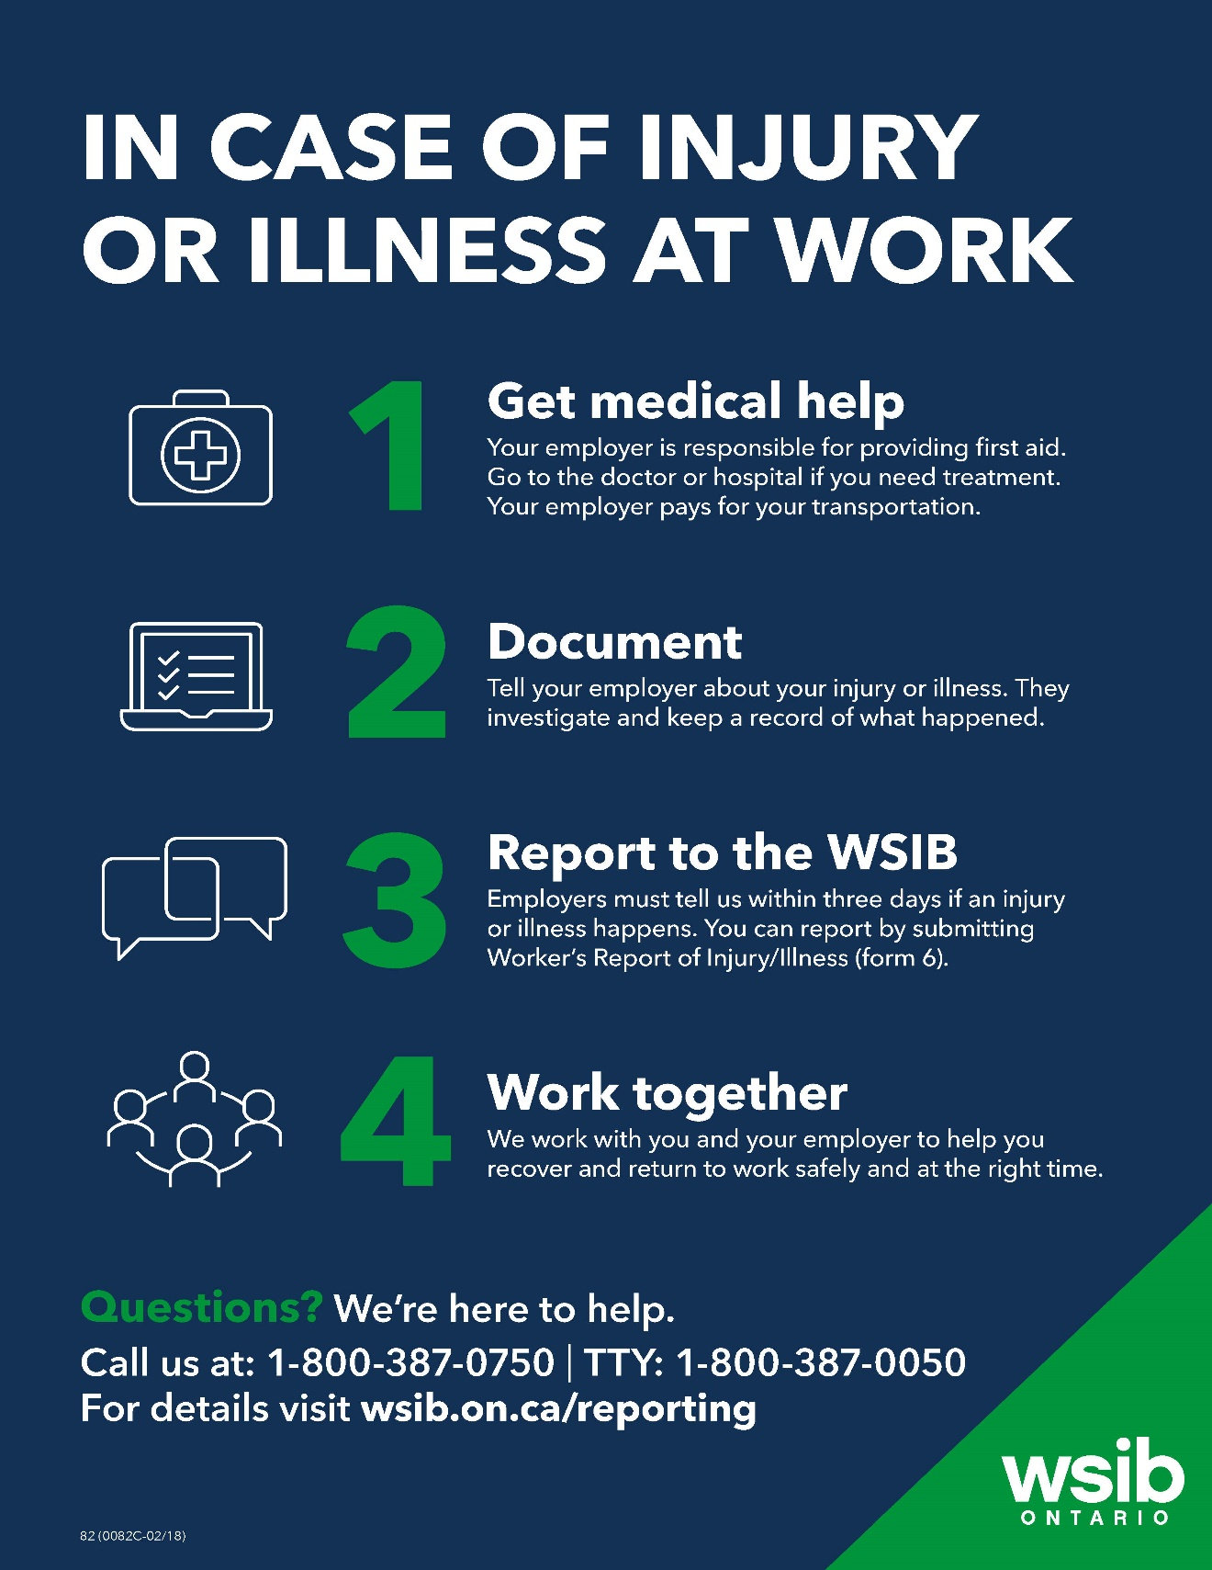
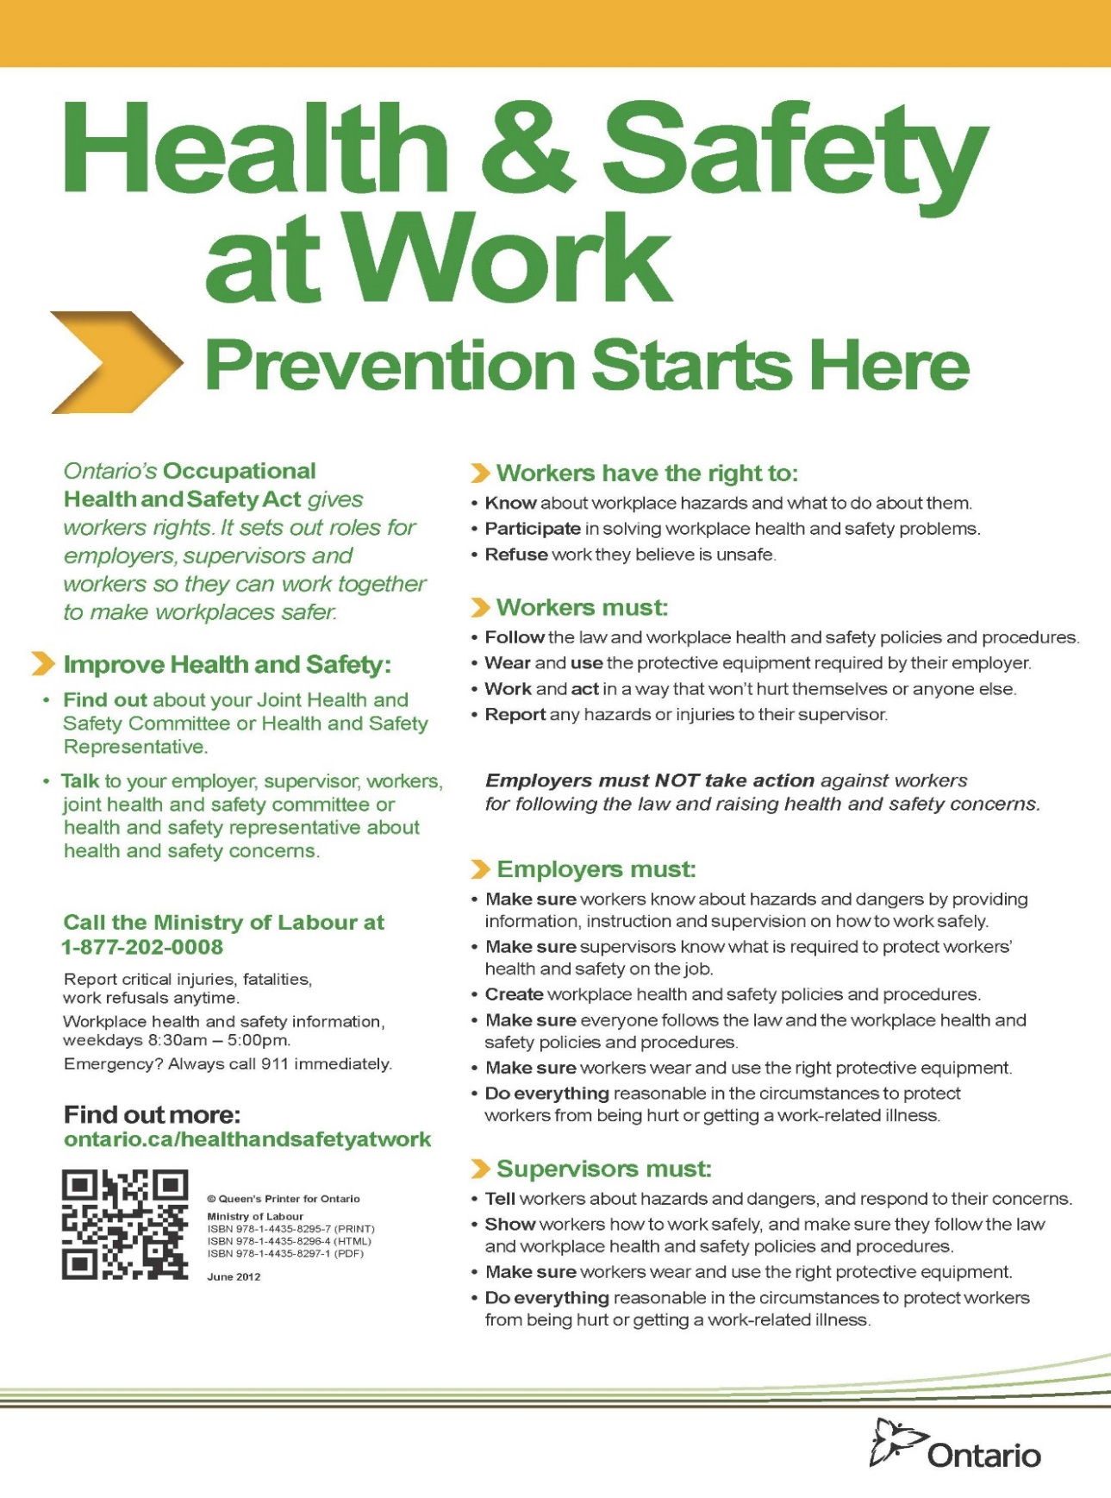

Worker Right to Refuse Flowchart
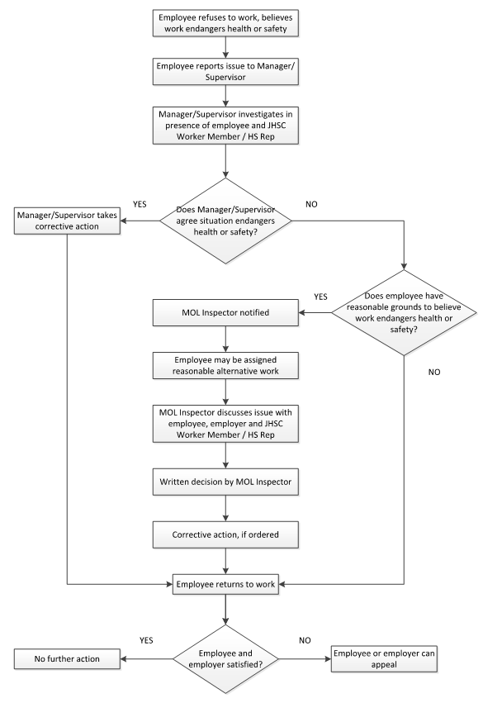
First Aid Kit Requirements

Supply | Qty
Current edition of a standard First Aid Manual | 1
Safety pins | 24
Basin, preferably stainless steel | 1
Adhesive dressings, individually wrapped | 48
Pair of splinter tweezers blunt end | 1
Pair of 4” scissors | 1
Pairs of non-latex surgical gloves | 6
Rolls of adhesive tape, 1 inch wide | 2
Rolls of 1-inch gauze bandage | 12
Adhesive dressings individually wrapped | 48
Sterile gauze pads, 3 or 4 inches square | 48
Rolls of 1-inch gauze bandage | 12
Rolls of 2-inch gauze bandage | 8
Rolls of 4-inch gauze bandage | 8
Sterile surgical pads suitable for pressure | 6
Triangular bandages | 12
Splints of assorted sizes | 1
Rolls of splint padding | 2
Bottle of hydrogen peroxide | 1
Bottles of eye wash solution | 2
CPR mask | 1
First aid inspection record | 1
Stretcher | 1
Blankets | 2
A notice board displaying WSIB’s Form 82
The names and locations of all First Aid Attendants
An inspection card

Notice of Accident - Critical Injury/Fatality Report
IMPORTANT: This report must be sent to the Ministry of Labour within 48 hours of the critical injury/fatality
Name and Address of Employer
Nature and the Circumstances of the Occurrence and the Bodily Injury Sustained
Description of Machinery or Equipment Involved
Time and Place of Occurrence
Name and Address of the Person Killed or Critically Injured
Name(s) and Address(es) of all Witness(es)
Name and Address of any Physician or Surgeon who attended the person’s injuries
Steps Taken to Prevent Recurrence

Notice of Incident - Incident, Explosion, Fire or Incident of Workplace Violence or Occupational Illness
IMPORTANT: This report must be sent to the Ministry of Labour within 4 days of the accident, explosion, fire or incident of Workplace Violence which disables a person from performing their regular duties. In the case of an Occupational Illness, the employer must submit the report within 4 days of being advised of the illness.
Name and Address of Employer
Type of Business of Employer
Nature and the Circumstances of the Occurrence and the Bodily Injury or Illness Sustained
Description of Machinery or Equipment Involved
Time and Place of Occurrence
Name and Address of the Person Suffering from the Injury or Illness
Name(s) and Address(es) of all Witness(es) to the Occurrence
Name and Address of any Physician or Surgeon who Attended or is Attending the Person’s Injury or Illness
Steps Taken to Prevent Recurrence

Injury/Incident Analysis Checklist
This checklist can be used in conjunction with the Injury/Incident Investigation Report
Background Information
Job Title of Employee
Department of Employee
Age Range of Employee
Male or Female |  |  |  | M F
Employee's Supervisor
Location (where the event took place)
Day of Event (Monday, Tuesday, etc.)
Date of event (dd/mm/yr)
Time of Event (include AM or PM)
Date of Investigation (dd/mm/yr)
Date of Return to Work – Full Duty (dd/mm/yr)
Date of Return to Work – Modified Duty (dd/mm/yr)
Incident Type
Near Miss |  |  | Yes No | Occupational Injury |  |  | Yes No
Hazard |  |  | Yes No | Violence/Harassment |  |  | Yes No
Occupational Health Hazard |  |  | Yes No | Occupational Illness |  |  | Yes No
Environmental Release |  |  | Yes No | Damage |  |  | Yes No
Other |  |  |  | Describe:
Injury Details
Critical injury |  |  | Yes No | Fatal Injury |  |  | Yes No
Non-Critical Injury |  |  | Yes No | Exposure to health hazards |  |  | Yes No
No injury or exposure |  |  | Yes No
Full Time Employee | Yes No | Part Time Employee |  |  | Yes No | Student/Seasonal |  | Yes No
Contractor | Yes No | Temporary Staff |  |  | Yes No | Volunteer |  | Yes No
Other |  |  |  | Describe:
Treatment Received
None
First Aid Required
Health Care Required
Time Loss Injury
Number of days lost
Has the Employee had a previous similar injury/disease? |  |  |  | Yes No
Returned to full duty? |  |  |  | Yes No
Returned to modified work? |  |  |  | Yes No
Form 7 Required? |  |  |  | Yes No
Damages
Property Damage |  |  | Yes No | Machinery/Equipment Damage |  |  | Yes No
Tool Damage |  |  | Yes No | Product Damage |  |  | Yes No
Materials Damage |  |  | Yes No | No Damage |  |  | Yes No
Root Causes
Performance Specifications:  - Are safe work policies/procedures in place? Are they adequate?  - Are instructions from Management creating an unsafe work environment? |  |  |  | Adequate Inadequate  Describe:

Task Interference:  - Enough time allotted to complete the task safely  - Equipment in proper working condition and available?  - Policies/procedures that are currently in place contributed to this hazardous event?  - Staffing issues?  - Inappropriate body position for the task |  |  | Adequate Inadequate  Describe:
Consequences:  - Discipline practiced for unsafe acts?  - Positive consequences for unsafe acts (e.g. rushing to get the job done quickly)  - Injury/illness occurring from tasks |  |  | Adequate Inadequate  Describe:
Feedback:  - Lack of communication (positive or negative) between Employees, team leaders and supervisors  - Improper motivation (feedback/ rewards/recognition reinforcing unsafe acts)  - Employees not reporting similar injuries/illnesses  - Employees not advising Supervisors of potential hazards |  |  | Adequate Inadequate  Describe:
Knowledge/Skill:  - Demonstrated lack of skill/knowledge?  - Failure to use prescribed personal protective equipment?  - Are Supervisors aware this hazardous event could occur (Supervisor and Employees trained on this hazard)?  - Failure to follow established procedures?  - Inadequate training? |  |  | Adequate Inadequate  Describe:
Individual Capacity:  - Stress  - Workload  - Rushing to complete tasks  - Staffing/Scheduling issues  - Unsuitable loading/lifting |  |  | Adequate Inadequate  Describe:
People/Behavioural Factors:  - Improper motivation  - Leadership or supervision issues  - Unauthorized use of equipment  - Failure to control, monitor or secure hazard  - Disabling safety devices or bypassing barrier/guards  - Operating at improper speed  - Abuse or misuse  - Horseplay  - Other |  |  | Yes No  Yes No  Yes No  Yes No  Yes No  Yes No  Yes No  Yes No  Describe:
Equipment Factors:  - Inadequate ventilation  - Defective tools, equipment or material  - Lack of adequate safety devices, barriers, or guards  - Inadequate warning systems  - Inadequate tools/equipment  - Inappropriate PPE  - Wear and tear of equipment  - Hazardous energy not controlled  - Other |  |  | Yes No  Yes No  Yes No  Yes No  Yes No  Yes No  Yes No  Yes No  Describe:
Materials Factors:  - Property damage caused by spilled materials  - Handling of raw materials  - Handling of products  - Handling/use of hazardous chemicals  - Handling of biological agents  - Supplier issues when sending product  - Manual material handling issues – lifting, carrying, pushing, pulling  - Mechanical material handling issues – handcarts, forklifts  - Other |  |  | Yes No  Yes No  Yes No  Yes No  Yes No  Yes No  Yes No  Yes No  Describe:
Environment Factors:  - Hazardous environment – air quality, leak or spill  - Presence of combustibles, fire or explosion hazard  - Temperature extreme  - Radiation hazard (non-ionizing)  - Noise hazard  - Poor lighting  - Congested area, blocked exits/stairways, disorder  - Condition of floors (e.g. slippery)  - Poor ventilation  - Hazards in product storage area  - Other |  |  | Yes No  Yes No  Yes No  Yes No  Yes No  Yes No  Yes No  Yes No  Yes No  Yes No  Describe:
Process Factors:  - Poor layout or ergonomic design  - Engineering issues  - Purchasing issues  - Staff schedules/patterns  - Physical condition of work area not inspected  - Maintenance issues/records  - Other |  |  | Yes No  Yes No  Yes No  Yes No  Yes No  Yes No  Describe:
Incident Event Type (Type of Contact)
Struck by object | Yes No |  | Struck against object | Yes No
Caught in – nip points | Yes No |  | Caught on snagged | Yes No
Caught between - crushed | Yes No |  | Voluntary motion | Yes No
Lifting | Yes No |  | Falls | Yes No
Overexertion | Yes No |  | Electricity | Yes No
Temperature extremes | Yes No |  | Radiation | Yes No
Noise | Yes No |  | Chemical Substance | Yes No
Vibration | Yes No
Other |  |  | Yes No Describe:
Injury/Illness Assessment
Has an event like this happened before in this job?  Rare – once/year  Occasional – once/month  Common – once/week |  | Yes No
Do you think this could happen again?  Rare – once/year  Occasional – once/month  Common – once/week |  | Yes No

Injured Body Part
Finger/Hand/Wrist  Arm/Elbow  Chest | Shoulder  Neck  Head/Face | Upper/Lower Back  Hip/Thigh  Knee |  | Lower Leg  Ankle/Foot  Other, Describe:
Nature of Injury
Sprain/Strain  Crushing/Bruising | Cuts/Lacerations  Fractures |  | Scratches/Abrasions  Falls |  | Other, Describe:

Worker’s Report of Injury/Disease (Form 6)

Employer’s Report of Injury/Disease (Form 7)

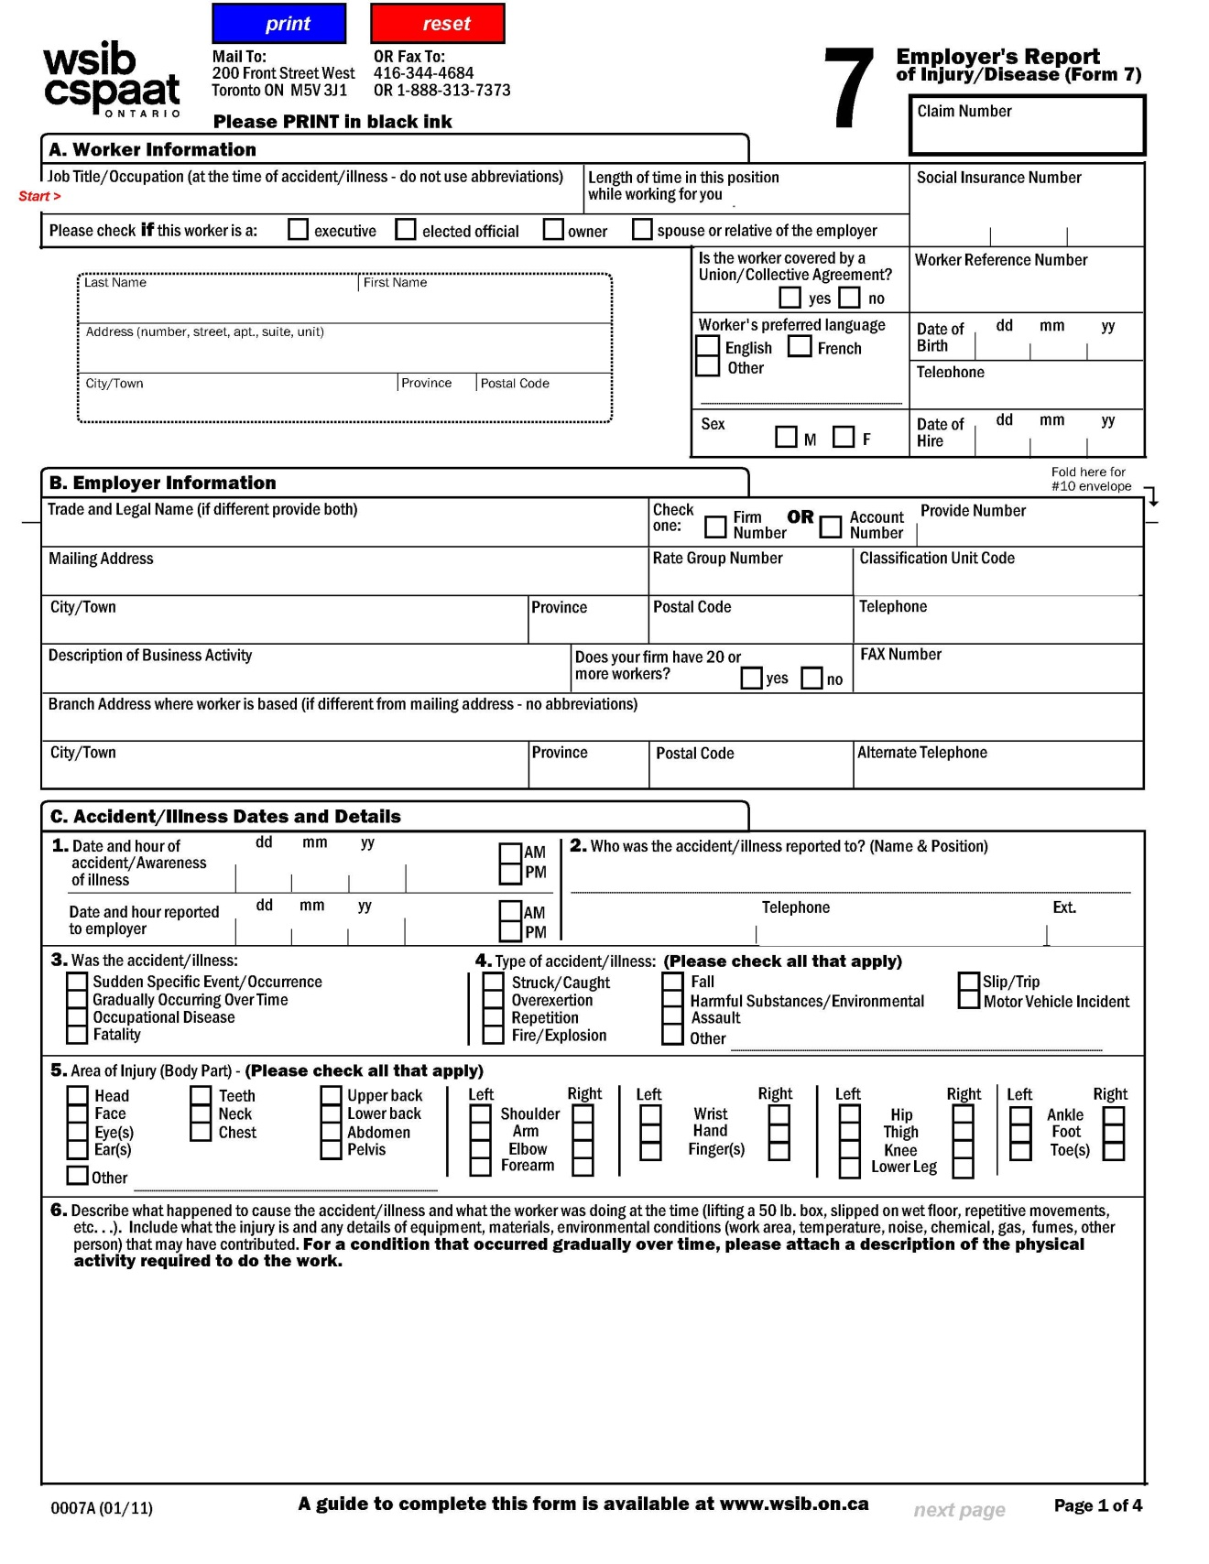

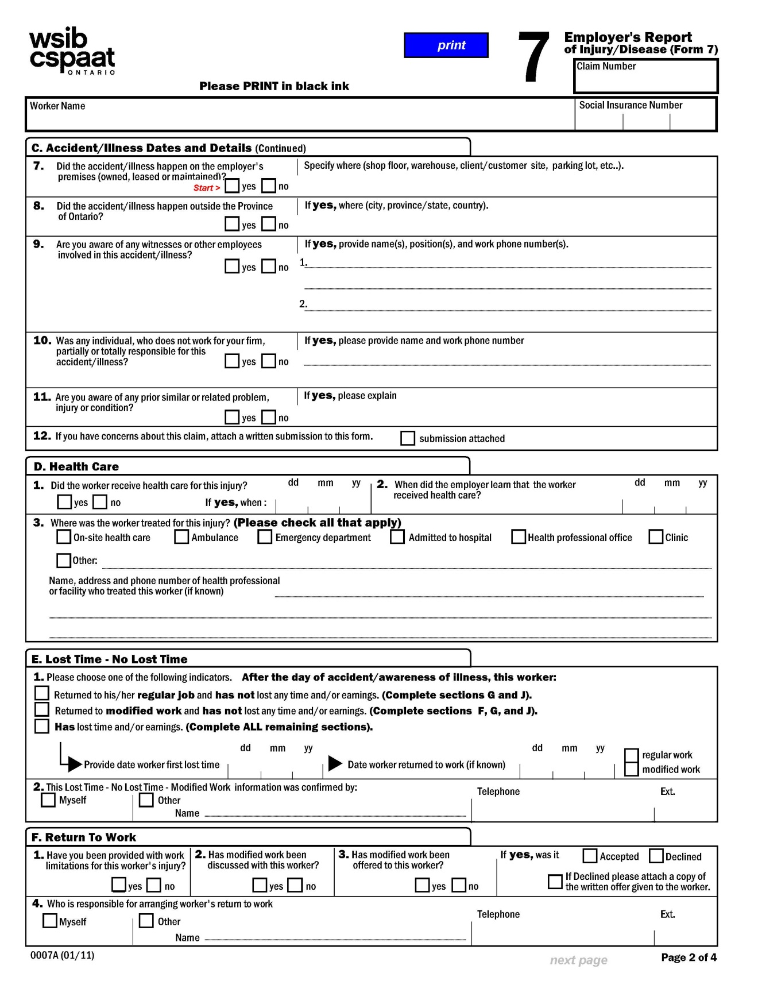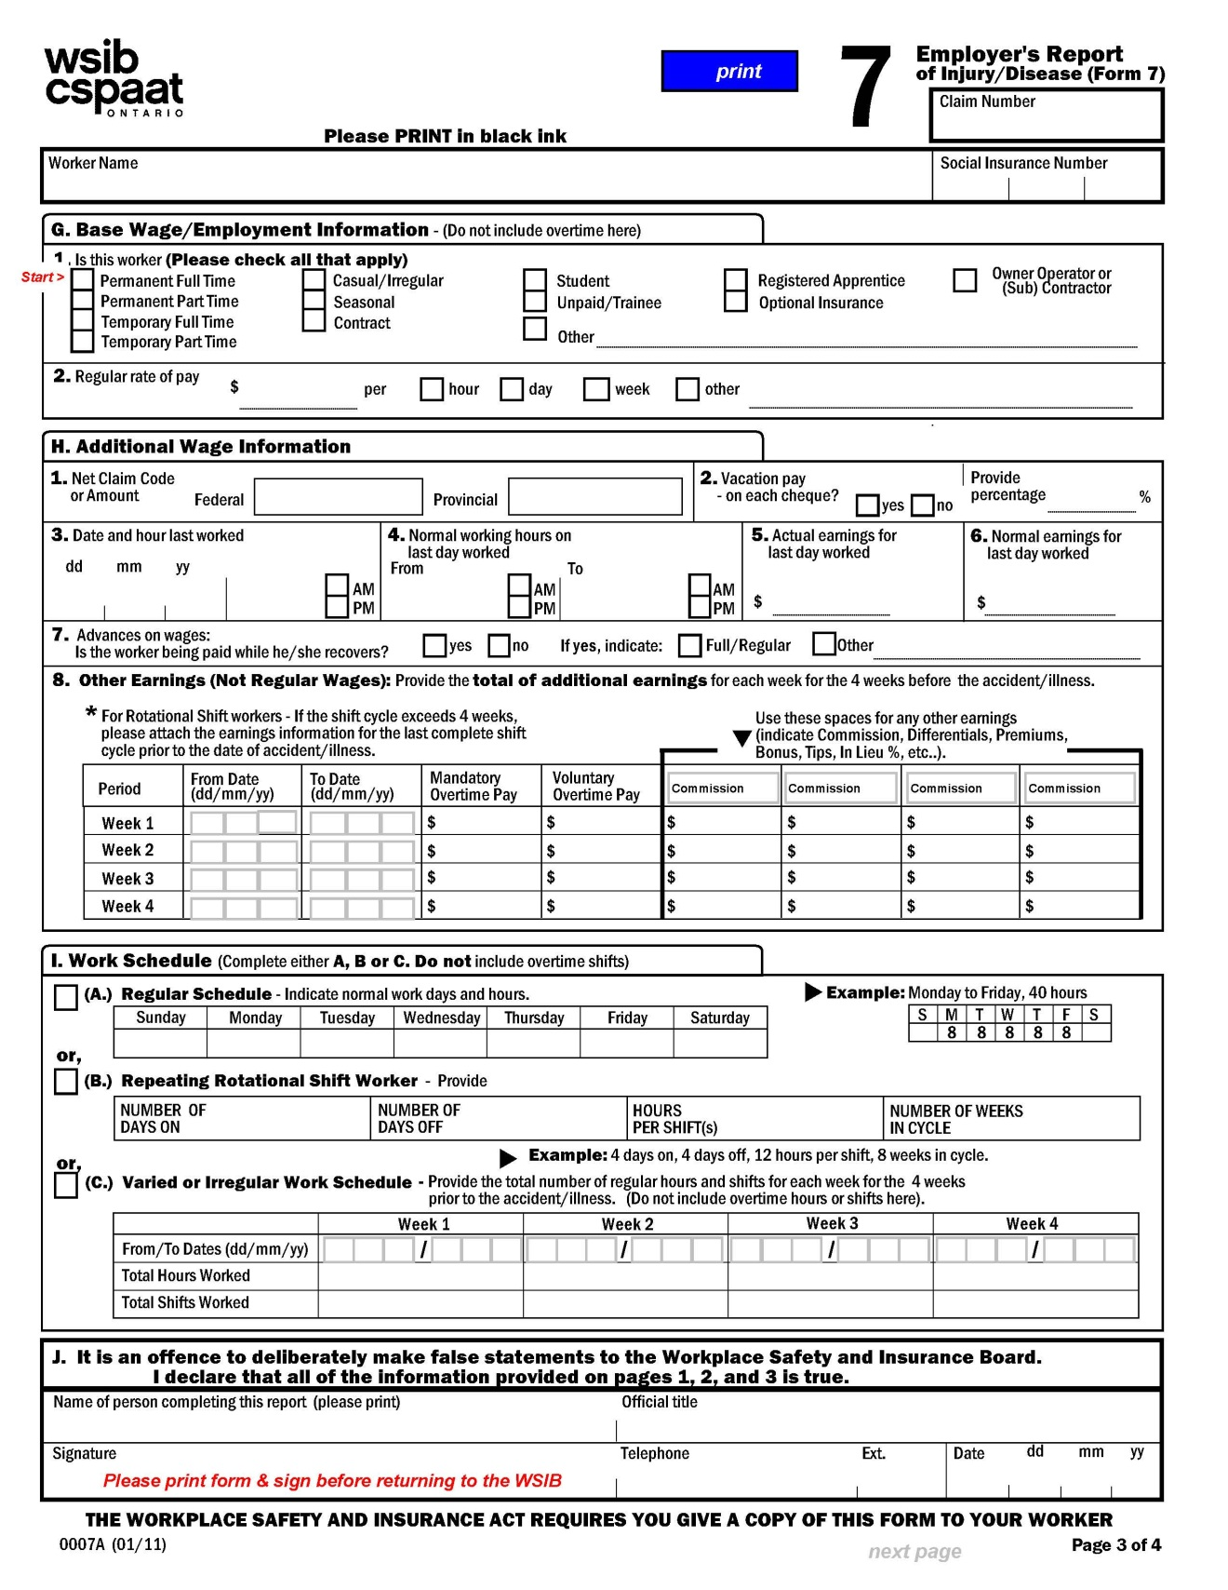
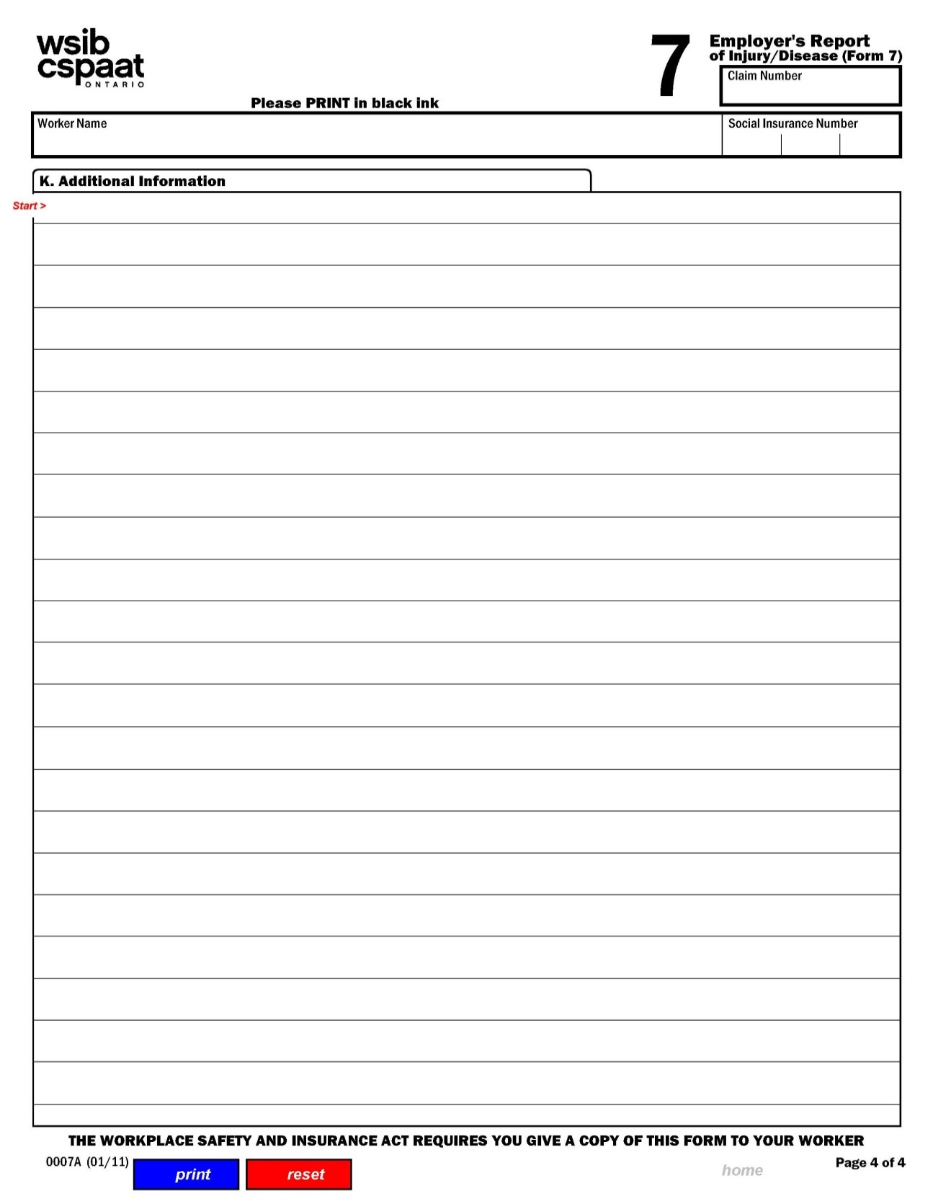
eForm 7 - Employer’s Report of Injury/Disease, Electronic Submission
Follow the instructions to register with WSIB:
www.wsib.on.ca, click on eWSIB heading for more information.
Form 7 Reference Guide for Employers

Health Practitioner’s Form (Form 8)

Functional Abilities Form (FAF)
Functional Abilities Form for Early and Safe Return to Work (PDF)

