Prince Edward Island

© 2018, Workplace Safety & Prevention Services (WSPS). All rights reserved.
All text, logos, illustrations, graphics, images, designs, the arrangement of information and other content in this publication are protected by copyright and other intellectual property rights. No part of this publication may be reproduced, distributed, displayed, broadcasted, stored in a retrieval system, transmitted in any form or by any means, electronic, mechanical, photocopied, recorded or otherwise, or otherwise exploited in any manner, without the prior written permission of Workplace Safety & Prevention Services (WSPS).
The information contained in this reference material is distributed as a guide only. It is generally current to the best of WSPS’s knowledge as at the revision date, having been compiled from sources believed to be reliable and to represent the best current opinion on the subject. No warranty, guarantee, or representation is made by WSPS as to the absolute correctness or sufficiency of any representation contained in this reference material. WSPS assumes no responsibility in connection therewith; nor can it be assumed that all acceptable safety measures are contained in this reference material, or that other or additional measures may not be required in particular or exceptional conditions or circumstances. Under no circumstances shall WSPS, its affiliates, or any of its respective partners, officers, directors, employees, agents or representatives be liable for any damages, whether direct, indirect, special or consequential damages for lost revenues, lost profits, or otherwise, arising from or in connection with this document.
Workplace Safety & Prevention Services (WSPS) and the above logos and marks are a Trademark of Workplace Safety & Prevention Services (WSPS). © WSPS, 2016. All Rights Reserved.
While WSPS does not undertake to provide a revision service or guarantee accuracy, WSPS shall be pleased to respond to your individual requests for information, at any time.

Provincial Appendix - Prince Edward Island
Overview | The Provincial Occupational Health & Safety Act(s) and associated regulations set a minimum standard for worker health and safety. This appendix outlines the specific requirements based on legislation and regulations for Prince Edward Island.  DQ or OJ Franchisee is committed to the health and safety of our employees, volunteers, visitors, suppliers and customers, customers, workplace and environment. It is important to understand that this appendix supports the Essential Elements Final.docx. Additional safety programs focused on hazard and risk specific programs, safe work practices and best practices will ensure we have a comprehensive program specific to our company.  We are committed to review our programs annually and make every effort to have the most up to date information for our workers.

Keys | Communicate Post / Display Review / Update  Link to other information Information / Training

Document Control | Effective Date: January 2019 Approved By:

Table of Contents
Workplace Violence and Harassment Prevention 3
Posted Health & Safety Materials Requirements 4
Joint Occupational Safety & Health Committee / Health & Safety Representative 5
First Aid Requirements 7
Injury/Incident Reporting and Investigation Requirements 8
Return to Work 11
Working Alone Requirements 14
Resources 15

Workplace Violence and Harassment Prevention
Overview | DQ or OJ Franchisee will be proactive in its prevention of workplace violence or harassment of any kind. We are committed to providing a work environment in which all workers are treated with respect and dignity.

Legislation | Occupational Health and Safety Act General Regulations Part 52 – Violence in the Workplace

Definition | Violence is defined as the threatened, attempted or actual exercise of any physical force by a person—other than a worker—that can cause, or that causes, injury to a worker, and includes any threatening statement or behaviour that gives a worker reasonable cause to believe that he or she is at risk of injury.

Procedure | If a risk of injury to a worker from violence in a workplace is identified by an assessment, the employer shall establish procedures, policies and work environment arrangements to either:  - Eliminate the risk of violence to workers in that workplace  - If elimination of the risk is not possible, minimize the risk of violence to workers in that workplace  - To provide for reporting, investigating and documenting incidents of violence in that workplace  See Workplace Violence and Harassment Prevention in the Essential Elements Final.docx for further information.

Employer Responsibilities | A risk assessment of the workplace shall be conducted to determine whether or not a risk of injury to workers from violence arising out of their employment may be present.  A risk assessment shall include a consideration of:  - Previous experience of violence in that workplace  - Occupational experience of violence in similar workplaces  - The location and circumstances in which the work will take place.

Resources | Workplace Violence and Harassment Prevention – Essential Elements Final.docx

Posted Health & Safety Materials Requirements
Overview | The following information and materials must be made available to all employees and will be posted in a common area on the Health & Safety Bulletin Board.

Materials to Post on Health & Safety Bulletin Board | 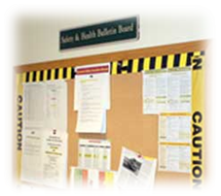  - Occupational Health and Safety Act and Regulations  - Code of Practice required pursuant to the Act and Regulations  - Health and Safety Policy Statement  - Workplace Violence and Harassment Policy Statement  - WHMIS Regulation  - Post current inventory of hazardous products used on site (review annually)  - Safety Data Sheets  - Occupational health and safety information prepared by the Workers’ Compensation Board of PEI  - Emergency Evacuation Plan and Emergency Numbers - Emergency Numbers must be posted and include the phone number for reporting health and safety concerns to the WCB.  - Joint Occupational Safety and Health Committee - names and work locations of members or name and work location of Health and Safety Representative, most recent meeting minutes  - Post warning signs in high hazard areas e.g. noise (if levels are above 85dBA a sign must be posted indicating the hazard and that hearing protection is required)  - Post signs indicating where first aid kits are available and the names & work locations of certified first aid providers  - In Case of Injury at Work Poster  - Notice outlining the written policy and procedure for reporting injuries  - Applicable Reports including:  - Health and/or safety assessments/surveys  - Orders, Compliance Notices, Notice of Appeals and/or decisions issued by the WCB (a copy must be posted and a copy provided to the Committee or HS Representative)  - WCB information as required  - Workplace incident summaries  - Other information applicable to the workplace – other WCB inspections, reports, articles on relevant workplace issues, information on rights and responsibilities, etc.

Roles & Responsibilities | Health & Safety Coordinator or designate will be responsible for the following:  - Ensuring the most current information is available at each location.  - Update the Checklist for Posted Health and Safety Materials as necessary.  Managers will be responsible for the following:  - Ensuring the most current information is available to all employees.  - Posting any materials as outlined on the Checklist for Posted Health and Safety Material.  - Complete check list provided signing off and forwarding to Health & Safety Coordinator or designate.  The content of the information will be reviewed and maintained to ensure that it is current.

Resources | Posted Health & Safety Material Checklist  In Case of Injury at Work (Poster)
Joint Occupational Safety & Health Committee (JOSHC) / Health & Safety (HS) Representative
Overview | To ensure designated JOSHC Members receive consistent recognized training in occupational health and safety and to support the effectiveness of the Internal Responsibility System.

Legislation | At a workplace where 20 or more persons are regularly employed by an employer, the employer shall establish and maintain a JOSHC.  Where the number of workers employed at a workplace is 5 or more but no committee is required under section 25, the employer shall require the workers to select at least one representative from among the workers who do not perform managerial functions.

Responsibilities | - Involve all persons in the workplace in health and safety concerns by responding to and discussing health and safety concerns brought up by coworkers.  - Hold monthly meetings and encourage each member to contribute their own expertise.  - Identify health and safety hazards in the workplace and make recommendations to correct them.  - Receive and investigate complaints about safety. Ensure these are referred to supervisors, reported to the committee and followed up.  - Educate fellow employees about risks and safe procedures.  - Orient new employees to health and safety risks and procedures.  - Participate in accident investigations and regularly scheduled inspections as outlined in the rules of procedure drawn up by the committee.  - Advise management on corrections for safety problems and monitor effectiveness.  - Obtain information when necessary and advise on appropriate protective devices, equipment and clothing.  - Advise on the establishment of appropriate health and safety programs, education and training.  - Maintain records of meetings and activities.  - Attend right to refuse situations  - Have a member accompany the WCB Occupational Health and Safety officer on inspections.

Training Requirements | Safety Committee Basics (1/2 day course)  Training is recommended for Joint Occupational Safety and Health Committee members. The most common topics for training are OH&S legislation, workplace inspection, accident investigation and injury prevention.  Training is conducted by the Workers Compensation Board of Prince Edward Island (WCB). WCB Education Consultant provides information on occupational health and safety requirements at no charge, and its safety education programs cover topics such as:  - Occupational Health and Safety Programs  - Safety for Managers and Supervisor  - Workplace Inspections  - As well as many other safety matters, including sessions that may be tailored to meet your industry's needs and delivered to you at your workplace.  For more information contact the OH&S Division of the WCB at (902) 368-5698, Toll-Free 1-800-237-5049, or visit; http://www.wcb.pe.ca/Workplace/WorkshopsAndSeminars

Meeting Minutes | Post Meeting Minutes on your Health & Safety Bulletin Board.

Resources | Guide to Workplace Health and Safety Committees  Safety Committee Poster  Worker Right to Refuse Flowchart  Health & Safety Committee – Essential Elements Final.docx

First Aid Requirements
Overview | 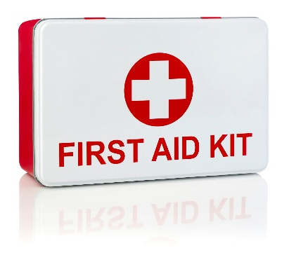  First Aid is an essential part of any health and safety system. Although we strive to eliminate workplace injuries and illnesses, it recognizes that the potential exists for these to occur.  We will protect the health, safety and well-being of its employees, volunteers, guest and visitors. Anyone injured or ill in the workplace shall be provided with the utmost care. Prompt and proper first aid will be administered by a certified First Aid Attendant.

Legislation | Occupational Health and Safety Act General Regulations Part 9 – First Aid

Training | At a minimum, we will ensure that at least one Certified First Aid Attendant will be available during every shift. A list of Certified First Aid Attendants, along with a copy of their current certification, will be posted on the Health & Safety Bulletin Board or near the first aid kits.  Standard First Aid with Level A CPR is a 2 day course and is valid for 3 years.  See First Aid Program in the Essential Elements Final.docx for further information.

First Aid Log | All first aid treatment given to a worker must be entered in the First Aid Log. Each case that is referred for further medical treatment must also be entered. The confidentiality of personal medical information must be maintained. First Aid Logs must be kept for at least 5 years.

First Aid Attendants | First Aid Attendants must record all reported signs and symptoms of injuries and exposures to contaminants found at your location using the Hazard Response Form. If an injury is more severe or beyond the training of the First Aider, the First Aider is responsible for referring the worker to seek additional medical attention.

Reporting Requirements | For any injury or illness requiring first aid, a First Aid Report must be filled out along with an Injury and Incident Analysis Checklist.  The first aid attendant is required to record in the Injury Incident Analysis Report, all treatment given to an employee. Should the injury/illness be serious enough that medical attention is required, an Incident Injury Investigation Report will be completed and provided to the location manager and HS Coordinator. The Injury/Incident Investigation Report will record the circumstances surrounding the incident as described by the injured employee. Specifically, the report must include:  - The name of the worker  - The name and qualifications of the person giving first aid  - A description of the illness or injury  - The first aid given to the worker  - The date and time of the illness or injury was reported  - Where at the work site the incident occurred  - The work-related cause of the incident

First Aid Area | DQ or OJ Franchisee will ensure that first aid services, first aid equipment, supplies and the first aid room required by the First Aid regulation are:  - Located near or at the work area they are intended to serve  - Available and accessible during all working hours  - Maintained in a clean, dry and serviceable condition  - Contained in a material that protects the contents from the environment, and  - Clearly identified as first aid equipment and supplies  - Post at conspicuous places at the work site, signs indicating the location of first aid services, equipment and supplies, and  - Emergency communication system is in place for workers to summon first aid services  Please see the first aid kit inventory list for minimum content requirements.

Resources | In Case of Injury at Work (Poster)  Injury/Incident Reporting and Investigation Requirements  First Aid - Essential Elements Final.docx

Injury/Incident Reporting and Investigation Requirements
Overview | There are legal requirements in all provinces under the Provincial Health & Safety Act(s) and Workers Compensation Boards for employers to record and report:  - Where a person is killed or critically injured at a workplace.  - Where a person is disabled from performing his or her work or requires medical attention because of an accident, explosion, fire or incident of workplace violence.  - If an employer is told that a worker has an occupational illness or that a claim for an occupational illness has been filed with the WCB.

Legislation | Workers Compensation Act

Definitions | An "accident" means a chance event occasioned by a physical or natural cause; and includes a wilful and intentional act that is not the act of the worker, any event arising out of, and in the course of, employment, or thing that is done and the doing of which arises out of, and in the course of, employment, and an occupational disease, and as a result of which a worker is injured.  An “occupational disease” means a disease arising out of and in the course of employment and resulting from causes and conditions peculiar to or characteristic of a particular trade or occupation, or peculiar to the particular employment, but does not include an ordinary disease of life.

Reporting | All serious workplace injuries must be reported immediately to the WCB’s Occupational Health and Safety Division, at 902-628-7513.  Where an accident occurs in the workplace in which a worker is seriously injured in a manner which causes or may cause a fatality or suffers:  - a loss of limb  - unconsciousness  - substantial loss of blood  - a fracture  - an amputation of a leg, arm, hand, or foot  - a burn to a major portion of the body  - or the loss of sight in an eye  We shall ensure that written notice is sent, by the fastest means available, to the WCB (Director) within 24 hours of the accident.  We shall, whether or not a person has been injured, provide the WCB (Director) with a written report of all accidental explosions.  We must notify the committee, where one exists and/or the representative, if any.  Except as otherwise directed by an officer, no person shall disturb the scene of an accident that results in a serious injury or a fatality except to the extent that it is necessary.  - to attend to persons injured or killed  - to prevent further injuries  - to protect property that is endangered as a result of the accident  Filing a Report  - Employees should see a doctor if medical care is required and tell the doctor that they were hurt at work.  - Employees must notify their manager about the injury.  - Use a Worker’s Report Form 6 to report the injury to the WCB. This report must be filled out whether time has been missed from work or not. The employee must submit the original report directly to the WCB.  - DQ or OJ Franchisee must report injuries to WCB within 3 days of being notified.  - Use the Employer’s Report Form 7 to report the injury. This report must be filled out whether the employee misses time from work or not.  - An Employer's Report Form 7 must be completed whether or not the injury or illness results in time off work. This includes injuries or illnesses that occurred over a period of time, as well as those caused by a single event. An Employer's Report Form 7, is also required for all accidents resulting in death.  - Form 6 and 7 are available on the WCB website at www.wcb.pe.ca  - File Form 7 by Fax, Mail or Online  Fax 902-368-5696  Submit Online http://wcb.pe.ca/Employers/OnlineServicesSignIn  Mailing Address Workers’ Compensation Board of PEI PO Box 757 14 Weymouth Street Charlottetown, PEI C1A 7L7

Investigation | The purpose of an accident investigation is to identify the real cause of an accident and take steps to prevent another one. Persons assigned to do this should receive training.  An investigation may be carried out by the authorized officers of the OHS Division of the WCB for all workplace fatalities or serious injuries that may cause a fatality or any other incident deemed necessary by the WCB. A Board of Inquiry may also be formed through the WCB.  The purpose of conducting an accident investigation is:  - to determine the causes and contributing factors of the accident  - to identify violations of the Occupational Health and Safety Act and Regulations  - to determine corrective actions and preventative measures  The employer shall retain all reports for 5 years after the serious injury or incident.

Administrative Penalties | An employer may be penalized where the employer fails to give any notice, make any report or furnish particulars of any accident or claim required by s. 59 of the Workers Compensation Act.

Resources | Injury and Incident Analysis Checklist  Worker’s Report (Form 6)  Employer’s Report (Form 7)  Injury/Incident Reporting and Investigation – Essential Elements Final.docx

Return to Work
Overview | Return to Work is sometimes referred to as disability management program, modified work program, alternate duties program or claims management program.

Legislation | Workers Compensation Act

Responsibilities | Employer  - Ensure employees are aware of reporting requirements.  - Promptly filing an Employer's Report Form 7 within 3 days of being notified by the employee of a workplace injury. The Form 7 is required whether time has been missed from work or not.  - Identify suitable work for injured workers to earn the same wages prior to the injury.  - Establish an effective and proactive return to work program.  - Contact the worker as soon as possible after the injury.  - Maintain effective communication throughout the worker’s recovery (WCB recommendation for communication is once/week).  - Accommodate a worker’s restrictions by providing suitable work.  - Continue to pay the employee’s wages at the pre-injury/illness pay rate for any hours worked.  - Provide the WCB with any information requested concerning the employee’s return to work.  - Use Physician Report Form 8 to document a written return to work plan.  - Advise the WCB of any changes in the return to work plan within one week of the change.  - Advise the WCB of any disputes between the employer and the employee.  - Accurately report time loss associated with individual claims to the WCB.  Employee  - Promptly seek medical treatment and have health care providers document any restrictions that require accommodation.  - Take all reasonable action to prevent the loss of earnings resulting from an injury/illness.  - Complete the Worker’s Report Form 6  - Fill out the form carefully and mail it to the WCB Office. The Form 6 is required whether time has been missed from work or not.  - Advise the employer of injury as soon as possible and any restrictions.  - Return to work as soon as suitable work is arranged.  - Cooperate with the employer and the WCB in timely and safe return to work.  - Keep the employer and WCB informed about progress and status of recovery.  - Assist the employer in identifying suitable work (e.g. safe, restores earnings as closely as possible, within functional abilities, using existing skills).  - Provide WCB with any information requested.  - Report significant changes immediately to the WCB and the employer.  - Maintain ongoing communication with WCB and the employer to help plan for return to work.  - Maintain a positive attitude about returning to work when appropriate. Understand the benefits of accepting appropriate work during the rehabilitation process so that the focus can be shifted from disability to regained abilities.  Health Care Provider  - Diagnose and treat the illness or injury.  - Submit completed medical reports to the WCB as soon as possible after treating the employee.  - Provide the employee with continued medical advice and support.  - Provide and communicate appropriate medical advice and information regarding the worker’s functional abilities to the worker, employer and the WCB.  - The employee may not have to lose time from work if the employer can identify modified or alternative job duties that are consistent with the worker’s functional abilities. If requested, review the RTW form and provide a medical opinion regarding the worker’s functional abilities.  - Work with other healthcare professionals to facilitate the worker’s timely and safe return to the most productive employment possible.  - Assist the employee in a timely and safe return to the most productive employment possible with the realization that this benefits the worker by enhancing recovery and reducing disability.  Workers’ Compensation Board  - Inform the employer as to what to expect through the Return to Work process.  - Providing guidance and support to employers who require assistance in establishing their timely and safe return-to work or re-employment programs.  - Advising the employer where to access useful information on setting up effective return to work programs.  - Assisting to determine suitable work.  - Providing coordination of services to employees.  - Monitoring progress of return to work activities.  - Addressing compliance issues.  - Determining if the employer and employee are fulfilling their obligations.  - Resolving disputes.

Return to Work Options | - Modified Duties – can include duties as close to the employee’s regular duties within their capabilities. Duties, work and treatment schedule should jointly be agreed upon with the employee, employer and health care provider.  - Ease Back – opportunities that allow employees to return to their regular occupation gradually, while building up strength and tolerance in the process  - Alternate Duties/Tasks – if the employee is unable to perform regular duties, the employee may be able to perform other duties, within the employee’s skills or abilities that are different from pre-injury duties.

Re-Employment Obligation | This obligation does not apply to an employer that in the opinion of the WCB, regularly employs fewer than 20 workers; or the construction industry.  “Duty to Accommodate” is a legal obligation for employers to make every reasonable effort to accommodate an injured worker. We are required to accommodate a worker who is unable to work in their pre-injury job as a result of a workplace injury if:  - 20 or more workers are regularly employed  - the worker was employed with the injury employer for a continuous period of 12 months immediately prior to the date of injury  We are obligated to accommodate a worker until the earliest of two years after the date of injury, or until the worker reaches age 65.

Return to Work Plan | A return to work plan is a documented plan/strategy to accommodate a worker with temporary work restrictions. The workplace parties must develop the plan and submit it to the WCB.  The plan must indicate the following:  - How the job is comparable in nature to the pre-injury job.  - How the job is comparable in earnings to the pre-injury job.  - How the job will accommodate the worker’s functional restrictions.  - The salary of the suitable job.  - The date the worker commences the suitable job.  We shall provide the WCB with written notification of any changes in the return-to-work plan.

Resources | Worker’s Report (Form 6)  Employer’s Report (Form 7)

Working Alone
Overview | When an employee works alone or in isolation, DQ or OJ Franchisee must identify the risks arising from the conditions and circumstances of the employee’s work in consultation with the employees when there is no Workplace Safety and Health Representative.

Legislation | Occupational Health and Safety Act General Regulations – Part 53 Working Alone

Definition | “Working alone” means a worker working at a workplace who is the only worker of the employer at that workplace, in circumstances where assistance is not readily available to the worker in the event of injury, ill health or emergency.

Employer Responsibilities | - Must develop and implement written procedures to ensure the health and safety of a worker working alone.  - Procedures must identify the risks, include steps for minimizing those risks and detail how the worker can get emergency assistance if needed.  - Implement a training program for each worker who is working alone and for each supervisor is responsible for a worker working alone.  - A copy of the procedures are made available to an officer upon request

Resources | Guide to Working Alone Regulations – Safety Matters WCB of PEI  Working Alone – General Information (ccohs.ca)  Working Alone – Essential Elements Final.docx

Resources
Overview | Some of the samples and templates referred to in this document follow this section. Other forms can be found in the Resource section of the Occupational Health & Safety Program – Canada (Resources Final.docx).  Posting Health & Safety Materials  Posted H&S Material Checklist 17  In Case of Injury at Work (Poster) 19
Joint Occupational Health & Safety Committee/Health & Safety Representative
Worker Right to Refuse Flowchart 20
Injury & Incident Forms
First Aid Kit Requirements 21
Injury/Incident Analysis Checklist 23
Worker’s Report 27
Employer’s Report 29

Posted Health & Safety Material Checklist
Material | Location | Links | Date Posted
Occupational Health and Safety Act | Health & Safety Bulletin Board | http://www.gov.pe.ca/law/statutes/pdf/o-01_01.pdf
General Regulations under the Occupational Health and Safety Act | Health & Safety Bulletin Board | http://www.gov.pe.ca/law/regulations/pdf/O&1-01G.pdf
Workers Compensation Act | Health & Safety Bulletin Board | http://www.gov.pe.ca/law/statutes/pdf/w-07_1.pdf
Health and Safety Policy Statement | Health & Safety Bulletin Board
Workplace Violence and Harassment Prevention Policy Statement | Health & Safety Bulletin Board
In Case of Injury At Work Poster | Health & Safety Bulletin Board  First Aid Kit | http://www.wcb.pe.ca/DocumentManagement/Document/pub_posterincaseofinjuryatwork.pdf
First Aid Requirements (Part 9 of OHS Act)  Include a list of all certified First Aiders in the workplace along with a copy of their certificate | Health & Safety Bulletin Board  First Aid Kit
WHMIS Regulation  Post inventory of hazardous products on site | Health & Safety Bulletin Board | http://www.gov.pe.ca/law/regulations/pdf/O&01-01-3.pdf
Safety Data Sheets (SDS)  To be stored in an easily accessible area near where the chemicals are being used, must be most current version available from supplier | SDS Binder
Emergency Services and Numbers  Examples: 911 (if available), fire, police, ambulance, poison control centre, Dept. of Employment & Labour, Dept. of Environment, Utilities, Internal contact numbers, Numbers specific to workplace, i.e. Chemical Spill Clean-up Contractor | Primary Telephones  Health & Safety Bulletin Board
Evacuation Plan | Health & Safety Bulletin Board
Joint Occupational Safety and Health Committee (JOSHC) or Representative  Post names and work locations of committee members | Health & Safety Bulletin Board
Health & Safety Explanatory Materials  Examples: Bulletins, Guidelines, Hazard Alerts | Health & Safety Bulletin Board (optional) | http://www.wcb.pe.ca/Employers/Publications
Other Reports relevant to workplace  Examples:  - Management and Committee health and safety inspections  - Committee Meeting Minutes  - Health and safety assessments and surveys  - Orders  - Workplace Incident summaries | Health & Safety Bulletin Board

Occupational Health & Safety Department and Workers’ Compensation Board
Safe Workplaces
14 Weymouth Street
PO Box 757
Charlottetown PE C1A 7L7
Telephone: (902) 368-5680 or
Toll-Free: 1-800-237-5049 (in Atlantic Canada)
Fax: (902) 368-5705
http://www.wcb.pe.ca

http://www.wcb.pe.ca/DocumentManagement/Document/pub_posterincaseofinjuryatwork.pdf
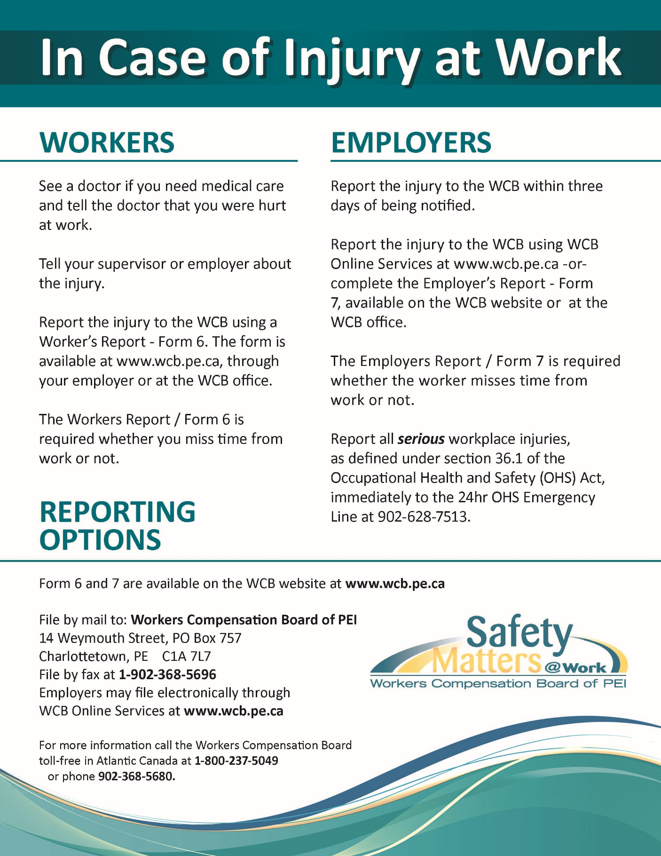

Worker Right to Refuse Flowchart

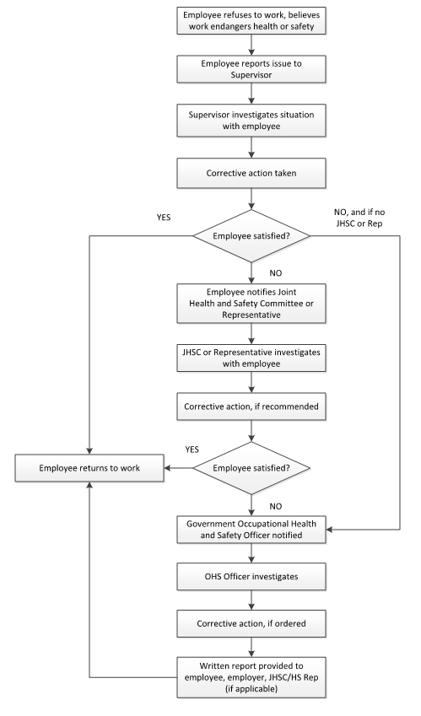
First Aid Kit Requirements

Supply | Qty
First aid manual | 1
First aid record book | 1
Safety pins (pack) | 1
Splinter tweezers | 1
Pair of scissors | 1
Approximately 50 band-aids (assorted sizes) | 50
Cotton tipped applicators (pack) | 1
Triangular bandages | 10
Adhesive tape (rolls) | 2
Eye pads | 2
Abdominal pads | 6
Sterile individually wrapped gauze [sic] pads | 36
Alcohol swabs (pack) | 1
Peroxide (bottle) | 1
Backboard | 1
Rescue blanket | 1
Splints (assorted sizes)

Injury/Incident Analysis Checklist
This checklist can be used in conjunction with the Injury/Incident Investigation Report
Background Information
Job Title of Employee
Department of Employee
Age Range of Employee
Male or Female |  |  |  | M F
Employee's Supervisor
Location (where the event took place)
Day of Event (Monday, Tuesday, etc.)
Date of event (dd/mm/yr)
Time of Event (include AM or PM)
Date of Investigation (dd/mm/yr)
Date of Return to Work – Full Duty (dd/mm/yr)
Date of Return to Work – Modified Duty (dd/mm/yr)
Incident Type
Near Miss |  |  | Yes No | Occupational Injury |  |  | Yes No
Hazard |  |  | Yes No | Violence/Harassment |  |  | Yes No
Occupational Health Hazard |  |  | Yes No | Occupational Illness |  |  | Yes No
Environmental Release |  |  | Yes No | Damage |  |  | Yes No
Other |  |  |  | Describe:
Injury Details
Critical injury |  |  | Yes No | Fatal Injury |  |  | Yes No
Non-Critical Injury |  |  | Yes No | Exposure to health hazards |  |  | Yes No
No injury or exposure |  |  | Yes No
Full Time Employee | Yes No | Part Time Employee |  |  | Yes No | Student/Seasonal |  | Yes No
Contractor | Yes No | Temporary Staff |  |  | Yes No | Volunteer |  | Yes No
Other |  |  |  | Describe:
Treatment Received
None
First Aid Required
Health Care Required
Time Loss Injury
Number of days lost
Has the Employee had a previous similar injury/disease? |  |  |  | Yes No
Returned to full duty? |  |  |  | Yes No
Returned to modified work? |  |  |  | Yes No
Form 7 Required? |  |  |  | Yes No
Damages
Property Damage |  |  | Yes No | Machinery/Equipment Damage |  |  | Yes No
Tool Damage |  |  | Yes No | Product Damage |  |  | Yes No
Materials Damage |  |  | Yes No | No Damage |  |  | Yes No
Root Causes
Performance Specifications:  - Are safe work policies/procedures in place? Are they adequate?  - Are instructions from Management creating an unsafe work environment? |  |  |  | Adequate Inadequate  Describe:

Task Interference:  - Enough time allotted to complete the task safely  - Equipment in proper working condition and available?  - Policies/procedures that are currently in place contributed to this hazardous event?  - Staffing issues?  - Inappropriate body position for the task |  |  | Adequate Inadequate  Describe:
Consequences:  - Discipline practiced for unsafe acts?  - Positive consequences for unsafe acts (e.g. rushing to get the job done quickly)  - Injury/illness occurring from tasks |  |  | Adequate Inadequate  Describe:
Feedback:  - Lack of communication (positive or negative) between Employees, team leaders and supervisors  - Improper motivation (feedback/ rewards/recognition reinforcing unsafe acts)  - Employees not reporting similar injuries/illnesses  - Employees not advising Supervisors of potential hazards |  |  | Adequate Inadequate  Describe:
Knowledge/Skill:  - Demonstrated lack of skill/knowledge?  - Failure to use prescribed personal protective equipment?  - Are Supervisors aware this hazardous event could occur (Supervisor and Employees trained on this hazard)?  - Failure to follow established procedures?  - Inadequate training? |  |  | Adequate Inadequate  Describe:
Individual Capacity:  - Stress  - Workload  - Rushing to complete tasks  - Staffing/Scheduling issues  - Unsuitable loading/lifting |  |  | Adequate Inadequate  Describe:
People/Behavioural Factors:  - Improper motivation  - Leadership or supervision issues  - Unauthorized use of equipment  - Failure to control, monitor or secure hazard  - Disabling safety devices or bypassing barrier/guards  - Operating at improper speed  - Abuse or misuse  - Horseplay  - Other |  |  | Yes No  Yes No  Yes No  Yes No  Yes No  Yes No  Yes No  Yes No  Describe:
Equipment Factors:  - Inadequate ventilation  - Defective tools, equipment or material  - Lack of adequate safety devices, barriers, or guards  - Inadequate warning systems  - Inadequate tools/equipment  - Inappropriate PPE  - Wear and tear of equipment  - Hazardous energy not controlled  - Other |  |  | Yes No  Yes No  Yes No  Yes No  Yes No  Yes No  Yes No  Yes No  Describe:
Materials Factors:  - Property damage caused by spilled materials  - Handling of raw materials  - Handling of products  - Handling/use of hazardous chemicals  - Handling of biological agents  - Supplier issues when sending product  - Manual material handling issues – lifting, carrying, pushing, pulling  - Mechanical material handling issues – handcarts, forklifts  - Other |  |  | Yes No  Yes No  Yes No  Yes No  Yes No  Yes No  Yes No  Yes No  Describe:
Environment Factors:  - Hazardous environment – air quality, leak or spill  - Presence of combustibles, fire or explosion hazard  - Temperature extreme  - Radiation hazard (non-ionizing)  - Noise hazard  - Poor lighting  - Congested area, blocked exits/stairways, disorder  - Condition of floors (e.g. slippery)  - Poor ventilation  - Hazards in product storage area  - Other |  |  | Yes No  Yes No  Yes No  Yes No  Yes No  Yes No  Yes No  Yes No  Yes No  Yes No  Describe:
Process Factors:  - Poor layout or ergonomic design  - Engineering issues  - Purchasing issues  - Staff schedules/patterns  - Physical condition of work area not inspected  - Maintenance issues/records  - Other |  |  | Yes No  Yes No  Yes No  Yes No  Yes No  Yes No  Describe:
Incident Event Type (Type of Contact)
Struck by object | Yes No |  | Struck against object | Yes No
Caught in – nip points | Yes No |  | Caught on snagged | Yes No
Caught between - crushed | Yes No |  | Voluntary motion | Yes No
Lifting | Yes No |  | Falls | Yes No
Overexertion | Yes No |  | Electricity | Yes No
Temperature extremes | Yes No |  | Radiation | Yes No
Noise | Yes No |  | Chemical Substance | Yes No
Vibration | Yes No
Other |  |  | Yes No Describe:
Injury/Illness Assessment
Has an event like this happened before in this job?  Rare – once/year  Occasional – once/month  Common – once/week |  | Yes No
Do you think this could happen again?  Rare – once/year  Occasional – once/month  Common – once/week |  | Yes No

Injured Body Part
Finger/Hand/Wrist  Arm/Elbow  Chest | Shoulder  Neck  Head/Face | Upper/Lower Back  Hip/Thigh  Knee |  | Lower Leg  Ankle/Foot  Other, Describe:
Nature of Injury
Sprain/Strain  Crushing/Bruising | Cuts/Lacerations  Fractures |  | Scratches/Abrasions  Falls |  | Other, Describe:

Worker’s Report (Form 6)
http://www.wcb.pe.ca/DocumentManagement/Document/frm_workersreportform6.pdf
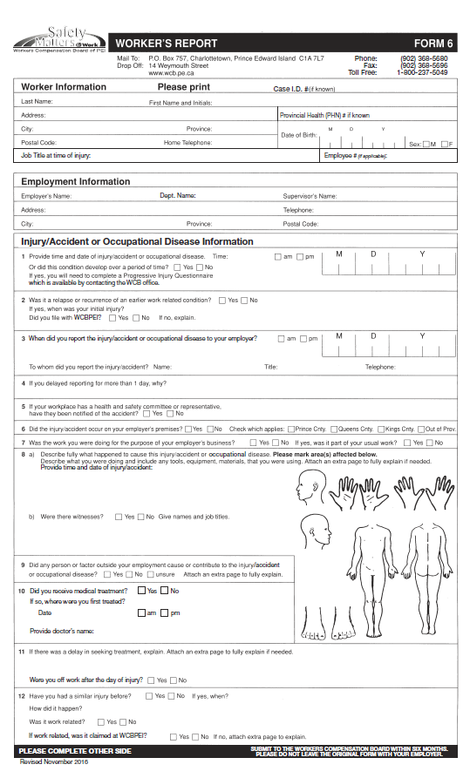

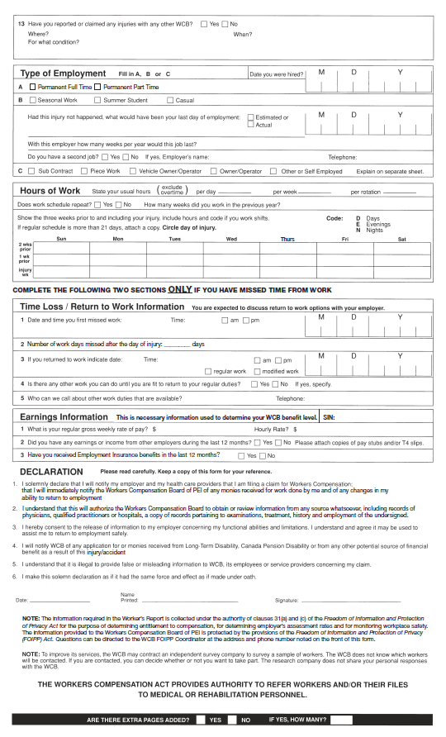

Employer’s Report (Form 7)
http://www.wcb.pe.ca/DocumentManagement/Document/frm_employersreportform7.pdf 