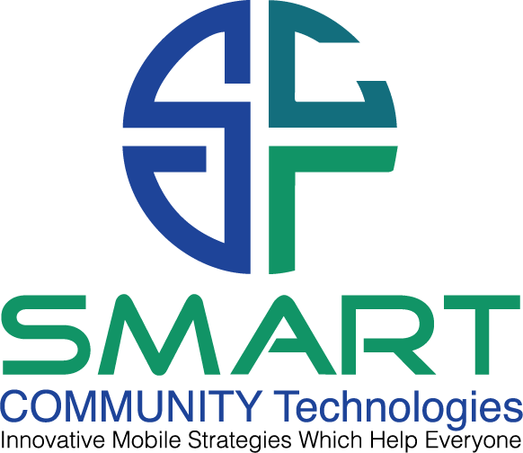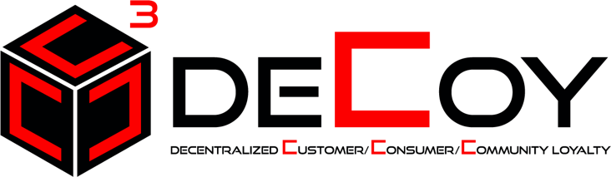

Nov 2021 Simple DeCoy Explanation

Section 1 - The problems

- Discounting: 1 trillion dollars is wasted by institutions in discounting to increase spending and loyalty. In the United States today, the word SALE means a lower price.
- 586 billion is spent on advertising to drive consumer behavior. The current advertising model for 2022 is that businesses must spend money in advertising FIRST and then hope that advertising works.
- Customer Loyalty is siloed. Each business in a community has their own ‘customer loyalty’ program that does not work in conjunction with other business owners in the community. AMEX Plenti was the last attempt in the U.S. to create a community loyalty solution. Since the foundation of customer loyalty is so flawed PLENTI ended up mirroring the problems rather than solving them. Community small business owners don’t work together to drive revenue, they compete with each other for business. They also compete with big box retailers which threaten their existence due to pricing advantages.
- Customer Loyalty is dominated by points, miles, stars, punches or other silly forms of rewards currencies which are confusing, have very little value, and are often locked into a location or chain. In other words, I can’t use my Starbucks Stars at Chick-Fil-a which uses points.
- Remote ordering options are very weak. Many businesses don’t understand the technologies which are available now to drive a customer service advantage for their business whether there is a pandemic or lockdown, or where everyone is moving freely.
- As of 2022 business owners were unaware of how to create memberships into their business specifically. We understand Sam’s Club, Costco, and now Wal-Mart Plus along with Amazon Prime are examples of the multi-billion-dollar subscription revenue space but smaller businesses don’t understand how to compete with their own membership using innovative and unique value to protect price points and drive added visitation.
- Brand Memberships are non-existent in 2022. In other words, if I visit a sports bar to order a beer, the sports bar owner does not care which brand I order, they make money from all the brands. But the brands care which one I order since it directly effects their bottom line.
- Fundraising: As of Winter of 2021, kids are still standing outside waving signs for a free car wash in order to raise money for their school. Churches are still begging for money; special needs groups deny benefits due to lack of funding and nobody in the community seems to understand how to mix customer loyalty into fundraising in order to make a difference in their community to better serve others.

Until now,

DeCoy: What is it and why do we want it?

DeCoy stands for Decentralized Customer Loyalty.

- All of customer loyalty today is centralized with poor customer service and poor value. Large databases on centralized servers have been hacked or used to sell advertising giving consumers pause as to who they trust.

- All data with DeCoy is decentralized and gives the opportunity for members to become a part of the blockchain community. Not just an investor, participant, or observer but a MEMBERSHIP designed to protect their interests, enhance their community, and support community needs.
- Decoy with the 3 C’s stands for more than just Customer Loyalty, it stands for Community Loyalty and Consumer Loyalty. Not everyone visits Chick-fil-a or Starbucks, but they are still a part of the Community based on geographical location. Everyone in the community is a consumer of something so by including everyone, we get everyone working together to create a better mouse trap than everyone not working together. It’s much easier for consumers to download 1 app than a dozen apps.

- In addition, COVID-19 opened up technologies which allows for Communities to form and communicate with each other all around the world. Community is no longer limited to a city, town, or geographical location. We have the technology for billions of people to be a part of a community no matter where they live. DeCoy gives these virtual communities their first ever loyalty solution to drive value and support in ways which have never been done previous.

How does it work?

- Download the Smart Community App from the app store or play store
- Join for free or pay $4.95 per month or $50.00 per year for added benefits.
- 50% of whatever fee the consumer chooses, automatically is forwarded by smart contract to the non-profit or special needs group of their choice. Our research showed that when a company gave 50% of a small fee in support of communities, consumers viewed the membership as more of an offering than a membership fee which needed to provide value for justification of joining and paying for that membership.
- For those who choose the subscription membership model, they receive FREE items with no strings attached.
- Items are redeemed direct from the phone which is triggered by geo location.
- Sample free items from early sponsors are the following. Free items are use it or lose it and controlled by Geo Location. For example, when I pull into the Papa John’s parking lot, a push message reminds me that I have a free large pizza to redeem. The customer walks into the Papa John’s and shows their phone to the employee. The consumer hits a REDEEM NOW button on their app and walks away with a free pizza. The next free pizza will not load until the next calendar month and everything is automated and tracked with blockchain technologies to protect their data and remind them when a new pizza is ready to pick up for the following month. Here is a list of benefits we have offered previous which we can expand nationwide.
  - $10.00 per month to spend at Wal-Mart
  - 1 Free Pizza per month from Papa John’s
  - 1 Free Miller Coors beer of choice every day from any participating location.
  - 1 Free Oil Change from any Ford Dealership.
  - 1 Free game of bowling every day from 4000 bowling centers across the U.S.
  - 1 free round of golf each month from American Golf or participating locations.
  - Each community can have customized free items and we secure free items by using free items to protect price points, drive added visitation, eliminate traditional advertising, and giving exclusivity to certain brands and locations.
  - The value far exceeds the $4.95 per month with 50% going to support community needs.

Institutions who would like to join the Decoy community can do so simply by offering a leader item that doesn’t need to be supplied unless the client is in the store to redeem it. I repeat there is no charge for the institutions to use Decoy. Partner with us and you can generate as much business as you want, simply by turning on the faucet when you want to drive business up and turning it down when you want to have less.

The value continues to grow. In our test case in Orlando, Florida with 31 Ford Dealers we found
- 1 million members ready to join upon launch in Southern Florida alone
- 1 million members generate 5 million dollars per month in gross revenue
- 2.5 million per month was allocated to Ford sponsored charities.
- Good will to the brand skyrocketed, we agreed to give Ford an exclusive in the auto space, but that can be changed if necessary, prior to DeCoy launching
- Just from Ford dealership databases and Ford marketing efforts which were arranged by Ford Direct who oversees all 4600 dealerships, we estimated a conservative 20 million members across the U.S. in year 1.

