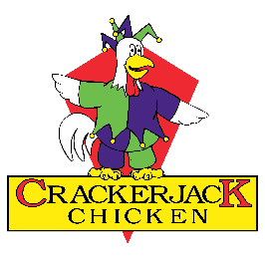
Name:
Date:

Thank you for your application and for showing interest in obtaining a position of employment with our company.
Please respond to the following questions at your earliest convenience & return via email.

We own the 3 stores in Toowoomba and Highfields – Mary Street Village, Wyalla Plaza & Highfields Village Shopping Centre. Our team works from 7.30am to 8.30pm 7 days a week, 364 days a year.
What is your availability?

Which stores would you be willing & able to work in?

What motivates you to work?

What is your 5 year plan?

What do you need from me, as your employer?

How many hours a week do you require?

Minimum hours?

Maximum hours?

Do you have a license? If so, what type of licence?

Do you have reliable transport?

What do you know about Crackerjack Chicken?

What is your favourite Crackerjack Chicken product?

Penny Dowling
Owner/Managing Director
0427 391 966
info@crackerjackchicken.com.au

