Instructional Story Design Plan
from Instructional Story Design (Appendix 2), by Rance Greene

The Instructional Story Design Plan collects the information you’ve unearthed from using the worksheets in Appendix 1 (also downloadable from the Book Resources page). This is the editable version of the plan. Visit needastory.com for upcoming events and workshops to help put the Instructional Story Design into action. If you’d like to schedule a workshop for your team or you just want to share your storytelling successes contact us here!

Goal of Training
Use the PRIMED for Learning questions in Appendix 1 to unearth the business outcome, the root problem, and the ideal solution. Record your answers below.

Business outcome (measurable)
Root problem (changeable)
Training solution (knowledge, skills, or attitude)

Use the answers you recorded above to write the goal for this training, like this:

Eliminate the root problem + to achieve the business outcome + by implementing the training solution

Write your goal for training in the space below.

Audience Profile Summary
Use the Audience Profile Questionnaire in Appendix 1 and summarize based on the following categories.

Personal information
What they already know
Values and motivation
Circumstances at work and reactions to circumstances
Fears
Benefits
Technology and logistics

Action List
Record the final action list below. See Appendix 1 for the Action List Template tips.

Main action
Sub action 1
Sub-sub action A
Sub-sub action B
Sub-sub action C
Sub-action 2
Sub-sub action A
Sub-sub action B
Sub-sub action C
Sub-action 3
Sub-sub action A
Sub-sub action B
Sub-sub action C
Sub-action 4
Sub-sub action A
Sub-sub action B
Sub-sub action C

Character Descriptions
Compile the character attributes from the Character Description Worksheet in Appendix 1 and write a summary description of each character.

Character Name | Character Description

Write Your Story
Use the Show the Action and the Build the Story worksheets to formulate your story. Record the final version below.

Produce Your Story
Choose a story form that is most appropriate for your audience.

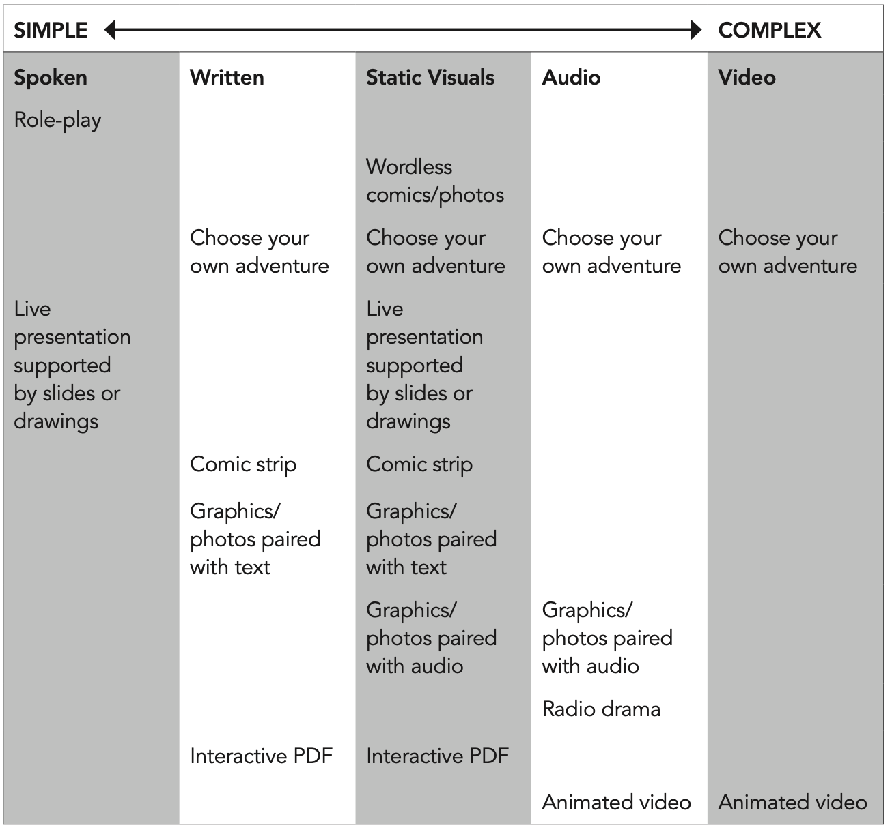

What development tools and applications are at your disposal to produce the story?

Audio equipment
Audio editing
Video equipment
Video editing
Animation tools
Camera
Graphics creation tools
E-Learning authoring tools
Webinar applications
Live presentation tools

If the final product of your story includes audio and visuals, use the Storyboard Template in Appendix 1 to plan for development. Then use the Story-Reflection-Solving-Feedback worksheet as a design document for training.

