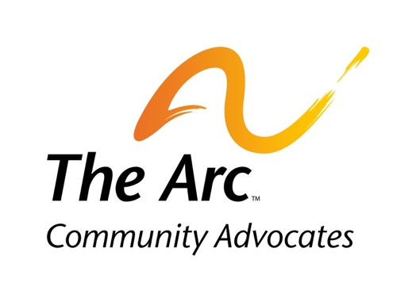
The Arc Community Advocates
Board of Directors Application

The Arc Community Advocates Board of Directors are elected at the Annual Meeting each September. Board members serve 3-year terms and can be re-elected for a second 3-year term. Applications to serve on the Board are gathered throughout the year with a deadline of August 31 each year.

Please complete the following application and send to rshepherd@communityadvocates.org or mail to:
Nominations
814 S. Westnedge Ave.
Kalamazoo MI 49008

A resume or a short biography along with your application would be helpful.

In addition to the application and resume/biography, you may have an interview with members of The Arc Community Advocates Nominating Committee. You will be informed of the Nominating Committees decision if you are nominated by July 31.

Name: ________________________________________________ Date: ___________________
Address: ______________________________________________________________________
Preferred Phone Number: ___________________ Alt. Phone Number: ____________________
Preferred Email Address: _________________________________________________________

Present Occupation:

What do you know about the mission of Arc Community Advocates?

Have you, a family member or friend received services from Arc Community?

Have you volunteered or donate to The Arc Community Advocates recently or in the past?
If so, what were the activities.

What calls you to be considered for nomination to The Arc Community Advocates Board of Directors?
If you are not nominated at this time, are you willing to serve on any of The Arc Community Advocates Committees? Yes _____ No _______
If yes, please select which ones:
- Membership
- Fund Development
- Fundraising
- Other

Thank you for your interest in serving The Arc Community Advocates.

