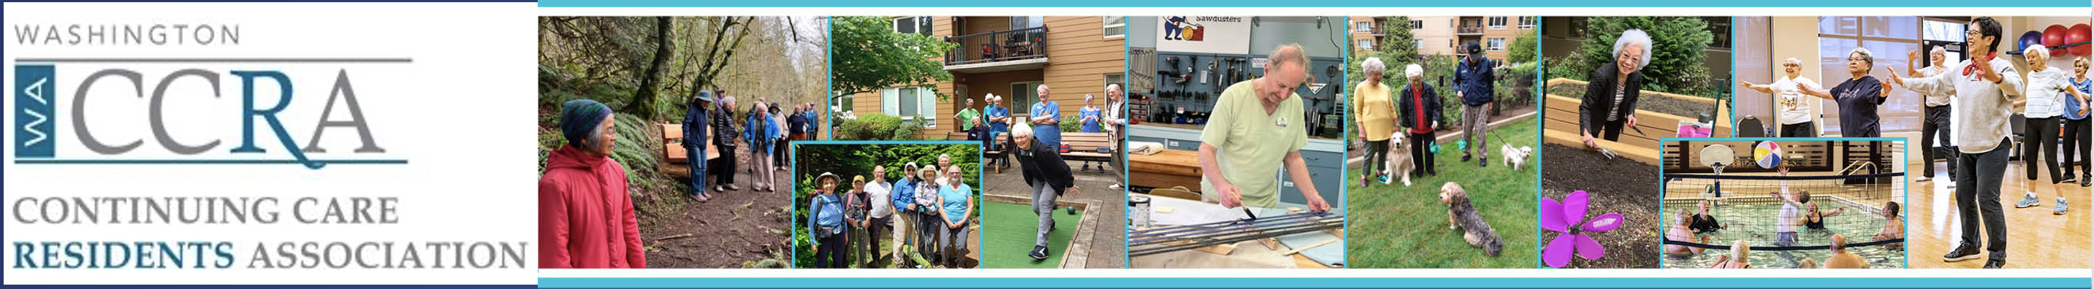
Member News-Mail
Good Reasons to Renew your Membership!
January 23, 2024
Greetings WACCRA Members!
It is time to renew your WACCRA membership for 2024 -25 to enable our continued work advocating for seniors living in CCRC communities throughout Washington. With your membership in 2023 we accomplished a lot:

- Obtained $300,000 in State funding to continue the work of creating expanded consumer protections for CCRC residents.
- Conducted our first electronic survey of member’s priorities for legislative reform.
- Conducted focus group meeting to improve our communication with members and re-designed our News-Mails based upon focus group responses.
- Heard from a national expert on CCRC governance and regulations, Katherine Pearson, J.D., on the importance of consumer protections in CCRCs.
- Consulted with residents, at the request of their Washington State CCRC’s Resident’s Council, to connect with regulators and legislators regarding their concerns about safety, organization finances and consumer protection.
WACCRA's top priority in 2024 is to continue our work to improve CCRC resident consumer protections. Our Legislative Committee is working hard on promoting our point of view with regulators who are developing a legislative framework for the Legislature to consider in 2025. Critical to this work is continuing to build WACCRA’s membership and that is where YOU are so important. By renewing your membership in WACCRA, and inviting others to join, you support the effort to expand consumer protections for CCRC residents.

We would appreciate your help to increase our membership too! Chat with your neighbors and friends in other CCRCs about why you continue to support WACCRA. Introduce them to our website for more information (WACCRA.org). Consider Family Membership for those who care about you and want to ensure that you are protected.
On continuing your membership, you will receive a pre-filled renewal form from your CCRC WACCRA Liaison or from WACCRA’s Membership Chair, Susan Dillon. Please confirm that all contact information is correct.

Finally, please consider making a contribution. Membership fees and contributions help us pay our lobbyist who is working on behalf of WACCRA in Olympia to advance our goals.

We thank you in advance for your renewed commitment to WACCRA!

Kim Hickman, WACCRA News-Mail Editor & Susan Dillon, WACCRA Membership Chair

