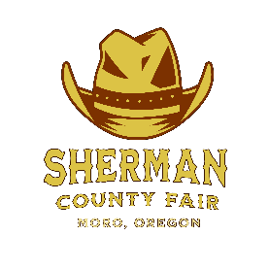
Sherman County Fair
66147 Lone Rock Rd
Moro, Oregon 97039

FOOD VENDOR APPLICATION

OWNER/BUSINESS NAME
TYPE OF FOOD TO BE SOLD

PHONE
MAILING ADDRESS
CITY
STATE & ZIP

BOOTH SPACE NEEDED

YES, I NEED ELECTRICAL
(WHAT KIND)
DO NOT NEED ELECTRICAL

THANK YOU FOR YOUR INTEREST AT THE SHERMAN COUNTY FAIR.
PLEASE INCLUDE ANY OTHER INFO THAT WILL BE IMPORTANT FOR US TO KNOW ABOUT.
Foods Vendors must be open till at least 11:00PM
PLEASE FILL IN ALL INFO AND SIGN BELOW. PLEASE SEND TO ABOVE ADDRESS.
I/WE WILL BE GIVING THE SHERMAN CO. FAIR A BOOTH SPACE FEE OF $350.00 FOR THE WEEK OF 8/19/24 THRU 8/24/24. THIS WILL BE PAID AT THE FAIR OFFICE UPON ARRIVAL AT THE FAIR GROUNDS BEFORE SETUP BEGINS, THANK YOU

VENDOR SIGNATURE DATE RECEIVED BY S.C BOARD SECRETARY, DATE

